Overview
Nunn opposed the Inflation Reduction Act, which allowed Medicare to negotiate lower drug prices for seniors and capped the cost of insulin at $35 per month for seniors. The Inflation Reduction Act benefited more than 88,000 Iowans.

Nunn Opposed Legislation That Lowered The Cost Of Prescription Drugs For More Than 88,000 Iowans

Nunn opposed the inflation reduction act, which allowed medicare to negotiate drug prices and capped the cost of insulin at $35 per month
Nunn Opposed The Inflation Reduction Act Despite Its Provisions To Lower The Cost Of Prescription Drugs. According to the Iowa Capital Dispatch, "Republican congressional candidate Zach Nunn said Saturday the Inflation Reduction Act passed Friday will hurt Iowans and small businesses. Nunn, a state senator running against U.S. Rep. Cindy Axne in Iowa’s 3rd District, spoke at the Register’s Political Soapbox at the Iowa State Fair. […] The $740 billion spending bill includes measures like hiring more IRS agents, lowering pharmaceutical costs and creating incentives for the purchase of electric vehicles. Nunn said these investments increase government spending, but do not help reduce everyday costs for Iowans." [Iowa Capital Dispatch, 8/20/22]
HEADLINE: “Nunn Assails Inflation Reduction Act At State Fair Soapbox” [KMA Land, 8/15/22]

The Inflation Reduction Act Capped Prescription Drug Costs Under Medicare, Which Benefited More Than 88,000 Iowans
The Inflation Reduction Act Allowed Medicare To Negotiate Prices For Certain Prescription Drugs. According to the U.S. Department of Health and Human Services, "Negotiations are underway between HHS and the participating drug companies of the first 10 prescription drugs selected for negotiation in the first cycle of the Medicare Drug Price Negotiation Program. The first 10 drugs selected treat conditions such as blood clots, diabetes, heart disease, heart failure, autoimmune diseases, and chronic kidney disease." [U.S. Health and Human Services, Inflation Reduction Act Of 2022, Viewed 7/1/24]
The Inflation Reduction Act Required Drug Companies To Pay A Rebate To Medicare If They Raised Prices Faster Than The Rate Of Inflation. According to the U.S. Department of Health and Human Services, "Allowing Medicare to negotiate with participating drug companies to get lower drug prices for certain drugs covered under Medicare Beginning negotiations with the participating drug companies that manufacture all 10 drugs selected for the first cycle of negotiations" [U.S. Health and Human Services, Inflation Reduction Act Of 2022, Viewed 7/1/24]
The Inflation Reduction Act Capped The Price Of Insulin To $35 A Month For Many People On Medicare. According to KFF, "In 2022, President Biden signed into law the Inflation Reduction Act, which included a provision that requires all Part D plans to charge no more than $35 per month for all covered insulin products, and also limits cost sharing for insulin covered under Part B to $35 per month. Deductibles no longer apply to insulins under Part D or Part B. These provisions took effect in 2023 (January 1 for Part D; July 1 for Part B)." [KFF, 6/12/24]
More Than 88,000 Iowa Medicare Enrollees Were Prescribed Drugs Selected For Price Negotiation Under The Inflation Reduction Act. According to the U.S. Department of Health and Human Services,
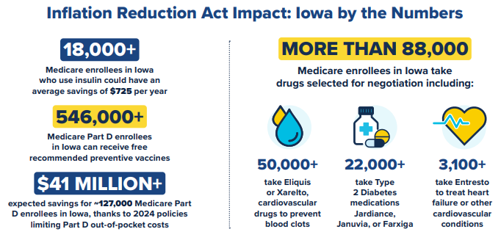
[U.S. Department of Health and Human Services, Lowering Prescription Drug Costs for Iowa, Viewed 5/6/25]

