Overview
Earle-Sears opposed red flag laws and called for enhanced gun rights as a way to address gun violence. After a mass shooting in Richmond in June 2023, Earle-Sears blamed the mass shooting on local officials and gang violence. Days after the Uvalde shooting in May 2022, Earle-Sears attended an NRA event and claimed mass shootings were attributed to societal “ills,” including lack of prayer in schools, “emasculated” men, abortion, mental illness, and more.

Earle-Sears Opposed Red-Flag Laws And Blamed Gun Violence And Mass Shootings On Local Officials And Societal “Ills,” Such As Lack Of Prayer In Schools, “Emasculated” Men, Abortion, Mental Illness, And More

In June 2023, After A Mass Shooting In Richmond, Earle-Sears Blamed Local Officials And Gang Violence
June 2023: After A Mass Shooting Following A High School Graduation In Richmond, Earle-Sears Blamed Local Officials And Gang Violence: “If All We Do Is Come In Front Of A Camera… And Keep Talking About, ‘Oh, This Shouldn’t Happen, And That Shouldn’t Happen.’ Well, You’re The One In Charge. You’re The One Responsible.” According to Dogwood, “Two people were killed and several others were injured in a mass shooting following Huguenot High School’s graduation ceremony on Tuesday evening near Richmond’s Altria Theater. The two victims have been identified as a Huguenot graduate and his stepfather. […] Virginia Lieutenant Governor Winsome Earle-Sears, who briefly represented part of Hampton Roads in the state House about 20 years ago, arrived at the scene of the Richmond tragedy to comment on the shooting. Earle-Sears, a military veteran who became notorious for a campaign poster featuring her brandishing an assault-style rifle, assigned blame for the violence to local Democratic officials and gang violence – but not guns. Claiming that Richmonders are ‘not safe in this city,’ Earle-Sears wondered: ‘Who is in charge – is that the mayor, is that the chief, who is that? I mean, let’s start naming names. Because otherwise, if no one is accountable, if all we do is come in front of a camera… and keep talking about, ‘oh, this shouldn’t happen, and that shouldn’t happen.’ Well, you’re the one in charge. You’re the one responsible.’ ‘This is not about law-abiding gun owners, this is about gangs,’ she further claimed.” [Dogwood, 6/7/23]
June 2023: After A Briefing On The Mass Shooting, Earle-Sears Said, “This Is Not About Law-Abiding Gun Owners. This Is About Gangs… The Others Who Mean Harm, Who Mean To Kill And Mayhem, They’re Going To Have The Guns.” According to WRIC ABC 8News, “Virginia Lt. Gov. Winsome Earle-Sears (R) addressed the crowd of reporters after the briefing ended, calling out city leaders and pointing to ‘gangs’ in remarks that Democrats said inserted politics into a tragedy before any details on the investigation were released. ‘I was told to stay away but the people that I represent are not safe. They’re not safe in this city and we have to figure out why that is. This is not about law-abiding gun owners. This is about gangs,’ Earle-Sears said. ‘This is about even if you took all the guns off the street from the law-abiding citizens, the others who mean harm, who mean to kill and mayhem, they’re going to have the guns.’” [WRIC ABC 8News, 6/7/23]

In An NRA Speech Delivered Days After The Uvalde School Shooting, Earle-Sears Blamed Mass Shootings On “Lack Of Prayer In Schools,” “Emasculated” Men, Abortion, Mental Illness, And More

In May 2022, The National Rifle Association Announced Earle-Sears Would Be The Keynote Speaker At A Pro-Gun Luncheon Held In Houston, Texas Mere Days After A Gunman Killed 19 Children And Two Adults At Robb Elementary In Uvalde, Texas
May 2022: Earle-Sears Was Slated To Be The Keynote Speaker At A National Rifle Association Women’s Luncheon In Houston Mere Days After A Gunman Killed 19 Children And Two Adults At Robb Elementary In Uvalde, Texas. According to Virginia Mercury, “Virginia Lt. Gov. Winsome Earle-Sears is scheduled to be the keynote speaker on Friday for a women’s luncheon at the National Rifle Association’s annual conference in Houston, just days after a deadly mass shooting at a Texas elementary school and another at a Buffalo grocery store pushed guns to the forefront of American politics. Tickets to the event with Earle-Sears, who famously posed with a military-style rifle during her 2021 campaign, range from $250 to $2,500, according to the NRA’s website. ‘Be part of this unforgettable gathering of like-minded women as we celebrate the sisterhood we share, hear from impactful speakers, participate in live and silent auctions, and raise funds essential to strengthening the NRA’s fight to protect our freedom,’ the NRA’s Women’s Leadership Forum says on a website promoting the event. On Wednesday, the Democratic Party of Virginia called on Earle-Sears to withdraw from the event in light of the shooting at Uvalde’s Robb Elementary School that left at least 19 children and two adults dead.” [Virginia Mercury, 5/25/22]
- The Democratic Party Of Virginia Called On Earle-Sears To Withdraw From The NRA Event In Light Of The Shooting In Uvalde. According to Virginia Mercury, “On Wednesday, the Democratic Party of Virginia called on Earle-Sears to withdraw from the event in light of the shooting at Uvalde’s Robb Elementary School that left at least 19 children and two adults dead. ‘Virginians should be in disbelief that our lt. governor would speak at an NRA event after an unconscionable elementary school shooting that left 19 children dead,’ DPVA spokesman Gianni Snidle said in a news release that also called on Earle-Sears to denounce the NRA. The lieutenant governor’s office didn’t immediately respond to an emailed request for comment.” [Virginia Mercury, 5/25/22]

Earle-Sears Defended Her Decision To Attend The NRA Event And Called For Enhanced Gun Rights, Mental Health Services And School Security
HEADLINE: “At NRA Gathering In Texas, Winsome Sears Says Guns Aren’t The Problem” [Washington Post, 5/27/22]
May 2022: At The NRA Event, Earle-Sears Called For Enhancing Gun Rights, Improving Mental Health Services, Fortifying School Security, And Called On Churches And Community To “Step Up,” Not Just The Government. According to the Washington Post, “Earle-Sears listed principles she supports to make things better, including a strong Second Amendment, better mental health services and stronger security in schools. And, she said, ‘Churches and communities need to step up. More government action cannot be the only answer.’ Despite her apocalyptic characterization of a nation on the brink, Earle-Sears said she is ultimately optimistic. ‘We will endure. For the sake of our children’s children. Our children will not just survive, they will thrive. Because we will leave it better than we found it. Our children are depending on us. There is no other refuge like America,’ she said.” [Washington Post, 5/27/22]

May 2022: Earle Sears Defended Her Decision To Attend The NRA Event, Claiming That Society Was “Blaming” Innocent NRA Members For The Uvalde Shooting. According to the Washington Post, “But Earle-Sears was defiant about attending. ‘They did not want me to come, thinking you are monsters, that you are culpable in the murder of the children,’ she said, according to a written copy of her remarks provided by her office. Reporters were not allowed to cover the event. ‘As you all know, the NRA was first established by Union veterans,’ continued Earle-Sears, who is Black. ‘I look at you, and I see mothers, daughters, sisters, and grandmothers, YOU are the NRA. People. You are not this nebulous entity. How far we have fallen that we have labeled you monsters, our fellow law-abiding Americans.’” [Washington Post, 5/27/22]

On May 24, 2022, Earle-Sears Tweeted “Prayers” For The Victims Murdered At Robb Elementary School
May 24, 2022: Earle-Sears Tweeted “Prayers” For The Victims Of The Robb Elementary School Shooting: “It Is A Season We Wish On No One.” According to Lieutenant Governor of Virginia on Twitter, “An ill-wind is blowing through our land; a wretched evil that destroys. Terry and I are praying for the parents, siblings, family members, and friends of Robb Elementary School who are now experiencing the deepest of pains. It is a season we wish on no one. 🙏”
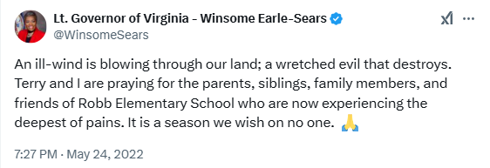
[Twitter, @WinsomeSears, 5/24/22]

Earle-Sears Attended The National Rifle Association Meeting And Blamed Societal “Ills” For The Tragedy, Including “Lack Of Prayer In Schools,” “Emasculated” Men, Abortion, Mental Illness, And More
May 2022: At The National Rifle Association Meeting After The Uvalde Shooting, Earle-Sears Defended Gun Rights And Blamed “Lack Of Prayer In Schools,” “Emasculated” Men, And COVID-19 Pandemic Safety Protocols. According to the Washington Post, “Virginia Lt. Gov. Winsome Earle-Sears (R) offered a full-throated defense of gun rights Friday at a National Rifle Association meeting in Texas, acknowledging the horror of this week’s shooting at a Uvalde elementary school but blaming it on a range of social factors from lack of prayer in schools to ‘emasculated’ men and pandemic safety protocols.” [Washington Post, 5/27/22]
May 2022: While Lamenting The Uvalde Shooting, Earle-Sears Claimed The Country Suffered From “The Breakdown Of The Family,” “Fatherless Homes,” “Lack Of Respect For Fellow Men,” “Black Men Murdering Each Other,” And Attacks Against Freedom Of Expression. According to the Washington Post, “In her remarks, Earle-Sears lamented the shooting at Robb Elementary School, quoting the Bible’s book of Jeremiah about Rachel weeping for her children. ‘This should not have happened again,’ Earle-Sears said. She characterized America as ‘in a battle for her children,’ and said the country weeps for social ills, from ‘the breakdown of the family’ to ‘fatherless homes,’ from ‘lack of respect for fellow men’ to ‘countless Black men murdering each other’ and ‘the onslaught against the liberty of thought and expression.’” [Washington Post, 5/27/22]
May 2022: Earle-Sears Blamed School Shootings On “Ills” That Were “Plaguing The Nation,” Such As Abortion Practices, Taking “Prayer Out Of Schools,” And Sexual Liberation. According to the Washington Post, “Earle-Sears, who has operated a prison ministry and often speaks in the tones of a preacher, warned that ‘America is running headlong into a dangerous abyss.’ She claimed that demonstrators are disrupting church services and babies are being aborted up until the moment of birth. Even language has deteriorated, she said, ‘such that F-bombs and even the startling MF bombs are spoken across our airways.’ These and other ills are plaguing the nation, she said, ‘Because we took prayer out of schools. We have so liberated our sexuality, that we are now informed that men can have abortions.’” [Washington Post, 5/27/22]

May 2022: Earle-Sears Blamed School Shootings On Social Justice, COVID-19 Protocols That Impacted Mental Health, The Absence Of Fathers And “Emasculation” Of Men. According to the Washington Post, “Society frees its criminals so they can pillage and plunder ‘in the name of social justice,’ she said, and meanwhile fails to teach children to read. Mental health is deteriorating, worsened by ‘covid protocols.’ Fathers are not present because ‘we have emasculated our men,’ she said.” [Washington Post, 5/27/22]

Earle-Sears: “A Determined Mentally Unstable Person Will Try To Find Other Means To Their Wicked Deed”
May 2022: While Lamenting School Shootings, Earle-Sears Claimed Mental Illness Posed The Real Threat To Public Safety: “A Determined Mentally Unstable Person Will Try To Find Other Means To Their Wicked Deed.” According to the Washington Post, “Earle-Sears considered citing personal experience to make the case that it’s mental illness, not gun policy, that poses a threat to public safety, according to an adviser who spoke on the condition of anonymity to share private deliberations. A grown daughter of hers with bipolar disorder — off her medication and driving at what police described as ‘an excessive rate of speed’ — died in a car wreck in 2012 that also killed Earle-Sears’s two young granddaughters. ‘We are told that guns are the problem but … a determined mentally unstable person will try to find other means to their wicked deed — whether with a car, molotov cocktail, or some other means,’ she said.” [Washington Post, 5/27/22]

Facing South Reported That Earle-Sears “Stood With The NRA After The Uvalde Massacre” And Noted She Accepted $35,000 From Gun Organizations
HEADLINE: “The Politicians Who Stood With The NRA After The Uvalde Massacre” According to Facing South, “Just days after the massacre of 19 students and two teachers at Robb Elementary School in Uvalde, Texas, at least a half-dozen politicians went ahead with their planned appearances at the NRA's annual meeting in Houston. They included, clockwise from top left, former President Donald Trump, U.S. Sen. Ted Cruz of Texas, Gov. Kristi Noem of South Dakota, Texas state Rep. Tom Oliverson, Virginia Lt. Gov. Winsome Earle-Sears, and North Carolina Lt. Gov. Mark Robinson. (Official portraits.)”

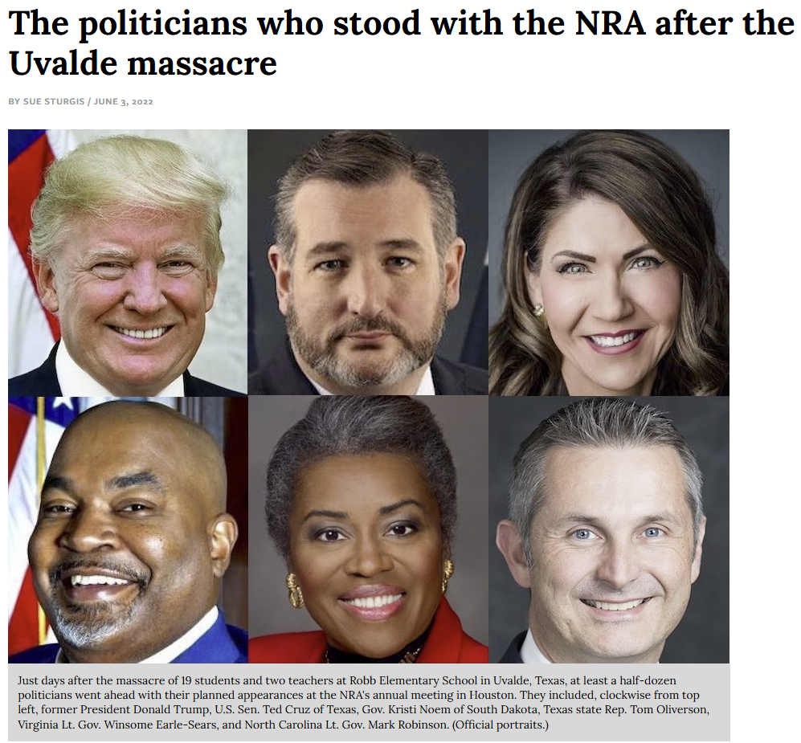
[Facing South, 6/3/22]
June 2022: Facing South Reported That Earle-Sears Accepted $35,000 From Pro-Gun Organizations During Her Lieutenant Governor’s Campaign, Including $10,000 From The NRA And $25,000 From The Virginia Citizens Defense League. According to Facing South, “Of the over $3.1 million Earle-Sears' lieutenant governor's campaign has raised, $35,000 has come from pro-gun groups: $10,000 from the NRA, and $25,000 from the Virginia Citizens Defense League, which has been described as being to the NRA's right. Among the top corporate contributors to Earle-Sears' campaign are real-estate developer Haulover Creek Development Co. of Richmond; Athdel Ventures, the corporate entity behind the Miles Agency, a Virginia Beach public-relations firm; and McShane LLC, a media consultancy based in Las Vegas that works for many GOP organizations as well as Gun Owners of America.” [Facing South, 6/3/22]

Earle-Sears Pledged Never To Support “Red Flag Laws” Temporarily Blocking Gun Access For People Considered A Danger To Themselves Or Others

Earle-Sears Rose To National Prominence After A Photo Of Her Brandishing An Assault Rifle Went Viral Alongside Her Pledge: “I Won’t Ever Support A Red Flag Law”
2021: Earle-Sears Posted A Photo Of Herself Holding An Assault-Style Rifle At Clark Brothers Guns, Alongside The Statement “I Won’t Ever Support A Red Flag Law!” According to Earle-Sears' Twitter, “Beautiful day ☀️ = Range day! Marines know how to use guns and I won’t ever support a red flag law! The 2nd Amendment says ‘shall not be infringed!’ #SemperFi Always good to see my friends at Clark Brothers Guns.”
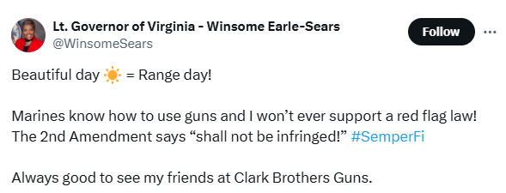
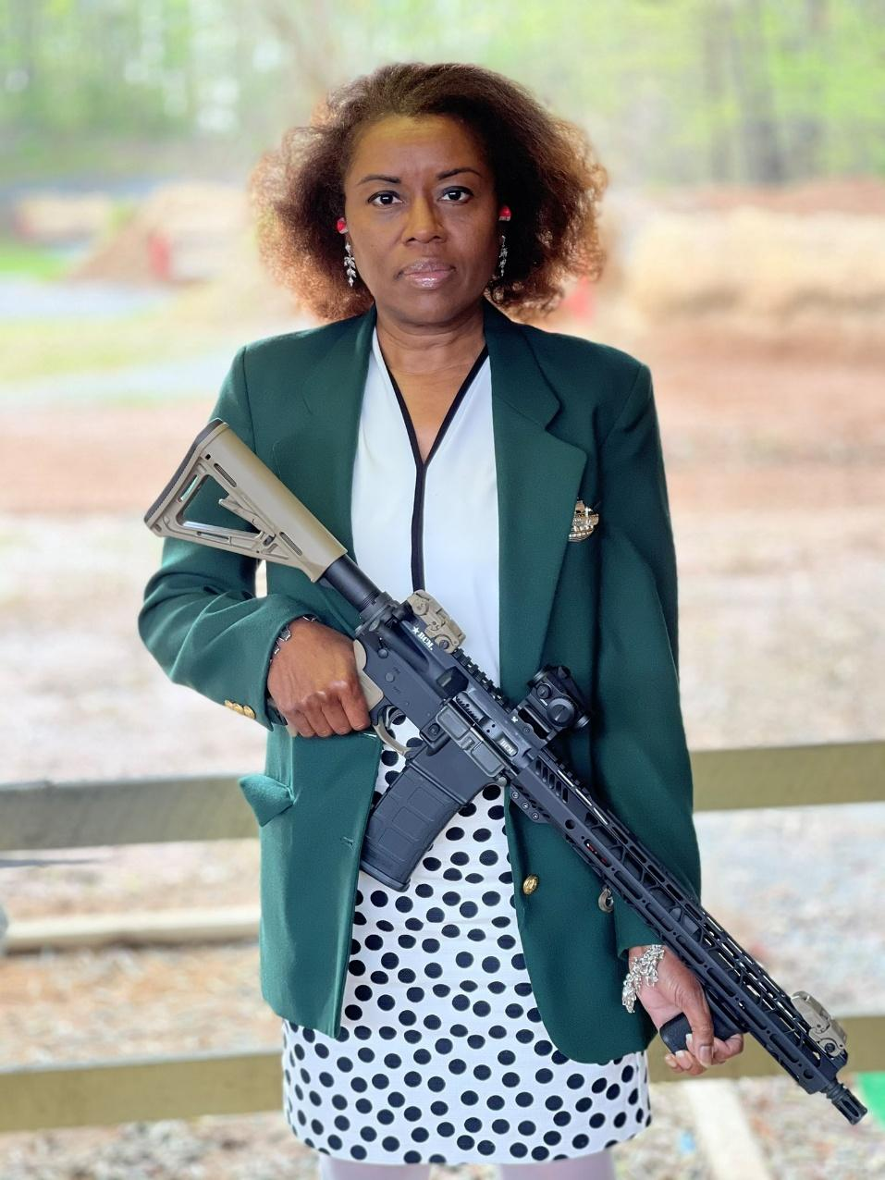
[Twitter, @WinsomeSears, 4/15/21]
- 2023: Earle-Sears Described The Origin Of The Assault Rifle Photo In Her Memoir, And Said The Photo Went Viral Because It Was “Powerful, A Black Woman Standing With A Gun Like That.” In her 2023 memoir “How Sweet It Is: Defending the American Dream,” Winsome Earle-Sears wrote, “During the cycle, we were on our way to a GOP meeting when we passed a rifle range. It had been a while since I'd been at the range. So we stopped by Clark Brothers Range in Warrenton, Virginia. I put on a green coat to keep the spent gun- power blowback off my blouse. When you look at the photo taken there, you can see that I still have my earplugs in. Nothing staged there. The picture took off. It went viral. It's not as if an AR is unknown to me. In the Marines I had an M-16. I had to break the thing down and put it back together. There's a photo of me with my M-16 in full battle dress, my helmet, my camouflage, my flak jacket, my extra magazines, everything. I look ready to go, because I was. We were engaging in a war game at the time. So standing with that AR was normal and natural for me. I think it's pretty powerful, a Black woman standing with a gun like that.” [Earle-Sears, Winsome. “How Sweet It Is: Defending the American Dream.” Center Street, 8/1/23]

The National Rifle Association Posted The Photo Of Earle-Sears And Quoted Her As Saying “I Will Never Surrender Our Second Amendment!”
The National Rifle Association Posted A Photo Of Earle-Sears And Quoted Her As Saying “I Will Never Surrender Our Second Amendment!” According to the National Rifle Association on Twitter, “Our rights are not negotiable.”
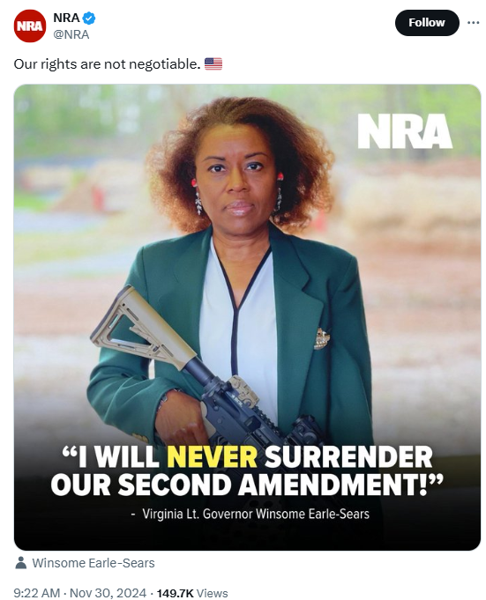
[Twitter, @NRA, 11/30/24]

The Richmond Times-Dispatch And WVTF Reported That Virginia’s Red Flag Law Had Been Used Hundreds Of Times To Temporarily Remove Firearm Access From People Who Posed A Danger To Themselves Or Others
Virginia Was One Of 19 U.S. States With A Red Flag Law, A Provision Allowing Temporary Firearm Removal From Individuals Believed To Be At Risk Of Harming Themselves Or Others. According to the Richmond Times-Dispatch, “Virginia is one of 19 states with a red-flag law, which allows for temporary firearm removal from individuals believed to be at risk of harming themselves or others. The policy, which took effect in Virginia in 2020, is one that gun-safety advocates are pushing for in other states once again across the U.S. in the aftermath of the Nashville school shooting that killed six people in late March. Since the substantial risk order law took effect in Virginia, it has been used hundreds of times across the commonwealth. As of March, there were 28 orders issued in Virginia in 2023. A bill to adjust the order filed in the state legislature has so far not advanced beyond the Democratic-controlled Senate.” [Richmond Times-Dispatch, 4/21/23]
WVTF: “Virginia’s Red Flag Law Has Successfully Taken Guns Out Of The Hands Of People Who Pose A Danger To Themselves Or Others.” According to WVTF, “Virginia's red flag law has successfully taken guns out of the hands of people who pose a danger to themselves or others. Proposed legislation would encourage more law enforcement agencies to use risk orders. Stories of Virginia's red-flag law show it's been used over and over again to take dangerous weapons out of the hands of dangerous people.” [WVTF, 2/27/24]

