Overview
Earle-Sears staunchly supported education policies that would divert funds from Virginia’s public schools toward private and charter schools. Earle-Sears claimed public school districts were “redlining” and contended the Brown v. Board of Education decision was not about desegregation but instead about parental choice in which citizens could send their children to a school of their choosing. Experts on Brown v. Board found that Earle-Sears’ characterization of the landmark case was inaccurate.

Earle-Sears Took Aim At Virginia Teachers, Accusing Them Of Indoctrinating Children With Critical Race Theory, Marxism And “Family Destroying Propaganda”
In Her 2023 Memoir, Earle-Sears Accused Virginia Teachers Of “Dividing The Children,” “Condemning Their Parents And Relatives,” And Claimed Children Were “Being Taught Hate.” In her 2023 memoir “How Sweet It Is: Defending the American Dream,” Winsome Earle-Sears wrote, “How was having a mom and a dad in the home something called ‘White privilege’? How did having been in our country's military make somebody an oppressor? Activist teachers were dividing the children, condemning their parents and relatives. What did any of this have to do with history? With English? With math? Many kids were asking their parents why White people were so bad. And this included themselves or their friends who were White. They were being taught hate. Black children were taught they were victims.” [Earle-Sears, Winsome. “How Sweet It Is: Defending the American Dream.” Center Street, 8/1/23]

In Her Memoir, Earle-Sears Suggested Virginia’s Schools And Teachers Were Engaged In A Marxist Project To Take Over Society
In Her 2023 Memoir, Earle-Sears Claimed That Teachers In Virginia Were Teaching Students To Hate White And Heterosexual People, And Painted Virginia’s Teachers As Being Engaged In A “Marxist” Project To Take Over Society. In her 2023 memoir “How Sweet It Is: Defending the American Dream,” Winsome Earle-Sears wrote, “If you're White, you're privileged? If you're heterosexual-they call it cisgender-you're privileged? If you're married to somebody of the opposite sex, that's privilege?! They say we must teach these things to all our children. That that's what education is for, in fact. No. This is teaching everyone to hate. It's fomenting chaos. And who will step in as the savior? The Marxists. Who wants to live under Marxism? We've seen the kind of police states and despotic regimes Marxists create in this world. These are the folks who call wrong right. Up is called down. Two plus two equals whatever you want it to equal. Everything, especially the education of the young, is in service to this power-mad ideology. No. This is America. We're not doing that. Education is where the rubber meets the road. These parents who observed what was going on and spoke out were the alarm bells, the sirens, of free society. They said, ‘No! This is my child. I'm not going to stand for it!’ You had thousands of parents who had formerly been Democrats come over to the Republican side. You can talk about party loyalty all you want, but when it comes to my child, all bets are off, baby. If my child isn't learning, I don't care if you are Democrat, Republican, Green Party, or Reform Party, we've got problems. Enough of these parents who were Democrats, independent-leaning Democrats, and others were saying no, something's got to change. Many Democrats began to realize that the revolution had started to come for them and their families, too. They may have thought, ‘Hey, I'm safe; I'm a Democrat.’ That stopped working. No. You're still White. Or still married. Still believe family is essential and important. You are now the enemy of the system. Parents are the enemy.” [Earle-Sears, Winsome. “How Sweet It Is: Defending the American Dream.” Center Street, 8/1/23]
In Her 2023 Memoir, Earle-Sears Claimed That Virginia Schools And School Boards Were Advancing “Activist Marxism” Under The Guise Of Teaching American History. In her 2023 memoir “How Sweet It Is: Defending the American Dream,” Winsome Earle-Sears wrote, “Of course the media and Democrats set up a chorus of disdain. Those Republicans are lying. We're not teaching that! There is no critical race theory in the classroom! We found that many school systems had received taxpayer money for CRT instruction and seminars. School boards were not merely going along, they were instigating and cheering this nonsense on. Our own Board of Education had put it on their website that schools should be teaching critical race theory. Books were recommended, curricula advanced. They called this teaching history? How? It's activist Marxism. It creates chaos. It isn't teaching. It's indoctrination. It's the difference between learning how to think for yourself and being told what to think. Power is all that matters in this indoctrination technique-not education, understanding, working together, competition, hope, love, or belief in God. All of that is illusion, in this view. Only power relationships matter. There was always that word, ‘privilege.’ If you are privileged, you have gained power by harming others. You are bad. You are evil. You are to be despised.” [Earle-Sears, Winsome. “How Sweet It Is: Defending the American Dream.” Center Street, 8/1/23]

Earle-Sears Accused Virginia School Libraries Of Providing Children With Pornography, And Compared LGBTQ Identity In Schools To The Novel “1984”

Earle-Sears Accused Virginia School Libraries Of Providing Pornography To Their Students
Earle-Sears Accused Virginia School Libraries Of Providing Pornography To Their Students In Her Memoir: “Pictures Of People Having Sex. Blow Jobs. Penises Erect.” In her 2023 memoir “How Sweet It Is: Defending the American Dream,” Winsome Earle-Sears wrote, “It was an onslaught of hateful, antidemocratic ideology. It was antihuman and antifamily. In some cases it was just simply disgusting. We discovered that school libraries possessed pornographic books, and teachers were promoting these and other books, these books were nothing less than filth. Not just in high schools, which would be bad enough, but in elementary and middle schools. Pictures of people having sex. Blow jobs. Penises erect. And the language was astonishing. To say these books were unsuitable for children is the under- statement of the century. They were unsuitable for education. Parents came to school board meetings and read from these books, and in one case the reader was stopped by a school board member. It was too pornographic!” [Earle-Sears, Winsome. “How Sweet It Is: Defending the American Dream.” Center Street, 8/1/23]

Earle-Sears Accused Public Schools Of “Advance LGBT Ideology” And Compared Schools To George Orwell’s 1984
Earle-Sears Said There Were Efforts To “Advance LGBT Ideology” In Schools, And Compared Modern Schools To The Dystopian Novel “1984.” According to the Christian Post, “Responding to the efforts to advance LGBT ideology and expose children to other concerning content, Sears remarked that ‘it’s 1984’ in American society, referring to the dystopian novel forecasting a tyrannical government that declares war on reality. ‘If we don’t get a grip, we’re going to be living in some kind of dystopian society,’ she warned. Schlapp asked Sears to react to the fact that several public schools in northern Virginia ‘held merit awards from students’ out of a desire for ‘equity.’ She described the situation as part of an effort to ‘dumb down’ education where ‘instead of trying to bring everybody up, we’re just going to bring everybody down.’ Sears lamented the state of American education, asserting that ‘by the time a child even goes to college now, 65% of them need remedial education. We’re paying for it twice. We’re paying for it in the public schools [where] they’re not getting [an education] and we’re paying for it when they do go to college or other post-high school ed.’ ‘America is a superpower, and the only way to maintain that superpower status is to ensure that everybody has a quality education because China is right behind,’ she added. ‘And guess what? They don’t care about that.’” [Christian Post, 3/3/23]

Earle-Sears Repeatedly Pushed For Legislation That Would Divert Public Education Funds Toward Charter Schools And Private Schools

Earle-Sears Was A “Long-Time Charter School Advocate” And Argued That Charter Schools Would “Make Public Schools Better”
Earle-Sears Was A “Long-Time Charter School Advocate.” According to WVTF, “Lt. Governor Winsome Earle-Sears is backing a pair of conservative school choice bills. But her support isn’t expected to be enough to overcome Democrats’ opposition. ‘We’re talking about our future and we’re not going to stand in the way of a parent who wants better for their child,’ said Earle-Sears. A long-time charter school advocate, the Lt. Governor spoke Wednesday before a crowd of students from a collection of private schools who lobbied legislators in the hopes of new funding from the state.” [WVTF, 1/24/24]
In Her Memoir, Earle-Sears Passionately Advocated For An Expansion Of Charter Schools In Virginia, Writing “Choice In Education… Will Make The Public Schools Better.” In her 2023 memoir “How Sweet It Is: Defending the American Dream,” Winsome Earle-Sears wrote, “So why do Virginia Democrats keep denying charter schools when Black children have been failing spectacularly—yet when given the opportunity have flourished? I’m not a Johnny-come-lately to the education process. It’s something that I’ve been involved with for decades. When I ran for lieutenant governor primarily on education I could truthfully say: I know education. When I sat on the State Board of Education, I accepted no excuses. We need to understand why our children aren’t learning. That’s the primary purpose of school: to learn. That’s why their parents are sending them to school. If schools are not going to do it because school boards take positions that destroy families and separate parents from their children, then parents need to be able to make a different decision. We need school choice. We’ve needed it for some time. Choice in education will lift all boats. It will make the public schools better, and it will bring back the true purpose of education. Unfortunately, it is still mostly a dream in the Commonwealth. But the day is coming when parents will make it a reality.” [Earle-Sears, Winsome. “How Sweet It Is: Defending the American Dream.” Center Street, 8/1/23]

In 2024, Earle-Sears Backed A Pair Of Conservative Education Bills That Would Have Diverted Taxpayer Funds Away From Public Schools And Toward Private Schools
2024: Earle-Sears Backed A Pair Of Conservative School Choice Bills: One That Created A Tax Credit For Private And Home Schooling, And Another That Allowed Public Funds To Be Diverted From Public Schools Toward Private Schools For Certain Students. According to WVTF, “Lt. Governor Winsome Earle-Sears is backing a pair of conservative school choice bills. But her support isn’t expected to be enough to overcome Democrats’ opposition. ‘We’re talking about our future and we’re not going to stand in the way of a parent who wants better for their child,’ said Earle-Sears A long-time charter school advocate, the Lt. Governor spoke Wednesday before a crowd of students from a collection of private schools who lobbied legislators in the hopes of new funding from the state. Spotsylvania County Delegate Phillip Scott is carrying a pair of bills that would offer that funding. The first involves creating a tax credit for homeschooling or sending a child to a private school, though it's limited to families that make under 200% of the poverty line. The second, called the Education Excellence for All Program, would allow parents making under 300% the poverty line to access funds currently allotted by the state to their student. Instead of the money going towards their expected public school, it could go towards a private program or support the purchase of home-schooling equipment.” [WVTF, 1/24/24]
- In January 2024, Earle-Sears Spoke Before A Crowd Of Private School Students Who Lobbied Legislators For State Funding. According to WVTF, “Lt. Governor Winsome Earle-Sears is backing a pair of conservative school choice bills. But her support isn’t expected to be enough to overcome Democrats’ opposition. ‘We’re talking about our future and we’re not going to stand in the way of a parent who wants better for their child,’ said Earle-Sears. A long-time charter school advocate, the Lt. Governor spoke Wednesday before a crowd of students from a collection of private schools who lobbied legislators in the hopes of new funding from the state.” [WVTF, 1/24/24]

HB 1180 (2024) Created A Tax Credit For Parents Who Homeschooled Their Children Or Sent Them To Private Elementary Or Secondary Schools
HB 1180 (2024) Created A Tax Credit For Parents Who Homeschooled Their Children Or Sent Them To Private Elementary Or Secondary Schools. According to Virginia’s Legislative Information System, HB 1180 “Creates a tax credit for taxable years 2024 through 2028 that may be claimed by any parent of a child who receives home instruction or attends a private elementary or secondary school in Virginia. The bill specifies that an eligible individual may claim the credit for certain eligible education expenses, as defined in the bill and imposes certain limitations on who may claim the credit and how much credit may be claimed based on a taxpayer's Virginia adjusted gross income.” The bill ultimately died in committee after the House Education Subcommittee on Finance laid the bill on the table. [Virginia's Legislative Information System, HB 1180 (2024), 1/10/24]

HB 1164 (2024) Created A Process To Divert Public Education Funds From Public Schools In Order To Fund Private Or Charter School Tuition On A Per-Pupil Basis
HB 1164 (2024), The “Education Excellence For All Program,” Created A Process To Divert Public Education Funds From Public Schools In Order To Fund Private Or Charter School Tuition On A Per-Pupil Basis. According to Virginia's Legislative Information System, HB 1164 “Permits the parents of qualified students, defined in the bill, to apply for a one-year, renewable Education Excellence for All Savings Account, defined in the bill, that consists of an amount that is equivalent to a certain percentage of all applicable annual Standards of Quality per pupil state funds appropriated for public school purposes and apportioned to the school division in which the qualified student resides, including the per pupil share of state sales tax funding in basic aid and any per pupil share of state special education funding for which the qualified student is eligible. The bill permits the parent of the qualified student to use the moneys in such account for certain qualified expenses of the qualified student, including tuition, deposits, fees, and required textbooks at a private elementary school or secondary school that is located in the Commonwealth. The bill also contains provisions relating to program and account administration by the Department of the Treasury and a third party that serves as program administrator pursuant to a contract with the Department.” The bill ultimately died in committee after the House Education Subcommittee on K-12 laid the bill on the table. [Virginia's Legislative Information System, HB 1164 (2024), 1/10/24]

In 2023, At A CPAC Event Titled “Parents With Pitchforks,” Earle-Sears Warned Of “Dystopian Society” If Virginia Did Not Adopt School Vouchers
March 2023: At During A CPAC Panel Titled “Parents With Pitchforks,” Earle-Sears Warned Of “Dystopian Society” If Virginia Did Not Adopt Her Preferred Policy Of Diverting Public Funds To Private Schools. According to the Christian Post, “A prominent politician is warning of a ‘dystopian society’ if the public education system is not reformed, insisting that she would rather lose her seat than abandon her goal of improving American education by embracing school choice. The Conservative Political Action Conference, an annual gathering of conservative activists and politicians, is being held at the Gaylord National Resort and Convention Center this week for the first time since the coronavirus pandemic lockdowns. One panel at the event, titled ‘Parents with Pitchforks,’ addressed concerns about the state of public education in the United States. ‘We’ve got to protect our children, we’ve got to defend our parents and not allow the leftist radical agenda to take over our school system,’ declared Mercedes Schlapp, co-host of CPAC Now, who moderated the panel. One of the panelists, Virginia's Republican Lt. Gov. Winsome Sears, has seen the issue of education play a prominent role in her November 2021 election as well as her tenure as lieutenant governor. Sears used her platform on the panel to advocate for school choice programs, which enable parents to send their children to the school of their choice regardless of where they live and, in some cases, parents receive vouchers so they can send their children to private schools.” [Christian Post, 3/3/23]
- Earle-Sears Said She Would Risk Losing Her Re-Election If It Meant Virginia Were To Enact Policies Diverting Public Funds To Private Schools. According to the Christian Post, “She responded to concerns of some politicians that supporting school choice, an idea not supported by the politically influential teachers’ unions, would come with an electoral backlash. ‘If I have to lose the next election so that the children can get an opportunity for a good education, I’ll do it,’ she proclaimed. ‘It’s not about maintaining a seat. It’s about our children and their future.’ Sears characterized the issue of school choice as ‘the new Brown v. Board of Education fight,’ referring to the U.S. Supreme Court decision determining that segregated schools were unconstitutional. She had previously noted that ‘the rich people have already made a decision on school choice’ by sending their children to private school. ‘You sent your children to private school, so why can’t everybody have that same option?’ Sears asked. Characterizing opponents of school choice who send their children to private school as ‘hypocritical,’ Sears added: ‘We’ve got to make a change.’” [Christian Post, 3/3/23]

In 2022, Earle-Sears Pushed For An Expansion Of Charter Schools And Called Public School Districts “Redlining”
2022: Earle-Sears Called For An Expansion Of Lab Schools And Charter Schools, While Virginia Senate President Louise Lucas Pushed Back, Saying “We Are Going To Call It Just What It Is: Siphoning Off Funds For Public Schools.” According to 13 News (ABC), “Topping the list of priorities for Lt. Gov. Winsome Sears is expanding lab schools and charter schools. ‘We’ve got to get education through,’ Sears told 7News in an interview on Tuesday. ‘I want parents to have choices in their children’s education opportunities. To me the real racism is the redlining. Whereby your zip code, the child is stuck in that school system.’ The Virginia Republican’s plans for education are largely being blocked by Senate Democrats and their leader Senate President Louise Lucas. ‘When it comes to charter schools and siphoning off money from public schools for charter schools, I am opposed to that,’ said Sen. Lucas. ‘We are going to call it just what it is: Siphoning off funds for public schools.’” [13 News (ABC), 2/13/22]
2022: Earle-Sears Said: “To Me The Real Racism Is The Redlining,” Referring To The Zoning Of School Districts Based On Zip Code. According to 13 News (ABC), “‘We’ve got to get education through,’ Sears told 7News in an interview on Tuesday. ‘I want parents to have choices in their children’s education opportunities. To me the real racism is the redlining. Whereby your zip code, the child is stuck in that school system.’ The Virginia Republican’s plans for education are largely being blocked by Senate Democrats and their leader Senate President Louise Lucas. ‘When it comes to charter schools and siphoning off money from public schools for charter schools, I am opposed to that,’ said Sen. Lucas. ‘We are going to call it just what it is: Siphoning off funds for public schools.’” [13 News (ABC), 2/13/22]
Wall Street Journal Opinion: Referencing The Education System That Funded Schools Directly, Earle-Sears Said She Did Not Care About The School Buildings And Suggested Funding Should Follow Students. According to a Tunku Varadarajan opinion from the Wall Street Journal, “She portrays school choice in terms of class: It’s available, she says, for the rich, but not for the poor. ‘The money in education follows the brick building, it doesn’t follow the child,’ she says. ‘I don’t care about the brick building. I care about the human life. We don’t get do-overs for our children.’” [Tunku Varadarajan Opinion – Wall Street Journal, 1/7/22]

Earle-Sears Falsely Claimed That Brown V. Board Of Education Was Not About Desegregation In Order To Bolster Her Position On Funding Private Schools With Taxpayer Funds
Reason: “Winsome Earle-Sears: School Choice ‘Is New Brown V. Board’ Fight” [Reason, 1/25/23]
Earle-Sears Said “This Is Our New Brown V. Board Of Education Fight” About A Bill She Was Backing To Create Education Savings Accounts, Which Could Have Diverted Public Education Funds For Private School Tuition. According to WUSA 9 (CBS), “On Wednesday, the Virginia legislature will convene its annual session and a proposal championed by the Commonwealth’s lieutenant governor will likely gain a lot of attention. Virginia Lt. Gov. Winsome Sears and Delegate Glenn Davis, both Republicans, unveiled legislation last week that would essentially redirect money the Commonwealth spends on a student’s education in a public school to new individual savings accounts, if a parent asks. The ‘education success accounts,’ which could have anywhere from four- to six-thousand dollars, could be used to pay for tuition, and other education essentials, in non-public school settings. ‘It’s just like your health savings account,’ Sears said. ‘Where you put some money in and then you choose your doctor, and et cetera, it's the same principle.’ ‘This is our new Board versus Brown fight,’ she said. ‘And, what is that, it was never about Black children being able to attend White schools. It was always about a parent being able to make the best educational decision for their child. So, that’s what we’re trying to do.’’ [WUSA 9 (CBS), 1/10/23]
March 2023: At A CPAC Event Called “Parents With Pitchforks,” Earle-Sears Referred To Diverting Public Education Funds To Private Schools As “The New Brown V. Board Fight.” According to the Christian Post, “The Conservative Political Action Conference, an annual gathering of conservative activists and politicians, is being held at the Gaylord National Resort and Convention Center this week for the first time since the coronavirus pandemic lockdowns. One panel at the event, titled ‘Parents with Pitchforks,’ addressed concerns about the state of public education in the United States. […] She responded to concerns of some politicians that supporting school choice, an idea not supported by the politically influential teachers’ unions, would come with an electoral backlash. ‘If I have to lose the next election so that the children can get an opportunity for a good education, I’ll do it,’ she proclaimed. ‘It’s not about maintaining a seat. It’s about our children and their future.’ Sears characterized the issue of school choice as ‘the new Brown v. Board of Education fight,’ referring to the U.S. Supreme Court decision determining that segregated schools were unconstitutional. She had previously noted that ‘the rich people have already made a decision on school choice’ by sending their children to private school. ‘You sent your children to private school, so why can’t everybody have that same option?’ Sears asked. Characterizing opponents of school choice who send their children to private school as ‘hypocritical,’ Sears added: ‘We’ve got to make a change.’” [Christian Post, 3/3/23]
March 2023: Earle-Sears Used Brown V. Board Of Education’s Impact On Social Equality, Including Access To Quality Education, To Push For School Vouchers, Alleging Children Were “Trapped In Failing Schools.” According to Earle-Sears’ Twitter, “Brown v. Board of Education played a pivotal role in the civil rights movement for social equality. Part of that equality was the ability of parents to access a quality education for their child. […] VIDEO: Hello everyone, my name is Winsome Earle-Sears, and I am Virginia’s Lieutenant Governor. Brown versus Board of Ed played a pivotal role in the civil rights movement on social equality. Part of that equality was the ability for parents to access quality education for their children. Don’t let anyone tell you differently. That’s what we’re about – we want all children to be able to do that. And some children can’t – they’re trapped in failing schools, and so I wanted to push forward education savings accounts so that parents could make the decision on where to send their children to school. We’ve got to get it through, we will get it through. Parents, I’m with you – know that I care about your child, I want your child to have a hope and a future. That was the primary reason that I ran, and we’ll get it through with your help. Thank you.”
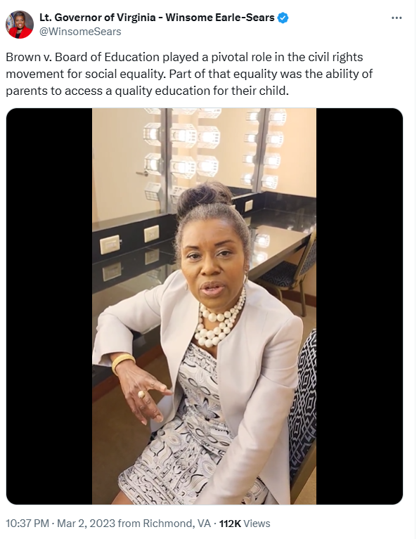
[Twitter, @WinsomeSears, 3/2/23] (VIDEO)

Earle-Sears Downplayed Brown V. Board’s Impact On Racial Segregation, And Appeared To Use The Case To Bolster Her Support For Bills That Diverted Public Education Funds To Private Schools
Earle-Sears Downplayed Brown V. Board’s Impact On Racial Segregation, And Appeared To Use The Case To Argue For Diverting Public Education Funds To Private Schools. According to Reason, “’Brown v. Board of Ed ultimately was never about black kids getting into a white school. It was always about ultimately a parent being able to decide where their children should attend school,’ Virginia Lt. Gov. Winsome Earle-Sears tells me in today’s Reason Interview podcast. She is one of the driving forces behind a new bill that would create so-called backpack funding for kids in Virginia. Parents would be allowed to use the state’s portion of per pupil funding—somewhere between $4,000 and $6,000—at any public or private school, for tutoring, books, and other educational expenses. If the bill passes, Virginia would join eight other states with education savings accounts (ESAs) that accomplish similar goals.” [Reason, 1/25/23]
January 2023: Earle-Sears Said: “Brown V. Board Of Ed Ultimately Was Never About Black Kids Getting Into A White School. It Was Always About Ultimately A Parent Being Able To Decide Where Their Children Should Attend School.” According to Reason, “‘Brown v. Board of Ed ultimately was never about black kids getting into a white school. It was always about ultimately a parent being able to decide where their children should attend school,’ Virginia Lt. Gov. Winsome Earle-Sears tells me in today’s Reason Interview podcast. She is one of the driving forces behind a new bill that would create so-called backpack funding for kids in Virginia.” [Reason, 1/25/23]

A PolitiFact Analysis Found Earle-Sears “Offered A Faulty Analysis” Of Brown V. Board: “Her Statement Conflicts With The Very Words Of The Supreme Court… We Rate Earle-Sears’ Statement False”
PolitiFact VA Analysis: “Winsome Earle-Sears Has Offered A Faulty Analysis Of The 1954 U.S. Supreme Court Landmark Brown V. Board Of Education Decision… Her Statement Conflicts With The Very Words Of The Supreme Court… We Rate Earle-Sears Statement False.” According to a PolitiFact VA analysis published by Virginia Public Media, “In her efforts to win state tuition funds for private and charter schools, Lt. Gov. Winsome Earle-Sears has offered a faulty analysis of the 1954 U.S. Supreme Court landmark Brown v. Board of Education decision — which banned government-enforced segregation of public schools. ‘It was never about sending Black children to white schools,’ Sears, a Republican, said during a Feb. 2 radio interview on WRVA. ‘It was about parents being able to decide where to send their children to school after all.’ […] “Earle-Sears said that Brown v. Board of Education ‘was never about sending Black children to white schools. It was about parents being able to decide where to send their children to school.’ Her statement conflicts with the very words of the Supreme Court in ruling that mandated segregation of public schools violates the 14th Amendment granting all citizens equal protection of laws. As SCOTUS wrote in its unanimous decision, ‘We come then to the question presented: does segregation of children in public schools solely on the basis of race, even though the physical facilities and other ‘tangible’ factors may be equal, deprive the children of the minority group of equal educational opportunities? We believe that it does.’ We rate Earle-Sears’ statement False.” [PolitiFact VA via Virginia Public Media, 2/21/23]
PolitiFact VA Analysis: Earle-Sears Repeatedly Claimed Brown V. Board Of Education Was About Parental Rights In Choosing Schools, And Not Desegregation, Which “Conflicts With Key Phrasing In The Supreme Court’s Unanimous Ruling.” According to a PolitiFact analysis published by Virginia Public Media, “For decades, school voucher advocates have argued that Brown v. Board has failed to produce equal education opportunities for children. Academic research has shown that school segregation ramped up after the court-ordered demise of busing in 1991 and that many Black children are once again locked in poorly performing schools. Earle-Sears’ statement goes a step further by saying that the Brown decision was about parental rights in choosing schools and not desegregation. She made similar claims during a September 2022 interview on Fox News. Her statements conflict with key phrasing in the Supreme Court’s unanimous ruling: ‘We come then to the question presented: does segregation of children in public schools solely on the basis of race, even though the physical facilities and other ‘tangible’ factors may be equal, deprive the children of the minority group of equal educational opportunities? We believe that it does.’” [PolitiFact VA via Virginia Public Media, 2/21/23]

Two Experts On Brown V. Board Found Earle-Sears’ Characterization Of The Case To Be Inaccurate, Each Pointing Out That The Ruling Found School Segregation Violated The 14th Amendment, And That The Case Was “Not About Parental Choice”
University Of Virginia Constitutional Law Professor A.E. Dick Howard Said Earle-Sears’ Interpretation Of Brown V. Board Was Off-Base, Stating That The Case Was “Not About Parental Choice,” And That The Court Ruled That Segregation In Schools Violated The 14th Amendment. According to a PolitiFact VA analysis published by Virginia Public Media, “We spoke to two experts on Brown v. Board. Both said Earle-Sears’ interpretation of the case is off-base. ‘Brown v. Board of Education was not about parental choice,’ said A.E. Dick Howard, a University of Virginia constitutional law professor. ‘In 1954, the court in Brown ruled that segregation of children in public schools by race violated the 14th Amendment.’” [PolitiFact VA via Virginia Public Media, 2/21/23]
New York University Sociology Professor Lisa Stulberg Said Earle-Sears’ Interpretation Of Brown V. Board Was Inaccurate, And That The Case Was About Opening Public Institutions To Serve “All Students, Regardless Of Race.” According to a PolitiFact VA analysis published by Virginia Public Media, “We spoke to two experts on Brown v. Board. Both said Earle-Sears’ interpretation of the case is off-base. […] Lisa Stulberg, a professor of sociology of education at New York University, said: ‘I do not believe that [Sears’ statement] is an accurate reading of the Brown decision. Brown … was about opening up public institutions to serve all students, regardless of race. It was about ensuring that the state — through its public schools — provided equal protection under the law.’” [PolitiFact VA via Virginia Public Media, 2/21/23]

PolitiFact Considered A.E. Dick Howard And Lisa Stulberg “Experts On Brown V. Board”
PolitiFact VA Spoke To Professors A.E. Dick Howard And Lisa Stulberg, And Wrote That They Were Each Experts On The Brown V. Board Of Education Decision. According to a PolitiFact VA analysis published by Virginia Public Media, “We spoke to two experts on Brown v. Board. Both said Earle-Sears’ interpretation of the case is off-base. ‘Brown v. Board of Education was not about parental choice,’ said A.E. Dick Howard, a University of Virginia constitutional law professor. ‘In 1954, the court in Brown ruled that segregation of children in public schools by race violated the 14th Amendment.’ Lisa Stulberg, a professor of sociology of education at New York University, said: ‘I do not believe that [Sears’ statement] is an accurate reading of the Brown decision. Brown … was about opening up public institutions to serve all students, regardless of race. It was about ensuring that the state — through its public schools — provided equal protection under the law.’” [PolitiFact VA via Virginia Public Media, 2/21/23]

Earle-Sears Railed Against Student Loan Forgiveness, Writing “It’s Morally Wrong”
In Her 2023 Memoir, Earle-Sears Opposed Student Loan Forgiveness, Writing “It Makes No Economic Sense. It’s Morally Wrong.” In her 2023 memoir “How Sweet It Is: Defending the American Dream,” Winsome Earle-Sears wrote, “The government tried to provide remedies on the adjustable rate mortgage debacle, and they came up with crazy rules that often made the situation worse. They forced people to take stupid measures, to behave in a way that makes no sense to anybody, such as to let their mortgages go into default in order to obtain a fixed rate loan. The sort of thing is what would happen with the government bailing out student loans. It won't benefit the poor. In fact, it hurts the worker in trades, the plumbers and electricians and welders. They don't have these loans. They work and pay taxes. It benefits those who don't need it. People who went to college took these loans and understood when they took them that this is what they promised to pay back. It makes no economic sense. It's morally wrong. They're not saving everybody, as they claim. They're bankrupting us. This is what happens when you have government involved in banking on an individual level, calling winners and losers.: [Earle-Sears, Winsome. “How Sweet It Is: Defending the American Dream.” Center Street, 8/1/23]

Earle-Sears Applauded The Supreme Court Case That Ended Affirmative Action
2023: Earle-Sears Applauded The Supreme Court Case That Ended Affirmative Action, Arguing That Americans Would “Have Access To The Best” Regardless Of Their Racial Background. According to Earle-Sears’ Twitter, “’I applaud the Supreme Court's landmark ruling today that will ensure college admissions are based on a student's merits, not the color of their skin. Students across America, regardless of their background, will now have access to the best educational opportunities available and be judged on their academic achievements and the content of their character — as they should be. Today's decision is a tremendous victory for our country and gives our children a hope and a future. America continues to work toward her declared ideal that all men are created equal.’ https://conta.cc/3JzPw6Y #SCOTUS ”
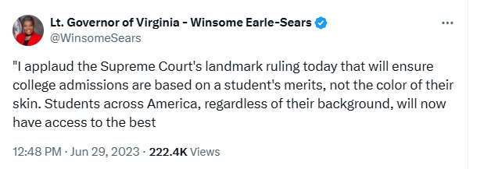
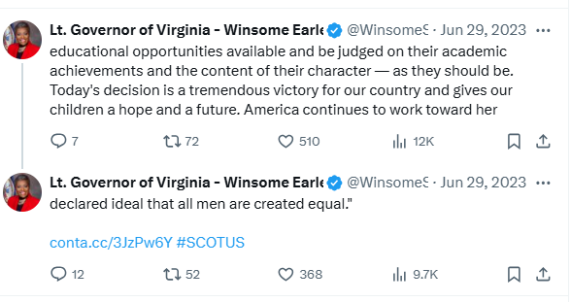
[Twitter, @WinsomeSears, 6/29/23]

In May 2022, Earle-Sears Joined An Amicus Brief In Support For Students For Fair Admissions, Inc., V. President & Fellows Of Harvard College And Students For Fair Admissions, Inc., V. University Of North Carolina, Et Al
In May 2022, Earle-Sears Joined An Amicus Brief In Support For Students For Fair Admissions, Inc., V. President & Fellows Of Harvard College And Students For Fair Admissions, Inc., V. University Of North Carolina, Et Al, Which Ultimately Found Affirmative Action Unconstitutional. According to a press release from the Commonwealth of Virginia Office of the Lieutenant Governor, “In May 2022, Lieutenant Governor Winsome Earle-Sears joined a brief of amici curiae in support of Students for Fair Admissions, Inc., v. President & Fellows of Harvard College and Students for Fair Admissions, Inc., v. University of North Carolina, et al, Nos. 20-1199 and 20-707, recognizing the need to enforce the time limits acknowledged by the Court in Grutter vs. Bollinger, 539 U.S. 306 (2003), which approves certain types of educational Affirmative Action programs, and enshrined into constitutional law the permissibility of racial discrimination by government entities, thereby violating the Equal Protection Clause and Title VI of the Civil Rights Act of 1964.” [Press Release – Commonwealth of Virginia Office of the Lieutenant Governor, 6/29/24]

Earle-Sears Aligned Herself With Extremist Group Moms For Liberty
Earle-Sears Held A Meeting With Moms For Liberty In Stafford, Virginia, Writing On Twitter That The Meeting Was “Inspiring” And Saying “Parents Are The Backbone Of Our Education System.” According to Earle-Sears' Twitter, “Enjoyed an inspiring conversation with Moms for Liberty in Stafford today. Parents are the backbone of our education system—let’s keep working together to ensure every child succeeds. #ParentsMatter #BackToSchool”
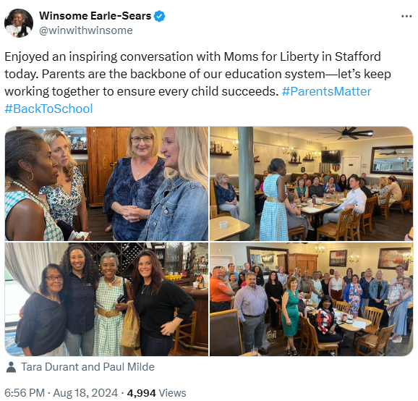
[Twitter, @winwithwinsome, 8/18/24]

In April 2023, Moms For Liberty Shared A Video Of Earle-Sears On Its Main Twitter Account
April 2023: Moms For Liberty Shared A Video Of Earle-Sears In A Television Appearance, Garnering 15,000 Views, And Quoting Her As Saying “I Do Not Co-Parent.” According to Moms for Liberty on Twitter, “I do not co-parent’ – @WinsomeSears”
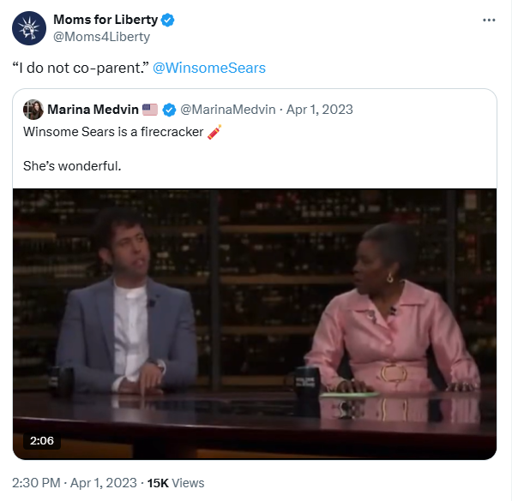
[Twitter, @Moms4Liberty, 4/1/23]

Earle-Sears Stood With Moms For Liberty At A Campaign Rally For Congressional Candidate Hung Cao, And Was Photographed Signing The Group’s “Parent Pledge”
Earle-Sears Stood With Moms For Liberty At A Campaign Rally For Congressional Candidate Hung Cao, And Appeared To Sign The Group’s “Parent’s Pledge,” In An Undated Photo. According to Moms For Liberty, “Winsome Sears, the Lt Governor of Virginia signed the Parent Pledge today.”
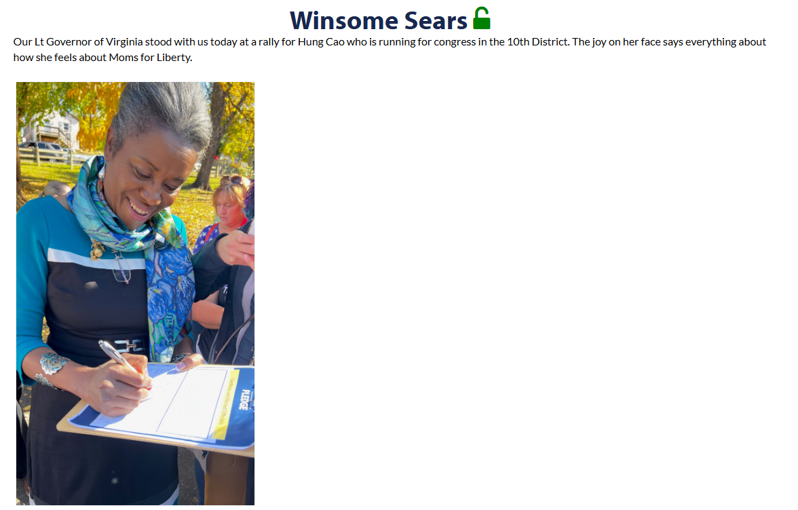
[Moms For Liberty, Viewed 11/20/24]

