Overview
Barrett opposed the Inflation Reduction Act, which lowered prescription drugs costs and capped the cost of insulin at $35 per month for seniors. More than 348,000 Michiganders on Medicare took prescription drugs that were selected for price negotiation under the Inflation Reduction Act’s provisions.
In Lansing, Barrett voted to preserve Michigan’s unique law that shielded pharmaceutical companies from being sued by Michigan families. The law was finally repealed in 2023, after Barrett left the state legislature.

Before Getting Elected To Congress, Barrett Attacked Michiganders’ Affordable Access To Health Care

2022: Barrett Opposed Capping The Cost Of Insulin At $35 Per Month
2022: Barrett Said He Opposed Capping Insulin At $35 Per Month And Referred To It As “Price Fixing.” According to Argus Press, “Barrett also indicated that he did not support health care reforms passed by Congress in August and did not approve of the capping of insulin prices at $35, calling the practice ‘price fixing’.” [Argus Press, 10/8/22]
- 2022: Argus Press Reported Barrett Expressed His Disapproval Of Insulin Price Caps Along With “Health Care Reforms Passed By Congress In August.” According to Argus Press, “Barrett also indicated that he did not support health care reforms passed by Congress in August and did not approve of the capping of insulin prices at $35, calling the practice ‘price fixing’.” [Argus Press, 10/8/22]
- The Inflation Reduction Act Capped Insulin Prices At $35 Per Month For Medicare Part D Recipients. According to KFF, “In 2022, President Biden signed into law the Inflation Reduction Act, which included a provision that requires all Part D plans to charge no more than $35 per month for all covered insulin products, and also limits cost sharing for insulin covered under Part B to $35 per month.” [KFF, 6/12/24]

Barrett Was A Vocal Critic Of The Inflation Reduction Act
Barrett In 2022: “This Phony Inflation Reduction Act Is Just More Spending Masked By An Orwellian Title.” According to a post on Tom Barrett’s Twitter account, “.@ElissaSlotkin has voted for more than $10 TRILLION in new spending in her 3 terms in Congress, accounting for 1/3 national debt. This phony Inflation Reduction Act is just more spending masked by an Orwellian title.” [Twitter, Tom Barrett, 8/11/22]
2023: Barrett Claimed The Biden Administration And “Legacy Media” Were “Gaslight[ing] Americans That The Inflation Reduction Act Is Working.” According to a post on Tom Barrett’s Twitter account, “The @JoeBiden Administration and legacy media continue to gaslight Americans that the Inflation Reduction Act is working. Yet gas is $4 per gallon, basic necessities are too expensive, and Fed is raising interest rates. We need to go a different direction.” [Twitter, Tom Barrett, 9/20/23]
2024: Gander Newsroom Reported Barrett Was A “Vocal Critic Of The Inflation Reduction Act.” According to the Gander Newsroom, “Barrett has also been a vocal critic of the Inflation Reduction Act, which has since raised taxes on big corporations and lowered prescription drug costs for thousands of Michiganders.” [Gander Newsroom, 8/26/24]
Inflation Reduction Act Capped Prescription Drug Costs Under Medicare, Which Benefited More Than 348,000 Michiganders
The Inflation Reduction Act Allowed Medicare To Negotiate Prices For Certain Prescription Drugs. According to the U.S. Department of Health and Human Services, “Negotiations are underway between HHS and the participating drug companies of the first 10 prescription drugs selected for negotiation in the first cycle of the Medicare Drug Price Negotiation Program. The first 10 drugs selected treat conditions such as blood clots, diabetes, heart disease, heart failure, autoimmune diseases, and chronic kidney disease.” [U.S. Health and Human Services, Inflation Reduction Act Of 2022, Viewed 7/1/24]
The Inflation Reduction Act Required Drug Companies To Pay A Rebate To Medicare If They Raised Prices Faster Than The Rate Of Inflation. According to the U.S. Department of Health and Human Services, “Allowing Medicare to negotiate with participating drug companies to get lower drug prices for certain drugs covered under Medicare Beginning negotiations with the participating drug companies that manufacture all 10 drugs selected for the first cycle of negotiations” [U.S. Health and Human Services, Inflation Reduction Act Of 2022, Viewed 7/1/24]
More Than 348,000 Michigan Medicare Enrollees Were Prescribed Drugs Selected For Price Negotiation Under The Inflation Reduction Act. According to the U.S. Department of Health and Human Services,
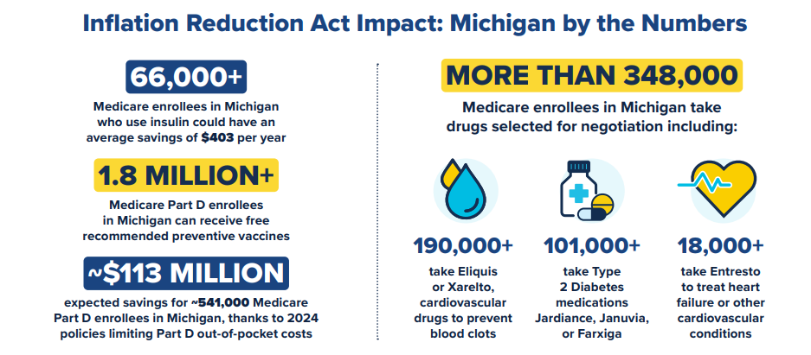
[U.S. Department of Health and Human Services, Lowering Prescription Drug Costs for Michigan, Viewed 9/16/24]

While In The Michigan State Legislature, Barrett Voted Against Repealing a Provision of Michigan Law That Made It Nearly Impossible to Sue Big Pharma

Barrett Voted Against Repealing A Provision Of Michigan Law That Shielded Pharmaceutical Companies From Liability Lawsuits In The State
While In The State Legislature, Barrett Voted Against Repealing A Part Of Michigan Law That Shielded Pharmaceutical Companies From Liability Lawsuits In The State. According to Detroit News, “Slotkin has criticized him for voting against a measure to eliminate Michigan’s liability shield for drug companies — the only state with such a law — saying he ‘sided with Big Pharma.’ Barrett said he didn’t consider the merits but voted no because Democrats tried adding it to a gas tax suspension bill. ‘We just wanted to run a clean bill,’ he said.” [Detroit News, 10/31/22]
- 3/15/22: Barrett Voted Against An Amendment That Sought To Prevent A Different Bill From Taking Effect Unless Senate Bill 961 Was Enacted Into Law.
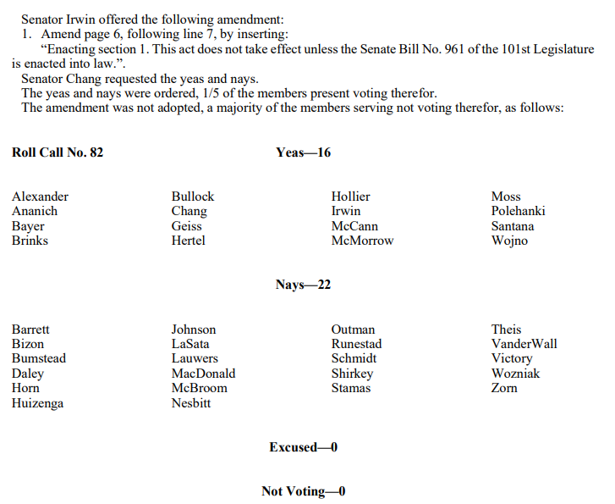
[Michigan State Senate Journal, 3/15/22]
- March 2022: Michigan Democrats Introduced Senate Bill 961, Which Would Repeal A Provision In Michigan Law That Gave Immunity To Drug Manufacturers. According to a press release from Michigan State Senator Jeff Irwin, “Sen. Jeff Irwin (D-Ann Arbor) has introduced legislation, supported by Michigan Attorney General Dana Nessel, that allows consumers to hold pharmaceutical companies responsible when their products harm them. Senate Bill 961 will repeal a provision of the Product Liability Act, a law Michigan adopted in 1995, that provides immunity for drug manufacturers. By increasing accountability, Sen. Irwin’s bill will also improve the safety of drugs.” [Press Release – Michigan State Senator Jeff Irwin, 3/18/22]

The Michigan Product Liability Act Granted Pharmaceutical Companies Near Absolute Immunity From Lawsuits Filed By Consumers
The Michigan Product Liability Act Granted Pharmaceutical Companies Near Absolute Immunity From Lawsuits Filed By Consumers. According to Detroit News, “A one-of-a-kind law is likely to prevent Michigan communities and the state from winning lawsuits to reclaim the millions of dollars they’ve spent fighting the opioid epidemic, legal experts say. The 1995 Michigan Product Liability Act grants pharmaceutical companies nearly absolute immunity from lawsuits filed by consumers and has kept the state of Michigan from suing over dangerous or deadly drugs. Michigan Attorney General Bill Schuette was then a state senator who co-sponsored the bill, but now says he is open to reconsidering the law.” [Detroit News, 6/15/18]
- The Law Only Allowed Lawsuits To Proceed If The U.S. Food And Drug Administration Determined It Was Misled During The Drug Approval Process. According to Detroit News, “The state law allows lawsuits to proceed if the federal Food and Drug Administration determines it was misled during the approval process for a drug, said Wendy Block, the chamber’s vice president of business advocacy. ‘In fact, the law states that Michigan residents may proceed with a lawsuit against a drug manufacturer if they first follow an administrative process that returns a finding by the FDA of wrongdoing by the drug manufacturer,’ Block said.” [Detroit News, 6/15/18]

Michigan’s Law Protected Opioid Manufacturers And Prevented The State From Participating In Some Opioid Crisis Lawsuits
2018: Michigan Attorneys Had To Work Around The Product Liability Act During The Opioid Crisis To Sue Drug Makers, Wholesalers, And Large Drug Store Chains. According to the Detroit News, “The city of Detroit is among the scores of Michigan cities that have sued over the opioid crisis. The city’s attorneys argue Detroit will prevail in court regardless of the Michigan Product Liability Act. Detroit’s lawsuit targets not only drug makers, but wholesalers and large drug store chains that are accused of contributing to the opioid epidemic, said Eli Savit, an attorney in the office of Detroit Mayor Mike Duggan. ‘We did our research before we filed the suit, and we’re confident that the conduct which we allege is not immunized by that law,’ Savit said. ’The drug immunity law by its terms only (pertains to) state causes of action, and many of our causes of action, including a federal conspiracy claim, are federal.” [Detroit News, 6/15/18]
Michigan Attorney General Dana Nessel Sued Opioid Distributers For Creating A Public Nuisance Because The Product Liability Act Protected Manufacturers From Suits Over Product Safety. According to Bridge Michigan, “Michigan Attorney General Dana Nessel, a Democrat, is advocating for repeal of the drugmaker immunity law. She said the law has prohibited her from individually suing companies that played a role in ‘creating the opioid epidemic.’ To avoid dismissal of opioid litigation, Nessel’s office employed treated distributors as drug dealers and sued them for creating a public nuisance rather than attempt to sue manufacturers for product safety.” [Bridge Michigan, 10/11/23]
- Michigan Attorney General Nessel In 2023: “I’ll Never Forget Going To Washington D.C. For A Special Meeting Just On The Opioid Litigation, Sitting Around A Table With All The Other Attorneys General In The United States, […] And Being The Only Attorney General That Could Not Bring Some Of This Opioid Litigation Because Of This Law.” According to Michigan Advance, “With the stroke of a pen, Michigan’s one-of-a-kind law that prevented state lawsuits against drug manufacturers, is no more. On Thursday morning in Flint, Gov. Gretchen Whitmer signed into law a repeal of a nearly 30-year-old law that gave drug manufacturers immunity if their drugs caused harm for Michiganders. […] Nessel said prior to Thursday’s repeal, Michigan was singularly deficient in the legal means at its disposal. ‘I’ll never forget going to Washington D.C. for a special meeting just on the opioid litigation, sitting around a table with all the other attorneys general in the United States, and not just the states, but also the territories, and being the only attorney general that could not bring some of this opioid litigation because of this law,’ she said.” [Michigan Advance, 12/7/23]
- HEADLINE: “Whitmer Signs Repeal Of Nation’s Only Immunity Law That Shielded Drugmakers From Legal Liability” [Michigan Advance, 12/7/23]

Michigan’s Law Also Prevented Michiganders From Seeking Damages From Harm Caused By Other Drugs
2011: Michigan Court Of Appeals Threw Out The Michigan Attorney General’s Lawsuit Over A Pain Medication That Caused Heart Attacks And Strokes Because The Product Liability Act Prohibited Lawsuits For Drugs Approved The Federal Regulators. According to the Detroit News, “In 1995, the Michigan Legislature narrowly approved the legislation pushed by Republican then-Gov. John Engler, the Michigan Chamber and other business groups. The Michigan Product Liability Act bars lawsuits brought by the state and its residents for any drug that is approved for safety and efficacy by the FDA and labeled in compliance with FDA standards. The law has proved to be an obstacle even for a Republican attorney general. In 2011, the Michigan Court of Appeals threw out a $20 million lawsuit filed against Merck by then-Attorney General Mike Cox over the arthritis pain medication Vioxx, which caused heart attacks and strokes. The court ruled that the state couldn’t sue because Michigan’s law prohibits lawsuits for drugs approved by federal regulators. The Michigan Supreme Court agreed.” [Detroit News, 6/15/18]
The Product Liability Act Prohibited 200 Michiganders From Receiving Their Share Of A $425 Million Settlement Over Claims A Heartburn Drug Caused Chronic Kidney Injuries. According to Michigan Advance, “The Michigan law was specifically cited by a federal judge in February when she dismissed nearly 200 Michiganders from litigation against British pharmaceutical giant AstraZeneca, which resulted in a $425 million settlement over claims the company’s heartburn drugs, Nexium and Prilosec, caused chronic kidney injuries.” [Michigan Advance, 12/7/23]

