Overview
When he was running for Congress, Barrett lamented that Americans were “hyper-focused on tribalism” and called for people to “come together.” However, now that he is elected, he refused to accept his constituents’ requests for public discourse or a town hall. Barrett’s staff even claimed town halls would be unproductive and public dialogue was pointless. Barrett later sent a campaign email claiming constituents protesting at his Lansing office were “storming my office, harassing my staff.” Protestors claimed Barrett’s staff was ignoring their meeting requests, but Barrett and his staff insisted he was “not hiding” and was meeting with constituents. Except, Barrett and his staff pointed to Barrett’s meetings with an elected Republican as constituent outreach.
Later in 2025, Barrett’s staff claimed they had been instructed by Capitol Police not to hold in-person town halls over safety concerns, but there was no evidence of such guidance. Before that Barrett had also spoken at a public anti-choice rally held on the steps of the Michigan state capitol.

Barrett Refused To Hold An In-Person Town Hall To Defend His Support For Health Care Cuts and Tariffs
HEADLINE: “Tom Barrett’s Office Refuses To Hold Town Hall: ‘Wouldn’t Be Productive’” [Heartland Signal, 3/5/25]

Early In 2025, Barrett and His Staff Refused to Host a Town Hall for His Constituents and Claimed It Would Be Unproductive

Barrett’s Staff Claimed Town Halls Would Be Unproductive And Public Dialogue Was Pointless
HEADLINE: “Barrett Stays Silent As Pressure Mounts For A Town Hall” [Lansing City Pulse, 2/26/25]
2/26/25: Barrett’s Staff Reportedly Told Protestors That A Town Hall With Constituents Would Be Unproductive. According to the Lansing City Pulse, “‘Town hall now,’ chanted a crowd of nearly 250 Monday outside the office of U.S. Rep. Tom Barrett R-Charlotte. Five representatives from the Livingston County Democrats were allowed in the office to speak with staff But Barrett’s staff insisted that a conversation between the congressman and the disgruntled constituents would be unproductive.” [Lansing City Pulse, 2/26/25]
- Barrett’s Press Secretary: “They Asked [A Barrett Staffer] About A Town Hall, And He Said That If All Everyone Wanted To Do Was Yell And Not Discuss, Then It Wouldn’t Be Productive.” According to the Lansing City Pulse, “Barrett’s press secretary, Michael Gordon, insisted Barrett ‘is not hiding.’ Gordon said a representative from Barrett’s office had declined to organize a town hall after jeering protesters convinced him a public dialogue was pointless. ‘They asked him about a town hall, and he said that if all everyone wanted to do was yell and not discuss, then it wouldn’t be productive,’ Gordon said. ‘He walked outside, and somebody screamed in his face about being a traitor to the nation, and he said, ‘See, how is this productive?’” [Lansing City Pulse, 2/26/25]
Lansing City Pulse: “A Representative From Barrett’s Office Had Declined To Organize A Town Hall After Jeering Protesters Convinced Him A Public Dialogue Was Pointless.” According to the Lansing City Pulse, “Barrett’s press secretary, Michael Gordon, insisted Barrett ‘is not hiding.’ Gordon said a representative from Barrett’s office had declined to organize a town hall after jeering protesters convinced him a public dialogue was pointless. ‘They asked him about a town hall, and he said that if all everyone wanted to do was yell and not discuss, then it wouldn’t be productive,’ Gordon said. ‘He walked outside, and somebody screamed in his face about being a traitor to the nation, and he said, ‘See, how is this productive?’” [Lansing City Pulse, 2/26/25]

While Running For Congress, Barrett Lamented That Americans Were “Hyper-Focused On Tribalism” And Called For People To “Come Together”
July 2024: Barrett Claimed Americans Were “Hyper-Focused On Tribalism” And Called For People To “Come Together.” According to an op-ed written by Tom Barrett for Washington Reporter, “Lately, we seem hyper-focused on tribalism. My hope is that we can all come together for one of our nation’s most symbolic holidays: our Independence Day. There was a time when we stood shoulder-to-shoulder against a common enemy — without comparing our politics or religion or race or economic status. In fact, we have done that more than once throughout our country’s history. And we seem to be forgetting that, as Americans, we are bonded not by our differences, but by our history as a nation overcoming great odds together to preserve and protect our liberties.” [Tom Barrett Op-Ed – Washington Reporter via archive.org, 7/4/24]

In A Campaign Email, Barrett Claimed Protestors Were “Storming My Office, Harassing My Staff”
2/28/25 Barrett Campaign Fundraising Email: “George Soros-Backed Groups Have Been Storming My Office, Harassing My Staff, And Are Trying To Stop President Trump’s Efforts To Reform Our National Government.” According to an email from Tom Barrett’s campaign entitled “Midnight Deadline,”
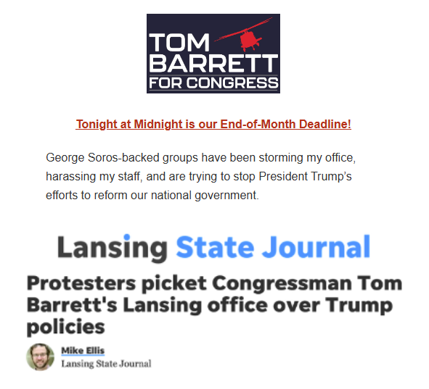
[Email, Tom Barrett for Congress, “Midnight Deadline,” 2/28/25]

Protestors Said Barrett’s Office Did Not Respond To Several Requests For A Meeting
HEADLINE: “Protesters Picket Congressman Tom Barrett’s Lansing Office Over Trump Policies” [Lansing State Journal, 2/21/25]
2/21/25: Protestors Said Barrett’s Office Did Not Respond To Several Attempts To Set Up A Meeting. According to the Lansing State Journal, “Protesters said Barrett’s office has not responded to several attempts to set up a meeting with Indivisible Michigan 7, a local branch of the national Indivisible movement.” [Lansing State Journal, 2/21/25]

Barrett And His Team Ignored Town Hall Requests And Claimed Meeting With Local Republican Elected Officials Counted As Constituent Outreach

Barrett And His Staff Claimed He Was “Not Hiding” And Was Meeting With Constituents
2/26/25: Barrett’s Press Secretary Claimed Barrett Was Meeting With Constituents “All Last Week” And Was “Not Hiding.” According to the Lansing City Pulse, “Barrett’s press secretary, Michael Gordon, insisted Barrett ‘is not hiding.’ […] ‘The congressman is very much willing to meet with constituents,’ Gordon continued. ‘That’s what he was doing all last week.’” [Lansing City Pulse, 2/26/25]
2/21/25: Barrett Claimed He And His Team Were “Committed To Hearing The Concerns Of Every Person In Our Community.” According to the Lansing State Journal, “Protesters said Barrett’s office has not responded to several attempts to set up a meeting with Indivisible Michigan 7, a local branch of the national Indivisible movement. ‘The First Amendment is a cornerstone of our democracy,’ Barrett said in a statement. ‘My team and I are committed to hearing the concerns of every person in our community, while also serving those who need our help with casework and dealing with federal agencies. This critical work will continue in both my Washington, D.C. and Lansing offices.’” [Lansing State Journal, 2/21/25]

Barrett Claimed Meeting With Another Elected Republican Was Constituent Outreach
Barrett Took Picture With Another Elected Republican And Claimed It Was Constituent Outreach. According to Heartland Signal, “On social media, Barrett’s staff dodged claims that he was ducking his constituents by referring to pictures of the representative with other members of the Republican Party, including Dan Schifko. While responding to a comment urging him to engage with the community, Barrett shared a link of him meeting with coffee shop owner Brandon Denby, who was elected as the Livingston County Register of Deeds as a Republican last November. And when a constituent asked on the Schifko post why Barrett was ‘hiding,’ former Barrett campaign treasurer Dan Wholihan said in a now-deleted comment that ‘he was with his constituents in that picture.’” [Heartland Signal, 3/5/25]

Later In 2025, Barrett’s Staff Claimed They Had Been Instructed Not to Host In-Person Events by Capitol Police Because of Safety Concerns, but He Had Appeared at A Public Rally
Barrett District Director Claimed Capitol Police Had Instructed Members Of Congress Not To Hold In-Person Town Halls Because Of Security Concerns, But There Was No Evidence Of Such Guidance. According to the Michigan Advance, “U.S. Rep. Tom Barrett (R-Charlotte) has been repeatedly criticized for having never hosted an in-person town hall since being elected to Congress in Michigan’s 7th Congressional District last year. That has drawn additional scrutiny after Barrett’s district director, Keith Lane, said that the U.S. Capitol Police instructed members of Congress not to host those events due to safety concerns, although there is no evidence of such guidance. In a video posted by Distill Social, Lane says, ‘Capitol Police, who are in charge of protecting all the members, are advising not to have in-person town halls due to almost double threats against congressional members,’ noting that the guidance was given to lawmakers on both sides of the aisle. Barrett’s office did not respond to requests for comment on the nature of this guidance from the Capitol Police, including when the guidance was given and what exactly it entails.” [Michigan Advance, 11/17/25]

Barrett Refused To Hold An In-Person Town Hall, But Spoke At A Public Anti-Choice Rally On The Steps Of The Michigan State Capitol
11/6/25: Barrett Spoke At A Public “March For Life” Rally On The Steps Of The Michigan State Capitol. According to Michigan Advance, “Lawmakers, religious leaders and anti-abortion activists rallied on the steps of the Michigan State Capitol on Thursday to call out what state Sen. John Damoose, a Harbor Springs Republican, referred to as ‘the devastation wrought by Proposal 3.’ The second ‘March for Life’ rally, hosted by Right to Life of Michigan, was hosted on the anniversary of the passage of Proposal 3, the ballot initiative that enshrined the right to an abortion into Michigan’s state constitution. A release from Right to Life of Michigan estimated that thousands of people attended the event, which filled the lawn in front of the Capitol steps. […] U.S. Rep. Tom Barrett (R-Charlotte) also made an appearance at the rally to discuss federal legislation, including the ‘Born-Alive Abortion Survivors Protection Act,’ a House bill that he has supported. In telling the crowd to call for Michigan’s senators to vote for it, he also jabbed to say, ‘while you’re at it, maybe ask them to open the government up, too.’” [Michigan Advance, 11/6/25]

