Overview
In 2022, Barrett sent campaign mailers that said he was “100%” opposed to abortion with “no exceptions.” He said he opposed exceptions for rape and incest. In 2022, Barrett also claimed that women used abortion as a form of birth control. He has also previously suggested that the would consider federal legislation to restrict abortion access. While in the Michigan state legislature he supported legislation that would ban abortion after approximately six weeks and introduced an abortion ban opposed by Michigan doctors that did not include exceptions for rape or incest. In 2018, Barrett suggested he would support legislation that designated a fetus as a tax dependent.
- Barrett: “Any way in which we can acknowledge the fact that a pregnancy and an unborn child is a human being, and is a child that’s fully participating and fully protected by our laws is something that I would encourage and support.”
Barrett opposed Roe v. Wade and called the Dobbs decision an anti-choice “call to action.” He has also described himself as an anti-choice leader. Barrett volunteered at so-called “crisis pregnancy centers,” which doctors have said mislead and endanger women with misinformation that can delay them from accessing appropriate care.

Barrett Said He Was “100-Percent Pro Life—No Exceptions” And Supported Abortion Bans

Barrett Opposed Abortion “100%” With “No Exceptions”
2022: Barrett Said He Was “100% Pro Life—No Exceptions”
2022: Barrett Sent Fundraising Flyers Saying He Was “100% PRO-LIFE – NO EXCEPTIONS.” According to the Detroit Free Press, “State Sen. Tom Barrett, R-Charlotte, who is in a tough race to try to knock off U.S. Rep. Elissa Slotkin, D-Holly, in a toss-up district that includes Lansing, has been sending out fundraising flyers calling himself ‘100% PRO-LIFE — NO EXCEPTIONS.’” [Detroit Free Press, 5/4/22]
2022: Barrett Said He Opposed Abortion Exceptions For Rape And Incest
May 2022: Barrett Said He Opposed Abortion Exceptions For Rape Or Incest. According to the Detroit News, “Barrett confirmed he doesn’t favor exceptions in cases of rape or incest but said in an interview that preserving the life of the mother is important: ‘I consider pro-life to be pro-life for the mother, as well.’” [Detroit News, 5/25/22]
- Barrett: “No One Is Defending [Rape]. This Is Simply A Fundamental Recognition That Human Life Is Worth Protecting, Especially The Most Vulnerable.” According to the Detroit News, “Barrett confirmed he doesn’t favor exceptions in cases of rape or incest but said in an interview that preserving the life of the mother is important: ‘I consider pro-life to be pro-life for the mother, as well.’ ‘Rape is a terrible, terrible offense. No one is defending that,’ Barrett said. ‘This is simply a fundamental recognition that human life is worth protecting, especially the most vulnerable.’” [Detroit News, 5/25/22]
- HEADLINE: “Audio Shows That GOP Congressional Candidate Tom Barrett Opposes Rape, Incest Exceptions For Abortion Bans” [Heartland Signal, 8/5/24]
2022: Asked If He Believed A Child Who Was Raped By Her Uncle Should Have To Carry A Baby To Term If She Got Pregnant, Barrett Said, “I Believe That Life Is Important, And I Believe Life Is Valued And Worthy Of Protection.” According to an MI-07 debate on WDIV, REPORTER: “If someone is raped by say an uncle, so you’ve got a case of rape and incest, you believe that girl should take that child to term?” BARRETT: “Devin, as I’ve said consistently from the beginning, I am pro-life. I believe that life is important, and I believe life is valued and worthy of protection.” [WDIV, 9/25/22] (video) 00:09:51
2022: Barrett Claimed He Only Supported Abortion Exceptions To Save The Life Of The Mother And Avoided Questions About Exceptions For Rape Or Incest. According to the Heartland Signal, “During the interview, LeDuff brought up Barrett’s stance on abortion, where the former state senator indicated that he only supports exceptions in the case to save the life of the mother. When LeDuff pressed Barrett on rape and incest exceptions, Barrett danced around the issue and seemingly indicated that he does not support them. ‘So again, I’m telling you that I believe life is worth protecting and life is valuable, and every life is important. And it tears at that fabric of life,’ Barrett said.” [Heartland Signal, 8/5/24]

2024: Right To Life Michigan, Which Opposed Abortion Exceptions For Rape And Incest, Endorsed Barrett For MI-07
2024: Right To Life Of Michigan Endorsed Tom Barrett For Michigan’s 7th Congressional District. According to the Lansing State Journal, “Barrett is endorsed by Right to Life of Michigan and former President Donald Trump.” [Lansing State Journal, 9/6/24]

Michigan Right To Life’s Endorsement Criteria Included Being “Prolife With No Exceptions Other Than Life Of The Mother”
Michigan Right To Life’s Endorsement Criteria Included Being “Prolife With No Exceptions Other Than Life Of The Mother” And Had “Consistently Stood Up For The Unborn Despite Possible Retribution.” According to Right to Life of Michigan’s Endorsement Criteria,
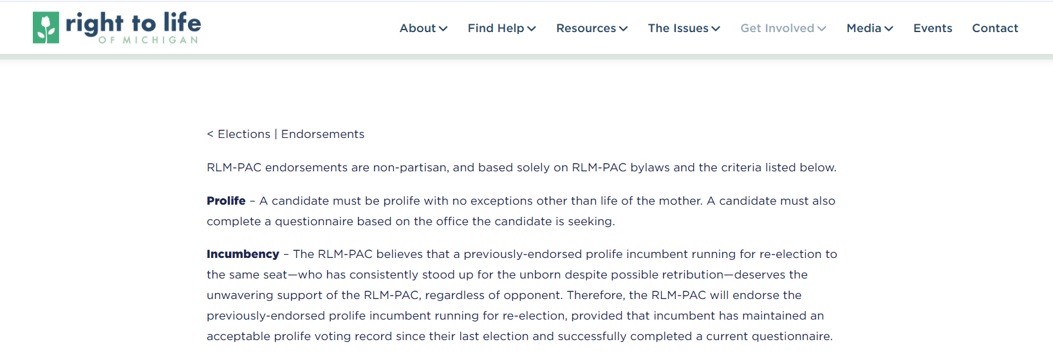
[Right To Life Of Michigan, Endorsement Criteria, Viewed 3/12/25]

2022: Barrett Claimed “Abortion As A Form Of Birth Control” Represented Part Of The “Overwhelming Majority Of Abortions”
2022: Barrett Claimed “Abortion As A Form Of Birth Control” Represented Part Of The “Overwhelming Majority Of Abortions.” According to the Heartland Signal, “Barrett went on to explain that he volunteers at pregnancy crisis centers with his wife. Crisis pregnancy centers are widely notorious for pretending to be medial clinics and spreading medical disinformation in order to intercept women that might get an abortion. ‘Again, I am not someone who is in favor of abortion as a form a birth control or all these other scenarios that represent the overwhelming majority of abortions that take place in our country and in our state. I am someone who believes life is valuable, and we ought to protect all life to the extent that we’re able. There are certainly options that we have to help women in a truly crisis situation.’” [Heartland Signal, 8/5/24]

Barrett Has Previously Suggested He Would Consider Federal Legislation to Restrict Abortion Access

May 2022: Barrett Said He Would Review A Federal Abortion Ban If Elected
May 2022: Barrett Said He Favored Leaving Abortion To The States But Would Review A Federal Abortion Ban If Elected. “Barrett said it’s long been his position that Roe was decided incorrectly. If it’s struck down, he favors returning the issue to the states over federal legislation to restrict abortion, though he’d review such a bill, he said.” [Detroit News, 5/25/22]
2024: Barrett Claimed Federal Involvement In Abortion Should Be In Support Of The Hyde Amendment, Parental Consent And Conscience Rights
October 2024: Barrett Claimed He Would Not Support A Federal Abortion Ban But Would Work To Protect The Hyde Amendment, Conscience Rights, And Parental Consent. According to the Detroit News, “When asked whether he would support a potential federal ban on abortion, Barrett said he believed that fell outside of congressional authority. ‘I’m not going to vote for something that is outside the scope of authority of the United States Congress,’ Barrett said. But Barrett said he would work at the federal level to protect the Hyde Amendment, which prevents federal funding from going toward abortions; protect rights of conscience for medical providers who decline to aid in an abortion; and ensure minors can’t be transported across state lines for an abortion without a parent’s permission. He also wants to decrease cost hurdles for adoption.” [Detroit News, 10/5/24]
- September 2024: Barrett Claimed Congress’ Role In Federal Abortion Legislation Was To Ensure Federal Funds Were Not Used For Abortions And Conscience Protections Were Upheld. According to the Detroit Free Press, “But like many other Republican candidates — not least Trump, who opposed abortion rights and appointed the conservative justices who overturned Roe vs. Wade — Barrett said he wouldn’t support any national ban that would thwart Michigan and other states’ decisions to protect it. ‘It’s going to be up to the people of Michigan to decide if and how they want to put some guardrails on that (state guarantee) and amend that proposal,’ he said. Barrett added that he sees Congress’ role as ensuring federal funds aren’t used for abortions and that doctors aren’t forced to perform the procedure in violation of their own consciences.” [Detroit Free Press, 9/9/24]
September 2024: Barrett Said He Saw A Federal Role In Abortion Legislation For Parental Consent Enforcement For Minors Travelling Over State Lines And Promoting Adoption. According to the Detroit Free Press, “Barrett added that he sees Congress’ role as ensuring federal funds aren’t used for abortions and that doctors aren’t forced to perform the procedure in violation of their own consciences. He also sees a role for Congress in making sure minors aren’t transported across state lines to receive an abortion without parental consent and trying to make adoption more of an acceptable option.” [Detroit Free Press, 9/9/24]

While In The Michigan State Senate, Barrett Supported Abortion Bans, Including a Ban without Exceptions for Rape or Incest

2019: Barrett Co-Sponsored Legislation That Sought To Restrict Abortion After Approximately Six Weeks
6/5/19: Barrett Co-Sponsored A Bill That Sought To Restrict Abortion After A Fetal Heartbeat Was Detected. According to the Michigan State Senate,
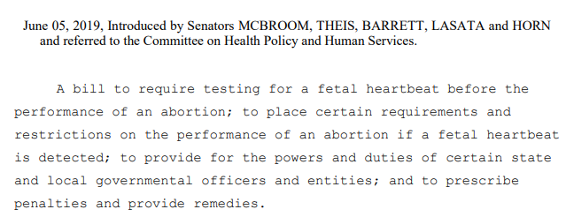
[Michigan State Senate, S.B. 357, Introduced 6/5/19]

2019: Barrett Introduced Legislation That Sought To Restrict Abortion Without Exceptions For Rape Or Incest
2019: Barrett Introduced Legislation That Would Restrict Abortion Access With No Exception For Cases Of Rape Or Incest. According to the Daily Beast, “Tom Barrett, the leading candidate running against Rep. Elissa Slotkin (D-MI) in a district Biden won by less than 1 percent, had spent his career as a Michigan state senator leading the charge against abortion access. In 2019, Barrett introduced legislation that proposed restricting second-trimester abortions with no exception for rape or incest survivors. In fundraising solicitations for his 2022 race, Barrett has described himself as ‘100% pro life—no exceptions.’ But after the draft opinion was leaked, Barrett’s stance became very circumspect.” [Daily Beast, 5/23/22]
- Despite Michigan State Doctors Opposing The Bill, Barrett Claimed Legislators Were “Taking A Stand For Life.” According to the Associated Press, “Michigan’s Republican-led Legislature voted Tuesday to ban a common second-trimester abortion procedure, pushing ahead with legislation Democratic Gov. Gretchen Whitmer said she would veto. The bills would prohibit physicians from performing abortion by dilation and evacuation except to save a woman’s life. Anti-abortion advocates refer to the procedure by the non-medical term ‘dismemberment abortion.’ […] The organization representing the state’s doctors, the Michigan State Medical Society, also opposes the legislation. But one of the bill sponsors, Republican Sen. Tom Barrett of Charlotte, said legislators were ‘taking a stand for life’ by restricting a procedure that should ‘shock the conscience’ of the public.” [Associated Press, 5/14/19]
2019: Despite Michigan Governor Gretchen Whitmer Saying She Would Veto Anti-Abortion Legislation, Barrett Said He Would Keep Fighting For The Ban Because He Was “Elected Under Certain Priorities.” According to Michigan Public Radio, “Controversial bills to ban a certain type of abortion procedure are scheduled for a state House committee hearing next week. The bills (HB 4320 and 4321) would ban the ‘dilation and evacuation’ or D-and-E procedure. The legislation has been moving steadily through the state House. That’s despite a likely veto by Governor Gretchen Whitmer. […] Senator Tom Barrett (R-Potterville) sponsored similar legislation in the state Senate. He says he’ll keep fighting for this ban despite Governor Whitmer saying she’ll veto anti-abortion bills. ‘I was elected under certain priorities that I put out there. I campaigned on the fact that I’m a pro-life legislator and will continue to advocate in that way,’ he says.” [Michigan Public Radio, 5/3/19]

2019: When Criticized For Not Including Exceptions For Rape Victims, Barrett Claimed So-Called “Dismemberment Abortions” Were Immoral And A Person Would “Rightfully” Be Arrested If They “Did That To A Cat”
2019: In Response To A Facebook User Pointing Out Barrett’s Abortion Bill Did Not Include Exceptions For Rape Victims, Barrett Said “Ultimately If I Can’t Convince You That Dismembering A Living Fetus-Something That Would Rightfully Get You Arrested If You Did That To A Cat- Is Immoral Then We Are Not Going To Make Any Progress Debating Pseudo Arguments On Facebook.” According to comments on Tom Barrett’s Facebook post,
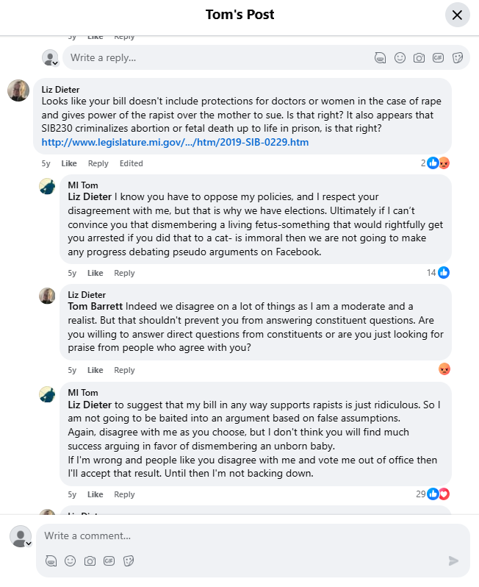
[Facebook, MI Tom, 3/26/19]

2018: Barrett Supported Designating Fetuses as Tax Dependents
2018: Barrett Supported Designating Fetuses As A Tax Dependent Because “Any Way In Which We Can Acknowledge The Fact That A Pregnancy And An Unborn Child Is A Human Being, And Is A Child That’s Fully Participating And Fully Protected By Our Laws Is Something That I Would Encourage And Support.” According to an answer Tom Barrett gave to the Michigan Family Forum, “HOST: Representative, I’ve heard from good sources that there’s going to be legislation introduced here pretty quickly that would allow a pregnant woman to count her unborn child as a dependent on her taxes if she’s under the care and observation of a physician and three months pregnant by the end of the tax year. What are your thoughts on that? Would you support somebody being able to write them off or count them as a dependent? BARRETT: Sure. I think any way in which we can acknowledge the fact that a pregnancy and an unborn child is a is a human being, and is a child that’s, you know, fully participating and fully protected by our laws is something that I would encourage and support. I’m very pro-life. It’s something that is deeply fundamental to my belief system. And a major reason why I’m involved in public policy is because I believe that we need to do a better job of protecting human life at all vulnerable stages, and in particular the life of the unborn. And whatever we can do to add encouragement to more, step forward from a point of view in a public policy role to encourage more women to keep their pregnancies, I think is something we should do. And it goes a way toward acknowledging this value on human life that we put on our society.” [Facebook, Michigan Family Forum, 3/23/18] (video) 00:02:21-00:03:34

Barrett Opposed Roe v. Wade and Claimed the Dobbs Decision Was an Anti-Abortion “Call to Action”

May 2022: Barrett Claimed Roe V. Wade Was Decided Incorrectly
May 2022: Barrett Said It Had Long Been His Position That Roe V. Wade Was Decided Incorrectly. According to the Detroit News, “Barrett said it’s long been his position that Roe was decided incorrectly.” [Detroit News, 5/25/22]
6/24/22: Barrett Said The Dobbs Decision Was An Anti-Choice “Call To Action”
6/24/22: Barrett Said The Dobbs Decision Was “A Call To Action” To Focus “On Life Affirming Pre-Natal Care.” According to a post on Tom Barrett’s Twitter account,
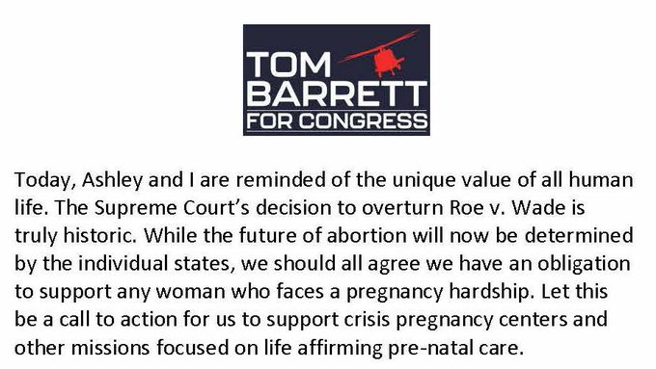
Image
[Twitter, @tombarrettmi7, 6/24/22]

May 2022: Barrett Described Himself As A “Pro-Life” Legislator And Leader

May 2022: Barrett Said He Was Elected On Being “Pro-Life” And Was Not Going To “Shy Away From It Because I Know I’m Right”
Barrett In May 2022: “I’ve Had A Long Legislative Record Of Being A Pro-Life Candidate, A Pro-Life Legislator — Elected And Reelected On That Position.” According to the Detroit News, “‘I’ve had a long legislative record of being a pro-life candidate, a pro-life legislator — elected and reelected on that position,’ said Barrett, noting his legislation that passed the state Senate in 2019.” [Detroit News, 5/25/22]
Barrett On Abortion In May 2022: “I’ve Been What I Consider To Be A Leader On This Issue, And I’m Not Going To Shy Away From It Because I Know I’m Right.” According to the Detroit News, “Barrett said it’s long been his position that Roe was decided incorrectly. If it’s struck down, he favors returning the issue to the states over federal legislation to restrict abortion, though he’d review such a bill, he said. ‘I’ve had a long legislative record of being a pro-life candidate, a pro-life legislator — elected and reelected on that position,’ said Barrett, noting his legislation that passed the state Senate in 2019. ‘I’ve been what I consider to be a leader on this issue, and I’m not going to shy away from it because I know I’m right. And I take it very seriously.’” [Detroit News, 5/25/22]

October 2024: Associated Press Reported Barrett “Hasn’t Backed Away From His Record Of Supporting Abortion Restrictions In The Statehouse
October 2024: Associated Press Reported Barrett “Hasn’t Backed Away From His Record Of Supporting Abortion Restrictions In The Statehouse.” According to the Associated Press, “Barrett hasn’t backed away from his record of supporting abortion restrictions in the statehouse, saying he is ‘pro-life,’ but he also described abortion access as a settled issue in Michigan.” [Associated Press, 10/4/24]

New York Times Reported Barrett Was Known For Wearing A Fetus Pin On The Floor Of The Michigan State Senate
New York Times Reported Barrett Was Known For Wearing A Fetus Pin On The Floor Of The Michigan State Senate. According to the New York Times, “In the heart of the battleground state of Michigan, Curtis Hertel Jr., a Democrat who is seeking an open seat in a competitive district that includes the state capital, contrasts his profile as a regular dad who coaches his children’s basketball team with that of his Republican opponent, Tom Barrett, who is known for wearing a fetus pin on the floor of the State Senate. ‘I think wearing a little fetus pin on the floor of the body is weird,’ Mr. Hertel said in an interview. ‘I think that trying to restrict people’s rights is weird.’” [New York Times, 9/12/24]

Barrett Volunteered At So-Called “Crisis Pregnancy Centers,” Which Were Known to Provide Misinformation to Women
Barrett Said He Volunteered At “Crisis Pregnancy Centers,” Which Doctors Said Endangered Women By “Misinterpreting And Misrepresenting Medical Advice”
2022: Barrett Said He Volunteered At “Crisis Pregnancy Centers.” According to the Heartland Signal, “Barrett went on to explain that he volunteers at pregnancy crisis centers with his wife. Crisis pregnancy centers are widely notorious for pretending to be medial clinics and spreading medical disinformation in order to intercept women that might get an abortion.” [Heartland Signal, 8/5/24]
- HEADLINE: “Why Crisis Pregnancy Centers Are Legal But Unethical” [American Medical Association Journal Of Ethics, Drs. Amy G. Bryant and Jonas J. Swartz, March 2018]
- American Medical Association Published An Article Explaining How “Crisis Pregnancy Centers” Endangered Women By “Misinterpreting And Misrepresenting Medical Evidence.” According to an article in the American Medical Association Journal of Ethics by Drs. Amy G. Bryant and Jonas J. Swartz, “Nonmaleficence, or the idea that health care professionals should ‘do no harm,’ is violated in multiple ways by CPCs. First, because these centers might tell women they have ‘plenty of time’ to get an abortion, they could delay access to abortion, which could lead to women missing the gestational age cut-off for abortion in a given state; expose women to more involved and slightly riskier procedures at higher gestational ages; or cause women to miss the opportunity for abortion altogether [8]. Second, false or misleading information about contraception, condoms, and abortion could lead to unnecessary anxiety or failure to use measures that protect against sexually transmitted infections [24]. From a public health standpoint, these centers endanger women by misinterpreting and misrepresenting medical evidence. States implicitly endorse these centers when they provide support for them. Women are put in a difficult position when they have to navigate a perplexing landscape: abortion is safe and legal in every state, yet some states support and promote centers that provide inaccurate information on abortion. These conflicting messages presume a level of sophistication on the part of patients—that they understand the political landscape that underlies the abortion debate and that they are able to make informed, autonomous decisions despite the misinformation that they are given [11].”[American Medical Association Journal Of Ethics, Drs. Amy G. Bryant and Jonas J. Swartz, March 2018]
- The American College Of Obstetricians And Gynecologists Said “Crisis Pregnancy Centers” Represented Themselves As Legitimate Reproductive Health Clinics, But “Actually Aim To Dissuade People From Accessing Certain Types Of Reproductive Health Care.” According to the American College of Obstetricians and Gynecologists, “CPC is a term used to refer to certain facilities that represent themselves as legitimate reproductive health care clinics providing care for pregnant people but actually aim to dissuade people from accessing certain types of reproductive health care, including abortion care and even contraceptive options.” [American College of Obstetricians and Gynecologists, Issue Brief, Viewed 9/4/24]
- The American College Of Obstetricians And Gynecologists Said “Crisis Pregnancy Centers” “Use False And Misleading Information, Emotional Manipulation, And Delays To Divert Pregnant People From Accessing Comprehensive And Timely Care From Patient-Centered, Appropriately Trained, And Licensed Medical Professionals.” According to the American College of Obstetricians and Gynecologists, “Abortion is a safe medical intervention backed by decades of robust data. Despite this fact, many CPC staffs use false and misleading information, emotional manipulation, and delays to divert pregnant people from accessing comprehensive and timely care from patient-centered, appropriately trained, and licensed medical professionals.” [American College of Obstetricians and Gynecologists, Issue Brief, Viewed 9/4/24]

October 2024: Barrett Supported Federal Funding For So-Called “Crisis Pregnancy Centers”
October 2024: Barrett Said His Focus Would Be On Supporting The Hyde Amendment And Providing Government Funding To So-Called “Crisis Pregnancy Centers.” According to Michigan Advance, “While Barrett said he would not support a national abortion ban, he noted his focus on protecting the Hyde Amendment, which bans the use of federal funding for abortion with exceptions for pregnancies that endanger the life of the pregnant person or that result from rape or incest. […] Barrett’s campaign previously told the Advance he would also focus on ensuring nonprofit crisis pregnancy centers continue to receive government funding.” [Michigan Advance, 10/10/24]

August 2022: Barrett Deleted Anti-Abortion Language From His Website

August 2022: Barrett Deleted Language From His Website Claiming He Would “Always Work To Protect Life From Conception”
August 2022: Barrett Deleted The “Values” Section Of His Website Detailing His History With The “Pro-Life” Movement And That He Would “Always Work To Protect Life From Conception.” According to the Detroit News, “Republican congressional candidate and state Sen. Tom Barrett has removed the ‘values’ section of his campaign website that touted his anti-abortion position and history with the pro-life movement. […] The portion of Barrett’s website that was deleted said in part that he and his wife have been involved in the pro-life movement ‘our entire lives and as an elected leader, I will always work to protect life from conception.’” [Detroit News, 8/27/22]

August 2022: Barrett Claimed He Did Not Know Why The Anti-Abortion Section Of His Website Was Removed And Said “I Am Sure We Probably Were Updating Things Based On The Issues That Were Most Salient Right Now”
August 2022: Barrett Claimed He Did Not Know Why The Anti-Abortion Section Of His Website Was Removed And Said “I Am Sure We Probably Were Updating Things Based On The Issues That Were Most Salient Right Now.” According to the Detroit News, “Republican congressional candidate and state Sen. Tom Barrett has removed the ‘values’ section of his campaign website that touted his anti-abortion position and history with the pro-life movement. Barrett told The Detroit News on Friday that he’s not changed his anti-abortion position. He’s still opposed to abortion and supports no exceptions in cases of rape or incest. He didn’t know why the website was changed but noted that it’s always being updated. ‘I don’t watch my own website every day, so I don’t know,’ Barrett said. ‘But I am sure we probably were updating things based upon the issues that were most salient right now, which are inflation, cost of living, crime, border security. Those are really the four pillars that are the leading issues that voters are most concerned with.’” [Detroit News, 8/27/22]

October 2024: Barrett Said He Had No Policy On In Vitro Fertilization And Contraception
October 2024: Barrett Said He Had No Policy On In Vitro Fertilization And Contraception. According to Michigan Advance, “However, Barrett told the Advance he would not support a national abortion ban, as he feels it falls outside of Congress’s authority. ‘I don’t support things that are outside of the authority of Congress and I don’t believe that a federal abortion ban is within the authority of the scope of what Congress can do,’ Barrett said. Barrett also said he has no policy on in vitro fertilization and contraception, accusing Hertel and his opponents of employing ‘scare tactics.’” [Michigan Advance, 10/10/24]

