Overview
- Tillis supported Trump’s tariffs.
- Tillis opposed legislation that would’ve blocked Trump’s tariffs.

Tillis Supported Trump’s Tariffs

Tillis Supported Trump’s Tariffs

Tillis Supported Tariffs On Mexico And Canada
Tillis Claimed That Trump Should “Absolutely” Threaten Tariffs On Mexico And Canada. According to Citizen Times, “Republican Senator Thom Tillis said Trump should ‘absolutely’ threaten tariffs on Mexico as leverage on efforts to stem the flow of fentanyl and migration, as well as on Canada to increase its defense spending to the North Atlantic Treaty Organization.” [Citizen Times, 1/31/25]

Tillis Supported Trump’s Tariffs
Tillis Claimed That He Supported Surgical Tariffs Used To Build The Economy. According to Roll Call, “‘However, if you’re talking about tariffs that are used surgically … to be used judiciously and to build the economy, then I’m all for it,’ he added. ‘So in other words, it all comes down to the implementation.’” [Roll Call, 3/5/25]

Tillis Claimed That He Didn’t Mind Uncertainty That Came With Trump’s Tariffs
Tillis Implied That He Wasn’t Concerned About Trump’s Use Of Tariffs Since They Could Snap Back Quickly. According to Roll Call, “With Trump signaling his reciprocal import taxes on goods from all other nations are still nearly a month from being applied, Tillis said it was too soon to determine if the president’s approach would further increase prices. ‘If this was an act of Congress, yeah, [tariffs] that couldn’t snap back quickly, then I’d have a concern. But this is a president who has the authority to flex and … use it as a device and see if it changes behaviors,’ he said.” [Roll Call, 3/5/25]
Tillis Claimed That Trump’s Tariffs Were Causing Market Uncertainty But Tillis Claimed That He Didn’t Mind For A “Brief Period Of Time.” According to the Hill, “‘I’m concerned, but I’m not surprised,’ Sen. Thom Tillis (R-N.C.) said, noting that businesses and the markets hate uncertainty. ‘If you’re advising a client on risk, they got a wide spread right now, all the way from all of [the tariffs] being retracted to all of them being doubled. That has to settle down. I don’t mind it for a brief period of time, but that can be very unsettling to business investment decisions, market decisions.’” [Hill, 3/11/25]

Tillis Claimed That Trump’s Tariffs Were A Negotiation Tactic
Tillis Claimed That Trump’s Tariffs Were To Try To “Create Some Sort Of Environment Where You Could Get A Negotiation.” According to the Wall Street Journal, “‘Absent retaliation, obviously, then the sky is the limit,’ Tillis said. ‘I think the idea is to try and create some sort of environment where you could get a negotiation.’” [Wall Street Journal, 4/2/25]
Tillis Claimed That If Countries Imposed Retaliatory Tariffs Then “The Sky Is The Limit.” According to the Wall Street Journal, “Sen. Thom Tillis (R., N.C.) said President Trump’s tariff announcement will likely represent a ceiling and not a floor—but that could change if countries impose retaliatory tariffs. ‘Absent retaliation, obviously, then the sky is the limit,’ Tillis said. ‘I think the idea is to try and create some sort of environment where you could get a negotiation.’” [Wall Street Journal, 4/2/25]

Tillis Supported Punitive Tariffs Against China
Tillis Claimed That He Was Ok With Being Punitive Against “Communist” Countries Like China And Russia But He Did Care About America’s Allies And Hoped That Those Who Recommended The Tariff Regime Thought That Through. According to the Ripon Society, “‘I don’t care about being punitive towards China right now,’ he said. ‘I don’t care about being punitive towards Russia or any other communist country that’s set on destroying democracy. I do care about generations- and centuries-old friendships, where you have to look at the total relationship to determine what fair and equitable trade means. Hopefully, those who have recommended this path to the President have thought that through. Like I said, if they have not, I hope their replacement will.’” [Ripon Society, 4/4/25]
Tillis Claimed That Trump’s Decision To Increase Tariffs On China Was The “Right Decision” And That The Focus Should Be On Holding China “Accountable For Its IP Theft, Currency Manipulation, And Unfair Trade Practices.” Senator Thom Tillis posted, “This is the right decision. We should focus on holding Communist China accountable for its IP theft, currency manipulation, and unfair trade practices.” [Twitter, @SenThomTillis, 4/9/25]
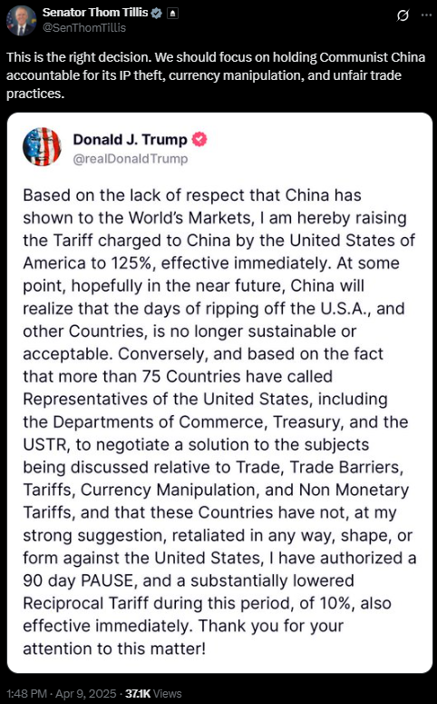

Tillis Opposed Legislation That Would’ve Blocked Trump’s Tariffs

Tillis Was Poised To Vote For A Resolution That Would Terminate The National Emergency Trump Declared Which Was Used To Justify Tariffs Against Canada But Later Reversed Course
Senator Tim Kaine Introduced A Resolution That Would Terminate The National Emergency Trump Declared Which Was Used To Justify Tariffs Against Canada. According to Politico, “Sen. Susan Collins (R-Maine) said Monday that she plans to back the resolution led by Sen. Tim Kaine (D-Va.) that would terminate the national emergency Trump declared last month, citing fentanyl trafficking and illegal immigration. Trump has used that declaration to justify 25 percent across-the-board tariffs on America’s northern neighbor and leading trade partner — duties that Trump has threatened to start levying later this week.” [Politico, 3/31/25]
Tillis Was Poised To Vote For The Resolution. According to Politico, “Collins is poised to join GOP Sens. Rand Paul of Kentucky, who is a co-sponsor of Kaine’s resolution and a strong opponent of tariffs, and Thom Tillis of North Carolina, who has also expressed concerns about Trump’s tariff plans for North American neighbors.” [Politico, 3/31/25]
Tillis Claimed That While He Supported High Tariffs On China, He Claimed That He Felt Differently About Tariffs On Canada And Mexico. According to Politico, “‘We need to fight battles with our foes first and then try to figure out any inequities with our friends second,’ Tillis said. ‘You want to go after China, there’s not enough tariffs that could ever anger me. Canada and Mexico, that’s a little different.’” [Politico, 3/31/25]
Tillis Claimed That The Reporting Was Wrong And That He Would Vote Against Kaine’s Resolution. According to Senator Thom Tillis, “Nope, this story is wrong. I was not talking about the Kaine resolution, which I will be voting against. Tariffs must be executed with precision to protect North Carolina farmers and businesses who have been hurt by bad trade policies before, including NAFTA.” [Twitter, @SenThomTillis, 4/1/25]
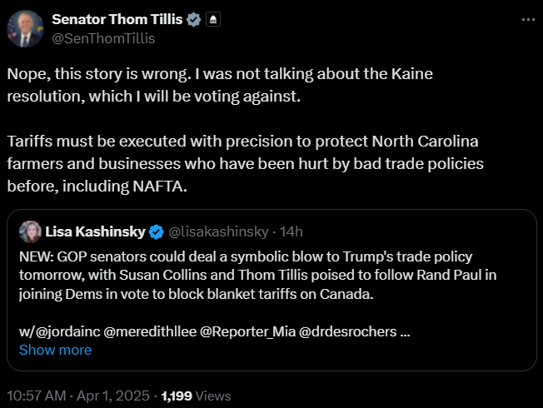
Tillis Voted Against Blocking Tariffs On Canada. According to the Herald-Sun, “On that evening, and likely what Nickel is referring to in the ad, Tillis and the rest of the senators voted on whether to block Trump’s tariffs on Canada. Neither Tillis, nor Sen. Ted Budd, North Carolina’s junior senator, voted in favor of the bill. But Democrats were able to get it passed in the Senate with the help of Republican Sens. Rand Paul, who co-sponsored the bill, Lisa Murkowski, Mitch McConnell and Susan Collins.” [Herald-Sun, 4/9/25]

Tillis Has Given Conflicting Views On Trump’s Tariffs

Tillis Warned That Trump’s Tariffs Could Bankrupt Farmers But Voted Against Legislation That Would Revoke Tariffs On Canada
Tillis Warned That Trump’s Tariffs Could Bankrupt Farmers But Voted Against Legislation That Would Revoke Tariffs On Canada. According to the Charlotte Observer, “He warned about how they could bankrupt farmers, while voting against legislation to revoke tariffs on Canada.” [Charlotte Observer, 4/7/25]

Tillis Claimed That If He Was Advising Businesses, He Would Tell Clients To Pause Capital Expenditures
Tillis Claimed That If Was In A Boardroom Or A C-Suite, That He Would Tell Clients To Not Talk To Him About Capital Expenditures Since There Were Too Many Unknowns To Deploy Capital. According to the Ripon Society, “‘If I were in the boardroom or in a C-suite with any of the clients that I had in the past,’ the former businessman observed, ‘I would say, ‘Talk to me in about 90 days on anything related to capital expenditures.’ There are too many unknowns to deploy capital right now. You’d have to be out of your mind, or you’ve discovered a secret to business that I just have never figured out.” [Ripon Society, 4/4/25]
- [VIDEO] Tillis Claimed That If Was In A Boardroom Or A C-Suite, That He Would Tell Clients To Not Talk To Him About Capital Expenditures Since There Were Too Many Unknowns To Deploy Capital. "You know, I did business advisory services for mainly fortune 500 companies either in banking, media, entertainment, telecommunications. If I were in the boardroom within a with or in a C-suite with any of the clients that I had in the past, I would say talk to me in about 90 days on anything related to my advice on capital expenditures. There is too there are too many unknowns to deploy capital right now. You'd have to be out of your mind or you've discovered a secret to business that I just have never figured out." [Ripon Society, 04/04/25]

