Overview
Mackenzie opposed the Inflation Reduction Act, which lowered prescription drug costs and capped the cost of insulin at $35/month for seniors. More than 450,000 Pennsylvanians took prescription drugs that had been selected for price negotiation under the law’s provisions.

Mackenzie Criticized the Inflation Reduction Act, Which Lowered Prescription Drug Costs for Pennsylvania Seniors
Mackenzie Criticized The Inflation Reduction Act’s Provision To Lower Prescription Drug Costs For Seniors. According to an op-ed written by Ryan Mackenzie in the Morning Call, “The changes to Medicare in the so-called Inflation Reduction Act could have helped seniors save on prescription drugs, but instead Pennsylvania retirees are paying 33% more on their premiums.” [Opinion – Ryan Mackenzie, Morning Call, 10/8/24]
- Mackenzie Criticized His Democratic Opponent For Voting For The Inflation Reduction Act, Which He Claimed “Hurt Pennsylvanians.” According to a post on Ryan Mackenzie’s Twitter account, “This includes voting for Biden’s failed Inflation Reduction Act which hurt Pennsylvanians with continued rising costs and increasing interest rates.” [Twitter, Ryan Mackenzie, 11/5/23]
September 2024: Mackenzie Claimed The Inflation Reduction Act Created More Problems For Seniors. According to Leigh Valley News, “As part of the Inflation Reduction Act, Democrats granted the federal government the ability to negotiate over high-cost prescription drugs available under Medicare. Ten drugs were negotiated under the program’s first year, and the Biden administration has expressed interest in negotiating 15 a year for 2028. However, Mackenzie argued that meddling in Medicare has only created more problems for seniors. ‘What happened when Susan Wild put a cap on only some things but not others? Those pharma companies just shift the cost to something else. We see premiums skyrocketing right now,’ Mackenzie said.” [Leigh Valley News, 9/6/24]

Inflation Reduction Act Capped Prescription Drug Costs Under Medicare, Which Benefited Pennsylvania Seniors
The Inflation Reduction Act Allowed Medicare To Negotiate Prices For Certain Prescription Drugs. According to the U.S. Department of Health and Human Services, “Negotiations are underway between HHS and the participating drug companies of the first 10 prescription drugs selected for negotiation in the first cycle of the Medicare Drug Price Negotiation Program. The first 10 drugs selected treat conditions such as blood clots, diabetes, heart disease, heart failure, autoimmune diseases, and chronic kidney disease.” [U.S. Health and Human Services, Inflation Reduction Act Of 2022, Viewed 7/1/24]
The Inflation Reduction Act Required Drug Companies To Pay A Rebate To Medicare If They Raised Prices Faster Than The Rate Of Inflation. According to the U.S. Department of Health and Human Services, “Allowing Medicare to negotiate with participating drug companies to get lower drug prices for certain drugs covered under Medicare Beginning negotiations with the participating drug companies that manufacture all 10 drugs selected for the first cycle of negotiations” [U.S. Health and Human Services, Inflation Reduction Act Of 2022, Viewed 7/1/24]
More Than 450,000 Pennsylvania Medicare Enrollees Were Prescribed Drugs That Had Been Selected For Price Negotiation Under The Inflation Reduction Act.
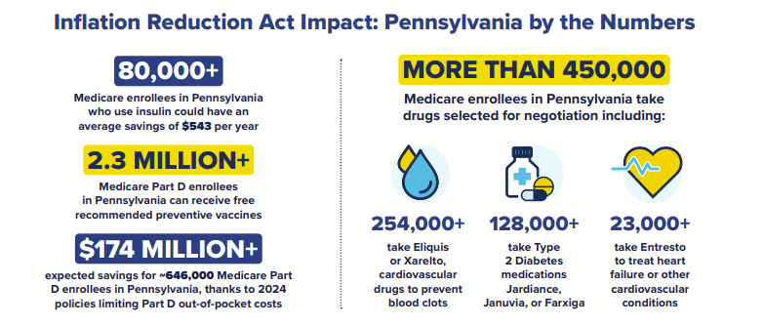
[U.S. Department of Health and Human Services, Lowering Prescription Drug Costs for Pennsylvania, Viewed 4/24/25]

