Overview
- McCormick echoed Donald Trump’s claims about voter fraud during the 2020 elections and refused to concede his loss in 2020.
- In May 2022, McCormick stated he was told he won the election before eventually being informed he had lost by over 10,000 votes.
- McCormick accused Georgia’s elections of rampant fraud but avoided directly addressing Trump’s victory claims.
- McCormick supported Dinesh D’Souza’s voter fraud conspiracies, alleging ballot drop boxes were misused in Georgia’s 2020 election.
- McCormick broadly accused Democrats of rigging elections, claiming they relied on tactics such as federalizing elections, mail-in voting, and ballot harvesting.

McCormick Was An Election Denier

McCormick Echoed Trump’s Big Lie And Refused To Concede His 2020 Race

May 2022: McCormick Was Eager To Cry Voter Fraud And Emphasized His Refusal To Concede In 2020
McCormick Declared “No One Was Hurt By Voter Fraud More Than Myself” And Bemoaned That, “At The End Of The Night At The End Of The Election In 2020, I Was Told I Won The Election, That We Were 5,000 Votes Up. And Then We Were Eventually Told We Lost The Election.” According to Georgia Public Broadcasting, “In a Sunday debate sponsored by the Atlanta Press Club, all nine candidates questioned Georgia's 2020 election results that saw former President Donald Trump narrowly lose his race but the GOP do well in other races up and down the ballot. Nearly $1.8 million in personal money has been loaned to campaigns seeking to win the nomination in this district that runs from North Fulton up to Dawson County, led by financial frontrunners Rich McCormick and Jake Evans. McCormick, who lost in the neighboring 7th District race in 2018, reiterated that he never conceded that election. ‘No one was hurt by voter fraud more than myself,’ he said. ‘At the end of the night at the end of the election in 2020, I was told I won the election, that we were 5,000 votes up. And then we were eventually told we lost the election.’ McCormick lost by more than 10,000 votes after all the votes were counted.” [GPB, 5/1/22]
Atlanta Magazine: “McCormick Claimed There Was Rampant Voter Fraud During Georgia’s 2020 Election—He Has Never Conceded His Loss To Bourdeaux—But Dodged On The Question Of Whether Trump Was The Rightful Winner Of The Presidential Election.” According to Atlanta Magazine, “ At one point, moderator and WSB-TV reporter Dave Huddleston asked all candidates whether they believed the 2020 election was stolen from President Trump. The array of responses illustrated the needle Republican politicians are threading in appealing to both hard-core Trump supporters and conservatives less fixated on the Big Lie. McCormick claimed there was rampant voter fraud during Georgia’s 2020 election—he has never conceded his loss to Bourdeaux—but dodged on the question of whether Trump was the rightful winner of the presidential election.” [Atlanta Magazine, 5/2/22]

October 2022: After His Contested GOP Primary, McCormick Tempered His Cries Of Voter Fraud
McCormick Said He Was “Not Focused On The 2020 Election” And Thought That Voters Had Moved On. According to The Atlanta Journal-Constitution, “McCormick also refused to say whether he still believes former President Donald Trump’s false claims that the 2020 election was stolen from him. In the past, McCormick has joined the majority of Republicans who have used conspiracy theories and misinformation to question the outcome of the race. He said Sunday that voters have moved on and so has he. ‘I think we spend a lot of time on the 2020 elections and 2020 elections are over,’ he said. ‘I’m not focused on the 2020 election. I’m focused on the next election when we take back the House and fix some wrongs.’” [Atlanta Journal-Constitution, 10/16/22]

McCormick Pushed Voter Fraud Conspiracies
2022: McCormick Pushed Dinesh D’Souza’s Vote Fraud Conspiracies And Alleged That Ballot Drop Boxes Were Involved In A Voter Fraud Scheme. Congressman Rich McCormick tweeted, “I can confirm. In Georgia in 2020 my team immediately requested video footage for just the Gwinnett County drop boxes and just the 3 days before the election. We were told it would cost $15,000 and take 3 weeks. Wouldn’t be available until after the election was certified.” [Twitter, @RichforGA, 5/13/22]
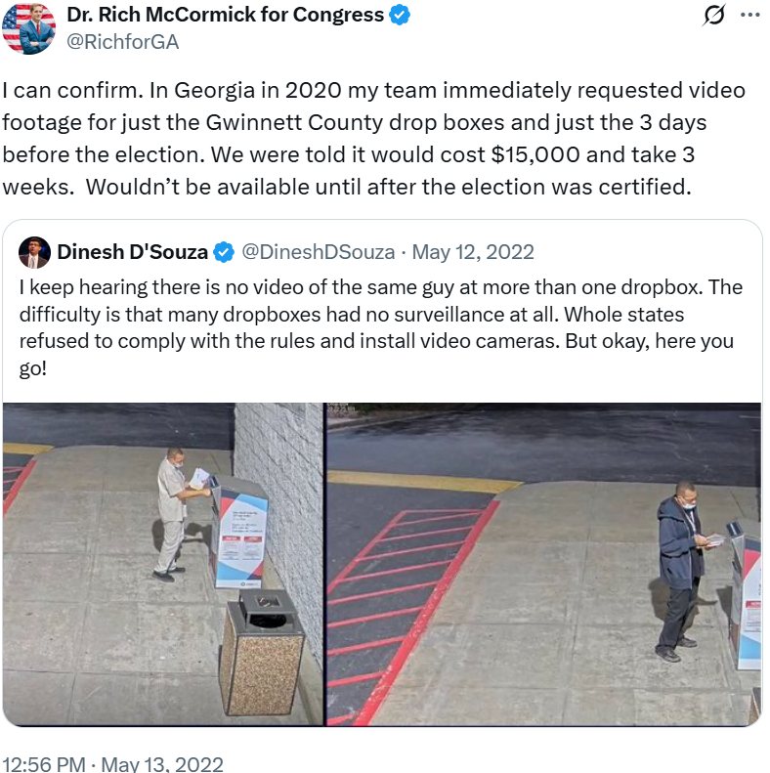

McCormick Broadly Accused Democrats Of Voter Fraud
2022: McCormick Claimed That Democrats “Can't Win In November Unless They Rig The System” And Were “Trying To Federalize Elections And Mandate The Mail In Voting And Ballot Harvesting Drop Boxes Used In 2020.” Congressman Rich McCormick tweeted, “This chart speaks for itself. The American people are fed up with Democrats and they know they can't win in November unless they rig the system. That is why they are trying to federalize elections and mandate the mail in voting and ballot harvesting drop boxes used in 2020.” [Twitter, @RichforGA, 1/13/22]
