Overview
- McCormick defended Georgia's Heartbeat Law and denied its role in Amber Thurman's death, claiming it did not prevent medical care in cases of fetal demise.
  - Georgia's Heartbeat Law bans most abortions after six weeks, with McCormick stating mothers are always protected but acknowledging challenges in accessing abortion care for complications.
  - McCormick campaigned on his support for the Heartbeat Bill and emphasized it as a state issue rather than a federal one.
- McCormick joined an amicus brief supporting restrictions on abortion pills, arguing the FDA exceeded its authority and endangered health with its approval of mifepristone.
  - McCormick raised concerns about complications from mail-order abortion drugs and cited a rise in related emergency room visits.
- McCormick strongly supported "Born-Alive" legislation, advocating for life-saving care for infants born after failed abortions, framing it as common decency.
- McCormick consistently backed fetal personhood, stating life begins at conception or when a heartbeat is detected.
- McCormick voted to prohibit restrictions on federal funding for crisis pregnancy centers and opposed efforts to limit their operations.
- McCormick celebrated the overturning of Roe v. Wade, describing it as a victory for protecting unborn children.
- McCormick supported measures like the Hyde Amendment to block federal funds for abortion services and voted against VA funding for abortions or related counseling.

McCormick Was An Anti-Abortion Extremist

McCormick Defended Georgia’s Heartbeat Law

McCormick Denied The Heartbeat Law’s Role In Amber Thurman’s Death
McCormick Claimed That The Heartbeat Law Did Not Apply To Thurman Because The “Baby Was Already In Demise.” According to Fox News, “Once a baby's heart has stopped, McCormick said, there are no restrictions on performing a D&C to ensure the safety of the mother. ‘In my understanding, is, this baby was already in demise. There was no reason that it had anything to do with whether she could have a D&C or not. That's actually irrelevant to the baby's life because the baby's already gone,’ McCormick said. ‘If the heartbeat stopped it's not about this law. Remember, it has nothing to do with this law at that point. It has everything to do with doing the best care for the woman.’” [Fox News, 9/25/24]
- Georgia’s Fetal Heartbeat Bill Banned Abortion After Six Weeks Into A Pregnancy. According to the Atlanta Journal-Constitution, “When Gov. Brian Kemp signed one of the nation’s strictest anti-abortion bills into law on Tuesday, he made good on a campaign promise but also set the stage for a legal battle that the legislation’s critics hope will spill over to the polls in 2020. Supporters filled a ceremonial room in Kemp’s office and applauded House Bill 481, which outlaws most abortions once a doctor can detect a fetus’ ‘heartbeat’ — usually about six weeks into a pregnancy and before many women know they’re pregnant.” [Atlanta Journal-Constitution, 5/7/19]
McCormick Said That Mothers In Georgia “Will Always Be Protected” But Clarified That “Doesn’t Mean It’s Easy To Get An Abortion Just Because You Have A Complication Or Because Something Goes Wrong.” According to Fox News, “But Rep. Rich McCormick, R-Ga., and state Rep. Mark Newton don't believe the law had anything to do with Thurman's death, but rather the complications allegedly caused by the abortion pills, as doctors may have waited too long to intercede. ‘We never deny a woman an abortion because it's going to harm her in some way. She will always be protected,’ McCormick, who previously served as emergency department head in a Navy deployment in Afghanistan, said in an interview with Fox News Digital. ‘You have every right to an abortion, even with that heartbeat law,’ he continued. ‘So, let's make that very clear right now. When they say there's no exceptions, there's never any law in any state where there's no exceptions. That doesn't exist. That's simply not the way it works. The mother's life is always protected. With that said, it doesn't mean it's easy to get an abortion just because you have a complication or because something goes wrong.’” [Fox News, 9/25/24]

McCormick Campaigned On His Support For The Heartbeat Bill
McCormick Emphasized His Support On The Debate Stage And Wanted The Issue Decided By The States. According to The Atlanta Journal-Constitution, “McCormick said he supports Georgia’s abortion law, which bans procedures after fetal cardiac activity is detected with limited exceptions. He said the issue should be left up to states, casting doubt on whether he would support the 15-week abortion ban that some Republicans in Congress have proposed.” [Atlanta Journal-Constitution, 10/16/22]

McCormick Sought To Limit ABortion Pill Access

McCormick Joined Senator Cindy Hyde-Smith And Rep. August Pfluger In An Amicus Brief Supporting A Fifth Circuit Court Stay Of The FDA’s 2016 And 2021 Actions To Broaden Access To Mifepristone
McCormick Signed The Brief, Authored By Americans United For Life, In Support Of The Conditional Cross Petition Field By Alliance For Hippocratic Medicine Considering Initial “Approval Irregularities” By The Food And Drug Administration In Its 2000 Approval Of Mifepristone. According to a press release from Representative August Pfluger, “Representative August Pfluger (R-Texas-11) and U.S. Senator Cindy Hyde-Smith (R-Miss.) today led the filing of an amicus brief in support of the U.S. Supreme Court considering initial ‘approval irregularities’ by the Food and Drug Administration (FDA) in its 2000 approval of chemical abortion drugs. Ninety-two members of the House of Representatives and 17 U.S. Senators signed the amicus brief, which was authored by Americans United for Life (AUL), in support of the Conditional Cross Petition filed by Alliance for Hippocratic Medicine. [...] [...] In addition to Pfluger, the brief was also signed by U.S. Representatives [...] Dr. Rich McCormick (Ga.-06)” [Press Release – Representative August Pfluger, 11/17/23]
- The Brief Declared That “By Approving And Then Deregulating Chemical Abortion Drugs, The Fda Failed To Follow Congress’ Statutorily Prescribed Drug Approval Process And Subverted Congress’ Critical Public Policy Interests In Upholding Patient Welfare.” According to a press release from Representative August Pfluger, “The cross petition asks the Supreme Court to consider the FDA’s 2000 drug approval should the court decide to hear challenges to a Fifth Circuit Court stay of the FDA’s 2016 and 2021 actions to broaden access to chemical abortion drugs. ‘As pro-life elected representatives, Amici are committed to protecting women and girls from the harms of the abortion industry. By approving and then deregulating chemical abortion drugs, the FDA failed to follow Congress’ statutorily prescribed drug approval process and subverted Congress’ critical public policy interests in upholding patient welfare,’ the brief stated. ‘Amici support the Fifth Circuit’s reinstatement of common-sense patient safeguards, which include in-person dispensing of mifepristone as well as an in-person follow-up examination to ensure a woman has not suffered complications or retained fetal tissue.Accordingly, Amici support Cross-Petitioners’ opposition to the FDA and Danco’s petitions for a writ of certiorari, which have asked this Court to reconsider patient safeguards that protect women and girls seeking chemical abortion drugs,’ the brief continued.” [Press Release – Representative August Pfluger, 11/17/23]
McCormick’s Brief Argued That “The FDA Exceeded It’s Subpart H Authority By Approving Mifepristone” And Declared That, “The FDA’s Approval Of Mifepristone Subverted Patient Health And Safety Safeguards Within Federal Laws.” According to a press release from Representative August Pfluger, “The lawmakers’ brief makes these arguments: I. The FDA exceeded its Subpart H authority by approving mifepristone. A. The FDA misclassified pregnancy as a ‘life-threatening illness.’ B. Chemical abortions do not provide a ‘meaningful therapeutic benefit’ over surgical abortions. II. The FDA’s approval of mifepristone subverted patient health and safety safeguards within federal laws. A. The FDA’s failure to adhere to the FDCA’s drug approval process has created grave health and safety risks to women and girls. B. The FDA endangers pregnant adolescents seeking chemical abortion drugs by subverting the pediatric study requirement.” [Press Release – Representative August Pfluger, 11/17/23]

McCormick Warned Of “Obstetric Hemorrhaging From Mail Order Abortion Drugs Like Mifepristone”
McCormick Claimed To Have “Standing To Challenge Dangerous Decisions By Bureaucrats At The FDA” And Warned Of Studies Confirming His Claims About Mifepristone. Congressman Rich McCormick tweeted, “As an ER doctor, I was on the frontlines treating women who experienced complications such as obstetric hemorrhaging from mail order abortion drugs like mifepristone. The idea that doctors don't have standing to challenge dangerous decisions by bureaucrats at the FDA is baffling. Studies indicate that abortion-related emergency room visits following the abortion pill increased by more than 500% from 2002 through 2015. Prescribing these medications without proper supervision of a physician is dangerous.” [Twitter, @RichforGA, 6/13/24]
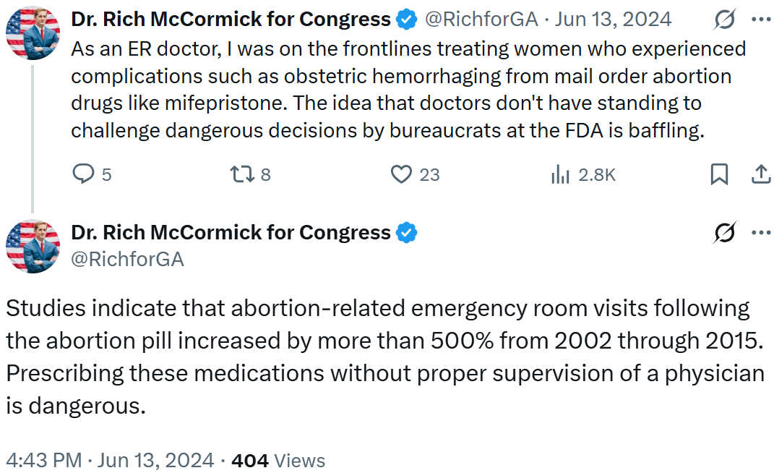

McCormick Repeatedly Backed “Born-Alive” Legislation

McCormick Celebrated The House’s Passage Of The “Born-Alive Abortion Survivors Protection” Act
McCormick: “As An Emergency Room Physician And Father, I Believe That Providing Life-Saving Care To Every Baby Born Is Common Sense. Every Human Life Matters.” Congressman Rich McCormick tweeted, “The Born-Alive Abortion Survivors Protection Act passed the House with a vote of 217-204. As an Emergency Room physician and father, I believe that providing life-saving care to every baby born is common sense. Every human life matters.” [Twitter, @RepMcCormick, 1/23/25]
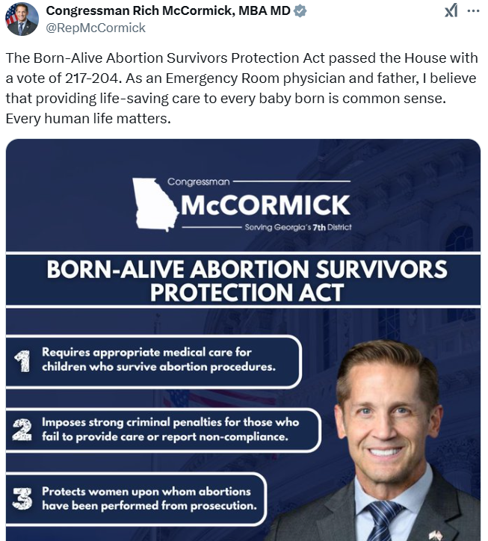
[AUDIO] McCormick Claimed The Bill Was About “Common Decency” And Said, “If You Have A Child Is Born And Is Living, You Have To Take Care Of It.” “HOST: The House passed the Born Alive Infant Protection Act. Why, from your experience, was that bill something that you believe was necessary? MCCORMICK: It should have never been necessary. If you think about just common decency. If you have a child is born and is living, you have to take care of it. That's something you actually pledge to as a physician, do no harm to protect life, to watch over those people who are vulnerable, to take care of people. That's your charge in life as a physician.” [Daily Signal, 1/28/25]

McCormick Repeatedly Supported The Born-Alive Abortion Survivors Protection Act
2025: McCormick Voted For The Born-Alive Abortion Survivors Protection Act, Which Would Mandate Health Care Workers To Provide Proper Medical Care To An Infant Born After A Failed Abortion. In January 2025, according to Congressional Quarterly, McCormick voted for the Born-Alive Abortion Survivors Protection Act, which would “require health care practitioners to provide the same care to a child that is ‘born alive’ after an abortion or attempted abortion as they would for a child born at the same gestational age and to ensure the child is immediately transported and admitted to a hospital; require hospital and clinic practitioners and employees to report any knowledge of failures to provide such care; and impose criminal fines and penalties for failures to meet these requirements. It would state that a child born alive under these conditions is a legal person under U.S. law, entitled to the protections of U.S. law, and it would specifically make any act that kills or attempts to kill such a child punishable as murder or attempted murder. The bill also would prohibit the prosecution of the mother of a child born alive after an abortion or attempted abortion and permit such mothers to seek relief through civil action against any person who violates the measure’s requirements, including monetary and punitive damages. The bill would also change the chapter name of Title 18, Chapter 74 of the U.S. Code from ‘Partial-Birth Abortions’ to ‘Abortions.’” The vote was on passage. The House passed the bill by a vote of 217-204, thus, the bill was sent to the Senate. [House Vote 27, 1/23/25; Congressional Quarterly, 1/23/25; Congressional Actions, H.R. 21]
- Different Iterations Of The Bill Have Been Introduced Since 2015. According to Congressional Quarterly, “Lawmakers have introduced iterations of this legislation in both chambers since 2015. The House passed similar bills in January 2018 and again in January 2023 after reclaiming control of the chamber. As the minority in 2019, House Republicans unsuccessfully attempted to trigger a vote through other procedural tools.” [Congressional Quarterly, 1/23/25]
- Republicans Called The Bill “Anti-Infanticide” Rather Than “Anti-Abortion.” According to the Hill, “Republicans have framed the bill as not being anti-abortion but anti-infanticide.” [Hill, 1/23/25]
- Democrats Called The Bill Redundant, Solely Criminalizing Doctors, As Killing Born-Alive Infants Following An Abortion Attempt Is Already Illegal. According to the Hill, “Democrats have criticized the legislation as being redundant, as killing infants born alive after an attempted termination, a rare occurrence, is already illegal, and the bill only serves to ‘criminalize’ doctors. Health care practitioners who fail to comply with the law would face fines and up to five years in jail or both.” [Hill, 1/23/25]
2023: McCormick Voted For The Born-Alive Abortion Survivors Protection Act, Which Would Mandate Health Care Workers To Provide Proper Medical Care To An Infant Born After A Failed Abortion. In January 2023, according to Congressional Quarterly, McCormick voted for Born-Alive Abortion Survivors Protection Act, which would “require health care practitioners to provide the same care to a child that is ‘born alive’ after an abortion or attempted abortion as they would for a child born at the same gestational age and to ensure the child is immediately transported and admitted to a hospital; require hospital and clinic practitioners and employees to report any knowledge of failures to provide such care; and impose criminal fines and penalties for failures to meet these requirements. It would state that a child born alive under these conditions is a legal person under U.S. law, entitled to the protections of U.S. law, and it would specifically make any act that kills or attempts to kill such a child punishable as murder or attempted murder. The bill would also prohibit the prosecution of the mother of a child born alive after an abortion or attempted abortion and permit such mothers to seek relief through civil action against any person who violates the bill’s requirements, including monetary and punitive damages.” The vote was on passage. The House passed the bill by a vote of 220-210, thus the bill was sent to the Senate. [House Vote 29, 1/11/23; Congressional Quarterly, 1/11/23; Congressional Actions, H.R. 26]
- Republicans Argued The Bill Would Enhance Protections For An Infant Born After A Failed Abortion. According to Congressional Quarterly, “Republicans say the bill (HR 26) from Scalise, and Reps. Ann Wagner, R-Mo., and Kat Cammack R-Fla., would increase protections for an infant born after an attempted abortion.” [Congressional Quarterly, 1/11/23]
- Under The Bill, Any Violations By Health Care Workers Could Be Punished With Fines Or Up To Five Years In Prison But Mothers Would Be Protected From Any Penalties Or Prosecution. According to CNN, “Under the bill, health providers who fail to comply with the requirements for care could face fines or up to five years in prison. The bill would not impose penalties on the mother and would grant the mother protection from any kind of prosecution.” [CNN, 1/12/23]
- Opponents Of The Bill Argued It Would Restrict Abortion Access By Threatening Medical Workers And Emphasized That It Was Already Illegal To Intentionally Kill An Infant That Was Born Alive. According to CNN, “Opponents have argued that such measures restrict abortion access by threatening health care providers. It is already considered homicide in the US to intentionally kill an infant that is born alive.” [CNN, 1/12/23]
- The Bill Would Mandate For Infants That Survived Failed Abortions To Be Provided The Equal Medical Care Provided To Other Babies Born Prematurely And Require The Infant To Be Transported To A Hospital. According to The Hill, “The bill, which House Republicans vowed to bring up even before they clinched the majority, would mandate that an infant born alive after an attempted abortion receives the same degree of care that any other child born prematurely would receive. The measure also requires that the infant is taken to a hospital. And it threatens providers who don’t comply with a fine or up to five years in prison.” [The Hill, 1/11/23]
- Passage Of The Legislation Comes After The U.S. Supreme Court Struck Down Roe V. Wade In June 2022 And After Almost 50 Years Since The Roe V. Wade Ruling. According to The Hill, “House passage of the bill comes days before the 50th anniversary of the Supreme Court ruling in Roe v. Wade, which made access to abortion a constitutional right. The justices struck down that decision in June.” [The Hill, 1/11/23]
2023: McCormick Effectively Voted For The Born-Alive Abortion Survivors Protection Act, Which Would Mandate Health Care Workers To Provide Proper Medical Care To An Infant Born After A Failed Abortion. In January 2023, according to Congressional Quarterly, McCormick voted against the “motion to recommit the bill that would require medical professionals to provide medical care for children who are born alive during an attempted abortion procedure to the House Judiciary Committee.” The vote was on a motion to recommit. The House rejected the motion by a vote of 212-219. [House Vote 28, 1/11/23; Congressional Quarterly, 1/11/23; Congressional Actions, H.R. 26]

McCormick Supported Fetal Personhood

McCormick Claimed That Life Began “When The Heart Starts Beating”
[VIDEO] McCormick Believed That “Life Begins When That Heart Starts Beating” And Framed Reproductive Health Care Through A Deeply Religious Lens. “Today we're going to celebrate life. There is nothing hateful about that. It's not just about a constitution that guarantees life, liberty and the pursuit of happiness. But where did that promise came from? From God. It's God's greatest gift. It's something that we celebrate. Something that we give thanks for, Something that we rejoice in all people. It doesn't matter what your background is. It doesn't matter what your religion is, should understand the value of life. And we believe that life begins when that heart starts beating, when you actually have something that is a miracle in the first place, take place to create a human being. Unless something violent or toxic is done, that life will grow to be a human being that will produce fruits, something used in this life to benefit others. I think this is what this fight is all about, is making sure that we are celebrating God's greatest gift to us and that we're giving grace in these arguments as we fight for what is right and we do what is right and own hearts. God bless you for going out of your way on a very cold day and doing the right thing, standing up for what is good and righteous” [Rich McCormick Social Media Video, 1/24/25]

McCormick Declared That An “Unborn Child Is A Human Life”
McCormick Said That “An Unborn Child Is A Human Life” And Listed Fetal Development Stages. Congressman Rich McCormick tweeted, “An unborn child is a human life. AT 6 WEEKS: - The unborn baby has a heartbeat of approximately 98 beats per minute. - Blood vessels are forming into the circulatory system. - The brain is rapidly developing.” [Twitter, @RepMcCormick, 1/19/23]
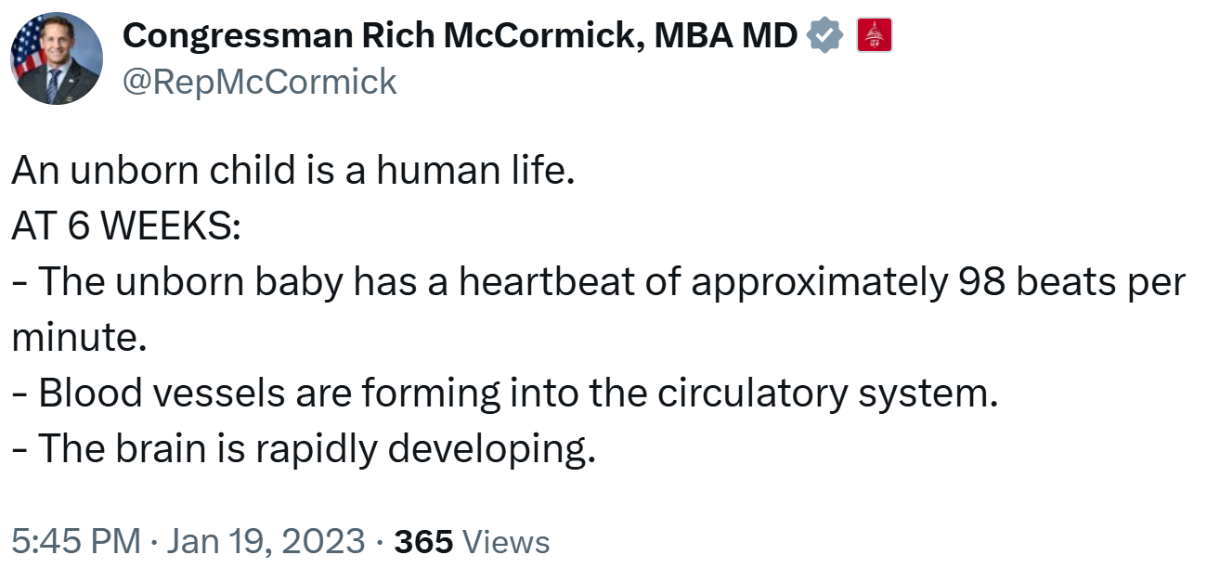
McCormick Listed More Fetal Development Stages For What He Described As “A Preborn Baby.” Congressman Rich McCormick tweeted, “BY 10 WEEKS A PREBORN BABY: - has arms, legs, fingers, and toes - is sucking his or her thumb - can now sigh, stretch, move his/her head, mouth, and tongue - can kick and will jump if startled - has developed pain receptors (week 7)” [Twitter, @RepMcCormick, 1/20/23]
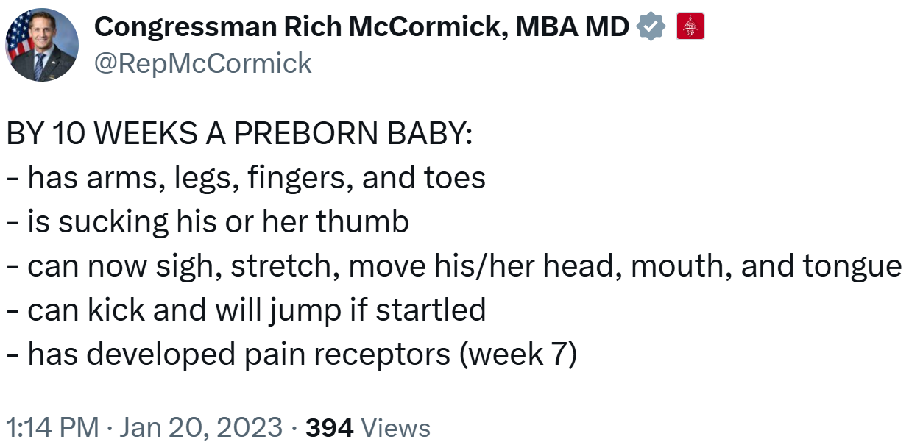

McCormick Claimed That Life Began “At Conception”
McCormick Called For The Supreme Court To “Overturn Roe V. Wade” And Declared That “Life Begins At Conception.” Congressman Rich McCormick tweeted, “I look forward to speaking at @FrontlineGA's fight for life rally today at the Georgia Capitol. The Supreme Court must stay strong and overturn Roe v Wade. Life begins at conception and every life is a sacred gift from God.” [Twitter, @RichforGA, 5/6/22]
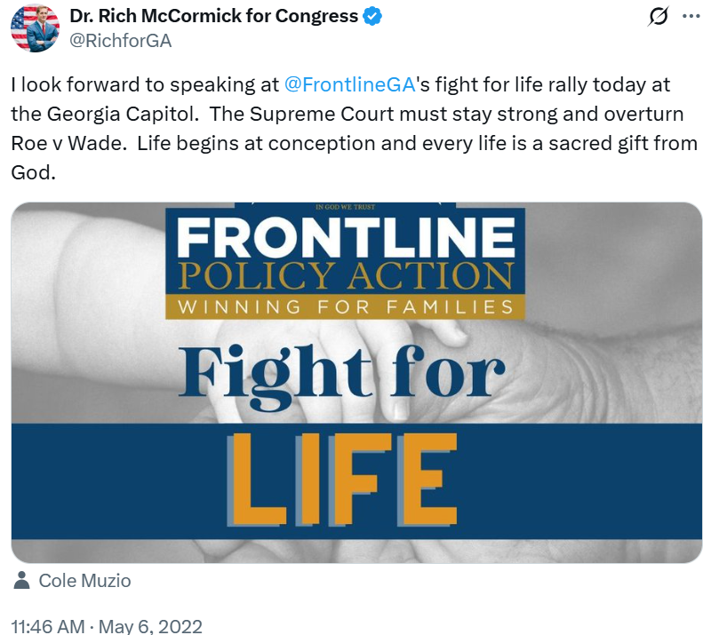

McCormick Opposed Restrictions On Federal Funding For Crisis Pregnancy Centers
2024: McCormick Voted To Prohibit Restrictions On Federal Funding For Pregnancy Centers. In January 2024, according to Congressional Quarterly, McCormick voted for the “passage of the bill that would prohibit limitations on the use of federal Temporary Assistance for Needy Families funding for pregnancy centers. The bill would prevent the Health and Human Services secretary from finalizing, implementing or enforcing policies that discriminate against pregnancy centers seeking federal funding. It also would define a pregnancy center as any organization, such as a pregnancy resource center, pregnancy help center or organization, or pregnancy medical center that supports protecting the life of the mother and the unborn child, and offers resources and services to mothers, fathers and families including counseling, education, pregnancy testing, diapers, baby clothing or material supports.” The vote was on adoption of the rule. The House adopted the rule by a vote of 214 to 208. [House Vote 17, 1/18/24; Congressional Quarterly, 1/18/24; Congressional Actions, H.R. 6918]
- Democrats Opposed Funding Pregnancy Centers Out Of Concern That They Mislead Women Seeking Contraception Or Abortion. According to Congressional Quarterly, “The panel also readied for the floor a bill (HR 6918), approved by the House Ways and Means Committee, to prevent the Health and Human Services Department from establishing or enforcing restrictions on federal funding for pregnancy centers, which abortion opponents have endorsed as an alternative to abortion clinics for providing information on pregnancy care and services. Many Democrats argue that these centers can mislead women seeking contraception or abortion services.” [Congressional Quarterly, 1/16/24]
- Georgia Had The 10th Highest Number Of Crisis Pregnancy Centers Nationwide. According to the Crisis Pregnancy Center Map, “Georgia has the 10th highest number of CPCs* of all states in the U.S. […] CPCs oppose contraception and comprehensive sex education. CPCs do not adhere to national medical and ethical practice standards, which could cause individual and public health harms. CPCs In Georgia: Number Of CPCs: 95.” [Crisis Pregnancy Center Map, Georgia, Accessed 5/12/25]
2024: McCormick Effectively Voted Against Allowing Restrictions On Federal Funding For Pregnancy Centers. In January 2024, according to Congressional Quarterly, McCormick voted against the “motion to recommit the bill to the House Ways and Means Committee.” The vote was on the motion to recommit. The House rejected the motion by a vote of 208 to 214. [House Vote 16, 1/18/24; Congressional Quarterly, 1/18/24; Congressional Actions, H.R. 6918]
2024: McCormick Effectively Voted To Prohibit Restrictions On Federal Funding For Pregnancy Centers. In January 2024, according to Congressional Quarterly, McCormick voted for the “adoption of the rule (H Res 969) that would provide for floor consideration of [..] the Supporting Pregnant and Parenting Women and Families Act (HR 6918). The rule would provide for up to one hour of debate on [the] bill and consider as adopted one amendment to […] HR 6918.” The vote was on adoption of the rule. The House adopted the rule by a vote of 198 to 194. [House Vote 11, 1/17/24; Congressional Quarterly, 1/17/24; Congressional Actions, H.Res. 969; Congressional Actions, H.R. 6918]

McCormick Wanted To Restrict Access To Reproductive Health Care

McCormick Believed That Abortion Should Be Illegal, With No Exceptions
2020: McCormick Declared That Abortion “Should Be Illegal” With No Exceptions To Prevent The Death Of The Mother Nor In Cases Of Rape And Incest. According to Rich McCormick’s Georgia Life Alliance Pro-Life Certification Application, “Do you believe abortion should be illegal? Yes _RM_ No ____ If you answered ‘yes’ to question 1, do you believe there should be an exception to laws prohibiting abortion in any of the following circumstances? (please initial all that you agree with) (a) _______ To prevent the death of the mother. (b) _______In cases of rape where the rape is reported to an appropriate law enforcement agency. (c) _______In cases of incest where the incest is committed against a minor and it has been reported to an appropriate agency.” [Georgia Life Alliance Pro-Life Certification Application – Rich McCormick, 1/22/20, Accessed via Internet Archive 5/9/25]

McCormick Applauded The Overturn Of Roe V. Wade
2022: McCormick Declared That “Without A Doubt” Life Began “At Conception” And Praised The Supreme Court’s Decision “To Strike Down The Most Barbaric Law In U.S. History.” According to a press release from Rich McCormick’s campaign, “In response to a draft majority opinion of the U.S. Supreme Court that announces the High Court’s decision to overturn Roe V. Wade, Marine Pilot and pro-life Emergency Room Doctor Rich McCormick issued the following statement: ‘As a doctor, Christian, and father of seven, I know without a doubt that life begins at conception. That’s why I have boldly championed pro-life legislation as a private citizen and candidate for public office. All life has value and must be protected at all costs. If reports today are true and the Supreme Court is poised to strike down the most barbaric law in U.S. history, there’s no doubt that President Donald J. Trump’s legacy will be securing a rock-solid, conservative Supreme Court majority, which resulted in the protection of millions of innocent, unborn children in the United States. Today, we celebrate this encouraging news and President Trump’s bold leadership. We also prepare for the fight to come, as left-wing radicals map out their plans to undermine the Court’s ruling and once again legalize the murder of innocent babies in America.’” [Press Release – Dr. Rich McCormick For Congress, 5/3/22]

McCormick Voted To Block The Use Of VA Funds To Provide Abortions Or Allow Abortion Counseling
2023: McCormick Voted To Prohibit The Use Of VA Funding To Provide Abortions Or Allow Abortion Counseling. In July 2023, according to Congressional Quarterly, McCormick voted for the Military Construction, Veterans Affairs, and Related Agencies Appropriations Act, 2024, which would “also prohibit the use of the bill's funds to provide abortions, to implement a September 2022 VA rule that allows abortion counseling and establishes exceptions for the prohibition on abortions in the medical benefits package for veterans and civilian beneficiaries, to provide surgical procedures or hormone therapies for gender-affirming care, and to fly or display a flag over a VA facility or national cemetery that is not the U.S. flag, military-related or another government jurisdiction” The vote was on passage. The House passed the bill by a vote of 219 to 211, thus the bill was sent to the Senate. [House Vote 380, 7/27/23; Congressional Quarterly, 7/27/23; Congressional Actions, H.R. 4366]
- The Bill Would Prevent VA Medical Centers From Performing Abortions. According to The Hill, “But the administration did not hold back its criticism of policies in the bill it said would prevent VA medical centers from being able to perform abortions or ‘provide hormone therapies for the purpose of gender-affirming care.’” [The Hill, 7/27/23]

McCormick Supported The Hyde Amendment And Pledged To Block Federal Funds For Abortions
2020: McCormick: “I Strongly Support The Hyde Amendment And Will Never Let Federal Funds Be Used To Pay For Abortion.” Congressman Rich McCormick tweeted, “Real small businesses are struggling and need PPP loans to keep their employees on the payroll. I strongly support the Hyde Amendment and will never let federal funds be used to pay for abortion. #Covid_19 #COVID19 #OpenAmerica #PPP #GA07 #Gapol #ProLife” [Twitter, @RichforGA, 5/20/20]
