Overview
- Harrigan touted Robinson’s endorsement and highlighted Robinson’s support for his congressional campaign.
- Robinson was an active user on pornographic and adulterous websites and described himself as a “black Nazi.”

Harrigan Was Endorsed By The Self-Described “Black Nazi” Mark Robinson

Harrigan Touted Robinson’s Endorsement And Highlighted Robinson’s Support For His Congressional Campaign
Harrigan Was “Honored And Humbled” To Receive An Early Endorsement From Robinson And Claimed That He Was “One Of The Boldest Voices In Politics Today.” Pat Harrigan tweeted, “Lt. Governor Robinson understands the challenges that face North Carolina families better than almost anyone. In just a few years’ time, he’s gone from private citizen to one of the boldest voices in politics today, and I am both honored and humbled to receive his endorsement. #ncpol @markrobinsonNC” [Twitter, @PatHarriganNC, 12/6/23]
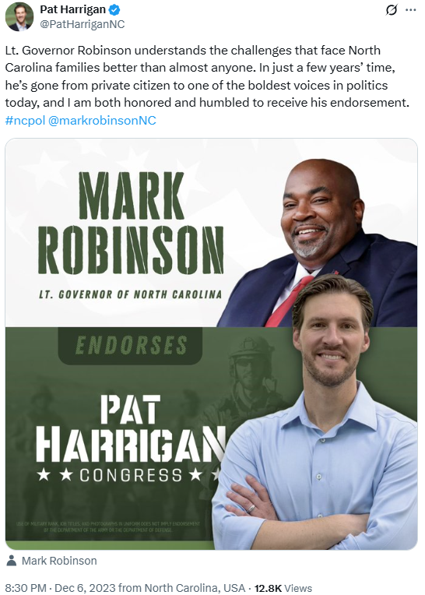
Harrigan Attended The Carolinas AAPI Business Alliance 2024 Gala Alongside Robinson And Emphasized That He Was “Grateful” For Robinson’s “Support And Endorsement.” Pat Harrigan tweeted, “The Carolinas AAPI Business Alliance 2024 Gala was a night to remember! Grateful for the chance to connect with Lt. Governor Mark Robinson at the event and for his support and endorsement in my run for Congress. #nc10” [Twitter, @PatHarriganNC, 2/24/24]
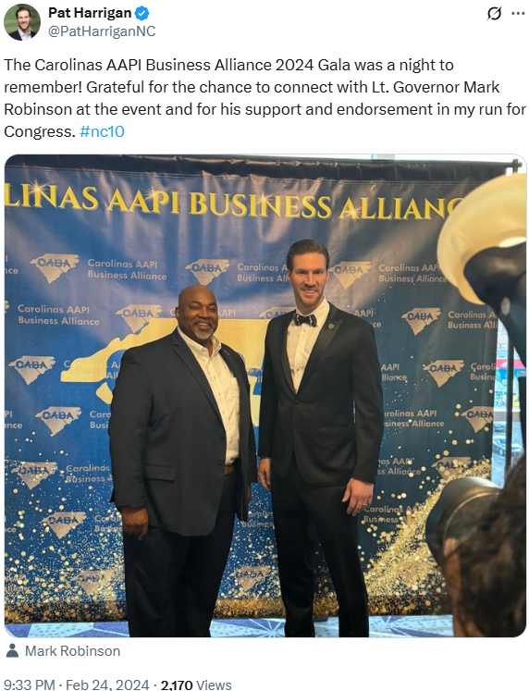

Robinson Was An Active User On Pornographic And Adulterous Websites And Described Himself As A “Black Nazi”
Robinson Had An Account On Ashley Madison, The Notorious Online Affairs Site, And Wrote On The Pornographic Site “Nude Africa” That He Was A “Black Nazi” Who Enjoys “Watching Tranny On Girl Porn.” According to Politico, “Republican officials in the state believe Robinson’s chances of winning the seat are now nearly nonexistent. On Thursday, news reports broke about his past online activities, including making posts on the pornographic website ‘Nude Africa’ that he enjoys ‘watching tranny on girl porn’ and that he was a ‘black Nazi,’ among other comments, and having an account registered on Ashley Madison, a website for married people seeking affairs. He denied making those posts or signing up for the website.” [Politico, 9/22/24]

