Overview
- Harrigan backed “born-alive” legislation.
- Harrigan celebrated the overturning of Roe v. Wade.
- Harrigan flip-flopped on a federal abortion ban.
- Harrigan praised North Carolina’s 12-week abortion ban.
- Harrigan supported fetal personhood.

Harrigan Was An Anti-Abortion Extremist

Harrigan Backed “Born-Alive” Legislation
2025: Harrigan Voted For The Born-Alive Abortion Survivors Protection Act, Which Would Mandate Health Care Workers To Provide Proper Medical Care To An Infant Born After A Failed Abortion. In January 2025, according to Congressional Quarterly, Harrigan voted for Born-Alive Abortion Survivors Protection Act, which would “require health care practitioners to provide the same care to a child that is ‘born alive’ after an abortion or attempted abortion as they would for a child born at the same gestational age and to ensure the child is immediately transported and admitted to a hospital; require hospital and clinic practitioners and employees to report any knowledge of failures to provide such care; and impose criminal fines and penalties for failures to meet these requirements. It would state that a child born alive under these conditions is a legal person under U.S. law, entitled to the protections of U.S. law, and it would specifically make any act that kills or attempts to kill such a child punishable as murder or attempted murder. The bill also would prohibit the prosecution of the mother of a child born alive after an abortion or attempted abortion and permit such mothers to seek relief through civil action against any person who violates the measure’s requirements, including monetary and punitive damages. The bill would also change the chapter name of Title 18, Chapter 74 of the U.S. Code from ‘Partial-Birth Abortions’ to ‘Abortions.’” The vote was on passage. The House passed the bill by a vote of 217-204, thus, the bill was sent to the Senate. [House Vote 27, 1/23/25; Congressional Quarterly, 1/23/25; Congressional Actions, H.R. 21]
- Different Iterations Of The Bill Have Been Introduced Since 2015. According to Congressional Quarterly, “Lawmakers have introduced iterations of this legislation in both chambers since 2015. The House passed similar bills in January 2018 and again in January 2023 after reclaiming control of the chamber. As the minority in 2019, House Republicans unsuccessfully attempted to trigger a vote through other procedural tools.” [Congressional Quarterly, 1/23/25]
- Republicans Called The Bill “Anti-Infanticide” Rather Than “Anti-Abortion.” According to the Hill, “Republicans have framed the bill as not being anti-abortion but anti-infanticide.” [Hill, 1/23/25]
- Democrats Called The Bill Redundant, Solely Criminalizing Doctors, As Killing Born-Alive Infants Following An Abortion Attempt Is Already Illegal. According to the Hill, “Democrats have criticized the legislation as being redundant, as killing infants born alive after an attempted termination, a rare occurrence, is already illegal, and the bill only serves to ‘criminalize’ doctors. Health care practitioners who fail to comply with the law would face fines and up to five years in jail or both.” [Hill, 1/23/25]
Harrigan Declared That “Every Child Deserves A Chance At Life, No Matter The Circumstances Of Their Birth” And Touted His Support For The Legislation “To Ensure Infants Who Survive Abortion Receive The Same Care As Any Newborn.” Representative Pat Harrigan tweeted, “Every child deserves a chance at life, no matter the circumstances of their birth. I voted for the Born-Alive Abortion Survivors Protection Act to ensure infants who survive abortion receive the same care as any newborn.” [Twitter, @RepPatHarrigan, 1/23/25]
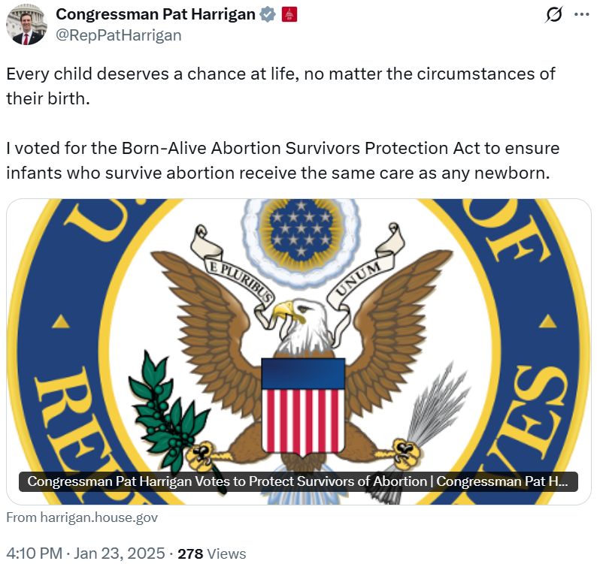
- Harrigan Claimed The Legislation Was “About Upholding The Most Fundamental Values Of Our Society: Protecting The Innocent And Defending The Defenseless” And Emphasized The “Immeasurable Value Of Every Single Life.” According to a press release from Congressman Pat Harrigan, “Harrigan (NC-10) voted to pass H.R. 21, the Born-Alive Abortion Survivors Protection Act, critical legislation that protects infants who survive attempted abortions by ensuring they receive the same medical care as any other newborn. ‘This vote is about upholding the most fundamental values of our society: protecting the innocent and defending the defenseless,’ said Congressman Harrigan. ‘As a father of two, I understand the immeasurable value of every single life. This bill sends a clear message that every baby, no matter how they enter this world, is entitled to the care and compassion they need to survive. There is nothing more basic or more important than ensuring every child is given the chance to live.’” [Press Release – Congressman Pat Harrigan, 1/23/25]
August 2024: Harrigan Declared His Support For ‘Born-Alive’ Legislation. According to Pat Harrigan’s 2024 North Carolina Family Voter Candidate Survey, “Should Congress pass a law requiring a health care practitioner, who is present at the time a child is born alive after a failed abortion attempt, to exercise the same degree of skill, care and diligence to preserve the life and health of the child as would be expected for any other child born alive at the same gestational age? ‘Yes.’” [North Carolina Family Voter Candidate Survey, Pat Harrigan, 8/8/24]

Harrigan Celebrated The Overturning Of Roe V. Wade
Harrigan Called Roe “An Errant Opinion That Removed Power From The People And Gave It To An Unelected Class” And Claimed There Was “No One-Size-Fits-All Solution For Our Most Emotional And Complex Issues” Which Meant That “The Best Approach Is To Grant The Voters Of Each State An Active Role In Determining What The Law Should Be.” Pat Harrigan tweeted, “I applaud the Supreme Court for correcting an errant opinion that removed power from the People and gave it to an unelected class. Full Statement: ‘I applaud the Supreme Court for correcting an errant opinion that removed power from the people and gave it to an unelected class. Because there is no one-size-fits-all solution for our most emotional and complex issues, the best approach is to grant the voters of each state an active role in determining what the law should be. As we reflect on what today’s decision means for all of us, this active role should be expressed through peaceful means, not with violence of any kind on either side of the debate. We must return to respectful dialogue, even on the most passionate of issues.” [Twitter, @PatHarringtonNC, 6/4/22]
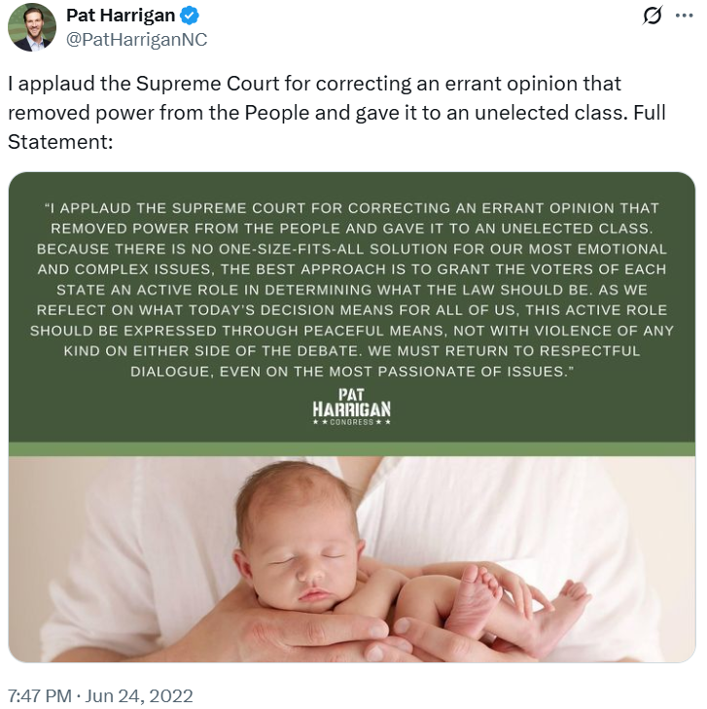
May 2022: Harrigan Said That An Overturn Of Roe “Should Be Treated As The Law Of The Land And People Should Abide By It.” According to The Charlotte Observer, “As part of our Voter Guide for the statewide primary elections on May 17, The Charlotte Observer and The News & Observer asked all candidates running for U.S. House, Senate and the state legislature what should happen if the Supreme Court overturns Roe. Below are the answers for each candidate who returned our questionnaires. [...] Pat Harrigan, Republican candidate for 14th Congressional District ‘The same thing that happens every other time the US Supreme Court makes a decision: it should be treated as the law of the land and people should abide by it.’” [Charlotte Observer, 5/3/22]
- Harrigan “Always Believed That The Roe And Casey Decisions Were Based On Political Motivations, Not Guiding Principles That Are Found Anywhere In The Constitution” And Hoped That “The Supreme Court Corrects This Errant Decision And Pushes The Matter Back To The States.” According to The Charlotte Observer, “What should happen if Roe v. Wade is overturned? ‘I am pro-life. I’ve always believed that the Roe and Casey decisions were based on political motivations, not guiding principles that are found anywhere in the Constitution. I hope the Supreme Court corrects this errant decision and pushes the matter back to the states.’” [Charlotte Observer, 5/13/22]

Harrigan Flip-Flopped On A Federal Abortion ban
Harrigan Opposed A Federal Abortion Ban During His 2022 Race But Ran On Supporting A Federal Ban, With “Certain Exceptions,” In 2024. According to Spectrum News, “On the question of a federal abortion ban, Mills said he would want to see the legislation before committing, but said he would vote to ‘save lives.’ In 2022, when Harrigan was running in the 14th District, he told us he did not support a federal ban on abortion. He now said, given the makeup of this different district. He would support one. But, he added, he supports certain exceptions.” [Spectrum News, 2/21/24]
2024: Harrigan Answered “No” When Asked, “Should Congress Pass Legislation That Establishes A Right To Abortion In Federal Law?” According to Pat Harrigan’s 2024 North Carolina Family Voter Candidate Survey, “Should Congress pass legislation that establishes a right to abortion in federal law? ‘No.’” [North Carolina Family Voter Candidate Survey, Pat Harrigan, 8/8/24]
2022: Harrigan Declared That The “Federal Government Belongs Out of Our Individual Lives And Personal Medical Decisions” And Claimed That The Power Was “Returned To The Individual People Of Each State” Post-Dobbs. According to the Gaston Gazette, “6. What federal legislation would you support on abortion? Jackson: ‘I support a federal law that implements the core provisions of Roe, which provided for a minimum set of rights that all 50 states had to respect. Now with Roe gone, we have candidates in North Carolina campaigning to outlaw abortion with no exceptions. That’s extreme and unreasonable.’ Harrigan: ‘The federal government belongs out of our individual lives and personal medical decisions. That power has now been returned to the individual people of each state, which is exactly where it belongs.’” [Gaston Gazette, 10/26/22]

Harrigan Praised North Carolina’s 12-Week Abortion Ban
Harrigan Called Governor Cooper’s Veto “Political Theater” And Praised The Legislature’s “Commitment To Protecting The Sanctity Of Life” On Their Override; He Claimed That The Ban “Not Only Protects Life But Also Ensures Critical Support For Foster Care And Parental Leave, Benefitting The Well-Being Of North Carolinians For Generations To Come.” Pat Harrigan tweeted, “Pat Harrigan on the override of SB20, the ‘Care for Women, Children, and Families Act’. #ncpol ‘Despite Governor Cooper’s veto staged as political theater just before Mother’s Day, the North Carolina legislature’s commitment to protecting the sanctity of life prevailed with the override of his veto on the ‘Care for Women, Children, and Families Act.’ This accomplishment not only protects life but also ensures critical support for foster care and parental leave, benefitting the well-being of North Carolinians for generations to come.’” [Twitter, @PatHarriganNC, 5/16/23]
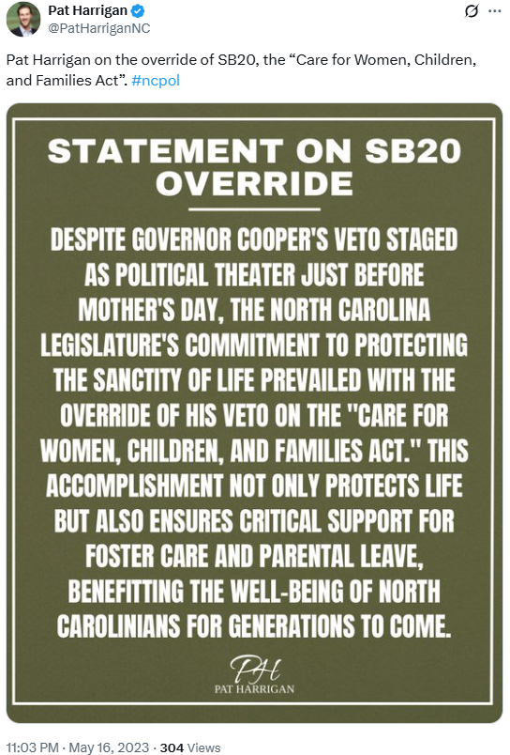
- The North Carolina Legislature Overrode Governor Cooper’s Veto On The Legislation, Implementing A Statewide 12-Week Abortion Ban. According to ABC 11, “Both chambers in the state legislature successfully overrode Gov. Roy Cooper's veto of a bill limiting abortion on Tuesday, enabling the legislation to become law. The House took up the debate Tuesday evening, hours after the Senate successfully overrode the governor's veto. The vote was 72-48 as GOP members withstood heavy and vocal opposition from critics desperate to uphold Cooper's veto. [...] ‘We sincerely thank Senator Berger, Speaker Moore, and Republican legislators for standing strong and voting on behalf of the 62% of North Carolinians who reject abortion after 12 weeks,’ she added.” [ABC 11, 5/17/23]

Harrigan Supported Fetal Personhood
Harrigan Touted His “Conservative Values” And Declared That He “Fights To Protect The Unborn.” According to Pat Harrigan’s campaign website, “Pat sees conservative values as the bedrock of our nation. To uphold these ideals, he fights to protect the unborn, stands firm with parental rights, defends women’s sports, and safeguards religious freedom.” [Harrigan for Congress, Issues, Accessed 7/10/25]

