Overview
Whatley supported the “One Big Beautiful Bill” which was estimated to kick over 650,000 North Carolinians off of their health coverage. The legislation was described as killing North Carolina’s Medicaid expansion which expanded healthcare to hundreds of thousands of North Carolinians. On top of ripping healthcare away from North Carolinians, the legislation was also placing rural hospitals at risk.
Despite warnings from outgoing Senator Tillis that the legislation was bad for North Carolina, Whatley did all he could to support it, including calling State Senate Leader Phil Berger to urge him to embrace the bill and touting that he would have voted for it if he were in the Senate.

Whatley Supported Cuts To Medicaid

2025: Whatley Supported Gutting Medicaid

Whatley Supported The “One Big Beautiful Bill”
[AUDIO] Whatley Claimed That The OBBB Was “Absolutely Essential.” “We saw a huge vote from the House just this week on the bill, you know, on the big, beautiful bill. And, you know, it's absolutely essential that we get that to the president's desk.” [Cats Roundtable, 5/25/25]
Whatley Claimed That The House Passage Of The “One Big Beautiful Bill” Was “GREAT NEWS.” Michael Whatley posted, “GREAT NEWS We're one step closer to getting the One, Big, Beautiful Bill to President Trump's desk. This will be the largest tax cut in history for the American people.” [Twitter, @ChairmanWhatley, 6/28/25]
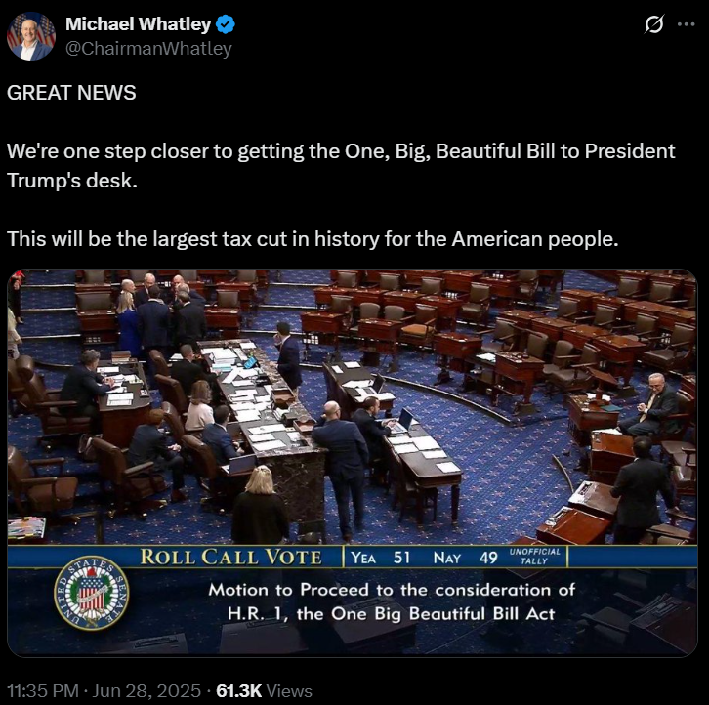
Whatley Claimed That The Passage Of The “One Big Beautiful Bill” Was A “Huge Win.” According to a press release from the Republican National Committee, “‘Today is a huge win for all Americans,’ said Chairman Whatley. ‘President Trump and Republicans in Congress are keeping the promises they made to the American people, delivering in this bill the America First Agenda they campaigned on: the largest tax cut in history for middle class and working Americans, permanent border security, and trillions in spending cuts to waste, fraud, and abuse. Every single Democrat in the House and Senate turned their backs on working Americans and voted against these policies, and as RNC Chairman, I will make sure that voters remember that fact next year.’” [Press Release – Republican National Committee, 7/3/25]
[VIDEO] Whatley Claimed That The “One Big, Beautiful Bill” Was “An Amazing Bill.” “Now, I've got to give Congress a lot of credit for passing the one big, beautiful bill. When you think about that legislation, it means that we're going to have no tax on tips. We're going to have no tax on overtime. We're going to have no tax on Social Security. We've extended the Trump tax cuts permanently. We also have national security provisions in that bill. We have energy security provisions in that bill. We have border security provisions in that bill. It's an amazing bill. And thank God Congress got it done. But we're not finished yet. We have a lot more work to do.” [Turning Point Student Action Summit, 7/12/25]
[VIDEO] Whatley Claimed That The “One Big Beautiful Bill” Was A “Huge Win.” “‘You know, and a huge win with the big, beautiful bill, a huge win on the rescission packages that we got done yesterday. But you have to look at what's happening on trade and tariffs. You have to look at what's happening on the regulatory relief agenda.’” [Newsmax TV: Wake Up America, 7/18/25]

Whatley Claimed That He Would’ve Voted For The “One Big Beautiful Bill”
[AUDIO] Whatley Claimed That He Would’ve Voted For The One Big Beautiful Bill. “I would have voted for that bill in a heartbeat. That was a bill that that really embodies the president's agenda and embodies the positions that we need here in North Carolina.” [Breitbart, 9/04/25]
[AUDIO] Whatley Claimed That He Would’ve Voted For The “Big Beautiful Bill” In A “Heartbeat.” “I would have voted for this bill in a heartbeat because of what it is going to do in terms of helping North Carolina's economy.” [Brett Winterble Show, 9/13/25]

Whatley Asked State Senate Leader Phil Berger To Embrace The Big Beautiful Bill
Whatley Asked State Senate Leader Phil Berger To Embrace The Big Beautiful Bill. According to the News & Observer, “Berger embraced the legislation, posting his support on social media — something he said then-Republican National Committee Chairman Michael Whatley asked him to do.” [News & Observer, 9/22/25]
Whatley’s Spokesperson Claimed That Whatley Spoke With Berger And Others About Supporting The Big Beautiful Bill. According to the News & Observer, “Whatley’s team confirmed he made the call to Berger. ‘Whatley spoke with Berger and others,’ said Jonathan Felts, spokesman for Whatley’s campaign. ‘President Trump needs an ally in the Senate and North Carolina wants a conservative fighter.’” [News & Observer, 9/22/25]

The “One Big Beautiful Bill” Contained Devastating Medicaid Cuts
North Carolina Was Set To Lose $32 Billion In Federal Funding Over The Next Decade And Over 650,000 North Carolinians Would Lose Their Coverage. According to the Guardian, “North Carolina is set to lose $32bn in federal funding in the next decade, according to an analysis by the office of the Republican senator Thom Tillis, who represents the state. He’s one of just three Senate Republicans who voted against the bill on Tuesday. North Carolina’s expansion only went into effect in December 2023, and in less than 19 months it enrolled more than 650,000 people – all of whom will lose coverage if the program ends.” [Guardian, 7/4/25]

The “One Big Beautiful Bill” Would Kill North Carolina’s Medicaid Expansion
The “One Big Beautiful Bill” Would Kill North Carolina’s Medicaid Expansion. According to NC Health News, “Now, state health officials are warning that President Donald Trump’s so-called One Big Beautiful Bill, a version of which is expected to go before the U.S. Senate for a vote as early as this weekend, would effectively kill North Carolina’s expansion — stripping coverage from hundreds of thousands of residents who only recently became eligible for it.” [NC Health News, 6/27/25]
Tillis Claimed That Experts Told Him That Over 600,000 North Carolinians Could Lose Healthcare. According to WUNC, “Tillis explained in a floor speech Sunday evening that he’d reached out to North Carolina legislators, the N.C. Healthcare Association, and Gov. Josh Stein's administration to gather estimates on the bill’s Medicaid impact locally. He said all agreed that the bill’s cuts to Medicaid funding would mean more than 600,000 people in his state would lose healthcare. That’s because when the Republican-led state legislature enacted Medicaid expansion in 2023, it included a provision that would automatically end the program if the federal government stops covering 90% of its cost.” [WUNC, 6/30/25]

Rural Communities Would Lose Healthcare Access
Five Rural Hospitals In North Carolina Were At Risk Of Closure. According to WRAL, “The research noted that 338 rural hospitals nationwide were at risk of closing. […] Five hospitals in North Carolina made the list, including Person Memorial in Roxboro and UNC Health Chatham in Siler City.” [WRAL, 6/16/25]
- The Bill Likely Would Prevent Martin General Hospital From Reopening. According to the New York Times, “But those plans are now in jeopardy, as is Medicaid coverage for hundreds of thousands of North Carolina residents, after Congress passed President Trump’s sweeping domestic policy bill. To help pay for tax cuts, the bill slashes federal spending on Medicaid, leaving states that expanded the program under Obamacare in a particularly difficult spot. If Medicaid expansion is eliminated in North Carolina, Martin General Hospital almost surely will not reopen” [New York Times, 7/6/25]
- Rural Hospitals Were At Risk Of Closure Due To The Bill. According to ABC News, “More than 300 hospitals could be at risk for closure if the Republicans' bill becomes law, an analysis by the Cecil G. Sheps Center at the University of North Carolina at Chapel Hill found last month. The center tracks rural hospital closures.” [ABC News, 7/2/25]

