Overview
Whatley, a long time oil lobbyist, supported the “One Big Beautiful Bill” which slashed clean energy credit. Whatley praised the legislation as a “huge win.” The end of clean energy credits threatened to spike North Carolinian’s energy bills and threatened thousands of clean energy jobs in North Carolina.

Whatley Supported Repealing Tax Credits That Supported North Carolina’s Clean Energy Industry

Whatley Supported The “One Big Beautiful Bill”
[AUDIO] Whatley Claimed That The OBBB Was “Absolutely Essential.” “We saw a huge vote from the House just this week on the bill, you know, on the big, beautiful bill. And, you know, it's absolutely essential that we get that to the president's desk.” [Cats Roundtable, 5/25/25]
Whatley Claimed That The House Passage Of The “One Big Beautiful Bill” Was “GREAT NEWS.” Michael Whatley posted, “GREAT NEWS We're one step closer to getting the One, Big, Beautiful Bill to President Trump's desk. This will be the largest tax cut in history for the American people.” [Twitter, @ChairmanWhatley, 6/28/25]
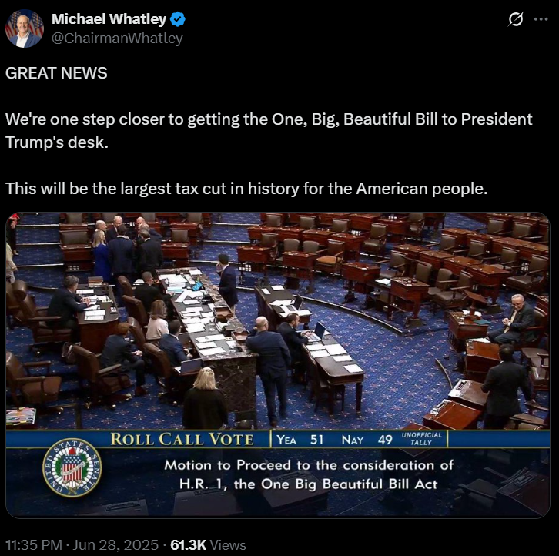
Whatley Claimed That The Passage Of The “One Big Beautiful Bill” Was A “Huge Win.” According to a press release from the Republican National Committee, “‘Today is a huge win for all Americans,’ said Chairman Whatley. ‘President Trump and Republicans in Congress are keeping the promises they made to the American people, delivering in this bill the America First Agenda they campaigned on: the largest tax cut in history for middle class and working Americans, permanent border security, and trillions in spending cuts to waste, fraud, and abuse. Every single Democrat in the House and Senate turned their backs on working Americans and voted against these policies, and as RNC Chairman, I will make sure that voters remember that fact next year.’” [Press Release – Republican National Committee, 7/3/25]
[VIDEO] Whatley Claimed That The “One Big, Beautiful Bill” Was “An Amazing Bill.” “Now, I've got to give Congress a lot of credit for passing the one big, beautiful bill. When you think about that legislation, it means that we're going to have no tax on tips. We're going to have no tax on overtime. We're going to have no tax on Social Security. We've extended the Trump tax cuts permanently. We also have national security provisions in that bill. We have energy security provisions in that bill. We have border security provisions in that bill. It's an amazing bill. And thank God Congress got it done. But we're not finished yet. We have a lot more work to do.” [Turning Point Student Action Summit, 7/12/25]
[VIDEO] Whatley Claimed That The “One Big Beautiful Bill” Was A “Huge Win.” “‘You know, and a huge win with the big, beautiful bill, a huge win on the rescission packages that we got done yesterday. But you have to look at what's happening on trade and tariffs. You have to look at what's happening on the regulatory relief agenda.’” [Newsmax TV: Wake Up America, 7/18/25]

Whatley Claimed That He Would’ve Voted For The “One Big Beautiful Bill”
[AUDIO] Whatley Claimed That He Would’ve Voted For The One Big Beautiful Bill. “I would have voted for that bill in a heartbeat. That was a bill that that really embodies the president's agenda and embodies the positions that we need here in North Carolina.” [Breitbart, 9/04/25]
[AUDIO] Whatley Claimed That He Would’ve Voted For The “Big Beautiful Bill” In A “Heartbeat.” “I would have voted for this bill in a heartbeat because of what it is going to do in terms of helping North Carolina's economy.” [Brett Winterble Show, 9/13/25]

Whatley Asked State Senate Leader Phil Berger To Embrace The Big Beautiful Bill
Whatley Asked State Senate Leader Phil Berger To Embrace The Big Beautiful Bill. According to the News & Observer, “Berger embraced the legislation, posting his support on social media — something he said then-Republican National Committee Chairman Michael Whatley asked him to do.” [News & Observer, 9/22/25]
Whatley’s Spokesperson Claimed That Whatley Spoke With Berger And Others About Supporting The Big Beautiful Bill. According to the News & Observer, “Whatley’s team confirmed he made the call to Berger. ‘Whatley spoke with Berger and others,’ said Jonathan Felts, spokesman for Whatley’s campaign. ‘President Trump needs an ally in the Senate and North Carolina wants a conservative fighter.’” [News & Observer, 9/22/25]

The Legislation Put Clean Energy Jobs At Risk
The Clean Energy Tax Credits Boosted The North Carolinian Economy And Brought Thousands Of Jobs To North Carolina. According to NC Voices, “ The federal tax credits helped boost the state’s economy by incentivizing companies to locate their clean energy manufacturing facilities in the state. Ultimately, the move brought thousands of jobs and over $24 billion in clean energy technology investments to North Carolina.” [NC Voices, 9/29/25]
The Rollback Of Clean Energy Tax Credits Placed Thousands Of Jobs In Jeopardy. According to NC Voices, “ The North Carolina Department of Environmental Quality is already warning North Carolinians that major incentives are set to expire this year—putting thousands of jobs in jeopardy and increasing energy bills for many.” [NC Voices, 9/29/25]
- Pine Gate Renewables Was Closing It’s Ashville Plant And Laying Off 78 Percent Of The Workforce Due To Clean Energy Changes That Were Enacted Under The Trump Administration. According to WLOS, “A notification filed with the state reveals Pine Gate Renewables on Roberts Street in Asheville is closing its plant, laying off more than 78% of its workforce as it files for bankruptcy. The database shows 223 people in Buncombe County will be impacted. The company cites renewable energy policy changes under the Trump administration.” [WLOS, 11/12/25]
NC Newsline: NC Solar Sector At Crossroads After Federal Funding Cuts [NC Newsline, 12/15/25]

The Legislation Would Spike North Carolinian’s Energy Bill
The Bill Could Increase Energy Rates By 18 Percent In North Carolina. According to WCNC, “North Carolina Gov. Josh Stein warns that the Big Beautiful Bill could increase electricity rates by 18% in the state. WFMY spoke to clean energy analyst Michael Thomas, who runs the national tracking company Clean View, said the bill could spike electricity costs across the country due to provisions that eliminate tax credits for new green energy projects. ‘There's no doubt this bill is going to increase electricity prices all over the country,’ Thomas said. ‘In states like North Carolina, folks can expect their bills to go up about 18%.’” [WCNC, 7/3/25]

