Overview

Rogers Was A Repeat Carpetbagger
Rogers was a Florida resident: he owned property in Florida, claimed a $50,000 homestead exemption in 2023 on his “permanent residence” in Lee County, and was registered to vote there prior to launching his failed Michigan Senate bid. Rogers eventually returned to Michigan but lived with his sister-in-law during the 2024 Election. Prior to 2024, Rogers had not voted in Michigan since 2016.
Rogers began his carpetbagging in 1994 when he moved from Chicago to run for a State Senate seat in Michigan.

Rogers Was A Repeat Carpetbagger

Rogers Moved Back To Michigan To Run For Office
Rogers Owned Property In Florida And Was Registered To Vote There Prior To His Senate Bid. According to Michigan Advance, “Records show Rogers, 60, owns homes in Michigan and Florida, but is registered to vote at a different Michigan address. Rogers, who retired from a Michigan U.S. House seat in 2015, was living in Florida and was registered to vote there before deciding to run for office again in Michigan in 2023, per the Detroit News.” [Michigan Advance, 1/30/24]
- Rogers And His Wife Purchased A Home In White Lake Township On July 10, 2023. According to Michigan Advance, “He also did buy a home 30 miles away. Oakland County tax records show Rogers and his wife purchased a one-bedroom, 728-square-foot home in White Lake Township for $295,000 on July 10, 2023.” [Michigan Advance, 1/30/24]
- Rogers And His Wife Registered To Vote At His Brighton, Michigan Address On August 16, 2023. According to Michigan Advance, “Livingston County records show Rogers and his wife registered to vote at a Brighton address on Aug. 16, 2023. That same address is also listed in county property records as being owned by his sister-in-law, Deborah Miller.” [Michigan Advance, 1/30/24]

Mike Rogers Was Still Registered To Vote In Florida
Mike Rogers Was Registered To Vote In Florida. [Lee County Supervisor Of Elections, accessed 7/6/23]
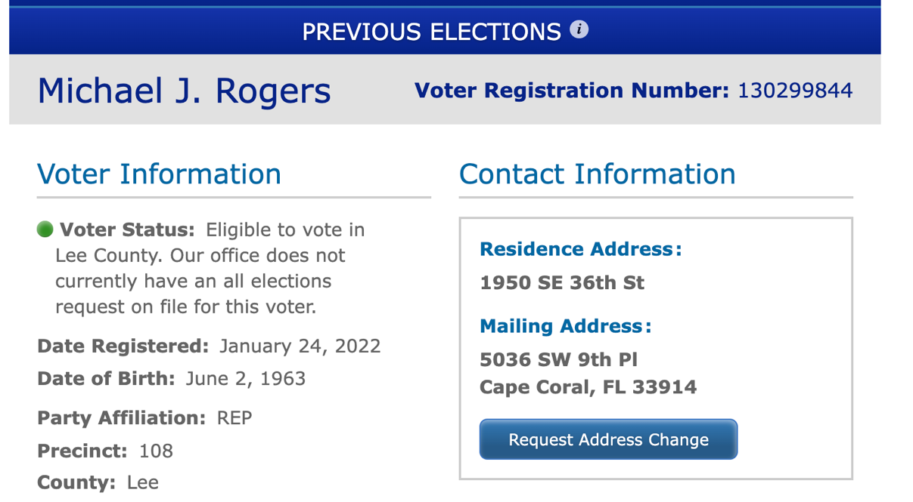
2022: Mike Rogers Voted In Florida Primary And General Elections. [Lee County Supervisor Of Elections, accessed 7/6/23]
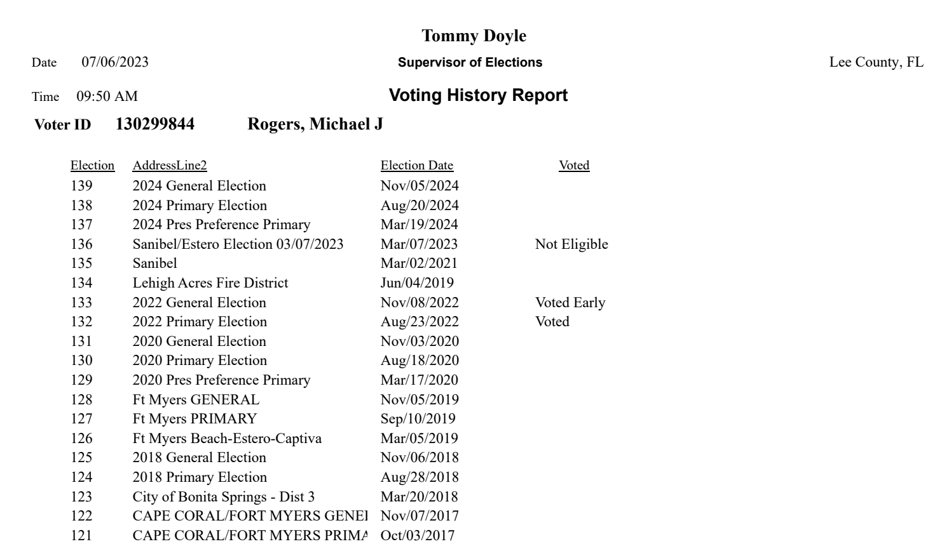

Mike Rogers Had Not Voted In Michigan Since 2016
Last Time Mike Rogers Voted In Michigan Was 2016 Presidential Primary. [Livingston County Elections Division, accessed 7/6/23]
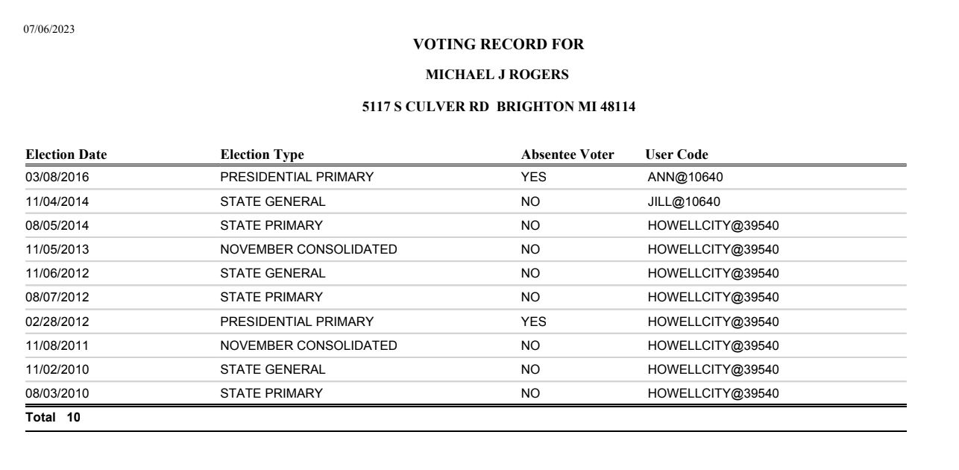

Before Running For Senate, Florida Was Rogers’ Main Residence

2023: Rogers Claimed $50,000 In Homestead Exemptions In Lee County, Florida
Rogers Owned A 4,751-Square-Foot Home In Cape Coral, Florida Valued At $1.7 Million. According to Michigan Advance, “Rogers also owns a large home in Florida. The 4,751-square-foot home in Cape Coral valued at $1.7 million was his official residence until his decision to run for U.S. Senate. Public records show he received a $50,000 homestead tax exemption on the property for 2022, as well as pulled a renovation permit that same year worth $327,000, more than the cost of the entire Michigan house. Both homes in Cape Coral and White Lake are listed under Rogers’ and his wife’s names, as trustees of the Rogers Family Trust, which has the same Brighton address he and his wife are registered to vote at.” [Michigan Advance, 1/30/24]
In 2023, Mike Rogers Claimed $50,000 In Homestead Exemptions For His Property In Cape Coral, Florida.
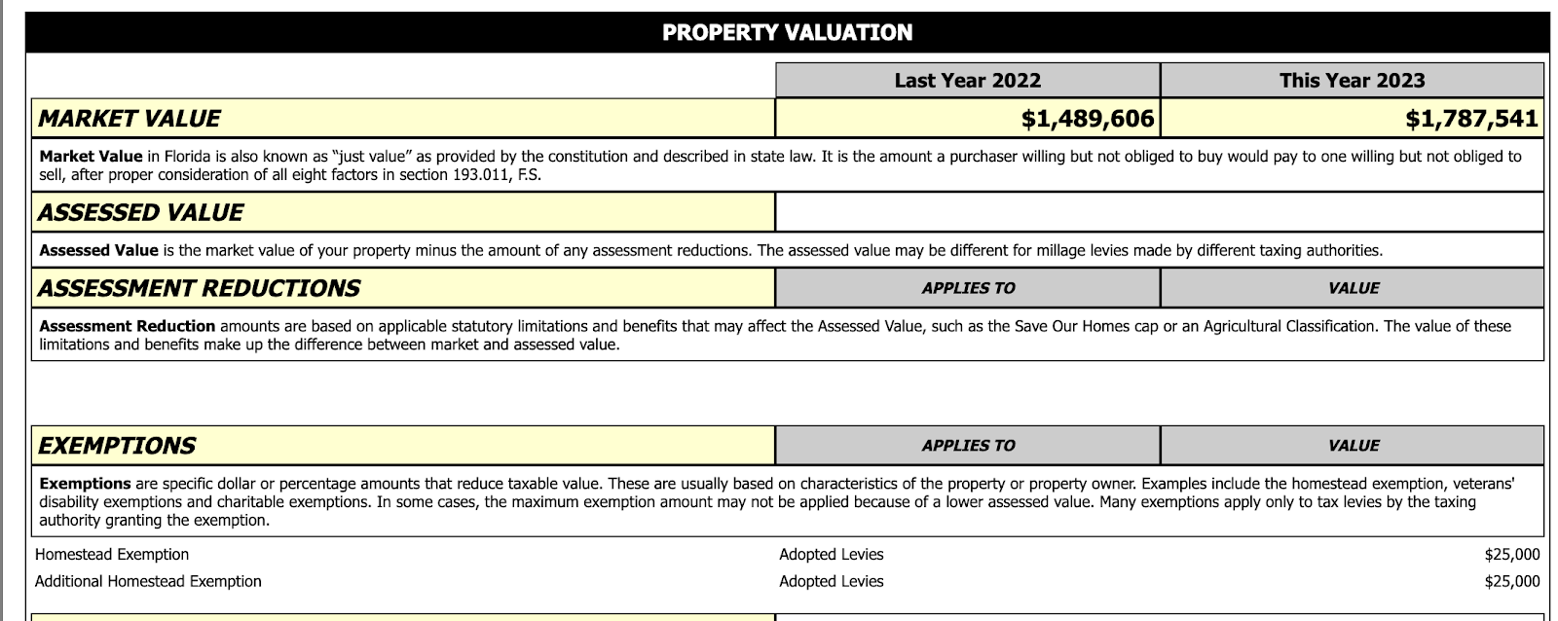
[Lee County Property Tax Appraiser, 2023]
To Claim A Homestead Exemption In Lee County, Florida, The Property Must Be A “Permanent Residence.” According to the Lee County Property Appraiser, “Who is eligible to file for homestead exemption? Property owners must meet certain qualifications to be eligible for a homestead exemption: You must have legal title or a beneficial interest in real property as of January 1. The property must be your permanent residence as of January 1. You cannot claim a residency-based exemption in Florida, or in another state. If married, you may claim only one property as your permanent residence for the purpose of tax deduction. It is recommended that all owners of record, who have made the property their permanent residence, apply for the exemption.” [Lee County Property Tax Appraiser, 1/24/24]

Rogers Was Reported To Live With His Sister-In-Law After Moving Back To Michigan For His Campaign

Rogers “Lived” With His Sister-In-Law While His White Lake Township Property Was Being Renovated
Rogers’ Spokesperson Confirmed He Lived With His Sister-In-Law While His White Lake Township Property Was Being Renovated. According to Michigan Advance, “The Michigan Advance asked Rogers’ campaign to comment on his residency. A spokesperson confirmed Rogers is living at his sister-in-law’s Brighton house pending renovations on the White Lake property, but declined to comment further despite repeated requests. When reached for comment, the National Republican Senatorial Campaign Committee referred the Advance to Rogers’ campaign. The real estate listing for the White Lake property shows the home was completely remodeled by the previous owner in 2022 just prior to its sale.” [Michigan Advance, 1/30/24]

Rogers Continued His Residence In The Genoa Township Home Of His Sister-In-Law, Providing No Timeline Of When He Would Move To His White Lake Township Home
Rogers Continued His Residence In The Genoa Township Home Of His Sister-In-Law, Providing No Timeline Of When He Would Move To His White Lake Township Home. According to Gander News, “The one-bedroom, 728-square-foot home, purchased by Rogers and his wife, Kristi, for $295,000 in July 2023, became a focus of questions about Rogers residency in January when the Michigan Advance first reported that he had never actually resided at the White Lake property. Instead, Rogers said he was living at his sister-in-law’s Genoa Township house, near Brighton, where he was also registered to vote. At the time, Rogers’ campaign provided copies of Oakland County permits to plug an onsite well and install a new one at the home, which had undergone $100,000 in renovations prior to its sale. But as of Tuesday morning, the old house was gone and the cement foundation for a new structure was in its place. There were no workers or active construction visible at the time. A sign on the property indicated the construction was being handled by EBI Inc., a home building company owned by Rogers’ brother, Bill Rogers. Mike Rogers campaign spokesman Chris Gustafson confirmed for the Advance that Rogers was still staying at the Genoa Township home of his sister-in-law with plans to move into the White Lake Township home once it was completed, although no timeline was provided.” [Gander News, 5/2/24]

Rogers Was A “Carpetbagger” Based On His Conflicting Residency And Political Interests
Pollster Bernie Porn Of EPIC-MRA Claimed There Was “Enough Info To Label Rogers As A Carpetbagger.” According to Michigan Advance, “Pollster Bernie Porn of the EPIC-MRA firm tells the Advance that despite the former congressman’s longtime connections to Michigan, there could be ‘enough info to label Rogers as a carpetbagger. ‘Today, ‘carpetbagger’ means someone who’s an opportunistic outsider, such as a political candidate who runs for office in a place where he has no deep ties or hasn’t lived in an area for a very long time,’ Porn said. ‘In my years working for state House Dems, I used similar situations involving residences as pretty powerful direct mail pieces or TV ad messages in campaigns. All you have to do is show the two houses next to each other and ask which state is more important to him based on the houses he owns in each state,’ he added.” [Michigan Advance, 1/30/24]

Rogers Was A Carpetbagger During His Michigan Senate Days As Well

Mike Rogers Moved From Chicago To Run For The Seat
Mike Rogers Moved Back To Livingston County To Run For The State Senate. According to the Livingston County Daily Press and Argus, “Rogers, a former special agent for the Federal Bureau of Investigations and the son of Brighton Chamber of Commerce Executive Director Joyce Rogers and former Brighton Township Supervisor John Rogers, moved back to the county in January. He is co-owner of a Brighton manufactured home business.” [Livingston County Daily Press and Argus, 7/20/94]

Mike Rogers Rebutted Carpetbagger Claims By Saying He Was Serving His Country
Mike Rogers Rebutted Carpetbagger Claims By Saying “I Do Take Offense To Him Belittling The Fact That Someone Left To Go Serve His Country.” According to the Livingston County Daily Press and Argus, “Rogers counters that the only reason he lived outside the district was during his time in the military and then as an agent for the Federal Bureau of Investigation. Rogers comes from a well-known Livingston County family. His mother, Joyce Rogers, is a former county commissioner and is currently the executive director of the Brighton Area Chamber of Commerce; his father, John, is a former Brighton Township supervisor. Rogers, who grew up in Livingston County, said he was last registered to vote in the county in 1988 when he was assigned by the FBI to Chicago. ‘I’ve lived more total years in this district than my opponent,’ Rogers said. ‘Quite frankly, I do take offense to him belittling the fact that someone left to go serve his country. The last time we had someone who was an attorney and didn’t serve his country and made fun of those who did, we elected him President. I don’t think we want to make that mistake again.’” [Livingston County Daily Press and Argus, 10/5/94]
Mike Rogers Said “This Is My Home. This Has Always Been My Home. Because I Leave To Serve My Country, Doesn’t Change That.” According to the Livingston County Daily Press and Argus, “Rogers is aware of Hatty’s statements about living in the community. ‘I know he’s taken shots at my background,’ Rogers said. ‘I went to the public schools in Livingston County. For the last four years, I’ve come back – at my own time and expense – to talk about a career in the FBI with school children. This is my home. This has always been my home. Because I leave to serve my country, doesn’t change that.’” [Livingston County Daily Press and Argus, 10/12/94]
Mike Rogers Said He Knew Michigan Because He Was Co-Owner Of The Family Business. According to the Livingston County Daily Press and Argus, “Rogers said that even if he hasn’t lived here, he has felt Michigan’s recent history through a family business he co-owns, EBI Builders. ‘I’ve never said I have run the company. I’ve said I am a co-owner,’ Rogers said. ‘As an owner in any business, you fill in the gaps where you can. I’ve worked a home show or two. I’ve swung a hammer on occasion and being a family business we all filled in and pulled together. And come tax time we were there. When you pay taxes and you are in business in an area, you know what’s going on.” [Livingston County Daily Press and Argus, 10/12/94]

