Overview
Collins doubled down on antisemitic posts, called to kill undocumented immigrants, praised Ole Miss students who used racist tropes to taunt Black women, mocked JFK’s assassination, and regularly pushed feverish islamophobia on Twitter.
Collins, in 2022, allegedly propositioned his masseuse for sex and exposed himself during a massage.
Collins hired Brandon Phillips—a corrupt, criminal, animal abuser—as his chief of staff. Phillips, and Collins, were under investigation by the House Committee on Ethics. Phillips hired his girlfriend to Collins’ district office, fired the whistleblower who raised concerns, and allegedly misused congressional funds for personal travel and his disproportionate salary. In 2024, Phillips spit in a Trump supporter’s face during a violent altercation at a Trump campaign event. In 2022, Phillips was arrested after he kicked a dog and lacerated the animal’s stomach. In 2008, Phillips attacked a man, slashed his tires, and pointed a gun at another woman.

Collins Shared Racist Tropes And Conspiracy Theories

Collins Tweeted An Endorsement Of An Antisemitic Account That Attacked A Reporter For Being Jewish.
Mike Collins Tweeted An Endorsement Of An Antisemitic Account That Attacked A Reporter For Being Jewish And Mocked Outrage Over The Post. According to Jewish Insider, “Rep. Mike Collins (R-GA) has continued to defend his social media comment endorsing a post by an antisemitic, racist account that was attacking a reporter for being Jewish. On Sunday, an account called ‘Garbage Human’ retweeted a New York Post story about a Washington Post reporter, commenting, ‘In case you were wondering, yes she is.’ Collins responded, ‘Never was a second thought.’ Garbage Human’s initial post was widely interpreted — by both critics and supporters — as referring to the fact that the reporter, Maura Judkis, is Jewish. The ‘Garbage Human’ account later confirmed as much, posting ‘Take note. It’s antisemitic to point out somebody is Jewish when they actually are indeed Jewish.’ The ‘Garbage Human’ account almost exclusively posts blatantly antisemitic, racist and homophobic content. But Collins has spent days refusing calls to apologize. He has not responded to a request for comment. Amid early criticism, he posted, ‘Some of y’all having a rough time wanting to see something that ain’t there,’ accusing his critics of ‘grasping at straws.’” [Jewish Insider, 3/6/24]
Jewish Insider Highlighted That Collins “Refused To Apologize For And Doubled Down On Engaging With An Antisemitic, Racist Twitter Account That Was Attacking A Reporter For Being Jewish” And Voted Against The Antisemitism Awareness Act. According to Jewish Insider, “But some elements of Collins’ record on antisemitism could raise red flags for others in the Jewish community. Last year, he refused to apologize for and doubled down on engaging with an antisemitic, racist Twitter account that was attacking a reporter for being Jewish. And he voted against the Antisemitism Awareness Act, and has a record of engaging in otherwise extremist rhetoric online. ‘Mike Collins has condemned the hate speech seen on college campuses and around the globe, and has been an ardent supporter of Israel in Congress. While Jon Ossoff capitulated to woke activists and voted to cut aid to Israel, Mike Collins has stood strong and protected its right to exist,’ a Collins campaign spokesperson told JI, when asked about his online history and vote on the antisemitism bill.” [Jewish Insider, 8/6/25]

Collins Called For Killing Undocumented Immigrants
Mike Collins Called For Killing Undocumented Immigrants, Saying To Put Them On “Pinochet Air.” According to the Atlanta Journal Constitution, “In early February, Collins responded on X to a photo circulating of a suspect who flipped off cameras upon his release from custody after being charged with attacking police officers. A fellow member of Congress had posted that the migrant should be sent away, and Collins responded: ‘Or we could buy him a ticket on Pinochet Air for a free helicopter ride back.’ That was a reference to Augusto Pinochet, a military officer and the de facto dictator of Chile for nearly two decades. Pinochet was known for punishing his enemies and critics by having his henchmen throw them from helicopters midflight. Collins’ post was flagged as violating X’s policies, and his account was taken down for a few hours. A Huffington Post reporter who covers the far right reported that references to Pinochet Air had long been circulating within ultraconservative pockets on social media. ‘The congressman here is parroting a meme that’s been popular among white supremacists & neofascists like the Proud Boys for the last 7 or so years,’ the reporter wrote. Three weeks later, a nursing student was killed while jogging on the University of Georgia’s campus in Collins’ own district. The man accused of attacking Laken Riley is an immigrant who arrived in the country without authorization, and Collins picked up again on the Pinochet meme. ‘Jose Antonio Ibarra would make a great first passenger for the new Pinochet Air,’ he wrote on Feb. 23, the day the man was identified as a suspect in the killing.” [Atlanta Journal Constitution, 4/12/24]

Collins Likened His Twitter Use To Old Baptist Preachers
Mike Collins Likened His Twitter Use To “Old Baptist Preachers.” According to the Atlanta Journal Constitution, “Collins said he uses X to bring more attention to what he and other Trump-aligned Republicans are trying to accomplish in Washington, and he especially wants to reach voters who usually aren’t very plugged into politics. Humor is the hook, but there is more substance than that, he said. ‘It’s kind of like the old Baptist preachers,’ Collins said. ‘In a way, they kind of mix in a few jokes and preach the Gospel at the same time.’ [Atlanta Journal Constitution, 4/12/24]

Collins Praised Racist Ole Miss Students Taunting A Black Woman
Mike Collins Shared A Video Of White Ole Miss Students Taunting A Black Woman. According to Fox5, “Just a week ago, Collins shared a controversial video from a pro-Palestine protest at the University of Mississippi, captioning it ‘Ole Miss taking care of business.’ The video depicted dozens of white, male Ole Miss students taunting a Black woman during the protest. After backlash, Collins responded that he didn't believe the racist behavior was ‘the focal point of the video,’ though he acknowledged some ‘potentially inappropriate behavior that none of us seek to glorify.’ He did not, however, remove the post.” [Fox5, 5/10/24]
Mike Collins Said The Ole Miss Students Who Were Making Monkey Gestures At A Black Woman Were “Taking Care Of Business.” According to Fox5, “Georgia Congressman Mike Collins is getting backlash after sharing a controversial video taken during a pro-Palestine protest at the University of Mississippi. The Israel-Hamas war demonstrations at the University of Mississippi turned ugly this week when one counter-protester appeared to make monkey noises and gestures at a Black student in a raucous gathering. ‘Ole Miss taking care of business,’ Republican U.S. Rep. Mike Collins wrote on Friday on the social platform X with a link to the video showing the racist jeers.” [Fox5, 5/6/24]

Collins Mocked The Assassination Of John F. Kennedy
Mike Collins Mocked The Assassination Of JFK And Tweeted “You Either Die A Kennedy With A Hole In The Brain Or Live Long Enough To Become A Kennedy With A Hole In The Brain.” According to the Atlanta Journal Constitution, “The latest trouble for Collins came as he responded to reports by The New York Times about Kennedy’s testimony in a 2012 deposition about memory loss that he was experiencing at the time. Kennedy said that a doctor told him scans showed the issue ‘was caused by a worm that got into my brain and ate a portion of it and then died.’ Kennedy is running for president as an independent, and he is largely considered to be drawing support away from former President Donald Trump. His campaign is built in part on Kennedy presenting himself as a younger and fresher voice in politics compared with Trump and President Joe Biden. Collins, who is a Trump surrogate and known for sarcastic and biting social media posts, laid into Kennedy with a crass reference. ‘You either die a Kennedy with a hole in the brain or live long enough to become a Kennedy with a hole in the brain,’ Collins wrote.” [Atlanta Journal Constitution, 5/8/24]

Collins Routinely Pushed Islamophobia

Collins Claimed That Muslims Had “Already Conquered Most Of Europe” And Warned That The United States “Can’t Make The Same Mistakes”
Collins Claimed That Muslims Had “Already Conquered Most Of Europe” And Warned That The United States “Can’t Make The Same Mistakes.” Congressman Mike Collins tweeted, “They already conquered most of Europe. We can’t make the same mistakes.” [Twitter, @RepMikeCollins, 4/7/25]
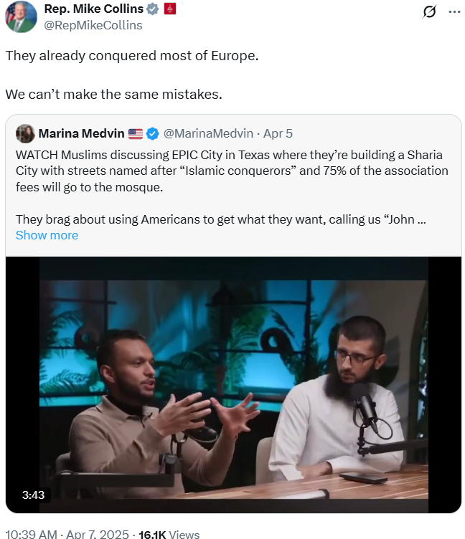

Collins Encouraged Silicon Valley Venture Capitalist Shaun Maguire’s Islamaphobic Attacks On Zohran Mamdani
Collins Told Maguire To “Pedal Down” In A Quote Tweet Of Maguire’s Post, Which Declared Maguire’s Plan To “Accelerate” As He Came Under Increased Scrutiny Following Islamaphobic Tirades Against Mamdani. Congressman Mike Collins tweeted, “Pedal down.” [Twitter, @RepMikeCollins, 7/9/25]
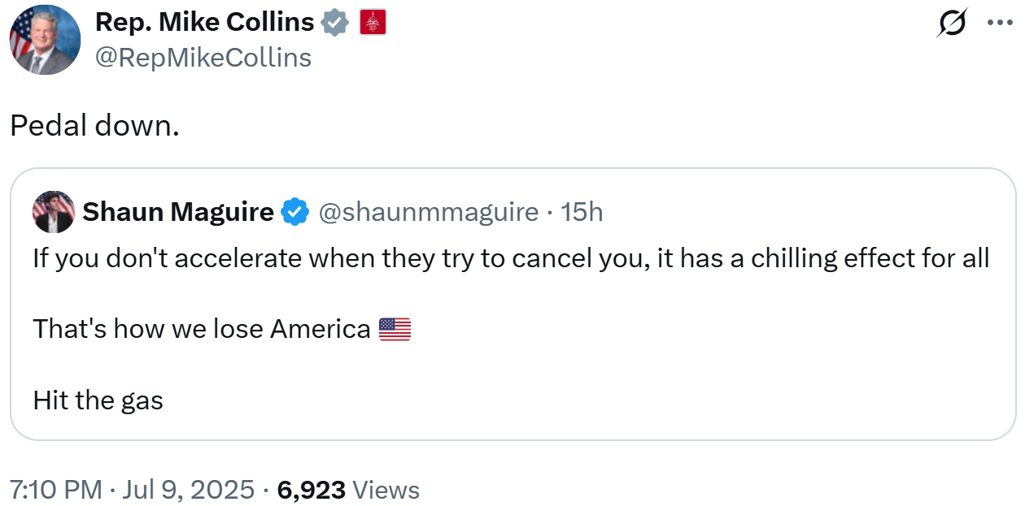
- [HEADLINE]: “Tech Founders Call On Sequoia Capital To Denounce VC Shaun Maguire’s Mamdani Comments.” [NBC News, 7/7/25]

Collins Claimed Afghani Migrants And “Islamists” Were “Incompatible With Western Civilization”
Collins Claimed That Afghani Migrants Were “Incompatible With Western Civilization, And No Amount Of Generosity Can Change That.” Congressman Mike Collins tweeted, “Some cultures are just incompatible with Western civilization, and no amount of generosity can change that.” [Twitter, @RepMikeCollins, 11/30/25]
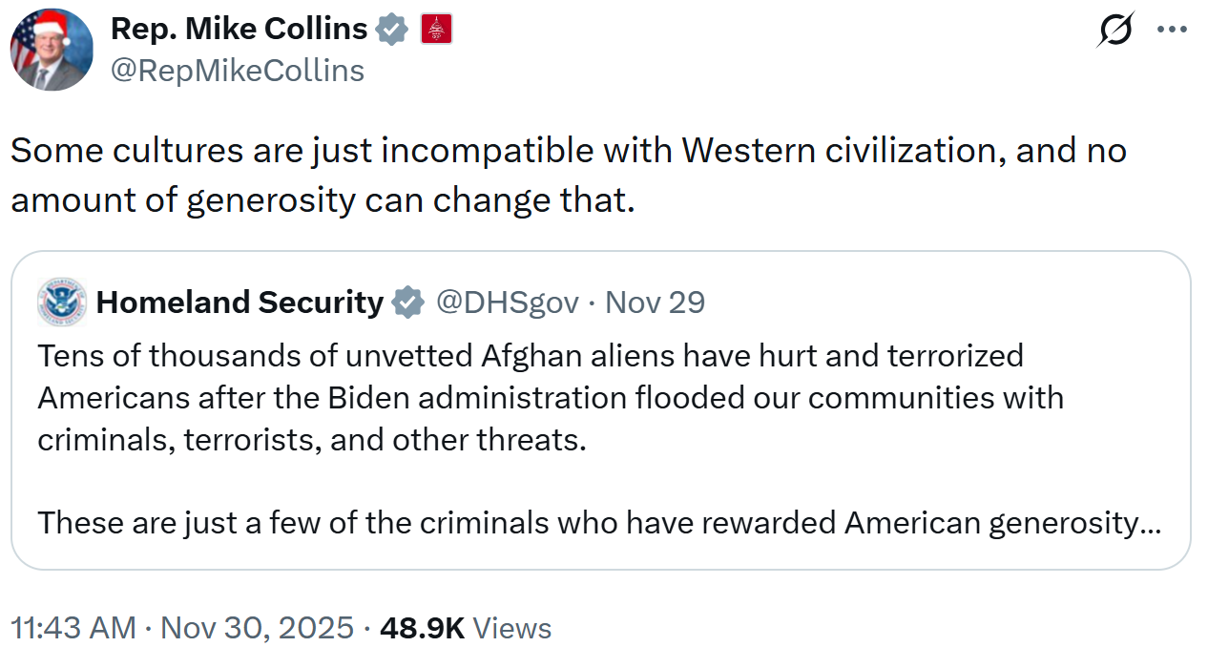
Collins Listed Recent Instances Of “Islamic Terror,” From “A Radical Pro-Palestinian Extremist Group” And “Islamic Terrorists” Worldwide, And Claimed That “Islamists” Were “Not Compatible With Western Culture, Its People, Or Its Traditions.” Congressman Mike Collins tweeted, “We are halfway through the month of December. So far, we’ve seen: The FBI foil a New Year’s Eve terror attack in Los Angeles by a radical pro-Palestinian extremist group. Paris cancel its New Year’s Eve celebration due to fears of Islamic terror. German police thwart a planned Islamic terror attack on a Christmas market. At least 15 people murdered by Islamic terrorists at a Hanukkah celebration in Australia. Islamists are not compatible with Western culture, its people, or its traditions. The proof is right in front of the world’s eyes.” [Twitter, @RepMikeCollins, 12/15/25]
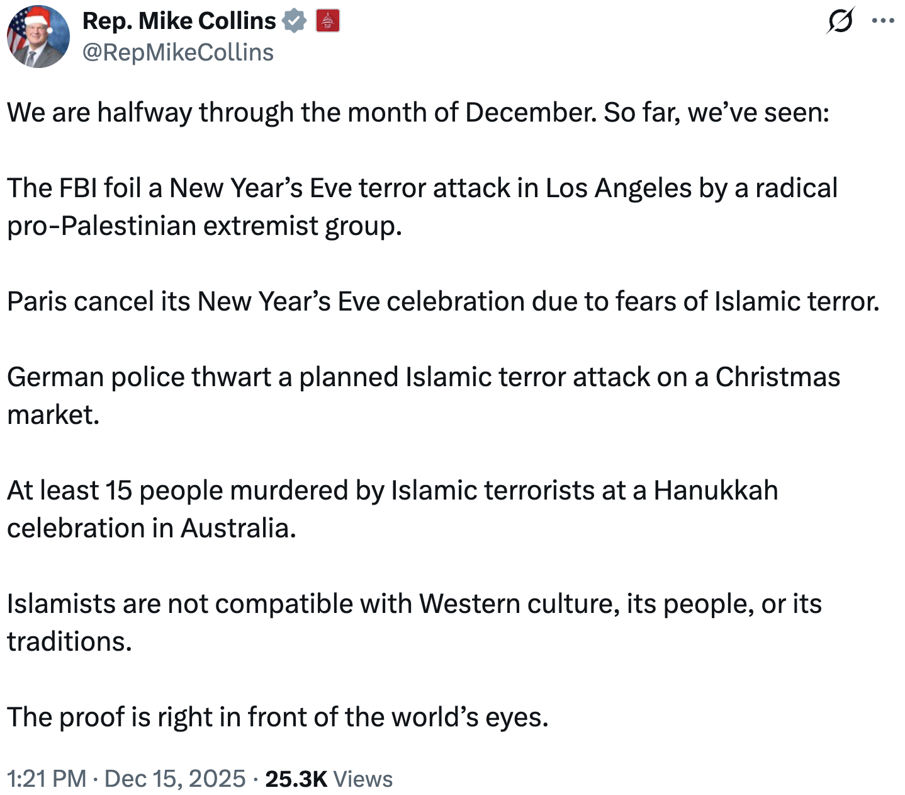

Collins Allegedly Propositioned His Masseuse For Sex

Collins Allegedly Propositioned A McDonough Area Masseuse For Sex And Was Subsequently Banned From The Massage Parlor

Collins, Allegedly, Gave His Masseuse “An Eerie Feeling” And Began “Grinding On The Table” Before He Attempted To Expose Himself
Collins Allegedly Propositioned A McDonough Area Masseuse For Sex And Was Subsequently Banned From The Massage Parlor. According to Valiant News, “Valiant News has obtained a recording in which a Georgia massage therapist accuses U.S. House candidate Mike Collins, a Republican, of propositioning her for a sexual act during a massage therapy appointment. The alleged incident took place in March of this year, roughly six months after Collins launched his current political campaign. Collins, through his lawyer, ultimately totally denied all of the allegations made in the recording 18 hours after Valiant News contacted the campaign for comment. It allegedly occurred at a McDonough area massage parlor, according to the recording, and ended when, according to the massage therapist, she told Collins that she does not perform sex work. She also claimed he was banned from the facility. Valiant News understands that the massage therapist later stopped performing services at that location, and that stakeholders for the massage parlor refused to confirm or deny that the incident occurred.” [Valiant News, 6/16/22]
- Collins, In His Second Massage Appointment, Gave His Masseuse “An Eerie Feeling” And Began “Grinding On The Table” Before He Attempted To Expose His Erect Penis. According to Valiant News, “Valiant News has established the provenance of the recording. According to the recording, it was Collins’ second appointment with the massage therapist. ‘I just had an eerie feeling about him,’ she said in the recording. ‘But I’m a professional, I do my job.’ At their second appointment, she alleges in the recording, Collins began ‘grinding on the table’ and ultimately attempted to expose his erect penis to the professional. ‘You don’t expose yourself on the table, like, you come to me for a reason,’ the massage therapist said in the recording. ‘If you have a massage therapy session, you come for a reason. You don’t begin to expose your body, the only thing you expose is the area that we touch.’ ‘This is not the place for that,’ said the woman while being recorded. ‘I’m a professional.’ The massage therapist claimed that, after grinding his penis against the table, Collins began to lower the white sheet used to cover his body toward his groin area.” [Valiant News, 6/16/22]
- The Masseuse Repeatedly Attempted To Stop Collins From Exposing Himself And Asked Him To Leave The Premises. According to Valiant News, “‘He began to, he took the sheet from up here, pushed it all the way down, just ready to expose his penis at that time,’ the massage therapist claimed in the recording. She claimed that she ‘stopped him a couple of times.’ ‘Unfortunately it happened, it is what it is. I don’t have anything to gain,’ she claimed at one point in the recording. Collins apparently apologized for the incident, according to the massage therapist, but she added that he was asked to leave the premises and told not to return. ‘No he can’t come back. He’s not welcome back,’ she said in the recording.” [Valiant News, 6/16/22]
Rumours Swirled For Months Surrounding Collins And The Massage Incident Before The Masseuse Came Forward To Confirm Its Occurrence. According to Valiant News, “Valiant News understands that at least three people deeply invested in Georgia politics, including an elected member of the Georgia legislature, heard rumors about this incident earlier this year but were unable to confirm whether it occurred. We spoke to one such individual via phone, who told Valiant News that they first learned of the rumor in April, but did not learn of the recording until this week. Another such individual who is prominent in Georgia politics confirmed hearing the rumor.” [Valiant News, 6/16/22]

Collins, Through His Attorney, Denied The Allegations
Collins, Through His Attorney, Denied The Allegations And Claimed That The Masseuse’s Recording Did Not Contain “A Scintilla Of Truth.” According to Valiant News, “The massage parlor where the alleged incident occurred did not return a phone call. Collins’ lawyer denied the claims made on the recording, telling Valiant News that the ‘allegations are false’ and the recording does not contain ‘a scintilla of truth.’” [Valiant News, 6/16/22]

But Collins Dodged Questions On The Incident
[AUDIO] Collins Ignored Questions From A Bird-Dogger Who Asked Whether He “Propositioned Women For Sex” At A Massage Parlor During His 2022 Campaign. “BIRD-DOGGER: Massage parlor. It's been reported in Valiant news. It was. It was four months ago. Mike is out here. Mike? It was four months ago. [STAFF: get the owner] Did you proposition a woman in a massage parlor four months ago. Four months ago. Come back on the campaign trail you propositioned a woman for sex and you won't admit to it. Are you denying it? It was Reported that you propositioned a massage therapist for sex. Are you going to deny these allegations? Why did you propositioned women for sex? Mike, this was done on the campaign trail. You went into a massage parlor. You exposed yourself to a woman involved in that. She's a professional. Why were you involved in this? Are you denying this, Mike? Are you going to deny these allegations? Wow.” [Mike Collins Birddogged, 11/14/25]

Collins Hired A Criminal GOP Operative As His Chief Of Staff

Brandon Phillips, Collins’ Chief Of Staff, Was A Corrupt Animal Abuser With Criminal Charges And A Violent Past
Mike Collins Hired “Serial Criminal” Brandon Phillips To Be His Chief Of Staff. According to the New Republic, “In noninfrastructure news, Collins also recently hired veteran Republican operative and serial criminal Brandon Phillips to be his chief of staff.” [New Republic, 3/8/23]

November 2025: The House Committee On Ethics Was Investigating Collins And Brandon Phillips On Unspecified Allegations
Collins And His Chief Of Staff Brandon Phillips Were The Subject Of An Unspecified And Anonymous October 7th Complaint; The Ethics Committee Needed More Time To Investigate. According to The Atlanta Journal-Constitution, “The committee on Friday said the case against Collins, a Republican candidate for U.S. Senate, and Brandon Phillips had been referred to its members on Oct. 7. In its brief release, the committee said it needed more time to consider the matter and would announce its course of action no later than Jan. 5. It was unclear what the matter involved. Before Friday’s extension notice, which was required by law, the complaint was not public. The committee could release a preliminary report as part of its upcoming announcement that contains details.” [Atlanta Journal-Constitution, 11/21/25]
The House Ethics Committee Received A Referral From The Office Of Congressional Conduct Regarding Collins; The Committee Planned To Announce Their “Plan Of Action” For Collins By January 5th. According to a press release from the House Committee on Ethics, “Pursuant to House Rule XI, clause 3(b)(8)(A), and Committee Rules 17A(b)(1)(A) and 17A(c)(1), the Committee on Ethics has extended the matter regarding Representative Mike Collins, which was transmitted to the Committee by the Office of Congressional Conduct on October 7, 2025. The Committee notes that the mere fact of a referral or an extension, and the mandatory disclosure of such an extension and the name of the subject of the matter, does not itself indicate that any violation has occurred, or reflect any judgment on behalf of the Committee. The Committee will announce its course of action in this matter on or before Monday, January 5, 2026.” [Press Release – House Committee On Ethics, 11/21/25]

July 2025: Brandon Phillips Hired His 26 Year-Old Girlfriend To A Paid Internship, Paid Himself The Maximum Salary, Fired Collins’ District Director When She Began To Ask Questions, And Used Official Funds For Personal Travel
Collins’ Chief Of Staff, Brandon Phillips, Hired His—Much Younger—Girlfriend, Caroline Craze, As An Intern In Collins’ District Office. According to the Daily Mail, “The top staffer to a Republican lawmaker running for Senate hired his girlfriend and made sure she was paid thousands, the Daily Mail has exclusively learned. Georgia Rep. Mike Collin's chief of staff, Brandon Phillips, 39, was hiring for an intern at the lawmaker's district office, and filled the position with girlfriend, Caroline Craze, 26.” [Daily Mail, 7/30/25]
- Former Collins Staffers Claimed That Craze “Rarely Showed Up For Work.” According to the Daily Mail, “Former Collins staffers revealed to the Daily Mail that Craze, despite getting paid thousands, rarely showed up for work.” [Daily Mail, 7/30/25]
- Craze Was Paid Over $10,000 For A Five Month Internship. According to the Daily Mail, “According to congressional salary tracker Legistorm, Craze was paid $5,044 for interning in the district for two months from November 4, 2023, until December 31, 2023. She was also paid $5,244 for interning in the district for three months between October 7, 2024, and December 5, 2024.” [Daily Mail, 7/30/25]
Collins’ District Director, Jessica Hayes, Asked Phillips About His Girlfriend’s Role And Salary, Hayes Was Fired Shortly Thereafter. According to the Daily Mail, “When Jessica Hayes, the former district director, asked Phillips about his girlfriend's role after being contacted by the office's financial department, she was let go shortly thereafter. ‘On the advice of counsel, I'm not in a position to discuss anything related to my former employment at this time,’ Hayes told the Daily Mail when reached for comment.” [Daily Mail, 7/30/25]
- Hayes “Had No Clue Who” Craze Was And A Former Collins Aide Claimed That Craze “Had Never Worked In The District Office And No One Even Knew Her Name. When Ms Hayes Discovered It Was The Chief Of Staff's Girlfriend, Ms Hayes Asked About It And Soon After Was Let Go.” According to the Daily Mail, “‘When Ms Hayes was contacted by the office's finance staffer asking her to confirm Caroline Craze's employment, Ms Hayes had no clue who that was,’ the former aide disclosed. ‘She had never worked in the district office and no one even knew her name. When Ms Hayes discovered it was the Chief of Staff's girlfriend, Ms Hayes asked about it and soon after was let go.’” [Daily Mail, 7/30/25]
- The Former Collins Aide Said, “The Nerve To Hire His Girlfriend, Which He Did, Is One Thing. But To Remove A Beloved District Director When She Began Asking Questions Is Beyond The Pale.” According to the Daily Mail, “‘The nerve to hire his girlfriend, which he did, is one thing. But to remove a beloved district director when she began asking questions is beyond the pale,’ a former Collins aide said to the Daily Mail.” [Daily Mail, 7/30/25]
The Former Collins Aide Claimed That Phillips Granted Himself The Maximum Salary For Chiefs Of Staff And Regularly Used Official Funds For He And His Girlfriend’s Travel Between DC And Georgia. According to the Daily Mail, “In addition to the staffing change, the aide who used to work in Collins' office told the Daily Mail that Phillips granted himself the max salary allowed for chiefs of staff and regularly used official funds for his and his girlfriend's travel to Washington, DC, and Georgia. The current max salary for chiefs of staff in the House of Representatives is $212,100 per year, a level which was voted on in 2021 under former Speaker Nancy Pelosi. Members of Congress make just $174,000 annually.” [Daily Mail, 7/30/25]
- The Former Collins Aide Claimed That “Adding His Girlfriend To Official Payroll And Using Official Funds To Shuttle Her Back And Forth From Atlanta Was A Slap In The Face” And Blamed “The Unhealthy Environment Brandon Fostered” In Collins’ Office For The “Revolving Door Of Staff.” According to the Daily Mail, “‘Adding his girlfriend to official payroll and using official funds to shuttle her back and forth from Atlanta was a slap in the face,’ the Collins aide said. ‘Brandon Phillips consistently engaged in unhinged behavior, often putting his desire for growing Collins twitter clout above Constituent service. Rep. Collins was often made aware that his office's revolving door of staff was due to the unhealthy environment Brandon fostered.’ Messages reviewed by the Daily Mail show that several former staffers were upset with how Phillips operated the lawmaker's office. ” [Daily Mail, 7/30/25]
Collins’ Office Denied Any Wrongdoing And Claimed They Were “One Of The Most Enjoyable And Sought After Offices On The Hill, Maintaining One Of The Lowest Turnover Rates For A Freshman Office.” According to the Daily Mail, “But Collins' office vehemently denied any wrongdoing. ‘Congressman Collins' office is one of the most enjoyable and sought after offices on the hill, maintaining one of the lowest turnover rates for a freshman office,’ a spokesperson told the Daily Mail.” [Daily Mail, 7/30/25]
- Collins’ Office Claimed The Allegations Were “Nothing More Than Two Disgruntled, Terminated Employees, Sore From Having Their Government Gravy Train Ride Come To An End And Want Revenge.” According to the Daily Mail, “‘These claims are nothing more than two disgruntled, terminated employees, sore from having their government gravy train ride come to an end and want revenge.’” [Daily Mail, 7/30/25]
- Collins’ Office Said Craze Was “An Excellent Team Member” And Denied Phillips Use Of Official Funds For Personal Travel, “Mr Phillips Is A Traveling Chief And Has Followed All Rules And Protocols When Using The MRA.” According to the Daily Mail, “‘Ms Craze was an excellent team member handling numerous tasks and assisting multiple other coworkers. No funds were ever used to shuttle Ms Craze back and forth as alleged and that claim is baseless.’ The spokesperson continued, adding that ‘Mr Phillips is a traveling chief and has followed all rules and protocols when using the MRA [congressional office funds].’” [Daily Mail, 7/30/25]

2204: Brandon Phillips Spit In A Trump Supporter’s Face During A Heated Altercation At A Trump Campaign Event
The Valdosta Police Reported That Brandon Phillips Spit In Sam Carnline’s Face At A Trump Campaign Event And Police Separated The Two Men Before The Brawl Escalated. According to The Atlanta Journal-Constitution, “According to the Valdosta Police Department report obtained by the AJC, one of the attendees who intervened was Brandon Phillips, a veteran Republican operative who is now the top aide to U.S. Rep. Mike Collins of Jackson. ‘Brandon Phillips got in the middle of the conversation because he didn’t like the questions he was asking,’ the police wrote of Carnline. ‘Words were exchanged between he and Brandon, because he was upset that Brandon spit in his face.’ [...] ‘I informed Brandon that he instigated the incident by spitting on Carnline,’ the officer wrote in the report. ‘Both parties agreed to separate and go their separate ways with no further law enforcement action needed.’” [Atlanta Journal-Constitution, 8/5/24]
- Phillips Inserted Himself Into An Argument Between GOP Activist Sam Carnline And State Rep. John LaHood; Phillips Confronted Carline And Began Insulting Carline’s Family Before He Spit In Carline’s Face. According to The Atlanta Journal-Constitution, “State Rep. John LaHood, R-Valdosta, told The Atlanta Journal-Constitution that after he finished speaking he went to mingle with the crowd when activist Sam Carnline of Cairo confronted him with his concerns that a series of election-related measures weren’t strong enough. [...] Carnline said in an interview that Phillips got in between him and LaHood and urged him to ‘quit bothering’ the lawmaker. When Carnline refused, he said Phillips started insulting his family. ‘I probably pointed at him and told him to get away from me. He immediately spit in my face. And at that point, I pushed him and shoved him as hard as I could,’ Carnline said. ‘He jumped back up. I cocked my fist back and was intending to hit him, but I might have just glanced his shoulder,’ Carnline said. ‘Then people talked me down. But he deserved it.’” [Atlanta Journal-Constitution, 8/5/24]
Phillips Claimed That He Escalated The Situation In An Attempt To Defend The Volunteers From “Outside Agitators.” According to The Atlanta Journal-Constitution, “Phillips told authorities he didn’t spit in Carnline’s face and that Carnline pushed him to the ground during the confrontation. LaHood and several other attendees said they saw Carnline punch Phillips at least twice. [...] Phillips told the AJC he intervened because he didn’t want the fight to escalate. ‘They say politics can be a contact sport, and sometimes it is,’ Phillips said. ‘I certainly don’t mind defending any volunteers or officials who are trying to contribute in a positive way toward a Trump victory from outside agitators with the opposite agenda.’” [Atlanta Journal-Constitution, 8/5/24]

2022: Brandon Phillips Was Arrested For Kicking A Dog With His Boot, Cutting The Animal’s Stomach
Brandon Phillips Was Arrested In November 2022 For Kicking A Dog With His Boot, Cutting The Animal’s Stomach. According to the New Republic, “Phillips was arrested in November 2022 for kicking a dog with his boot, cutting the animal’s stomach. He received one misdemeanor charge of animal cruelty and was held on a $1,200 bond, which he posted to get released.” [New Republic, 3/8/23]

2008: Brandon Phillips Attacked A Man, Slashed His Tires, Threw A Woman’s Laptop, And Pointed A Gun At Another Woman
In 2008, Phillips Attacked A Man, Slashed His Tires, Threw A Woman’s Laptop, And Pointed A Gun At Another Woman. According to the New Republic, “In 2016, Phillips resigned from the Trump campaign after more parts of his history were revealed. In 2008, Phillips attacked a man, slashed his tires, and threw a woman’s laptop. Phillips was said to have caused ‘visible bodily harm’ and ‘cuts and bruises to the head and torso’ of the male victim. He was arrested on charges of battery and felony criminal damage; before going to trial, Phillips pleaded guilty to lesser charges of criminal trespassing and battery. He was sentenced to three years of probation, 50 hours of community service, and a $1,567 fine, but Phillips got off with a year of probation after early release. That same year, Phillips allegedly pointed a gun at a woman. He was arrested on one charge of simple assault and battery, but the charges were dropped after Phillips completed pre-trial counseling.” [New Republic, 3/8/23]

