Overview
In 2025, Collins praised Trump’s “Department of Government Efficiency” as DOGE-driven cuts and downsizing were affecting the federal government’s ability to deliver services to seniors. More than 1.56 million Georgians relied on Social Security benefits and Collins stood by while DOGE closed five of Georgia’s local SSA offices. He downplayed DOGE’s federal layoffs and wanted federal workers to prove they were efficient while Trump fired over 2,300 CDC employees in Atlanta.
Collins sought to repeal clean energy incentives that created 10,000 jobs in his district and opposed bipartisan infrastructure investment with billions in funding for Georgia.

Collins Lauded DOGE While Elon Musk Shuttered Georgians’ Local Social Security Offices And Fired Over 2,300 Atlanta CDC Workers

Collins Praised DOGE
Collins Said “Whoever Came Up With DOGE” Was “A Genius” And Promised To “Get The 4th Branch Of Government–The Federal Bureaucracy–Under Control.” Congressman Mike Collins tweeted, “Whoever came up with @DOGE is a genius. We are going to get the 4th branch of government—the federal bureaucracy—under control. Good days ahead!” [Twitter, @MikeCollinsGA, 3/22/25]
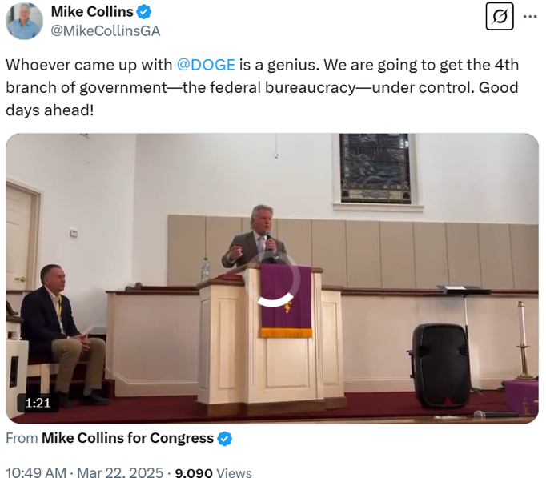
[AUDIO] Collins Thought DOGE Was “Definitely Making Some Headway On Waste, Fraud And Abuse.” “Well, let's let's do some recapping because I think it's it's pretty important. We've had we've had a great start to the 119th. I think you all would agree we're well on our way to the golden age of America. And we definitely started taking our country back and making it great again. So, a lot of exciting things are going on. Trump's winning in the courts. DOGE is definitely making some headway on waste, fraud and abuse.” [Right to the Point Podcast, 4/10/25]
[AUDIO] Collins Claimed That DOGE’s Cuts Were Easy To Codify And Lauded The Group For “Popping The Hood On These Federal Agencies And Saying, Hey, Guess What We Found Here.” “That's just one of the multi-prong approaches that that this administration is taking. that DOGE committee over there. What they're doing is they're just identifying what they see. They're just popping the hood on these federal agencies and saying, hey, guess what we found here? Guess what we found there? And then what the next step in this process is. The Trump administration will do a budget of rescissions on the budget for that agency. And then they'll just say, Hey, here, Congress, here's here's a memo stating we don't want that amount of money that we just found for whatever we're cutting, and then we just pull that back into the Treasury. And it's as simple as that. We'll vote on it. We won't have any problem voting on it.” [Mike Collins AFP Tele-Town Hall, 4/21/25]
[AUDIO] Collins Praised DOGE’s ‘What Did You Do This Week’ Emails And Mocked Federal Employees’ Anger With Elon Musk’s Demands; He Expected Good Federal Employees To Respond With “I Took A 13 Minute Lunch. I Didn't Go The Bathroom All Day.” “and that's where you're seeing the DOGE commission come in as well. You know, when you ask just for simple, tell me, tell me what you did this week, man. If I were if I were somebody I'd want, it may not be right now. Everything I did, I took a 13 minute lunch. I didn't go the bathroom all day. You know, show them that you're energetic, you want to be productive, and you're the best one in the agency. But yet what you saw a lot of was, you know, what do I have to do that? Do you think you asked me to do that? You know, And people say, well, you know, you almost got elected by anybody.” [Mike Collins AFP Tele-Town Hall, 4/21/25]

DOGE Cut CDC And Social Security Offices In Georgia

DOGE Closed Five Georgia Social Security Offices And Fired Over 2,300 Atlanta-Based CDC Employees
March 2025: DOGE Closed Five Social Security Offices In Georgia. According to ABC27, "Here’s the latest list of Social Security Administration offices that have been closed or are in the process of being closed by DOGE: Georgia - Brunswick, Columbus, Gainesville, Thomasville, Vidalia." [ABC27, 3/7/25]
May 2025: DOGE Fired Over 2,300 CDC Workers In Atlanta. According to State Affairs, “No federal agency in Georgia has felt the sting of firings more than the Atlanta-based Centers for Disease Control and Prevention (CDC), which has lost at least 2,300 employees since layoffs and buyouts began last month, according to a list provided by former workers.” [State Affairs, 5/2/25]

Collins Sought To Repeal Job-Creating Clean Energy Incentives

Mike Collins Sought To Repeal Clean Energy Incentives
Mike Collins Sought To Repeal Clean Energy Incentives. According to the Atlanta Journal Constitution, “Republicans used a congressional field hearing in suburban Atlanta to amplify the party’s call to roll back green energy tax incentives that were the centerpiece of President Joe Biden’s climate change law. The U.S. House Ways and Means Committee’s meeting Friday in Peachtree City was part of an intensifying effort by Republicans to blame Biden and other Democrats for sparking inflation with a spate of new federal spending measures since he took office in 2021. House Republicans are trying to leverage their power in Congress by pushing for a compromise to raise the debt ceiling if Democrats agree to repeal wide-ranging green energy incentives embedded in the Inflation Reduction Act that Biden signed last year. U.S. House Speaker Kevin McCarthy aims to pass a plan to wind down new solar power and electric-vehicle tax credits as early as next week, setting up a collision course with Democrats over raising the government’s borrowing cap to avert a financial catastrophe. Republican U.S. Rep. Mike Collins mocked the clean energy incentives at the hearing, saying they didn’t do anything to address the region’s traffic-choked interstate highways and ignored the growing threat that China poses to the U.S. economy. The GOP proposal, which spans more than 300 pages, was immediately rejected by the White House. Biden told union organizers in Maryland that it would ‘undo all the stuff you helped me get done’ over his first term.” [Atlanta Journal Constitution, 4/21/23]

Georgia Was The Top State For New Clean Energy Jobs, Including Nearly 10,000 In Mike Collins’ Own District
Georgia Was The Top State For New Clean Energy Jobs, Including Nearly 10,000 In Mike Collins’ Own District. According to Climate Power’s latest clean energy boom report, in less than two and a half years since the passage of the Inflation Reduction Act more than 400,000 new clean energy jobs and over $422 billion in investments across 48 states and Puerto Rico have been announced. Most of the clean energy projects and jobs are located in congressional districts represented by Republicans – 405 clean energy projects and 216,322 jobs, respectively. Of the top 10 states for new clean energy jobs, half have Republican governors welcoming the local investments. […] The top ten states for new clean energy jobs are Georgia, New York, Texas, Michigan, South Carolina, Nevada, Kansas, New Mexico, Arizona, and North Carolina. The top ten Republican districts for new clean energy jobs are: NV-02, represented by Rep. Mark Amodei, with 14,960 jobs GA-10, represented by Rep. Mike Collins, with 9,910 jobs” [Climate Power, 1/4/25]

Mike Collins Opposed Improving Georgia’s Infrastructure
Mike Collins Said The Infrastructure Bill Did “Nothing To Improve Real Transportation Infrastructure.” Mike Collins tweeted, “The Biden and Schumer infrastructure bill spends money we don't have, adds to our debt, raises taxes and the vast majority of it does NOTHING to improve real transportation infrastructure.” [Twitter, @MikeCollinsGA, 8/12/21]
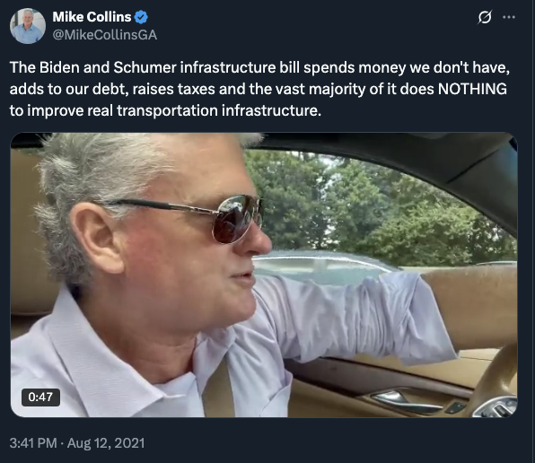
Mike Collins Said He Would Vote No On The Bipartisan Infrastructure Bill. Mike Collins tweeted, “As someone who makes a living on the roads and wants to see the best infrastructure possible I would still vote NO on this bill. It's a BAD bill. Republicans need to stand firm and reject the Biden and Schumer bribes. #infrastructure” [Twitter, @MikeCollinsGA, 7/29/21]
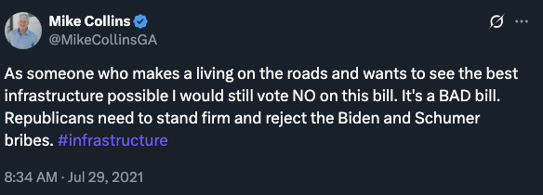

Bipartisan Infrastructure Bill Sent Billions To Georgia
Bipartisan Infrastructure Law Sent $8.9 Billion To Georgia For Roads And $255 Million For Bridges. According to the Atlanta Journal Constitution, “ROADS AND BRIDGES Minimum $8.9 billion for roads, $225 million for bridges Over 2,260 miles of highway across Georgia are categorized as in poor condition. The state also has 374 bridges that have been deemed ‘structurally deficient,’ including the I-75 span over Swamp Creek in Whitfield County that has over 66,000 daily crossings. The bill includes $8.9 billion for repairs to Georgia roads and highways, plus an additional $225 million for bridge replacement and repairs. Georgia can also compete for grants that could bring in additional dollars. ‘This monumental bill invests in one of the things families in the metro-Atlanta area need most: roads that make it quicker and safer to get to work,’ U.S. Rep. Lucy McBath, a Marietta Democrat, said in a statement. ‘We’ve made infrastructure one of our top priorities because it’s about safety, it’s about efficiency, and it’s about providing Americans with roadways and highways that connect them to their everyday lives.’” [Atlanta Journal Constitution, 11/12/21]
Bipartisan Infrastructure Law Sent $100 Million To Georgia To Increase Broadband Access. According to the Atlanta Journal Constitution, “BROADBAND Minimum $100 million Every state is receiving $100 million to increase broadband access, and billions more will be divided up among the states according to a formula that is based upon the number of people who don’t have reliable internet. The money is to be used to address both the lack of affordable internet options, which is usually a barrier in poorer neighborhoods, and the lack of connectivity, which affects rural areas. Georgia has both problems to address. The White House says 15% of Georgia households do not have an internet subscription, and 6% of Georgians live in areas where the Federal Communications Commission has determined broadband is not available.” [Atlanta Journal Constitution, 11/12/21]
Bipartisan Infrastructure Law Sent $1.4 Billion To Georgia For Public Transportation. According to the Atlanta Journal Constitution, “PUBLIC TRANSPORTATION $1.4 billion The bill includes nearly $1.4 billion over five years for public transportation in Georgia, including $923 million for metro Atlanta. MARTA CEO Jeffrey Parker said the additional money would have a big impact on the regional transit agency. Two projects that could benefit: proposed transit lines in Clayton County and along Campbellton Road in Atlanta. Voters in those communities have approved local funding for those and other projects, but Parker said federal funding would be crucial. ‘We’re not going to be successful if we can’t get federal funding,’ he said.” [Atlanta Journal Constitution, 11/12/21]
Bipartisan Infrastructure Law Sent $619 Million To Georgia For Repairs To Georgia Airports. According to the Atlanta Journal Constitution, “AIRPORTS $619 million The bill includes $619 million for repairs and upgrades at Georgia airports over five years. Georgia’s rural airports have millions of dollars of projects they would like to pursue with their share of the money. Airports Council International – North America said the projects to be funded by the infrastructure bill will increase capacity of airport terminals and runways while also improving the passenger experience. The airport lobbying group said critical needs at airports have ‘become even more pronounced during the COVID-19 pandemic.’ The Georgia Department of Transportation testified before a meeting of a state legislative joint study committee on airport infrastructure and improvements in September that it would need about $1.3 billion to fund recommended airport projects across the state. That amounts to about $411 million needed annually. With about $52 million in federal funding and $16 million in state funding available each year, there is an annual deficit of roughly $343 million.” [Atlanta Journal Constitution, 11/12/21]
Bipartisan Infrastructure Law Sent $8 Million To Georgia For Its Ports. According to the Atlanta Journal Constitution, “PORTS $8 million The Port of Savannah is getting $8 million to help convert five existing facilities into container yards, officials said Tuesday. The ‘pop-up yards’ will be used to lessen congestion on the docks at the port, an on-shore bottleneck in the supply chain leading from Asian factories to the manufacturers and retailers in America. That congestion — recently more than 80,000 containers were stacked at the Port of Savannah — slows deliveries and raises costs. Getting many of the containers inland by rail and truck will bring them closer to their destinations while freeing space at the port. Savannah, the second-largest port on the East Coast, has added nearly 400 workers in the past year, expanding its workforce to about 1,520. The Georgia Ports Authority also has other massive projects underway that will add to the port’s overall capacity.” [Atlanta Journal Constitution, 11/12/21]

