Overview
In 2025, Collins voted for a bill that is estimated to kick 17 million Americans off their health insurance, including nearly 12 million Americans who rely on Medicaid. Collins promised that “every single American will benefit” from the bill: more than 500,000 Georgians could lose their health insurance as a result of Collins’ vote.
Collins mocked the Affordable Care Act’s enhanced premium subsidies as a “failed program” and “short-term bandaid;” he opposed their extension. An estimated 460,000 Georgians could lose their health insurance without the subsidies Collins belittled and Georgians expected their health care premiums to more than double.
Collins wanted to fully repeal the Affordable Care Act, endangering over 1.8 million Georgians' health care, and “raise the retirement age” and Medicare eligibility to 67 under Paul Ryan’s health care disaster.

Collins Opposed Access To Affordable Health Care

Collins Voted For The “One Big Beautiful Bill,” Which Included Devastating Health Care Cuts To Fund Tax Cuts For The Wealthy

July 2025: Collins Voted For The Final Version Of The “One Big Beautiful Bill,” Which Would Cause 17 Million Americans To Lose Their Health Care
July 2025: Collins Voted For The Senate FY 2025 Budget Reconciliation Bill, The “One Big Beautiful Bill,” Which Extended $4 Trillion In Expiring Tax Cuts, Added New Tax Breaks, Appropriated $448 Million In Defense, Border, And Immigration Enforcement Funding, Increased The SALT Deduction To $40,000, And Cut Medicaid And Other Social Programs To Offset The Costs. In July 2025, Collins voted for, according to Congressional Quarterly, the “motion to concur in the Senate amendment to the bill that would permanently extend nearly $4 trillion in expiring individual and business tax cuts, create several new tax breaks and fund border and immigration enforcement and air traffic control upgrades. It would cut Medicaid and other safety net programs to partly offset the cost. Among other provisions, it would raise the statutory debt ceiling by $5 trillion and appropriate more than $448 billion in mandatory funding for Trump administration priorities and other needs, including $153 billion for defense, $89 billion for immigration enforcement, and $89.5 billion for border control and security. It also would increase the state and local tax deduction cap to $40,000 annually for five years for households making up to $500,000 a year until 2030, when it would permanently revert to $10,000.” The House passed the bill by a vote of 218 to 214. The bill was ultimately signed into law. [House Vote 190, 7/3/25; Congressional Quarterly, 7/3/25; Congressional Actions, H.R. 1]
- HEADLINE: "At Least 17 Million Americans Would Lose Insurance Under Trump Plan" [Washington Post, 7/1/25]
- HEADLINE: “By The Numbers: Harmful Republican Megabill Favors The Wealthy And Leaves Millions Of Working Families Behind” [Center On Budget And Policy Priorities, 8/1/25]
- The Congressional Budget Office Estimated That 11.8 Million People Would Become Uninsured As A Result Of The Medicaid Cuts In Republicans’ Reconciliation Bill. According to the Washington Post, "The bill, which narrowly passed the Senate on Tuesday and now heads back to the House, would effectively accomplish what Republicans have long failed to do: unwind many of the key components of the ACA, President Barack Obama’s signature domestic achievement, which dramatically increased the number of Americans with access to health insurance. To start, the Congressional Budget Office estimated that the Senate version of the bill would result in 11.8 million more uninsured in 2034, mostly because of Medicaid cuts, compared with 10.9 million if the House version became law." [Washington Post, 7/1/25]
- The Bill’s $50 Billion In Rural Hospital Relief Funding Would Not Come Close To The Gap Created By Medicaid Cuts, With 300 Rural Hospital At “Immediate Risk” Of Closure. According to the Center For American Progress, “The OBBBA includes $50 billion in relief funding for rural hospitals over a five-year period to help reduce the disastrous impacts of the bill’s roughly $1 trillion in Medicaid cuts. As of May 2025, there were approximately 2,086 rural hospitals receiving $12.2 billion a year in net revenue from Medicaid. At the median, rural hospitals’ revenue from Medicaid is $3.9 million a year.Rural hospitals have some of the lowest operating margins in the nation, especially compared with urban hospitals, meaning that any reductions in revenue could lead to closures. The average operating margin for rural hospitals was 3.1 percent in 2023, with 44 percent of rural hospitals operating with negative margins. As a result, more than 300 rural hospitals are currently at ‘immediate risk’ of closure, especially now that the OBBBA is projected to cut Medicaid spending by $1.02 trillion. The relief fund designed to blunt the negative impacts caused by the bill would not come close to filling that gap. If every rural hospital in the country received an even share of the $50 billion in relief support, it would amount to only $4.5 million every year for five years. At the close of those five years, that funding would disappear altogether.” [Center For American Progress, 7/3/25]

Collins Claimed That “Every Single American” Benefitted From The “Big Beautiful Bill”
Collins: “Every Single American Will Benefit From The Lower Taxes And Increased National Security In The One Big, Beautiful Bill.” Congressman Mike Collins tweeted, “Every single American will benefit from the lower taxes and increased national security in the One Big, Beautiful Bill. We’re not backing down from helping the American people.” [Twitter, @RepMikeCollins, 6/5/25]
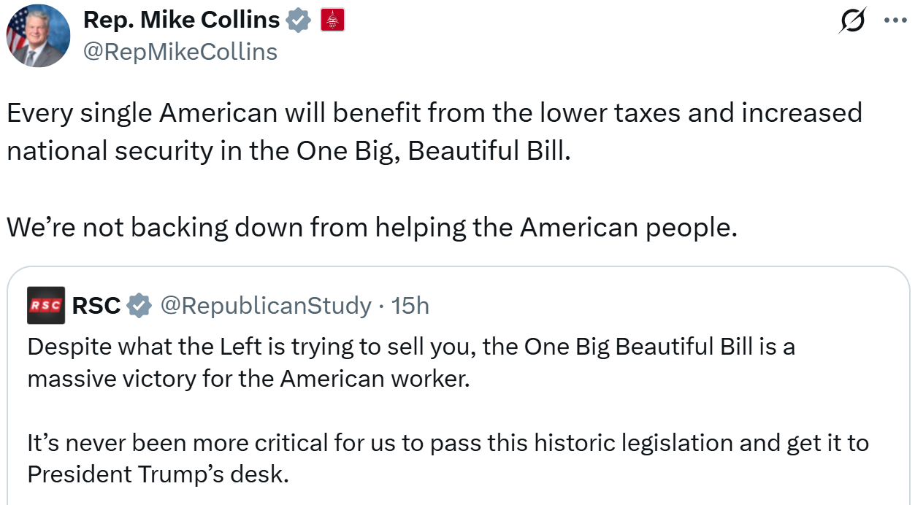
[VIDEO] Collins Claimed The Bill Was “A Good Piece Of Legislation That Will Help Get This Economy Spurred And Get It Going Again” But Admitted That “Sure, We Need To Make More Cuts.” “Sure, we need to make more cuts, and we're going to do that. We're going to make sure that those DOGE findings are codified and we get these executive orders that President Trump has signed off on and we get those codified and put into law. But in the meantime, this one big beautiful bill that President Trump has signed off on is a good piece of legislation that will help get this economy spurred and get it going again.” [NewsmaxTV2, 6/3/25]

The “Big Beautiful Bill” Ripped Health Care Away From 500,000 Georgians
500,000 Georgians Expected To Lose Their Health Care By 2034 Under The Big Beautiful Bill. According to KFF, “An Additional 14.2M People Nationwide Could be Uninsured in 2034 Due To The Budget Reconciliation Package and Expiration of the ACA Enhanced Tax Credits [...] About half (49%) of the 14.2 million more people who would be uninsured in this scenario live in California (1.7M), Florida (1.5M), Texas (1.4M), New York (860k), Illinois (520k), Georgia (500k) and Ohio (460k). The largest growth in ACA Marketplace enrollment since 2020, the year before the enhanced premium tax credits became available, occurred in 3 of these states: Texas (2.8M), Florida (2.8M), and Georgia (1.0M).” [KFF, 8/20/25]

The “Big Beautiful Bill” Endangered Rural Hospitals
Georgia Rural Hospitals Expected To Lose $540 Million In Funding Over The Next Ten Years Under The Big Beautiful Bill. According to The Atlanta Journal-Constitution, “President Donald Trump’s spending bill’s cuts to government-subsidized health insurance could send struggling rural Georgia hospitals into distress or bankruptcy, according to research released by its critics. A study commissioned by the American Hospital Association found that Georgia rural hospitals could lose $540 million over the 10 years of the bill’s run. Another by the Sheps Center at the University of North Carolina, based on the version of the bill that passed the House in May, listed hundreds of U.S. hospitals “at risk” of closing services or shutting down altogether in the face of Medicaid and other health cuts, including four in Georgia. The Senate is considering deeper cuts.” [Atlanta Journal-Constitution, 6/20/25]

The “Big Beautiful Bill” Increased Georgians Electricity Bills
The Big Beautiful Bill Raised Georgia Electric Rates By $270 Over The Next Ten Years. According to CNBC, “Here’s how much more households in every state could pay annually, on average, by 2035, due to changes in energy policies under the ‘big beautiful’ bill, according to Energy Innovation’s research. [...] Georgia: $270” [CNBC, 7/14/25]

The “Big Beautiful Bill” Ripped SNAP Away From Georgians
1.4 Million Georgians Received SNAP Benefits And It Was Estimated That “Hundreds Of Thousands of Georgians” Would Lose Their Nutrition Assistance Under The Big Beautiful Bill. According to Fox 5 Atlanta, “With 1.4 million Georgians receiving SNAP benefits, it is estimated that hundreds of thousands of Georgians will lose their primary way of buying food. The Atlanta Community Food Bank, which supplies hundreds of food pantries in the state, says that would harm a lot of families. [Fox 5 Atlanta, 7/3/25]

Collins Opposed The Affordable Care Act’s Enhanced Premium Subsidies

Collins Decried Affordable Care Act Subsidies And Opposed A Three-Year Extension

Collins Called For “Meaningful Reforms To Health Care That Increase Competition And Drive Down Premiums, Not More Subsidies For A Failed Program”
Collins Called For “Meaningful Reforms To Health Care That Increase Competition And Drive Down Premiums, Not More Subsidies For A Failed Program.” According to The Atlanta Journal-Constitution, “Both Collins, R-Jackson, and Clyde, R-Athens, said the subsidies are not the answer. ‘We need meaningful reforms to health care that increase competition and drive down premiums, not more subsidies for a failed program,’ Collins said.” [Atlanta Journal-Constitution, 11/1/25]
[AUDIO] Collins Downplayed The Expiring ACA Subsidies And Claimed That “The Solution Out There” To The Affordable Care Act Was “To Get The Federal Government Out Of Your Health Care.” “HOST: If the subsidies expire, which right now they will, what is your response to people who are concerned about the cost of their health coverage going up? COLLINS: Well, I think once again, you got to remember, the subsidies are not going away. It's the enhanced subsidies that are going away, not the subsidies. But there are plenty of plans that have been out there. As a matter of fact, Jon Ossoff voted against one of the plans out there to make sure that we put $50 million out there to rural hospitals. So we did that in a big, beautiful bill. So we understand that the Affordable Care Act is not affordable at all. But right now, while we have that opportunity. Let's have that discussion. Now, I understand people do fall into a bad situation where we're a very generous and giving country and we take care of our people. But that's not going to solve the solution. The solution out there is to get the federal government out of your health care, to give you more choices to make sure that insurance companies are not their their their profits and their stock rises in 1,000% since Affordable Care went into the act.” [Politically Georgia, 11/24/25]
Collins Called For “Meaningful Reforms To Health Care That Increase Competition And Drive Down Premiums, Not Endless Subsidies To The Largest Insurance Companies On The Globe.” According to The Atlanta Journal-Constitution, “Senate Minority Leader Chuck Schumer, D-N.Y., said his caucus is united behind a plan to pass a three-year extension of the subsidies, which were first approved in 2021 during the coronavirus pandemic. The vote is part of an agreement Senate Majority Leader John Thune, R-S.D., struck with eight Senate Democrats in exchange for their votes to end the federal government shutdown last month, which lasted a record 43 days. But the legislation is doomed. Many Republican senators argue the pandemic-era subsidies were always meant to be temporary. Thune said the Democratic proposal was ‘designed to fail.’ U.S. Rep. Mike Collins of Jackson —one of Ossoff’s top Republican rivals —supports Thune’s stance. ‘We need meaningful reforms to health care that increase competition and drive down premiums, not endless subsidies to the largest insurance companies on the globe,’ the Jackson Republican said.” [Atlanta Journal-Constitution, 12/8/25]

Collins Called An Extension On The Subsidies A “Short-Term Band-Aid”
Collins Claimed That “Obamacare Has Failed, And We Need To Open The Government So We Can Find A Permanent Solution, Not Another Short Term Band-Aid.” According to The Atlanta Journal-Constitution, “‘Obamacare has failed, and we need to open the government so we can find a permanent solution, not another short term band-aid.’” [Atlanta Journal-Constitution, 12/8/25]

Georgians’ Health Care Costs Would Skyrocket Without The ACA’s Premium Subsidies

Georgians’ ACA Insurance Premiums Were Set To More Than Double When The Subsidies Expired
The Georgia Health Initiative Found That Without Enhanced Subsidies Premiums In Georgia Will More Than Double, From An Average Of $69 Per Month To $148 Per Month. According to Rough Draft Atlanta, “At issue are tax credits that lowered the cost of ACA plans that are set to expire Dec. 31. The credits were enacted as part of a Covid relief package in 2021. Unless Congress takes action to extend the credits, premiums for Georgians will, on average, more than double, a recent Georgia Health Initiative analysis found. [...] The exact amount of the rate increases will vary based on several factors, but on average, premiums in Georgia will more than double, from an average of $69 per month this year to $148 per month in 2026, according to the GHI report.” [Rough Draft Atlanta, 12/12/25]

Georgians Planned To Drop Their Health Insurance Or Forego Care Without Their Premium Subsidies
[HEADLINE]: “Georgia Loses 190,000 Enrollees In First Steps Of 2026 ACA Enrollment.” [Atlanta Journal-Constitution, 12/18/25]
460,000 Georgians Planned To Drop Their ACA Health Insurance Over Increased Costs Without The Enhanced Premium Subsidies. According to The Atlanta Journal-Constitution, “But the most recent estimate from the health research organization KFF is that about 460,000 Georgians will drop ACA health insurance. That’s a result of two things: new barriers passed in President Donald Trump’s One Big Beautiful Bill Act, such as shortening the enrollment window, curtailing auto-enrollment, and adding paperwork and fees; and by far the biggest part of the projected loss, the expiration of the enhanced subsidies.” [Atlanta Journal-Constitution, 9/29/25]
Georgia’s Hospitals, Doctors, And Other Health Businesses Expected To Lose $3.7 Billion In Revenue After Georgians Forego Health Care Without The Enhanced Premium Subsidies. According to The Atlanta Journal-Constitution, “Georgia’s hospitals, doctors and other health businesses stand to lose $3.7 billion in revenue next year alone, if Congress and President Donald Trump allow Affordable Care Act health insurance subsidies to expire in December, a new forecast has found. [...] Without insurance, many of those people will skip doctor visits, medications, tests and other health care that they would otherwise have received. And other patients, especially in emergencies, will seek health care but not be able to pay for it.” [Atlanta Journal-Constitution, 9/29/25]

Collins Wanted To Fully Repeal The Affordable Care Act

Collins Called For A Repeal Of The Affordable Care Act
Collins Called For A Repeal Of The Affordable Care Act. According to the Mike Collins plan, “The cost and uncertainty that Obamacare has forced on small businesses is crippling job creation. If the bill is fully implemented, it will wreak havoc in the healthcare industry, reduce levels of care, and put government bureaucrats between patients and their doctors. We need to replace Obamacare with solutions that work such as eliminating individual state mandates and allow for consumers to purchase plans across state lines. Passing federal tort reform and encouraging more Health Savings Accounts will also reduce the cost of healthcare. Ronald Reagan would warn us when government says, ‘I'm here to help,’ we should proceed with caution. Obamacare was pushed down the throats of the American people and we were told to sit down, be quite, and take it. That's not who I am. I will stand and do everything in my power to get this burden off the backs of American businesses.” [Mike Collins Plan – Overhaul DC, 2014]
Mike Collins Said “I Want To Repeal” The Affordable Care Act. Mike Collins tweeted, “ Goodmorning! Obamacare is just as bad today as it was yesterday and I want to repeal it today just as bad as I did yesterday. #overhaulDC” [Twitter, @MikeCollinsGA, 12/11/13]
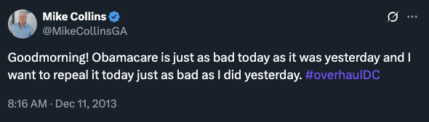

Collins Blamed The Affordable Care Act For Rising Health Care Premiums
Collins Claimed The ACA Was “A Massive Wealth Transfer System That Takes Money From American Taxpayers And Gives It To Insurance Companies,” Which He Blamed For Skyrocketing Premiums. Congressman Mike Collins tweeted, “Exactly. QRT: ‘If you are wondering why health insurance has gotten so expensive, this is why. The Democrats set up a massive wealth transfer system that takes money from American taxpayers and gives it to insurance companies. And everybody’s premiums have skyrocketed in the interim.’” [Twitter, @RepMikeCollins, 11/8/25]
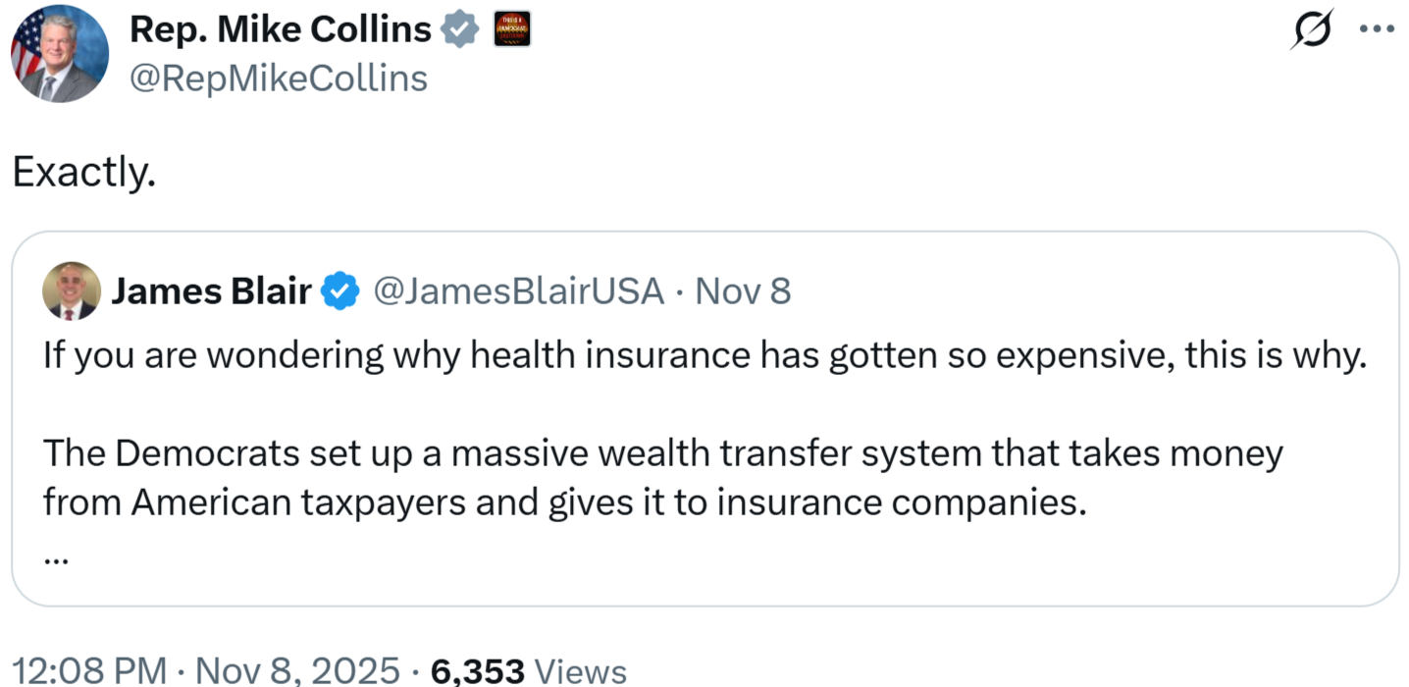

Repealing The Affordable Care Act Would Jeopardize 1.8 Million Georgians With Pre-Existing Conditions
Repealing The Affordable Care Act Would Remove Protections For Individuals With Pre-Existing Conditions. According to the Center On Budget And Policy Priorities, “Many Republicans have supported maintaining the ACA’s existing ban on excluding pre-existing conditions from coverage. But as discussed above, even if this protection remains, ACA repeal would undermine it, letting insurers accomplish much the same thing by failing to cover important benefits that people with pre-existing conditions need.” [Center On Budget And Policy Priorities, 10/5/20]
In Georgia, 1,805,000 Non-Elderly Adults Had Pre-Existing Conditions. [Kaiser Family Foundation, 10/4/19]

Collins Was Bad For Georgia Seniors And Their Health Care

Collins Supported Raising The Retirement Age For Social Security
Mike Collins Called To “Raise The Retirement Age.” According to the Mike Collins plan, “Current Social Security funding is unsustainable. We must reform the program to ensure that workers who have paid their fair share are able to depend on it. We should institute Rand Paul, Jim Demint, and Mike Lee's proposal to gradually raise the retirement age consistent with life expectancy levels and make benefits consistent with need. We also need to encourage individual saving and those who want to work past their full benefit age by giving tax incentives, not taxing their income. Social Security is a program millions of our retired workers count on, we must reform it to both control spending and ensure its continued viability. Saving and strengthening Social Security will bolster our nation's future for growth, providing stability to the market and helping to spur investment and job growth.” [Mike Collins Plan – Overhaul DC, 2014]

Collins Supported Voucherizing Medicare

Collins Supported Paul Ryan’s Health Care Plan
Mike Collins Said The Ryan Budget Was A “Step In The Right Direction.” Mike Collins tweeted, “@RepPaulRyan budget is step in right direction w/ repeal of both Medicaid expansion and numerous tax increases. #overhauldc #gapol” [Twitter, @MikeCollinsGA, 4/7/14]
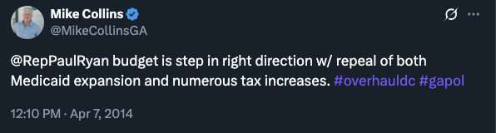
Mike Collins Supported The Paul Ryan Path To Prosperity. According to the Mike Collins plan, “Our national debt is out of control, and broken entitlements are the largest portion of a broken federal budget. Under President Obama, federal debt has grown by over $4 trillion. Obama has dumped more debt on the American people than any other President in history. I would push for a budget similar to Paul Ryan's Path to Prosperity which would reduce the size of government to 20% of the economy by 2015 and would cut spending by $5 trillion. This would encourage the American private sector to grow and create jobs.” [Mike Collins Plan – Overhaul DC, 2014]

The Ryan Plan Would Voucherize Medicare And Raise The Age Of Eligibility From 65 To 67
Ryan Plan Would Voucherize Medicare And Raise The Age Of Eligibility From 65 To 67. According to the Center On Budge And Policy Priorities, “The Medicare proposals in the 2015 budget resolution from House Budget Committee Chairman Paul Ryan (R-WI) are much the same as those in Ryan’s previous budgets. Once again, Chairman Ryan proposes to replace Medicare’s guarantee of health coverage with a premium-support voucher and raise the age of eligibility for Medicare from 65 to 67. Together, these changes would shift costs to Medicare beneficiaries and (with the simultaneous repeal of health reform) leave many 65- and 66-year-olds without health coverage.” [Center On Budge And Policy Priorities, 4/8/14]

