Overview
Collins praised Trump’s trade wars and told Americans to “trust the process” and deal with the fallout from Trump’s tariffs. He minimized Georgians economic suffering and claimed that “blue collar people” do not “participate in the stock market.” Tariffs slammed Georgians with increased housing costs and grocery bills.

Collins Was A Cheerleader For Trump’s Tariffs

Mike Collins Praised Trump’s Trade War
[AUDIO] Mike Collins Thought The World Was Dependent On The United States, Which Provided Trump With Leverage; He Proclaimed Himself “Free Trade” And “Free Market All Day Long” But Demanded That Things “Be Fair.” “You know, there's a reason that President Trump is hitting these tariffs as hard as he is. He is these countries depend on the United States of America. I don't care what they tell you. They want to be selling to the United States of America. But we don't have a fair trade system. I'm a big believer. I'm free trade. I'm a free market all day long. But it's got to be fair, whether it's for our farmers who are getting pummeled by Mexico, which is pushing produce over here, subsidizing Canada, doing the same thing with lumber they subsidize is China subsidizes everything because China, the CCP, owns everything. They can sell it from us. They could pay you to take it. Their whole goal is to break you. But those tariffs will fix that.” [Mike Collins AFP Tele-Town Hall 4/21/25]
Mike Collins Claimed That Everything Was “According To Plan” And Urged Americans To “Trust The Process” And “Trust The President.” Congressman Mike Collins tweeted, “All according to plan. Trust the process, trust the president.” [Twitter, @RepMikeCollins, 4/14/25]
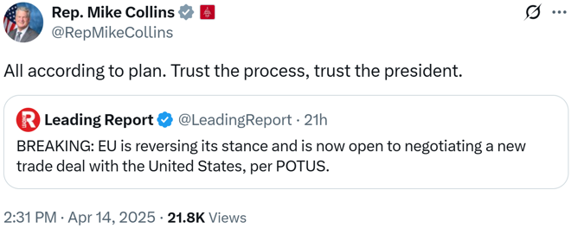
Mike Collins Bemoaned America’s Existing Trade Policy And Claimed Trump Was “Fixing That Imbalance.” Congressman Mike Collins tweeted, “Trump understands that America has done a lot of things well. Trade isn't one of them. He's fixing that imbalance.” [Twitter, @MikeCollinsGA, 4/9/25]
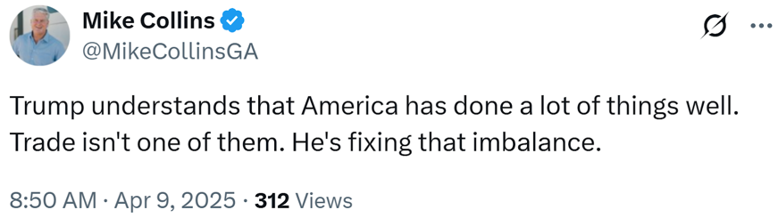

Mike Collins Downplayed The Impacts Of Trump’s Tariffs
[AUDIO] Mike Collins Said That “Them Blue Collar People” Do Not “Participate In The Stock Market” Which Meant The Market Crash Was Meaningless To Them; He Wanted Trade “To Be Fair Both Ways” And Promised That “This Place Will Hum Like A Sewing Machine Like It Did During The First Trump Administration” Thanks To Tariffs. “COLLINS: Trump has stepped out of the box and said, look, we we don't mind, we love free market out here, but it's got to be fair, and it's got to be fair both ways. And so, these countries that have been putting tariffs on us and keeping us from importing products into their country, those days are over with. And, you know, as far as that stock market is concerned, Brian, I would I would bet you and guarantee you 50% of America out there doesn't participate in the stock market. Them blue collar people. And Wall Street has had their day in the sun and in the limelight. It's time to let Main Street folks get their day. That's why those union workers are so happy with GM decided, you know what, we're going to produce more pickups in the United States of America. But it's not just a one prong approach with tariffs. There's a separate side of this. And that's one of the reasons that I came to Congress, and that is to get the regulations off the backs of the American small businesses. You get regulations more business friendly. You get taxes off the backs of these entrepreneurs out there. And, Brian, I guarantee you this place will hum like a sewing machine like it did during the first Trump administration. HOST: I will say that between 60 and 70% of the American public has either 401k or a pension involved in the stock market, whether you're a teacher or a firefighter. COLLINS: They do, but they're not trading daily. They're not looking at today. They're looking at the end of their career. HOST: Well, let's hope let's hope their careers not today.” [Brian Kilmeade Show, 4/7/25]
[AUDIO] Mike Collins: “I Wouldn't Bet Against President Trump. He's A Successful Businessman. He's Been He Knows How To Compete. He Knows How To Win. And I–He's Not Up There Trying To Kill The American Worker. He's Trying To Help These Folks That Need Help Across This Country.” “I tell you what, Brian, I wouldn't I wouldn't bet against President Trump. He's a successful businessman. He's been he knows how to compete. He knows how to win. And I–he's not up there trying to kill the American worker. He's trying to help these folks that need help across this country, then beat the best with inflation, taxes and regulations for their entire lives.” [Brian Kilmeade Show, 4/7/25]
[AUDIO] Mike Collins Claimed That Exporting Countries “Will Eat A Lot Of That Tariff” If Industry Leaders Are “Good Businesspeople.” “I can understand that. I'm a small businessman myself. I'm in the trucking business. But just because my tires go up or the cost of my equipment goes up, then if I've got contract rates that are set, I don't just run to my customer and raise my rates. My rates are set. Now, if they're good businesspeople, which I'm sure Ford is, I'm sure they've negotiated these prices coming from these other countries. Those those people will eat a lot of that tariff, that’s about to hit them, and they won't pass it on to their customer.” [Brian Kilmeade Show, 4/7/25]

Mike Collins Had “100% Confidence” In Trump’s Tariff Plans
[VIDEO] Mike Collins Said That Trump Believed “In Free Trade And Free Marketplace” And Bemoaned The “Excess Regulation And Overtaxation” That He Blamed For The “Business And Corporations Left Our Shores In The First Place.” “HOST: An announcement on tariffs, Liberation Day by the White House. What are your expectations there? Are you confident in the president and his plan? COLLINS: Oh, absolutely. I have absolutely 100% confidence that this administration knows what they're doing. So does 74 million people in this country. That's why he got the mandate. People understood that we we believe in free trade and free marketplace. But it has got to be fair in fair trade. You're going to couple these tariffs and you're going to turn around. You're going to see President Trump and this, this administration and Congress get regulations off the backs of businesses in this country. That's one of the reasons that business and corporations left our shores in the first place, this excess regulation and overtaxation. We're going to take care of those two things as well as get a level playing field for what's happening when we export goods out there. You're going to see this economy turn and it's going to get cranked up.” [NewsmaxTV: National Report, 4/2/25]

Trump’s Tariffs Put Georgia’s Economy At Risk

Georgia Businesses Braced For “Higher Costs, Tighter Margins, And Increased Uncertainty” Under Trump’s Tariffs
Georgia Businesses Braced For “Higher Costs, Tighter Margins, And Increased Uncertainty” Under Trump’s Tariffs. According to Fox 5 Atlanta, “While the Trump administration argues that long-term gains in domestic investment will outweigh short-term disruption, the outcome will depend heavily on how global trade partners respond–and how quickly new deals, if any, are created. For now, businesses across Georgia are bracing for potentially higher costs, tighter margins, and increased uncertainty” [Fox 5 Atlanta, 4/8/25]

