Overview
- Mike Collins promoted the false claim that the 2020 presidential election was stolen, stating that Donald Trump won Georgia and claiming there was fraud and irregularities in the election.
- Mike Collins supported January 6 insurrectionists, speaking at a Justice for J6 rally and referring to them as “political prisoners.”
- Mike Collins described January 6 as “peaceful” and supported Donald Trump's intention to pardon defendants involved in the Capitol riots.

Mike Collins Was An Election Denier And January 6 Supporter

Mike Collins Promoted Election Denialism
Mike Collins Promoted The Big Lie That The 2020 Election Was Stolen. According to Bloomberg, “Even a candidate like Mike Collins, who has fewer followers and is running for Congress in Georgia, has been able to use the idea of a stolen election to boost his presence on Facebook. Collins has just shy of 7,000 followers on the social network. Given his audience size, his posts did not collect as much engagement as some of his other heavyweight Republican peers. Still, Collins’s posts about the Big Lie did more than six times better than his average posts. Collins did not respond to a request for comment.” [Bloomberg, 11/3/22]
Mike Collins Claimed That Democrats “Stole The 2020 Election” And That “Donald Trump Won Georgia.” Mike Collins tweeted, “Newsflash: Joe Biden and the Democrats stole the 2020 election. Donald Trump won Georgia. Send me to Washington, and I’ll blow up the Democrats’ cover up.” [Twitter, @MikeCollinsGA, 1/13/22]
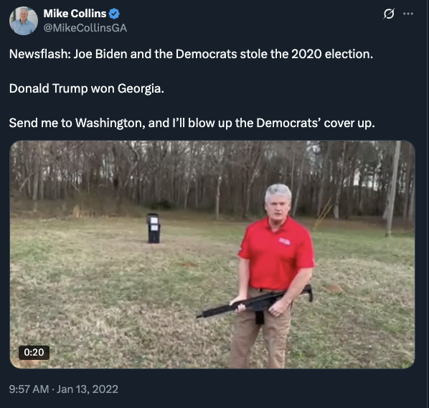
Mike Collins Said There Was Fraud And Irregularities In The 2020 Election. Mike Collins tweeted, “Anyone who thinks there was no fraud or irregularities in the 2020 election is the April Fool.” [Twitter, @MikeCollinsGA, 4/1/22]
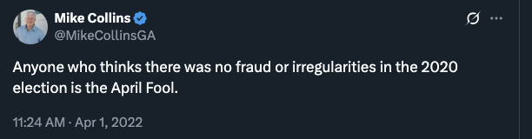

Mike Collins Supported January 6 Insurrectionists
Mike Collins Spoke At A Justice For J6 Rally. According to the Atlanta Journal Constitution, “ One of your Insiders spoke with Georgia congressional candidate Mike Collins ahead of his keynote speech Saturday at a Washington rally in support of those imprisoned and charged with crimes related to the Jan. 6 riot at the Capitol. More than 600 people have been charged for crimes-- from assaulting police officers to conspiracy, theft, destruction of government property, and resisting arrest. More than 60 have pleaded guilty. Collins, a candidate for the Republican nomination in Georgia’s 10th Congressional district, said he wasn’t familiar with the particulars of what occurred on Jan. 6. He said he wasn’t coming to Washington to defend rioters, but the Constitution. ‘These people deserve their day in court; everybody deserves their day in court,’ he said. ‘And I’m going up there to say to these people need their day in court, and it’s time for it to happen.’” [Atlanta Journal Constitution, 9/17/21]
Mike Collins Said Insurrectionists Were “Political Prisoners.” According to Newsweek, “ We have political prisoners,’ Collins said. ‘And the media, the left's biggest ally, want you to believe that it's just a conspiracy theory, but the facts are clear. Non-violent, misdemeanor offenders are currently being held without bond, without access to lawyers and sometimes in solitary confinement with some not slated to see trial until next year.’” [Newsweek, 9/18/21]
Mike Collins Said “Release All J6 Political Prisoners Now.” According to Newsweek, “Republican Congressman Mike Collins has called for the release of those arrested in connection with the January 6 attack after Fox News' Tucker Carlson aired new footage from the riots at the U.S. Capitol in 2021. Collins, who represents Georgia's 10th congressional district, said in a tweet on Monday: ‘I've seen enough. Release all J6 political prisoners now.’ The tweet was sent as Carlson played clips of the Capitol attack—handed over to him by House Majority Leader Kevin McCarthy—during his primetime show.” [Newsweek, 3/7/23]
Mike Collins Said January 6 Was “Peaceful” And Supported Trump Pardoning Insurrectionists. Mike Collins tweeted, “On #ThisDayInHistory in 2021, thousands of peaceful grandmothers gathered in Washington, D.C., to take a self-guided, albeit unauthorized, tour of the U.S. Capitol building. Earlier that day, President Trump held a rally, where supporters walked to the Capitol to peacefully protest the certification of the 2020 election. During this time, some individuals entered the Capitol, took photos, and explored the building before leaving. Since then, hundreds of peaceful protestors have been hunted down, arrested, held in solitary confinement, and treated unjustly. Countless hours and taxpayer dollars have been spent pursuing innocent grandmothers and raiding President Trump’s home, while terrorists and millions of illegal immigrants continue to cross our nation’s borders, causing havoc in our communities. Thankfully, President Trump has announced that, on day one of his presidency, he will grant pardons to nonviolent defendants.” [Twitter, @RepMikeCollins, 1/6/25]
