Overview
Mike Collins was an out-of-touch anti-abortion extremist, who opposed abortion acccess, even in cases of rape, incest, and life of the mother, and celebrated the downfall of Roe v. Wade.
Collins endorsed Georgia’s extreme ‘heartbeat bill’ to ban abortions after six weeks of pregnancy and twice cosponsored the Life at Conception Act–which sought to ban abortions nationwide and jeopardized access to IVF.

Collins Opposed Abortion With No Exceptions

Collins Opposed Abortion, Even In Cases Of Rape, Incest, And Life Of The Mother
Collins Opposed Abortion With No Exceptions. According to the Associated Press, “Under questioning in the debates sponsored by the Atlanta Press Club, McCormick, Evans, Collins and Jones all declared that they wanted a ban on abortion that had no exceptions. McCormick called himself the ‘100% life doctor.’ He said after the debate that he could foresee no circumstances in which a viable fetus would threaten the life of the mother, saying he did not favor that as an exception. McCormick said women could abort a nonviable fetus in examples such as an ectopic pregnancy.” [Associated Press, 6/6/22]
Collins Opposed Abortion, Even In Cases Of Rape, Incest, And Life Of The Mother. [Georgia Life Alliance Questionnaire, 2022]
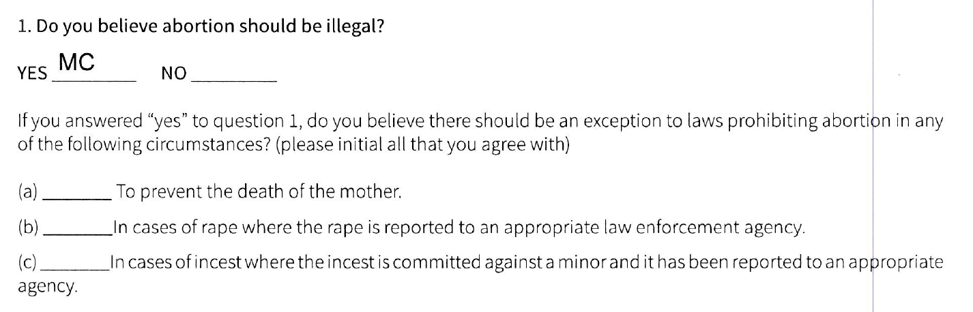

Mike Collins Supported Georgia’s Fetal Heartbeat Bill

Collins Supported Georgia’s Fetal Heartbeat Bill Banning Abortion After Six Weeks
Mike Collins Supported Georgia’s Fetal Heartbeat Bill Banning Abortion After Six Weeks. [Georgia Life Alliance Questionnaire, 2022]
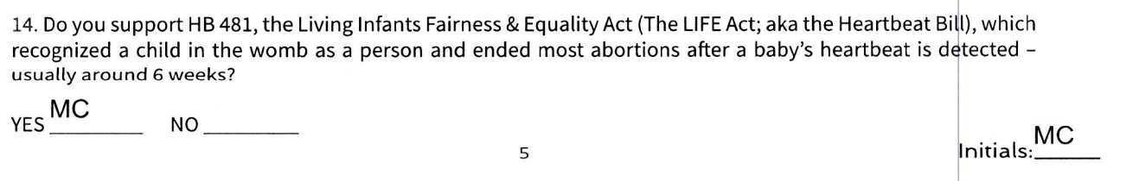
Mike Collins Supported Georgia’s Heartbeat Bill. According to the Associated Press, “Under attack by Collins for voting against a Georgia bill that bans abortion after fetal heart activity can be detected, Jones continued to take the position that he voted against the bill while serving as a Democrat in the state House because it allowed some early term abortions. ‘Life starts at conception, not at six weeks,’ Jones said. Collins was dismissive of Jones, saying no one should trust him. ‘This is just obvious,’ Collins said. ‘Vernon Jones is a con man.’” [Associated Press, 6/6/22]

Georgia’s Heartbeat Law Banned Abortions After Six Weeks Of Pregnancy
Georgia’s Heartbeat Law Banned Abortions After Six Weeks Of Pregnancy. According to NPR, “The Georgia Supreme Court Wednesday reinstated the state's ban on abortions after roughly six weeks of pregnancy, abruptly ending access to later abortions that had resumed days earlier. In a one-page order, the justices put a lower court ruling overturning the ban on hold while they consider an appeal. Abortion providers who had resumed performing the procedure past six weeks again had to stop. Attorneys and advocates who pushed to overturn the ban said the abrupt halt will traumatize women who must now arrange travel to other states for an abortion or keep their pregnancies.” [NPR, 11/23/22]

Mike Collins Co-Sponsored Legislation To Ban Abortion And Outlaw IVF

Mike Collins Twice Co-Sponsored The Life At Conception Act
2023: Mike Collins Co-Sponsored The Life At Conception Act. [Congress.gov – H.R. 431, 1/20/23]
2025: Mike Collins Co-Sponsored The Life At Conception Act. [Congress.gov – H.R. 722, 1/24/25]
Mike Collins Said He Was “Proud To Support The Life At Conception Act.” Mike Collins tweeted, “Sadly, radical politicians across the country are calling for abortion on demand up to the moment of birth. That’s wrong, and we must act to save unborn children. That’s why I am proud to support the Life at Conception Act, which guarantees the right to life for all human beings.” [Twitter, @RepMikeCollins, 1/30/23]
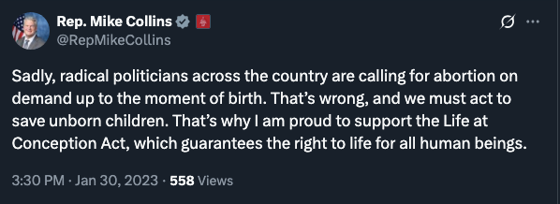

Life At Conception Act Would Ban Nearly All Abortions Nationwide And Jeopardizes Access To IVF Treatments
Life At Conception Act Would Ban Nearly All Abortions Nationwide And Jeopardizes Access To IVF Treatments. According to the Washington Post, “The congressional proposal, known as the Life at Conception Act, defines a ‘human being’ to ‘include each member of the species homo sapiens at all stages of life, including the moment of fertilization or cloning, or other moment at which an individual member of the human species comes into being.’ The bill would also provide equal protection under the 14th Amendment ‘for the right to life of each born and preborn human person.’ The measure has no provisions for processes like IVF, meaning access to the procedure would not be protected. It would ban nearly all abortions nationwide. The legislation is co-sponsored by 125 Republicans in the House, including Speaker Mike Johnson (R-La.), who, in the wake of the Alabama ruling, said in a statement to The Washington Post that he supports efforts to allow IVF treatments because he believes ‘the life of every single child has inestimable dignity and value.’” [Washington Post, 2/25/24]

Mike Collins Touted The Overturn Of Roe v. Wade

Collins Called For, And Later Celebrated, The Overturn Of Roe v. Wade
Collins Called For The Overturn Of Roe v. Wade. Mike Collins tweeted, “ Spending my morning with fellow Georgians at First Baptist Church Woodstock to pray for life. Pray for our nation to choose policy that protects the unborn. It's time to overturn Roe v. Wade.” [Twitter, @MikeCollinsGA, 12/1/21]
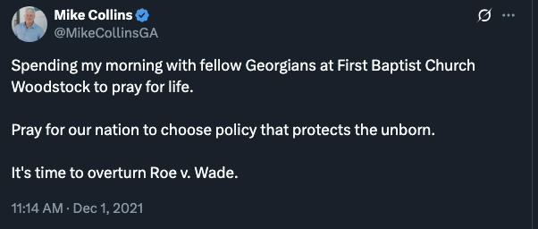
Mike Collins Touted The Overturn Of Roe v. Wade. Mike Collins tweeted, “One year ago today, the Supreme Court overturned Roe v. Wade, leading to countless lives being saved and bringing us one step closer to ending abortion in America. #ChooseLife” [Twitter, @RepMikeCollins, 6/24/23]
