Overview
Miller-Meeks faced an ethics complaint over where her primary address was actually located.
- Following redistricting, in 2022, Miller-Meeks changed her voter registration from her known home in Ottumwa to Le Claire which was in the 1st congressional district. The address belonged to Republican State Senator Chris Cournoyer. She used that address to vote in the 2022 general election.
- Leading up to the 2024 election, Miller-Meeks changed her voter registration to an apartment in Davenport. The Davenport apartment building was partially managed by a group affiliated with David Barker, who served on the Iowa Board of Regents and had donated $52,900 in support of Miller-Meeks’ campaigns throughout the years. Barker claimed he was unaware Miller-Meeks was living there.
- It was reported that Miller-Meeks used her Ottumwa address on official government forms. In October 2024 it was also reported that she collected a homestead tax credit at that home during the previous two tax periods. She also reported on her 2023 and 2024 personal financial disclosures that she owed a mortgage on a personal residence in Ottumwa.
- Iowa state law required voters to register to vote at their primary address and vote in the county where they primarily resided. Bleeding Heartland reported that Miller-Meeks’ actions could have put her at risk for election misconduct or perjury, which were both Class ‘D’ felonies in Iowa.

2024: Miller-Meeks Faced An Ethics Complaint Over Accusations That She Was Voting From An Address That Was Not Her Primary Residence

Miller-Meeks Changed Her Voter Registration To Addresses That Weren’t Believed To Be Her Primary Residence
January 2021: Miller-Meeks Posted A Photo Of Herself Voting In Wapello County.
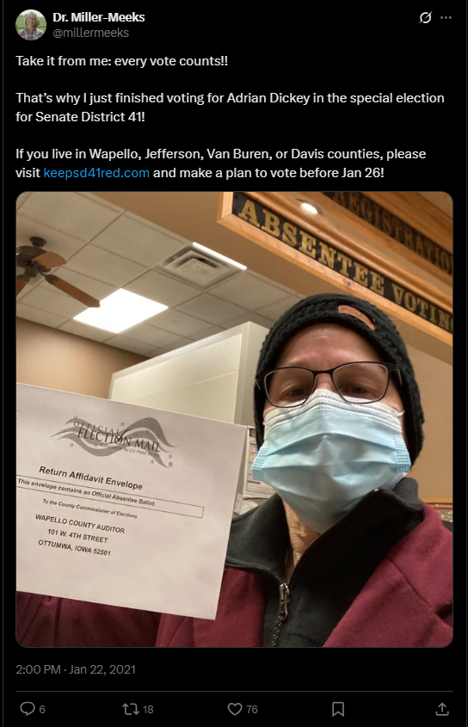
[Twitter, @millermeeks, 1/22/21]
October 2022: Miller-Meeks Changed Her Voter Registration To An Address In Scott County, IA. According to the Des Moines Register, “But she has not been registered to vote there since 2022. In October 2022, Scott County voting records show Miller-Meeks changed her voter registration from her Ottumwa address to the address of state Sen. Chris Cournoyer, a LeClaire Republican. Cournoyer’s home is on Great River Road in Scott County in the 1st District. Miller-Meeks voted in the 2022 general election in Scott County.” [Des Moines Register, 10/22/24]
- The Address In Scott County Miller-Meeks Used To Vote From In 2022 Was The Home Of State Sen. Chris Cournoyer. According to the Des Moines Register, According to the Des Moines Register, “But she has not been registered to vote there since 2022. In October 2022, Scott County voting records show Miller-Meeks changed her voter registration from her Ottumwa address to the address of state Sen. Chris Cournoyer, a LeClaire Republican. Cournoyer’s home is on Great River Road in Scott County in the 1st District. Miller-Meeks voted in the 2022 general election in Scott County.” [Des Moines Register, 10/22/24]
Prior To The June 2024 Election, Miller-Meeks Changed Her Voter Registration To An Apartment In Davenport, Iowa And Voted In The Primary. According to the Des Moines Register, “Before this year’s June 4 primary election, records show she changed her voter registration address to an apartment on Jersey Ridge Road in Davenport and voted in the primary. The apartment is part of Indian Ridge Apartments, a complex managed by Barker Apartments. Iowa Board of Regents member David Barker is a partner in Barker Financial, which owns and manages apartments around eastern Iowa, including the one Miller-Meeks lists as her residence, The Gazette first reported. He also is treasurer for the Republican Party of Iowa and has donated $52,900 to Miller-Meeks’ campaign and her various campaign arms since 2020, FEC filings show.” [Des Moines Register, 10/22/24]
- After More Than 20 Years Of Living In Ottumwa, Miller-Meeks Adjusted Her Address To Be In Le Claire, Then Davenport. According to KCRG, “For more than 20 years, Miller-Meeks and her husband Curtis have lived at their home in Ottumwa. In 2022, Miller-Meeks changed the address of her voter registration to the home of a State Sen. Chris Cournoyer in Le Claire. Now, she claims the address of an apartment in Davenport.” [KCRG, 9/24/24]

Miller-Meeks’ Davenport Apartment Complex Was Partially Owned By A Group Affiliated With A Prominent Campaign Donor
Miller-Meeks’ Davenport Apartment Was Part Of The Indian Ridge Apartment Homes Complex, Which Was Partially Managed By Baker Apartments. According to the Gazette, “The Davenport apartment that Iowa Republican U.S. Rep. Mariannette Miller-Meeks claims as her voting address — and which is the subject of a congressional ethics complaint — is partially owned by a prominent campaign contributor and member of the Iowa Board of Regents. Miller-Meeks, who has a home in Ottumwa outside of the district she represents, lists a Davenport apartment on Jersey Ridge Road as her primary residence on her voter registration and affidavit of candidacy filed with the Iowa Secretary State. The apartment is part of a large complex called Indian Ridge Apartment Homes managed by Barker Apartments. Regent David Barker is part of the group that owns the complex.” [Gazette, 10/16/24]
- David Barker, A Member Of The Iowa Board Of Regents, Was Part Of The Group That Owned The Indian Ridge Apartment Homes. was part According to the Gazette, “The Davenport apartment that Iowa Republican U.S. Rep. Mariannette Miller-Meeks claims as her voting address — and which is the subject of a congressional ethics complaint — is partially owned by a prominent campaign contributor and member of the Iowa Board of Regents. Miller-Meeks, who has a home in Ottumwa outside of the district she represents, lists a Davenport apartment on Jersey Ridge Road as her primary residence on her voter registration and affidavit of candidacy filed with the Iowa Secretary State. The apartment is part of a large complex called Indian Ridge Apartment Homes managed by Barker Apartments. Regent David Barker is part of the group that owns the complex.” [Gazette, 10/16/24]
Barker Has Donated $52,900 To Support Miller-Meeks’ Campaigns. According to the Gazette, “Federal Election Commission filings show sizable campaign contributions by Barker to Miller-Meeks’ campaign, joint fundraising committee and leadership PAC. In total, Barker has contributed $52,900 to her various fundraising arms since 2020, FEC filings show. He also has donated to other Republican campaigns in and outside of Iowa. In June, he contributed $6,600 to Miller-Meeks’ 2024 re-election campaign, the maximum allowed by individual donors per candidate per election cycle. Federal contribution limits allow individual donors to give up to $3,300 per candidate between the primary and general elections — or up to $9,900 total if a race leads to a runoff.” [Gazette, 10/16/24]
- Barker Claimed He Was Unaware Miller-Meeks Was Living In An Apartment Complex He Partially Owned. According to Gazette, “Barker, speaking Monday to The Gazette by phone, said he is not involved in the day-to-day operations at Indian Ridge Apartments and was unaware the Republican incumbent was living there. He said the company in past years has rented to staffers from various campaigns.” [Gazette, 10/16/24]

Miller-Meeks Was Drawn Into A new Congressional District After 2020 Redistricting And Said She Would Take Up A New Residence In The New District, But Would Not Sell Her Ottumwa Home
After 2020 Redistricting, Miller-Meeks Home Was Drawn Into A Different Congressional District After Which She Said She Would Take Up Residence In The 1st Congressional District, But Would Not Sell Her Property In The New 3rd Congressional District. According to the Des Moines Register, “Miller-Meeks, who is seeking a third term representing southeast Iowa’s 1st Congressional District, said during an Iowa PBS debate that she has apartments in Davenport and Washington, D.C., and a property in Wapello County. When Iowa redrew its congressional districts after the 2020 census, Miller-Meeks’ Ottumwa home in Wapello County became part of south-central Iowa’s 3rd District. She said then that she would not sell her house in Ottumwa but would take up residence in the redrawn 1st District, but she wouldn’t give up her existing land. ‘In Iowa, land is valuable and we hold onto it, so I have a property there,’ Miller-Meeks said.” [Des Moines Register, 10/22/24]

Miller-Meeks Used Her Ottumwa Address On Important Political Forms And Collected A Homestead Tax Credit On The Property
HEADLINE: “Ethics Complaint Alleges Rep. Miller-Meeks Voting In Davenport Despite Living In Ottumwa” [KCRG, 9/24/24]
Miller-Meeks Used Her Ottumwa Address For Her Federal Election Commission Statement Of Candidacy, The 2024 Iowa Secretary Of State Candidate List, And A December 2023 Political Donation. According to KCRG, “Despite claiming a Scott County address for the past two years, Miller-Meeks continues to use her Ottumwa address for some things. It’s on her Federal Election Commission Statement of Candidacy form for this election. An Ottumwa P.O. Box is listed as her address on the Iowa Secretary of State’s 2024 candidate list. She also donated to a Virginia congressional candidate in December and used an Ottumwa address.” [KCRG, 9/24/24]
October 2024: Des Moines Register Reported Miller-Meeks And Her Husband Received A Homestead Tax Credit For Their Ottumwa Residence During The Previous Two Tax Periods. According to the Des Moines Register, “Federal law requires members of Congress live in the state they represent, but they don’t have to live in the district. But Iowa law defines a voter’s residence as ‘the place which the person declares is the person’s home with the intent to remain there permanently or for a definite, or indefinite, or indeterminable length of time.’ Property tax records list Miller-Meeks and her husband owning 33 acres in Ottumwa. They received a homestead credit for the property in the last two tax periods, the latest property tax statement shows.” [Des Moines Register, 10/22/24]
Miller-Meeks Reported A Mortgage On A “Personal Residence In Ottumwa” On Her 2023 Personal Financial Disclosure. According to the Des Moines Register, “Miller-Meeks also reported a mortgage on her ‘personal residence in Ottumwa’ in the 2023 congressional disclosure report. Miller-Meeks also lists Ottumwa as her address on campaign forms filed with the Federal Election Commission.” [Des Moines Register, 10/22/24]
2024: Miller-Meeks Reported That She Owed A Mortgage Worth Between $100,001 And $250,000 On A Personal Residence In Ottumwa, IA.
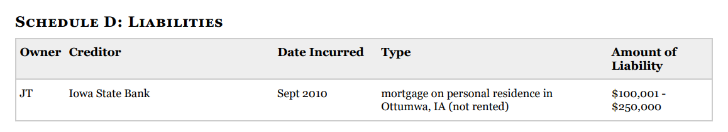
[Clerk of the U.S. House of Representatives, Personal Financial Disclosure, Rep. Mariannette Miller-Meeks, Filed 5/11/25]

Miller-Meeks May Have Committed A Class “D” Felony In Iowa
Bleeding Heartland Reported That Miller-Meeks’ Address Change Raised “Legitimate Questions About Whether She Committed Election Misconduct Or Perjury, Which Are Both Class ‘D’ Felonies In Iowa.” According to the Bleeding Heartland, “In contrast, the circumstances surrounding Miller-Meeks’ address change raise legitimate questions about whether she committed election misconduct or perjury, which are both class ‘D’ felonies in Iowa.” [Bleeding Heartland, 12/16/22]
- Iowa State Law Required Voters To Register To Vote At Their Primary Address And Vote In The County Where They Primarily Resided. According to the Gazette, “Federal rules don’t require members of Congress to live in the district they represent, just in the same state. Iowa law, though, requires voters to register to vote at their primary address and vote in the county where they primarily reside.” [Gazette, 10/16/24]

