Overview
Miller-Meeks defended the “Department of Government Efficiency,” even joining the congressional DOGE caucus. She suggested federal government changes were only “a little bit of disruption” even though DOGE-driven cuts and downsizing were affecting the federal government’s ability to deliver services to seniors. More than 178,000 Iowans in Miller-Meeks’ district relied on Social Security benefits.
Miller-Meeks defended the Trump administration’s cuts even though they proposed cuts to National Institutes of Health (NIH) funding that could be devastating the research conducted by the University of Iowa – research that Miller-Meeks has repeatedly touted in the past. NIH funding supported thousands of jobs and hundreds of businesses in Iowa.

Miller-Meeks Supported DOGE, Which Weakened Iowa Medical Research, And The Social Security Administration

Miller-Meeks Joined The Department Of Government Efficiency Caucus In Congress And Said She Would Work Closely With DOGE
Miller-Meeks Said She Would Work Closely With DOGE. According to an op-ed from Rep. Mariannette Miller-Meeks in the Southeast Iowa Union, “The DOGE Caucus, in partnership with President Trump’s Department of Government Efficiency, seeks to curb this reckless spending and improve the effectiveness of our federal agencies. Led by Elon Musk, we will work closely with them to bring fresh perspectives and real solutions to the table. With their leadership and expertise in business efficiency, we are well-positioned to tackle the long-standing issues within the federal bureaucracy.” [Mariannette Miller-Meeks Op-Ed – Southeast Iowa Union, 1/28/25]
1/13/25: Miller-Meeks Announced She Joined The Department Of Government Efficiency Caucus. According to KCCI Des Moines, “Today, Congresswoman Mariannette Miller-Meeks announced she has joined the bipartisan DOGE Caucus in the U.S. House of Representatives. The Bipartisan House DOGE Caucus will lead the partnership between Congress and President Trump’s Department of Government Efficiency (DOGE). The nation expects sweeping common-sense reform, and the DOGE Caucus will pave the way for the House of Representatives to streamline government operations and to save taxpayer money. ‘I am thrilled to join the House DOGE caucus to tackle ongoing waste, abuse, and fraud in the federal bureaucracy,’ said Miller-Meeks. ‘Everyday Iowans are living paycheck to paycheck and know the value of every dollar. Meanwhile, unelected bureaucrats in Washington are freely spending taxpayer money.’” [KCCI Des Moines, 1/13/25]

Miller-Meeks Said The DOGE Plan Was Working And Dismissed Mass Federal Layoffs, Calling Them “A Little Bit Of Disruption”
February 2025: Miller-Meeks Claimed DOGE’s Plan Was Working. According to an interview with Mariannette Miller-Meeks on Fox Friends First, “MODERATOR: Is the DOGE plan working? MILLER-MEEKS: Well, I would think so.” [Fox News, Fox Friends First, 2/10/25] 00:02:08
4/14/25: Miller-Meeks Said Despite “A Little Bit Of Disruption,” The Federal Government Was On “The Right Path.” According to Radio Iowa, “Iowa Congresswoman Mariannette Miller-Meeks says while there’s been ‘a little bit of disruption’ in the federal government this year, the Trump Administration and Republicans in congress are on ‘the right path.’ ‘You know you’re over the target when they’re in your district and they are protesting and they’re doing fake town halls and they’re sending money in,’ Miller-Meeks said this weekend. ‘…You know you’re going where God wants you to go and we’re going to keep going and keep charging until David slays another Goliath and that is the behemoth of the federal government that is taking away our rights and liberties.’” [Radio Iowa, 4/14/25]
- HEADLINE: “Federal Layoffs Create Uncertainty For Local Head Start Programs” [KWQC, 4/8/25]
- HEADLINE: “Federal Layoffs Cause Chaos And Confusion Among Iowans” [Daily Iowan, 4/1/25]
- HEADLINE: “Federal Layoffs, Frozen Funding Threatens Program Helping 6M Americans Pay Utility Bills” [KCRG 9 (ABC), 4/14/25]
- HEADLINE: “Iowa City VA Medical Center Gears Up For Major Job Cuts” [KCRG (ABC), 3/5/25]
- HEADLINE: “Workers Protest Firings Of Federal Employees Outside Mariannette Miller-Meeks’ Davenport Office” [WQAD (ABC), 3/6/25]

Trump and DOGE Proposed Slashing the NIH Budget, Which Funded University of Iowa Research that Miller-Meeks Has Previously Touted
HEADLINE: “Mariannette Miller-Meeks Defends NIH Cuts, Which Could Slash University Of Iowa Research She Previously Supported” [Heartland Signal, 2/21/25]
- February 2025: The Trump Administration Announced It Wanted To Cut $4 Billion From NIH. According to Heartland Signal, “Earlier this month, the DOGE and President Donald Trump’s administration announced a $4 billion cut to funding provided through the National Institute of Health (NIH), which reportedly equates to 11% of the department’s 2023 budget. If enacted, these cuts would slash funding for vital medical research, including at the University of Iowa (UI), which is located in Miller-Meeks’ district.” [Heartland Signal, 2/21/25]
- May 2025: Trump’s Budget Proposed Slashing $18 Billion From The National Institutes Of Health Budget. According to the New York Times, “The plan would slash $18 billion out of the N.I.H. budget, shrinking it to $27 billion — a stark contrast from its heyday in the 1990s, when a bipartisan Congress voted to double its budget within five years because Republicans argued biomedical research was an engine for economic growth.” [New York Times, 5/7/25]
- HEADLINE: “Scientists Fear Trump Administration Cuts To NIH Could Impact The Health Of Americans For Generations” [CBS News, 4/27/25]
- HEADLINE: “Universities Feel Ripple Effects Of DOGE Cuts To Health” [Axios, 2/26/25]
Miller-Meeks Has Previously Touted Her Support For The University Of Iowa Medical Programs
2/3/25: Miller-Meeks Visited The University Of Iowa’s Hospitals And Clinics To Talk About The Psychiatry Department’s Research Connecting Veterans To Care Through Rural Clinics And The VA. According to a post on Rep. Mariannette Miller-Meeks’ Twitter,
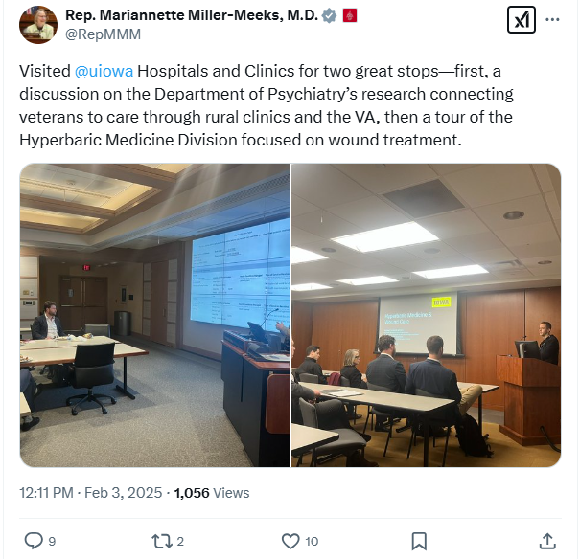
https://lh7-rt.googleusercontent.com/docsz/AD_4nXdH5tgI8ql4me5ZKdTDRdhe7N2Wac9iAPJaGwySKc1CFpvD78sQ8Y5PUyAXUOH7DgfhGtZv7ibOWtwvISHHDnOYgNJkBfLqbtsVQEpYHiDSrd6l182Ex19Q_-Er7KlF78-nuMRqcq5tS84VMYlJ7a4?key=oL7NANkIwo_yhpMcjFN0q1Q2
[Twitter, @RepMMM, 2/3/25]
March 2024: Miller-Meeks Met With A Doctor From The University Of Iowa’s Department Of Microbiology And Immunology To Discuss The “Importance Of Continued NIH Funding For Biomedical Research.” According to a post on Rep. Mariannette Miller-Meeks Twitter,
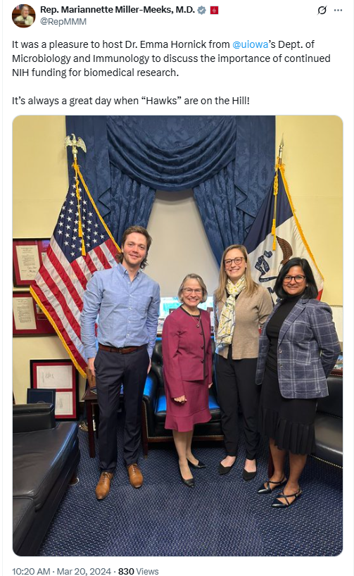
[Twitter, @RepMMM, 3/20/24]
3/20/24: Miller-Meeks Met With The University Of Iowa’s Dean Of The College Of Public Health To Discuss “How Critical It Is For The United States To Fund Various Public Health Initiatives Looking Towards The Future.” According to a post on Rep. Mariannette Miller-Meeks Twitter,
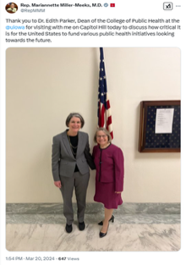
https://lh7-rt.googleusercontent.com/docsz/AD_4nXf4pnqTTs6pS-80Hl4rozW97JD8IVEIvk6fMR7uOZE1WSoy1kVKCo5ywitw3MYx89Dm58xT5sr8F9K6gUbhdbHUeLgUndlbYj1xOR0c2N0LvhtYuLmswL7vBSMcaXxSnsZC5ma51IUAcR55Sn2sneI?key=IKR69eDNBdim9-VTq5ajkA
[Twitter, @RepMMM, 3/20/24]
November 2023: Miller-Meeks Met With University Of Iowa Faculty And Staff To Talk About Their Ongoing Rural Health Initiatives With The Iowa Governor. According to a post on Rep. Mariannette Miller-Meeks Twitter,
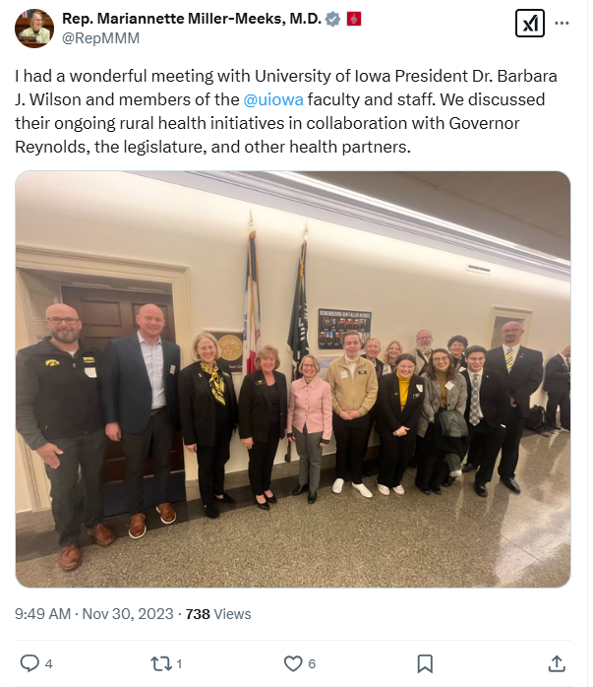
https://lh7-rt.googleusercontent.com/docsz/AD_4nXdIdM5xrNWh8KdQk8bDHth2H1UIwZQLSIJFeHo_G1BG6xYnTSN0dRL4RCNe5j2wqcckQ7m2sFnpCsp-L3D-0ZqqXWEE56mChofIWyYJW-zCzHQcu1AQHSPR5b7FpAo0tI_Ut7b–F8EoBnpiUkj3is?key=IKR69eDNBdim9-VTq5ajkA
[Twitter, @RepMMM, 11/30/23]
October 2023: For Breast Cancer Awareness Month, Miller-Meeks Pointed Her Constituents Toward The University Of Iowa’s Holden Comprehensive Cancer Center For Resources And Said We Had To “Remain United As We Work To Find A Cure.” According to a post on Rep. Mariannette Miller-Meeks’ Twitter,

https://lh7-rt.googleusercontent.com/docsz/AD_4nXe7-uYcWfquX25shBR6KjQ8Kw4cUD0GDYjR_wS0PaQMV-mKsZM_ZEMPgwA01AGx6lwInGkLWcc-M3axNeKRzddXxHN57syu0klDnTDTdJI2XnIPguslf7QmzBrmoH1EW6BeSxGIGbhvbLOcbgAdfa0?key=IKR69eDNBdim9-VTq5ajkA
[Twitter, @RepMMM, 10/20/23]
October 2022: Miller-Meeks Held A Roundtable At The University Of Iowa To Showcase Its Simulation In Motion-Iowa Program, Which Provided Clinical Continuing Education To EMS And Hospital Professionals. According to a post on Rep. Mariannette Miller-Meeks’ Twitter,

https://lh7-rt.googleusercontent.com/docsz/AD_4nXf_6FjhlBpiiF1YzZkPUQflJuRw_1JTw0GR6VWggOvvUIk9z13uokFVGoGpSkJ1WY1ieNEKgacg0mb0aAAjHzJh5LAfDrI2KQXL1h15v0LeZ2fAftqzwvgmG9bhhdc93jHi2VlzMC_x7Dv9iHbNIkg?key=IKR69eDNBdim9-VTq5ajkA
[Twitter, @RepMMM, 10/12/22]
May 2022: Miller-Meeks Met With The American Society Of Radiation Oncology And A University Of Iowa Professor To Discuss Payment Models And “Funding Cancer Research.” According to a post on Rep. Mariannette Miller-Meeks’ Twitter,

https://lh7-rt.googleusercontent.com/docsz/AD_4nXcsRs9tkfoHqeV8DurIjfOLa_XBsNu_b6DEYLLblSZ_3jyr97cDxBmalmjVEruEJ9WvGJwcc3badK9_0ETfoXbmP0rDBIwWxHWYWiTrjjGkNTLKyE2k3U4oh1agBQLmSEAeluFJzZoJAcfZBWuB7g?key=IKR69eDNBdim9-VTq5ajkA
[Twitter, @RepMMM, 5/19/22]
NIH Funding Supported Thousands Of Jobs And More Than 1,500 Businesses In Iowa
2024: The University Of Iowa Received More Than $190 Million In NIH Funding And Could Lose An Estimated $33 Million In Funding If Trump’s Proposed February 2025 Cuts Went Into Effect. According to Heartland Signal, “According to the U.S. Department of Health and Human Services, the University of Iowa received over $190 million of NIH funding last year. Although the cuts have been temporarily paused by a federal judge, UI could lose an estimated $33 million in funding. UI health care reportedly has over 1,000 active clinical research and trials studies that could be impacted, including 459 focused on cancer research. The NIH also announced a 15% cap on existing grants, prompting UI to pause new grant applications and stop hiring new research assistants.” [Heartland Signal, 2/21/25]
United For Medical Research Found That NIH Funding Directly Supported 2,579 Jobs In Iowa. According to Inside Higher Ed, “According to United for Medical Research, NIH funding helps to directly supports 2,579 jobs—and indirectly supports 18,452 jobs and 1,669 businesses related to biotech—in Iowa, where cancer and heart disease are the two most common fatal diseases. (This paragraph was updated to clarify the jobs supported by NIH grants.)” [Inside Higher Ed, 2/12/25]
United For Medical Research Found That NIH Funding Indirectly Supported 18,452 Jobs And 1,669 Business Related To Biotech In Iowa. According to Inside Higher Ed, “According to United for Medical Research, NIH funding helps to directly supports 2,579 jobs—and indirectly supports 18,452 jobs and 1,669 businesses related to biotech—in Iowa, where cancer and heart disease are the two most common fatal diseases. (This paragraph was updated to clarify the jobs supported by NIH grants.)” [Inside Higher Ed, 2/12/25]

At The Social Security Administration, DOGE Forced Mass Layoffs, Longer Wait Times and Frequent Website Crashes
HEADLINE: “Social Security Stops Reporting Call Wait Times And Other Metrics” [Washington Post, 6/20/25]
HEADLINE: “As Social Security Services Are Cut Back, Millions Of Seniors Face Long Drives” [Axios, 6/8/25]
HEADLINE: “Social Security Website Keeps Crashing, As DOGE Demands Cuts To IT Staff” [Washington Post, 4/7/25]
HEADLINE: “Social Security Faces Thousands More Job Cuts Even With Service In Tailspin” [Washington Post, 4/4/25]
CBPP Said The Trump Administration Had Pushed Out 7,000 Social Security Workers. According to the Center on Budget and Policy Priorities, “Over the past five months, the Trump Administration has forced the Social Security Administration (SSA) through a radical transformation that threatens to disrupt services for the largely older and severely disabled people who most rely on the agency.[1] The Trump Administration and its so-called Department of Government Efficiency (DOGE) have created huge gaps in customer service and support by indiscriminately pushing out 7,000 workers to hit an arbitrary staffing reduction target. This is the largest staffing cut in SSA’s history.[2] (See Figure 1.)” [Center on Budget and Policy Priorities, 6/23/25]
The Social Security Administration Website Crashed Four Times In Ten Days In March Because Servers Were Overloaded. According to the Washington Post, “The Social Security Administration website crashed four times in 10 days this month because the servers were overloaded, blocking millions of retirees and disabled Americans from logging in to their online accounts. In the field, office managers have resorted to answering phones in place of receptionists because so many employees have been pushed out. Amid all this, the agency no longer has a system to monitor customer experience because that office was eliminated as part of the cost-cutting efforts led by Elon Musk. And the phones keep ringing. And ringing.” [Washington Post, 3/25/25]
Field Office Managers At Social Security Offices Had To Answer Phones In Place Of Receptionists Because DOGE Had Pushed Out So Many Federal Employees. According to the Washington Post, “The Social Security Administration website crashed four times in 10 days this month because the servers were overloaded, blocking millions of retirees and disabled Americans from logging in to their online accounts. In the field, office managers have resorted to answering phones in place of receptionists because so many employees have been pushed out. Amid all this, the agency no longer has a system to monitor customer experience because that office was eliminated as part of the cost-cutting efforts led by Elon Musk. And the phones keep ringing. And ringing.” [Washington Post, 3/25/25]
DOGE Eliminated The Social Security Administration’s System To Monitor Customer Experience. According to the Washington Post, “The Social Security Administration website crashed four times in 10 days this month because the servers were overloaded, blocking millions of retirees and disabled Americans from logging in to their online accounts. In the field, office managers have resorted to answering phones in place of receptionists because so many employees have been pushed out. Amid all this, the agency no longer has a system to monitor customer experience because that office was eliminated as part of the cost-cutting efforts led by Elon Musk. And the phones keep ringing. And ringing.” [Washington Post, 3/25/25]
Early February-Late March 2025: AARP Said More Than 2,000 People Per Week Had Called Expressing Concerns About Whether They Would Continue To Get Their Social Security Benefits. According to the Washington Post, “Alarmed lawmakers are straining to answer questions back home from angry constituents. Calls have flooded into congressional offices. AARP announced Monday that more than 2,000 people a week have called the retiree organization since early February — double the usual number — with concerns about whether benefits they paid for during their working careers will continue. Social Security is the primary source of income for about 40 percent of older Americans.” [Washington Post, 3/25/25]

More Than 177,000 Iowans In The 1st Congressional District Relied On Social Security Benefits
2024: 177,341 Iowans In The 8th Congressional District Relied On Social Security Benefits. According to the Social Security Administration, in 2024, 177,341 Iowans in the 1st congressional district received Social Security benefits. [Social Security Administration, Iowa,2024]

