Overview
Miller-Meeks, who has previously expressed climate skepticism, voted against protecting Iowans’ clean energy jobs. Miller-Meeks signedletters urging the Republican leadership not to repeal clean energy tax credits from the Inflation Reduction Act, then voted to repeal those credits and make them harder to access, threatening hundreds of clean energy jobs in her state.

Miller-Meeks Voted Against Protecting Iowans’ Clean Energy Jobs

2024-2025: Miller-Meeks Signed Letters Urging Republican Leaders Not to Repeal Clean Energy Tax Credits Created by The Inflation Reduction Act

March 2025: Miller-Meeks Signed A Letter Urging House Republican Leaders Not To Repeal Clean Energy Tax Credits Created By The Inflation Reduction Act
March 2025: Miller-Meeks Signed A Letter Urging House Republican Leadership Not To Repeal Clean Energy Tax Credits In The Reconciliation Process. According to a letter led by Rep. Andrew Garbarino, "As Members of the House Republican Conference, we write to emphasize the importance of prioritizing energy affordability for American families and keeping on our current path to energy dominance amid efforts to repeal or reform current energy tax credits. We strongly support the Administration’s America First national energy dominance initiative. Continued energy expansion and innovation is necessary to bolster national security, create goodpaying American jobs, and guarantee energy independence. The United States continues to produce energy from a myriad of sources that are cleaner and more efficient than anywhere else in the world. As our conference has long believed, an all-of-the-above energy approach, combined with a robust advanced manufacturing sector, will help support the United States’ position as a global energy leader." [Letter, Rep. Andrew Garbarino, 3/9/25]

August 2024: Miller-Meeks Signed A Letter Urging House Speaker Mike Johnson Not To Repeal Clean Energy Tax Credits Created By The Inflation Reduction Act
August 2024: Miller-Meeks Signed A Letter To Speaker Johnson Urging Him To Not To Repeal Clean Energy Tax Credits Created By The Inflation Reduction Act. According to The Hill, "More than a dozen House Republicans wrote to Speaker Mike Johnson (R-La.) on Tuesday asking him not to axe clean energy tax credits in the Inflation Reduction Act (IRA) if the GOP maintains or expands its House majority next year. […] In addition to Garbarino, the letter was signed by GOP Reps. David Valadao (Calif.), Lori Chavez-DeRemer (Ore.), Marc Molinaro (N.Y.), Erin Houchin (Ind.), Anthony D’Esposito (N.Y.), Mike Lawler (N.Y.), Nick LaLota (N.Y.), Young Kim (Calif.), Jen Kiggans (Va.), John Curtis (Utah), Don Bacon (Neb.), Tom Kean Jr. (N.J.), Dave Joyce (Ohio), Mariannette Miller-Meeks (Iowa), Juan Ciscomani (Ariz.), Mark Amodei (Nev.) and Buddy Carter (Ga.)." [The Hill, 8/7/24]
- The Letter Said The Clean Energy Tax Credits Provided Good Jobs And Incentivized Investment. According to The Hill, "‘Energy tax credits have spurred innovation, incentivized investment, and created good jobs in many parts of the country – including many districts represented by members of our conference,’ they wrote. ‘We must reverse the policies which harm American families while protecting and refining those that are making our country more energy independent and Americans more energy secure. As Republicans, we support an all-of-the-above approach to energy development and tax credits that incentivize domestic production, innovation, and delivery from all sources.’" [The Hill, 8/7/24]
Miller Meeks Said Clean Energy Tax Credits Benefitted Iowans
Miller-Meeks Met With The Solar And Storage Industry Association And Discussed How Energy Tax Credits Were Benefitting Iowa By Boosting Domestic Manufacturing. According to a post on Rep. Mariannette Miller-Meeks’ Twitter, "Met with @SEIA to discuss how the energy tax credits are benefiting Iowa by boosting domestic manufacturing, reducing reliance on Chinese imports, and driving onshoring in our supply chain." [Twitter, @RepMMM, 2/5/25]

Miller-Meeks Voted for The Republican Budget Bill that Eliminated Inflation Reduction Act Clean Energy Tax Credits

July 2025: Miller-Meeks Voted For The Final Version Of Republicans’ Budget Bill, Which Repealed Electric Vehicle Tax Credits And Made It Harder For Projects To Qualify For Clean Energy Tax Credits
July 2025: Miller-Meeks Voted For The Senate FY 2025 Budget Reconciliation Bill That Extended $4 Trillion In Expiring Tax Cuts, Added New Tax Breaks, Appropriated $448 Billion In Defense, Border, And Immigration Enforcement Funding, Increased The SALT Deduction To $40,000, And Cut Medicaid And Other Social Programs To Offset The Costs. In July 2025, Miller-Meeks voted for, according to Congressional Quarterly, the “motion to concur in the Senate amendment to the bill that would permanently extend nearly $4 trillion in expiring individual and business tax cuts, create several new tax breaks and fund border and immigration enforcement and air traffic control upgrades. It would cut Medicaid and other safety net programs to partly offset the cost. Among other provisions, it would raise the statutory debt ceiling by $5 trillion and appropriate more than $448 billion in mandatory funding for Trump administration priorities and other needs, including $153 billion for defense, $89 billion for immigration enforcement, and $89.5 billion for border control and security. It also would increase the state and local tax deduction cap to $40,000 annually for five years for households making up to $500,000 a year until 2030, when it would permanently revert to $10,000.” The House passed the bill by a vote of 218 to 214. [House Vote 190, 7/3/25; Congressional Quarterly, 7/3/25; Congressional Actions, H.R. 1]
- The Republican Reconciliation Bill Restricted The Ability Of Projects To Qualify For Certain Clean Energy Tax Credits And Repealed Electric Vehicle Tax Credits. According to Utility Dive, "The bill restricts the ability of projects to qualify for the tech-neutral clean electricity 45Y production tax credit and 48E investment tax credit, shortens the timeline for those credits, and ends the 25D residential solar credit after this year. The 25E, 30D, 30C and 45W electric vehicle credits will terminate after Sept. 30. While clean energy advocates and congressional Democrats maintain that the final version of the bill goes too far in slashing IRA credits, some Republicans wanted to see more significant cuts." [Utility Dive, 7/3/25]
- The Final Republican Reconciliation Bill Allowed Projects To Avoid A Requirement That They Be In Service By 2027 To Qualify For Certain Credits If They Began Construction Within A Year Of The Bill Being Signed. According to Utility Dive, "Before the House Freedom Caucus reached an agreement with House leadership to vote in favor of the bill, the caucus circulated a memo that criticized the Senate’s version of the bill for offering an exemption from the House’s onerous requirement that clean energy projects be placed in service by 2027 to qualify for the 45Y and 48E credits. The Senate version allows projects to avoid this requirement if they begin construction within a year after the bill is signed into law." [Utility Dive, 7/3/25]

May 2025: Miller-Meeks Voted For The House Republican Budget Bill, Which Cut Clean Energy Tax Credits Provided By The Inflation Reduction Act
May 2025: Miller-Meeks Voted For The FY 2025 Budget Reconciliation Bill That Included $3.8 Trillion In Tax Cuts Offset By $1.5 Trillion In Spending Reductions To Programs Like Medicaid And The Supplemental Nutrition Assistance Program. In May 2025, Miller-Meeks voted for, according to Congressional Quarterly, “the bill that would provide for approximately $3.8 trillion in net tax cuts and $321 billion in military, border enforcement and judiciary spending, offset by $1.5 trillion in spending reductions, as instructed in the fiscal 2025 budget resolution (H Con Res 14). It would raise the statutory debt limit by $4 trillion and provide for increased spending on defense and border security, spending cuts on social safety net programs, such as Medicaid and the Supplemental Nutrition Assistance Program. It also includes a mix of tax breaks for businesses and individuals; tax increases on universities and foundations; and a phase-down of clean energy tax credits. […] It would reduce federal spending on the Supplemental Nutrition Assistance Program by requiring states to shoulder more of the cost, expand work requirements for SNAP, extend programs authorized under the 2018 farm bill, and prohibit the U.S. Department of Agriculture from increasing the cost of the Thrifty Food Program. As amended, it would cap state and local tax deductions at $40,000 for households with incomes below $500,000.” The House passed the bill by a vote of 215 to 214. [House Vote 145, 5/22/25; Congressional Quarterly, 5/22/25; Congressional Actions, H.R. 1]
- The House Republican Budget Bill Included Cuts To Federal Tax Credits For Wind, Solar, Storage, And Other Clean Energy Projects. According to Utility Dive, "House Republicans on Thursday morning narrowly passed a sweeping budget bill that guts federal support for wind, solar, storage and other clean energy industries. The bill terminates most technology-neutral clean energy tax credits for projects placed in service after 2028 and those that begin construction more than 60 days after the bill’s passage. It also tightens restrictions on foreign entities’ involvement in projects, creating a ‘truly untenable’ situation for developers, Jefferies analysts said Thursday. Nuclear projects have more time to qualify for the credit." [Utility Dive, 6/3/25]
- One Trade Association CEO Said The Bill Would Weaken Power Systems, Send Shockwaves Through The U.S. Economy, And Kill Tens Of Thousands Of Jobs. According to Utility Dive, "The House bill ‘abruptly dismantles bipartisan, long-standing tax policy that has catalyzed billions in private investment for affordable, reliable energy while sparking a rebirth of manufacturing across America,’ AEU President and CEO Heather O’Neill said. ‘If enacted as written, this bill will weaken our power system and send shockwaves throughout the U.S. economy by raising electricity prices, killing tens of thousands of jobs and ceding energy dominance to China.’" [Utility Dive, 5/22/25]

Clean Energy Projects in Iowa Relied on Inflation Reduction Act Clean Energy Incentives
A Solar Farm In Miller-Meeks’ District Relied On IRA Tax Credits
MidAmerican, A Major Power Company, Planned To Massively Expand Solar Capacity In Iowa Due To Inflation Reduction Act Tax Incentives. According to the Des Moines Register, "MidAmerican, the power company owned by Warren Buffett's Berkshire Hathaway, says it can build nearly 2,100 megawatts of wind and solar energy generation at ‘no net cost to consumers.’ That's due in part to last year's Inflation Reduction Act, which earmarked $369 billion in tax credits and other support for renewable energy generation that cuts greenhouse gas emissions. […] Even with a healthy financial return, the company anticipates customers would bear no costs with the project, given federal tax credits provided through the Inflation Reduction Act and clean energy sales, said Michael Schmidt, an Iowa Environmental Council attorney." [Des Moines Register, 5/1/23]
- October 2024: Miller-Meeks Visited The Hills Solar Farm In Johnson County, Iowa And Claimed She Wanted To Expand On Wind Power With Reform. According to the Iowa City Press-Citizen, "U.S. Rep. Mariannette Miller-Meeks visited a Johnson County solar project on Friday afternoon, championing a future focused on reducing the barriers for Iowans to utilize forms of renewable energy. Miller-Meeks is the chair of the U.S. House Conservative Climate Caucus and attended the event alongside members of the Iowa Conservative Energy Forum. The Hills Solar Farm, where the event took place, is owned and operated by MidAmerican Energy a few miles south of Iowa City. […] In Iowa, Miller-Meeks pointed to the 10,000-panel solar farm behind her and said, on a gusty Friday afternoon, that wind is an abundant renewable energy resource that is already being used and can be expanded with reform."
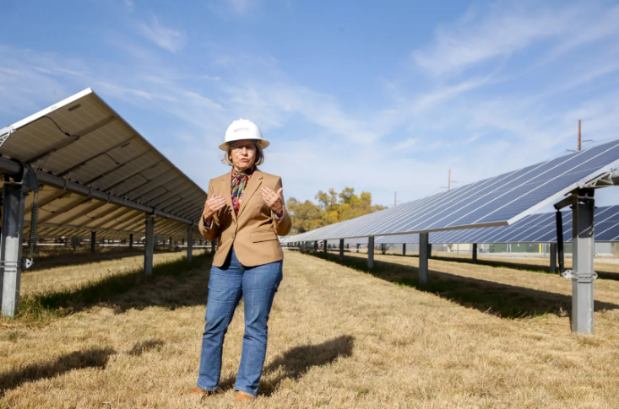
[Iowa City Press-Citizen, 10/25/24]
2022: A Wind Plant In Iowa Planned To Employ 1,000 People Thanks To The Inflation Reduction Act
2022: A Major Wind Turbine Manufacturer Announced It Planned To Reopen A Plant In Iowa Thanks In Part To The Inflation Reduction Act. According to Iowa Starting Line, "A strong Central Iowa employer will return to the state thanks, in part, to federal action taken by President Joe Biden. TPI Composites, a company that manufactures blades for wind turbines, announced in early November it will restart operations at its manufacturing plant in Newton, a city 30 miles east of Des Moines. The company signed a 10-year lease extension with General Electric Renewable Energy to produce wind turbine blades. […] ‘This agreement is possible in part due to the support provided by the Inflation Reduction Act of 2022 for critical American industries serving the domestic renewable energy sector,’ said Bill Siwek, President and CEO of TPI in the press release announcing the decision. ‘We look forward to working with GE to take advantage of this opportunity to relaunch the Iowa facility and thank GE for their confidence in TPI’s team to implement this strategy.’" [Iowa Starting Line, 12/2/22]
- The Plant Was Predicted To Employ Up To 1,000 People In Iowa. According to Wind Power Monthly, "US blade maker TPI Composites is on schedule to reopen its Newton, Iowa plant in mid-2025 to support GE Vernova, its CEO Bill Siwek said. […] The Iowa plant, which has always made GE Vernova blades exclusively, had employed around 720 workers before the manufacturer closed it in 2024 following a contraction in the market. TPI had previously said that it expects the re-opened plant to employ up to 1,000 people." [Wind Power Monthly, 2/27/25]

Miller-Meeks’ Votes Threatened Hundreds of Solar Jobs in Iowa
SEIA Said 1,800 Solar Jobs In Iowa Were At Risk If Congressional Republicans Repealed Inflation Reduction Act Clean Energy Tax Credits.
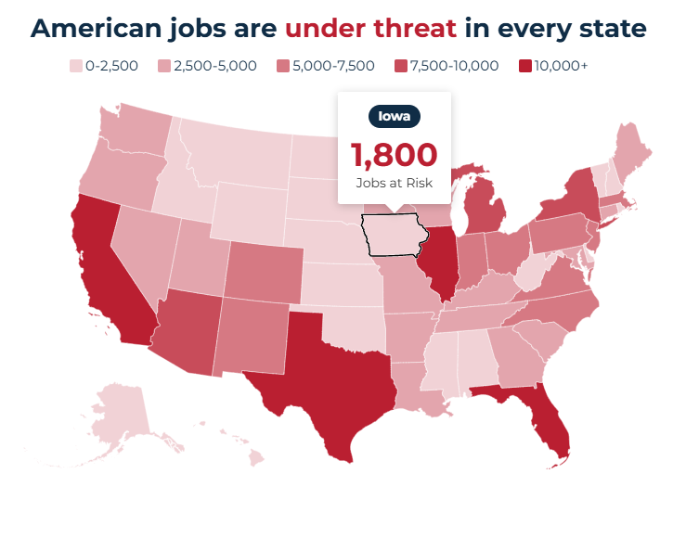
[Solar Energy Industries Association, Viewed 6/11/25]

Miller-Meeks’ Votes Could Prevent Iowans from Saving Money on Their Taxes
2023: Environment America Said Nearly 33,000 Iowa Families Utilized Clean Energy Tax Credits For A Total Of More Than $58 Million In Savings On Their Taxes. According to an opinion by executive director of Environment America Lisa Frank in the Gazette, "Rooftop solar can cost upwards of $20,000, a storage battery runs between $8,500 and $10,000, and highly efficient electric appliances such as heat pumps can be a few thousand dollars more than less efficient gas models. For example, in Iowa, a 7kw home solar installation will currently cost $21,954, but after the federal tax credit is applied that comes down to$15,479. That’s why tax credits are so important. In 2023, nearly 33,000 Iowa families used these credits for clean energy home improvements, saving more than $58 million dollars on their taxes. In exchange, all of us get cleaner air and a healthier environment." [Executive Director of Environment America Lisa Frank, Opinion – Gazette, 3/19/25]

Miller-Meeks Has Previously Voted to Repeal Inflation Reduction Act Clean Energy Tax Credits
April 2023: Miller-Meeks Voted For The Limit, Save Grow Act, Which Sought To Repeal Inflation Reduction Act Clean Energy Tax Credits
April 2023: Miller-Meeks Voted For A GOP Debt Limit Package, Which Would Sought To Repeal Several Climate Tax Credits Under The Inflation Reduction Act, Especially The Tax Credits For Solar And Wind Projects, Sustainable Aviation Fuel, And Clean Fuel Production. In April 2023, according to Congressional Quarterly, Miller-Meeks voted for the Limit, Save, Grow Act of 2023, which “Among energy- and climate-focused provisions, the bill would repeal, phase out or narrow a variety of climate-focused tax credits under the fiscal 2022 reconciliation package, including repealing new credits for solar and wind projects, sustainable aviation fuel and clean fuel production.” The vote was on passage. The House passed the bill by a vote of 217 to 215, thus the bill was sent to the Senate. [House Vote 199, 4/26/23; Congressional Quarterly, 4/26/23; Congressional Actions, H.R. 2811]
Miller-Meeks Said She Was Proud To Vote For The Limit, Save, Grow Act. According to a post on Rep. Mariannette Miller-Meeks’ Twitter, “I was proud to vote for the Limit, Save, and Grow Act last week to prove to Iowans and the American people that Congress is taking the responsible route and finding real solutions to lower the deficit.” [Twitter, @RepMMM, 5/1/23]
- The Limit, Save, Grow Act Sought To Reset U.S. Energy Tax Code To Before The Inflation Reduction Act’s Passage. According to E&E News by Politico, "House Republicans eked out a victory Wednesday evening on their sweeping measure to raise the debt ceiling — a win they achieved by offering myriad concessions, including slashing billions of dollars in clean energy tax incentives. […] At the same time, Republicans took the opportunity to make new, further cuts to billions of dollars in funding in the Inflation Reduction Act for various initiatives related to pollution reduction, energy efficiency and environmental justice. House Republicans involved in the negotiations downplayed the scope and scale of the eleventh-hour changes throughout the day Wednesday, insisting they were just ‘technical’ in nature — intended to clarify the text to better reflect conversations that have been happening out in the open for weeks. ‘The changes last night, to be very clear, were simply honoring what we’d already said publicly we would do,’ Rep. Chip Roy (R-Texas), a member of the House Freedom Caucus who also sits on the Rules Committee, said Wednesday. ‘There were no crazy machinations.’ Roy was referring to an agreement among members to target Inflation Reduction Act subsidies only and set the energy tax code back to 2022, pre-IRA conditions." [E&E News by Politico, 4/27/23]
- The Limit, Save Grow Act Sought To Repeal Most Of The Inflation Reduction Act’s Energy And Climate Tax Credit Expansions. According to the Committee for a Responsible Federal Budget, "The Limit, Save, Grow Act would return total discretionary spending to the Fiscal Year (FY) 2022 level in FY 2024 and cap annual growth at 1 percent for a decade thereafter; rescind unspent COVID relief funds; repeal most of the Inflation Reduction Act's (IRA) energy and climate tax credit expansions; rescind the IRA's increased Internal Revenue Service (IRS) funding; make changes to energy, regulatory, and permitting policies; impose or expand work requirements in several federal safety net programs; and prevent implementation of President Biden's student debt cancellation and Income-Driven Repayment (IDR) expansion." [Committee for a Responsible Federal Budget, 4/20/23]

2022: Miller-Meeks Voted Against the Inflation Reduction Act
2022: Miller-Meeks Voted Against The Inflation Reduction Act Of 2022, A Multi-Billion Dollar Package To Address Climate Resiliency, Taxes, And Health Care Costs. In August 2022, according to Congressional Quarterly, Miller-Meeks voted against concurring in the Senate amendment to the Inflation Reduction Act of 2022, “comprising a package of climate, tax and health care provisions.” The vote was on a motion to concur. The House concurred with the Senate by a vote 220-207, thus the bill was sent to President Biden for final signage. President Biden signed the bill and it ultimately became law. [House Vote 420, 8/12/22; Congressional Quarterly, 8/12/22; Congressional Actions, H.R. 5376]
- The Inflation Reduction Act Was The United States’ Greatest Investment To Combat Climate Change By Providing Approximately $370 Billion To Lower Greenhouse Gas Emissions To 40% Below Their 2005 Level By The End Of The 2020s. According to the Washington Post, “Dubbed the Inflation Reduction Act of 2022, the package would authorize the biggest burst of spending in U.S. history to tackle global warming — about $370 billion to reduce greenhouse gas emissions to 40 percent below their 2005 levels by the end of this decade.” [Washington Post, 8/7/22]

Miller-Meeks Was “Proud” To Have Voted Against The Inflation Reduction Act
Miller-Meeks Said She Was “Proud” To Vote Against The Inflation Reduction Act. According to a post on Rep. Mariannette Miller-Meeks’ Twitter, “I was proud to vote no on the $740 billion Inflation Reduction Act.” [Twitter, @RepMMM, 8/12/22]
Miller-Meeks Voted Against The Inflation Reduction Act Because She Believed It Was Bad For Iowans And The Economy. According to a press release from Rep. Mariannette Miller-Meeks, "Representative Mariannette Miller-Meeks issued the following statement today after voting NO on H.R. 5376, the Inflation Reduction Act: ‘Our country is facing skyrocketing inflation and our economy has been thrown into a recession. Now is not the time to pass a $740 billion spending bill, let alone one filled with partisan priorities,’ said Miller-Meeks. ‘This legislation will add 87,000 agents to the IRS—leaving the agency with more staff than the Pentagon, State Department and CBP combined. It will also allow the federal government to control drug pricing, which will limit competition and innovation within the pharmaceutical industry and potentially even limit availability of drugs already in use. This enormous spending package is bad for Iowans, bad for patients, bad for the economy and hardworking Americans, and bad for the future of American innovation.’" [Press Release – Rep. Mariannette Miller-Meeks, 8/12/22]

Before Entering Congress, Miller-Meeks Was a Climate Change Skeptic
2015: Miller-Meeks Shared An Article On Her Twitter Titled “Why Climate Change Won’t Matter In 20 Years.” According to a post on Mariannette Miller-Meeks’ Twitter, "Paris accord is static. Science & knowledge is dynamic; be futuristic! Why Climate Change Won’t Matter in 20 Years http://bit.ly/1lXTj0V"

[Twitter, @millermeeks, 12/20/15]
2013: Miller-Meeks Said She Read An Article Claiming The Planet Was Warming Was Less Than Predicted And That More Data And Less Urgency Was Needed. According to a post on Mariannette Miller-Meeks’ Twitter, "Did u read Saturday WSJ about upcoming UN climate change update from IPCC? Warming less than predicted, need more data, less urgency..."
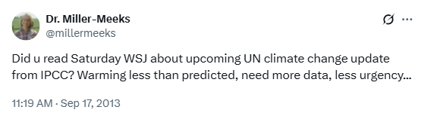
[Twitter, @millermeeks, 9/17/13]

