Overview
In 2022, Ciscomani campaigned on protecting Arizona’s water supply. However, in 2015, while Ciscomani worked for his administration, Governor Ducey struck a deal with a Saudi Arabian company to grow alfalfa, which required significant quantities of water. As part of the deal, the foreign company was not required to report its water usage. The deal happened while Arizona was in the middle of a drought and 10 years later Arizona remained in a serious drought. Ciscomani has touted his role as a “Senior Advisor” to Governor Ducey on his campaign website. Between 2021 and 2023, Ciscomani accepted $4,800 in campaign donations from a key architect of the 2015 deal.

2015: Ciscomani Was Senior Advisor To Arizona Governor That Worsened Arizona’s Water Crisis

2015: Ciscomani Worked for Governor Ducey’s Administration when It Struck a Deal that Worsened Arizona’s Historic Drought
2015: Arizona Governor Doug Ducey’s Administration Made A Deal With Fondomonte Arizona, A Saudi Arabian Company, To Grow Alfalfa, Which Required Large Water Usage. According to American Journal News, “In 2015, when Ciscomani held this position, the Ducey administration cut a deal leasing a large portion of the Butler Valley to Fondomonte Arizona, a Saudi Arabian farming company. They used the land to grow alfalfa, a crop that requires large amounts of water to thrive. Fondomonte Arizona was not required to report their water usage. Environmental and water conservation activists criticized the deal.” [American Journal News, 1/19/24]
- Fondomonte Arizona Was Not Required To Report Their Water Usage, Drawing Criticism From Environmental Groups. According to American Journal News, “Fondomonte Arizona was not required to report their water usage. Environmental and water conservation activists criticized the deal.” [American Journal News, 1/19/24]
- HEADLINE: “How A Saudi Firm Tapped A Gusher Of Water In Drought-Stricken Arizona” [Washington Post, 7/16/23]
Ciscomani Has Touted His Role As A Senior Advisor In Governor Ducey’s Administration On His Campaign Website. According to Juan Ciscomani’s 2022 campaign website, “As Senior Advisor to Governor Ducey for more than 7 years, Juan has worked closely with Border Patrol, border sheriffs, ranchers and residents along the border to bring resources and attention to our border crisis. Also, as Vice-Chair of the Arizona-Mexico Commission, Juan understands the value and importance of Arizona’s trade and tourism relationship with Mexico.” [Juanciscomani.com, Meet Juan, Archived 11/7/22 via archive.org]

Ciscomani Made Water Protection A Pillar Of His 2022 Campaign
2022: Ciscomani Stated He Would Fight For A Reliable And Safe Water Supply. According to Juan Ciscomani’s 2022 campaign website, “Water is critical for our district and our state. Today, Arizona uses less water than we did decades ago while utilizing technology, growing our population, and preserving our resources. But the water challenges facing the district today remain. Juan will fight for a reliable, safe and affordable water supply.” [Juanciscomani.com, Issues, Archived 11/7/22 via archive.org]

Arizona Was In The Middle Of A Drought When Ducey’s Administration Leased Arizona Land To A Foreign Company To Grow Crops That Required High Water Usage
2015: Arizona’s Water Source, Lake Mead, Hit A Record Low Amid A 15-Year Drought. According to USA Today, “Lake Mead sunk to a record low Tuesday night, falling below the point that would trigger a water-supply shortage if the reservoir doesn’t recover soon. Water managers expect the lake’s level to rebound enough to ward off a 2016 shortage thanks to a wetter-than-expected spring. But in the long run, as a U.S. Bureau of Reclamation spokeswoman said, ‘We still need a lot more water.’ The reservoir stores water for parts of Arizona, Southern California, southern Nevada and northern Mexico — all of which have endured a 15-year drought that continues.” [Arizona Republic, 6/24/15]

Arizona Remained In A Drought 10 Years After the Controversial Land Deal
HEADLINE: “Arizona’s Current Long-Term Drought Among Worst On Record” [Arizona’s Family, 4/10/25]
2024: Experts Said Arizona’s Key Source Of Water Was In A “Megadrought.” According to Arizona’s Family, “As the Phoenix area grows, so does the need for more secure water sources and that’s why Arizona is exploring options to import billions of gallons of water from out of state. The Colorado River is a key resource for Arizona’s water, with nearly 35% of the state relying on the river. Experts say over the last two decades, the basin has been in a megadrought.” [Arizona’s Family (CBS), 12/16/24]
2023: Arizona Experienced A Tier 2 Water Shortage In 2023 Over Record Low Water Levels. According to Axios Phoenix, “Arizona will have to reduce its Colorado River water usage by 592,000 acre-feet next year, or 21% of its total allotment, the U.S. Bureau of Reclamation announced Tuesday. he bureau declared that the Colorado River basin will be in a Tier 2 shortage starting in 2023, meaning Lake Mead’s water level will fall below 1,050 feet.” [Axios Phoenix, 8/16/22]

2021-2023: Ciscomani Received $4,800 from Key Player in Fondomonte Land Deal While Running for Congress
Ciscomani’s Campaigns Received $4,800 From Jordan Rose, A Chief Architect Of Ducey’s Foreign Land Deal Who Worked As A Lawyer And Lobbyist For Fondomonte Arizona. According to American Journal News, “A chief architect of the deal was Jordan Rose, an Arizona-based lawyer and lobbyist who worked on behalf of Fondomonte Arizona. Rose has donated a total of $4,800 to Ciscomani’s campaigns.” [American Journal News, 1/19/24]
- 2021-2023: Ciscomani’s Congressional Campaign Received $4,800 From Jordan Rose. According to the Federal Election Commission,
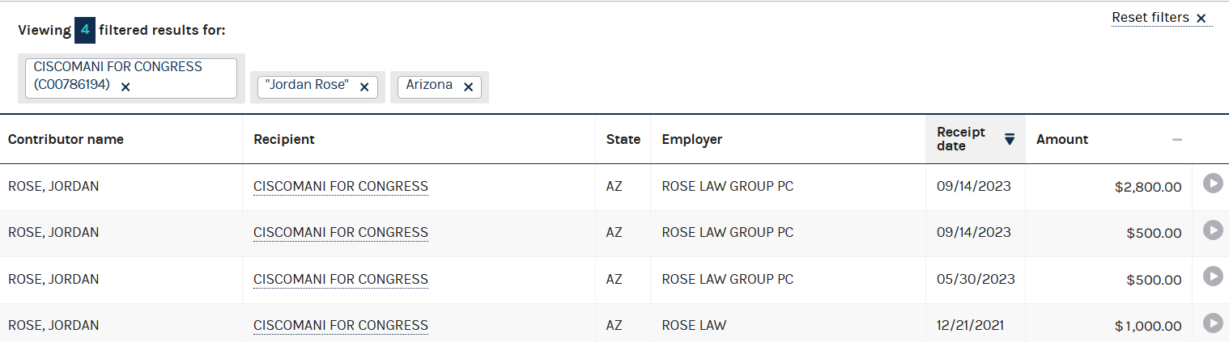
[Federal Election Commission, Individual Contributions Search: Jordan Rose, Viewed 8/16/25]
- Jordan Rose Founded Rose Law Group In Arizona And Specialized In Government Relations And Land Use Issues. According to Rose Law Group, “Jordan Rose started Rose Law Group pc leasing space for just herself in another lawyer’s storage room and has, in twenty-five years, grown the firm to the largest woman-owned law firm in Arizona history. Jordan practices in the areas of business consulting, government relations, municipal issues, land use, zoning, sports law, Web3, administrative law and lobbying. Jordan has been called by the Phoenix Business Journal the ‘Queen of Pinal County’ and by the ABA Journal a ‘metaverse pioneer’.” [Rose Law Group, Viewed 7/8/25]

