Overview
Before getting elected to congress, Ciscomani attended the controversial far-right, religious training group Patriot Academy and served on the board for several years. Ciscomani even helped establish a branch of the Patriot Academy in Arizona.
- Patriot Academy opposed same-sex marriage and abortion, and had an anti-LGBTQ, anti-abortion, climate denier on its board. Patriot Academy also offered what it claimed were self-defense classes that taught children as young as 11 years-old how to shoot a gun.
- Patriot Academy partnered with another far-right organization, Convention of States, that wanted to rewrite the U.S. constitution.
- Far-right Republican congresswoman and embarrassment to Colorado, Lauren Boebert, was also a student of Patriot Academy.

Ciscomani Had Close Ties To The Far-Right, Religious Training Group That Lauren Boebert Also Attended: Patriot Academy

Ciscomani Attended the Patriot Academy And Served On The Board For Several Years Until His Election To Congress
Ciscomani: “I Can Wholeheartedly Say That Nothing In My Life Has Given Me A Clearer Direction For My Life Than Patriot Academy.” According to a blog post Juan Ciscomani wrote for the Patriot Academy, “Your next step is attending Patriot Academy. I can wholeheartedly say that nothing in my life has given me a clearer direction for my life than Patriot Academy – and I am not the only alum that feels this way. The Lord may have called you into government and your Patriot Academy experience will definitely shine some light on your next steps.” [Juan Ciscomani, Blog – Patriot Press, 8/6/10]
2006-2008: Ciscomani Attended The Patriot Academy For Three Years. According to The Patriot Academy, “Juan Ciscomani attended Patriot Academy in 2006, 2007, and 2008. Even though Juan had a degree in political science, PA revolutionized the very core of his beliefs about government.”
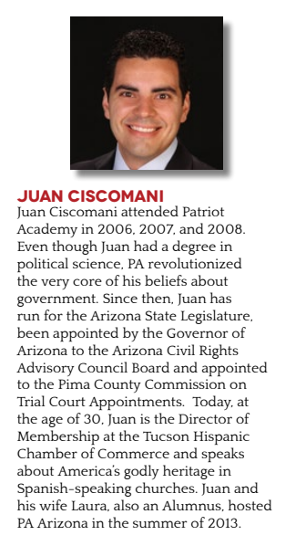
[Patriot Academy, Patriot Academy Impact, Page 11, Viewed 4/14/25]
Ciscomani Was Included On The List Of Patriot Academy Board Of Directors. According to the Patriot Academy,
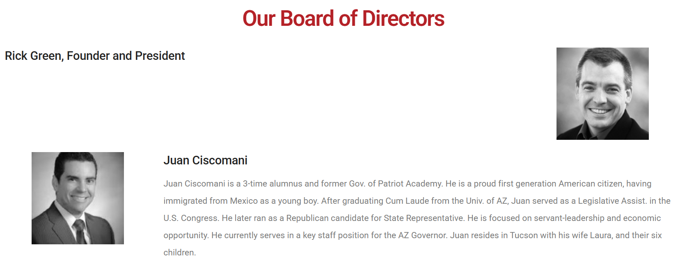
[Patriot Academy, Academy Leadership, Viewed 4/14/25]
Ciscomani Was On The Board Of Torch Of Freedom From 2007 Through 2021. According to the Copper Courier, “Ciscomani served on the board of Torch of Freedom, the organization that runs Patriot Academy, from 2007 through 2021. He was initially turned on to the group in 2006 when he first attended their courses.” [Copper Courier, 8/29/25]
- Patriot Academy Was The Flagship Arm Of The Torch Of Freedom Foundation. According to the Patriot Academy, “Patriot Academy is a 501(c)(3) non-profit organization, the flagship arm of The Torch of Freedom Foundation. All donations are tax-deductible.” [Patriot Academy, About, Viewed 4/14/25]

Ciscomani Helped Bring The Patriot Academy To Arizona
Ciscomani Was Responsible For Opening The Patriot Academy In Arizona. According to the Copper Courier, “Ciscomani does not have ownership over Patriot Academy, although he has been a prominent leader of the far-right group as a board member, and is responsible for campuses opening in Arizona.” [Copper Courier, 8/29/25]
Ciscomani Brought The Academy To Arizona And Sat On The Board For 14 Years. According to Cronkite News, “He attended again in 2007 and 2008, brought the program to Arizona in 2013, and sat on the board of directors for 14 years.” [Cronkite News, 7/25/24]

Patriot Academy Was a Far-Right, Religious Training Group that Advocated Anti-Lgbtq, Anti-Abortion, and Anti-Climate Views
The Patriot Academy Touted That It Had A “Proven Track Record” Of Training People To “Understand And Influence Government Policy With A Biblical Worldview.” According to the Patriot Academy, “A PROVEN TRACK RECORD Patriot Academy has a proven track record of excellence through a simple five-part strategy: 1. Train citizens to understand and influence government policy with a Biblical worldview.” [Patriot Academy, Viewed 5/9/25]

Patriot Academy Spread Anti-Abortion Disinformation
Patriot Academy Published A Blog That Claimed Planned Parenthood Murdered Babies And Sold “Murdered Baby Body Parts.” According to a blog published by the Patriot Academy, “Yes, I added the [murder of unborn babies] language because you ‘abort’ a mission, but what Planned Parenthood does is murder – kill — unborn babies. And it’s about time we stop pussyfooting around and trying to soften the language of what they do. We also know they’re in the business of harvesting murdered baby body parts for sale” [Allen West, Blog – Patriot Press, 1/22/18]
- HEADLINE: “Planned Parenthood Investigations Find No Fetal Tissue Sales” [NPR, 1/28/16]

Patriot Academy Published A Blog That Claimed Same-Sex Marriage Was A Sin
Patriot Academy Published A Blog Claiming Same-Sex Marriage Was A Sin. According to a blog published by the Patriot Academy, “The sadness of it all is that the Church, which is supposed to be the bastion for Christ, His body and a safe place for His followers, has in many places turned into a spineless, indoctrinated, broken place. Now do not get me wrong, I know all Churches are not like this. But some huge Church sects have turned willingly to openly supporting ‘gay marriage’ and transgenderism. The Church is being blatantly attacked, as it always has been, by the devil. Gay marriage, regardless of opinions, is scripturally sinful.” [Patriot Academy Alumnus Helen Bricker, Blog – Patriot Press, 2/18/19]

Patriot Academy Board Member Was A Climate Denier And Espoused Anti-Abortion And Anti-LGBTQ Views
Patriot Academy Published A Blog Praising David Barton, Who Sat On The Academy’s Board Of Advisors, For A Speech He Gave To Students Where He Provided “Ample Evidence To Counteract The Theory Of Man-Made Climate Change.” According to a blog published by the Patriot Academy, “I especially enjoyed historian David Barton’s speech about the history of science and other scientific figures. It set my heart at ease that I was not the only unwoke character who didn’t believe in man-made climate change. Not only was I not alone in my beliefs, David Barton had ample evidence to counteract the theory of man-made climate change, most of which I did not know about or had previously forgotten.” [Patriot Academy Alumnus Casey Lay, Blog – Patriot Press, 5/21/25]
- David Barton Was On The Board Of Advisors At The Patriot Academy. According to the Patriot Academy,

[Patriot Academy, Board of Advisors, Viewed 4/14/25]
- Patriot Academy Published A Blog By Barton Where He Called Abortion, Homosexuality, And Transgenderism “Manifestations Of The LGBT Agenda.” According to a blog written by David Barton published by the Patriot Academy, “Secular Progressives are more likely to be truly theocratic, for they regularly exercise coercion to force dissenters to adopt their beliefs. If you doubt this, just ask the bakers, florists, photographers, clerks, chaplains, and others who have tried to avoid participating in the Progressives’ religious rites to their great goddess of the Sexual Revolution, whether abortion, homosexuality, transgenderism, or other manifestations of the LGBT agenda.” [David Barton, Blog – Patriot Press, 12/31/19]
- Barton Rejected The Tenet Of Separation Of Church And State. According to Cronkite News, “Barton is the long-time vice-chair of the Texas Republican Party and ally of Sen. Ted Cruz. He helped usher in changes to make textbooks in Texas schools more conservative and Christian-friendly. He denounces church-state separation. His organization, WallBuilders, rejects the idea that America’s Founding Fathers intended for the country to be secular.” [Cronkite News, 7/25/24]

Patriot Academy Taught Children As Young As 11 To Shoot A Gun
Patriot Academy Offered A Constitution Defense Course, Which Was Effectively A Firearms Training, And Encouraged Children As Young As 11 To Take The Course. According to the Patriot Academy,
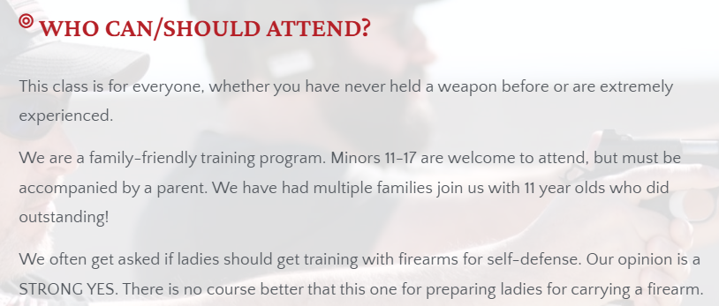
[Patriot Academy, Constitutional Defense Course, Viewed 4/14/25]

Patriot Academy Wanted To Rewrite The U.S. Constitution
One Journalist Who Attended A Patriot Academy Course Reported The School Was Engaged In The Struggle To Rewrite The Constitution. According to The New Republic, “Patriot Academy is engaged in a life-and-death struggle to rewrite America’s Constitution—and teaching its supporters how to defend themselves with a handgun, just in case.” [New Republic, 1/3/23]
Patriot Academy Partnered With Convention Of States Action, An Organization Dedicated To Rewriting The Constitution. According to Convention of States Action, “COSA PA Events Team wants to remind everyone September 17th - Constitution Day is just two months away. COSA PA Events Team and our partner, Patriot Academy, are looking for ‘Constitutional Coaches’. This positive, unifying program for students combats the ignorance and propaganda pushed by today’s Department of Education.” [Blog – Convention of States Action, 7/21/23]
- Patriot Academy Teamed Up With Convention Of States To Teach A Course On The Constitution. According to Convention of States Action, “Instead of watching Monday night football where players kneel during the National Anthem, thousands of patriots are gathering to study the U.S. Constitution. Today, we’re excited to invite you to join them. We’ve teamed up with Rick Green and Patriot Academy to bring you the most engaging, entertaining course on the Constitution… for free!” [Blog – Convention of States Action, 10/2/20]
The Convention Of States Action Sought A Constitutional Convention For The Purpose Of Proposing New Amendments Aimed At Limiting Federal Power, Mandating Fiscal Responsibility, And Imposing Term Limits. According to Convention of States Action, “A convention of states is a meeting initiated by the state legislatures under Article V of the Constitution for the purpose of proposing amendments to the U.S. Constitution. […] Our resolution calls for a convention to propose amendments on particular subjects–limiting federal power, mandating fiscal responsibility, and imposing term limits—rather than a particular amendment.” [Convention of States Action, Frequently Asked Questions, Viewed 7/7/25]

Far-Right Extremist Lauren Boebert Also Attended Patriot Academy
Boebert Took Several Courses At Patriot Academy And Claimed They Helped Her Navigate Congress. According to the Patriot Academy,
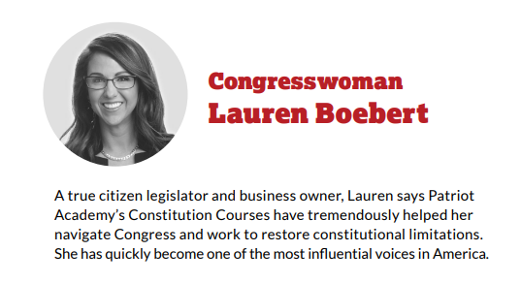
[Patriot Academy, Impact Report, April 2023]
- HEADLINE: “Lauren Boebert Praised Q’Anon. Now She’s Headed To Congress.” [Mother Jones, 11/4/20]
- HEADLINE: “Rep. Lauren Boebert Suggested Rep. Ilhan Omar Was Terrorist In Anti-Muslim Remarks At Event” [CNN, 11/27/21]
- HEADLINE: “Lauren Boebert Leads Colorado Republicans In Pushing Trump’s Baseless Election Claims” [Denver Post, 12/01/20]
- HEADLINE: “Lauren Boebert Is Part Of A Dangerous Religious Movement That Threatens Democracy, Experts Say” [Denver Post, 9/14/22]

