Overview
In November 2025, after 11 months, Ciscomani finally voted to release the Epstein files, but only after Donald Trump gave House Republicans permission to do so. Previously, Ciscomani had cast the deciding vote against releasing the Epstein files, protecting the accused pedophiles named within. Ciscomani claimed he full supported the federal government being transparent and releasing the Epstein files, but he never signed the discharge petition that called for the files’ release and he never co-sponsored Rep. Thomas Massie and Rep. Ro Khanna’s resolution that called for their release.

It Took Ciscomani 11 Months To Vote To Release The Epstein Files, Only After Trump Signaled To House Republicans He Approved

It Took Ciscomani 11 Months to Vote to Release the Epstein Files and He only Did After Trump Gave Republican Permission

November 16, 2025: Trump Said House Republicans Should Vote To Release The Epstein Files
HEADLINE: “In A Shift, Trump Says House Republicans Should Vote To Release Epstein Files” [NPR, 11/16/25]
11/16/25: Trump Said House Republicans Should Vote To Release The Epstein Files And That The House Oversight Committee Could Have Whatever It Was Legally Entitled To. According to Trump’s Truth Social post, “As I said on Friday night aboard Air Force One to the Fake News Media, House Republicans should vote to release the Epstein files, because we have nothing to hide, and it’s time to move on from this Democrat Hoax perpetrated by Radical Left Lunatics in order to deflect from the Great Success of the Republican Party, including our recent Victory on the Democrat ‘Shutdown.’ The Department of Justice has already turned over tens of thousands of pages to the Public on ‘Epstein,’ are looking at various Democrat operatives (Bill Clinton, Reid Hoffman, Larry Summers, etc.) and their relationship to Epstein, and the House Oversight Committee can have whatever they are legally entitled to, I DON’T CARE! All I do care about is that Republicans get BACK ON POINT, which is the Economy, ‘Affordability’ (where we are winning BIG!), our Victory on reducing Inflation from the highest level in History to practically nothing, bringing down prices for the American People, delivering Historic Tax Cuts, gaining Trillions of Dollars of Investment into America (A RECORD!), the rebuilding of our Military, securing our Border, deporting Criminal Illegal Aliens, ending Men in Women’s Sports, stopping Transgender for Everyone, and so much more! Nobody cared about Jeffrey Epstein when he was alive and, if the Democrats had anything, they would have released it before our Landslide Election Victory. Some ‘members’ of the Republican Party are being ‘used,’ and we can’t let that happen. Let’s start talking about the Republican Party’s Record Setting Achievements, and not fall into the Epstein ‘TRAP,’ which is actually a curse on the Democrats, not us. MAKE AMERICA GREAT AGAIN!” [Truth Social, @realDonaldTrump, 11/16/25]

November 17, 2025: Ciscomani Voted With Nearly Every Other Member Of The U.S. House To Release The Epstein Files
2025: Ciscomani Voted To Release The Epstein Files. In November 2025, Ciscomani voted for, according to Congressional Quarterly, “the bill that would require the attorney general, within 30 days of the bill’s enactment, to make publicly available all Justice Department records, documents, communications and investigation material related to the department’s investigation of Jeffrey Epstein, Ghislaine Maxwell and other individuals or entities associated with Epstein. It would require the DOJ to disclose any immunity deals or plea bargains involving Epstein or his associates. It would allow the Justice Department to withhold or redact certain materials to protect victims’ privacy, among other limited exceptions. It also would require the attorney general, within 15 days of making such records public, to submit a report to Congress that includes information on the materials it has released and withheld, a list of any redactions made and the legal justification for doing so, and a list of any government officials and politically exposed persons named in the investigation.” The vote was on passage. The House passed the bill by a vote of 472 to 1 and it was ultimately signed into law by President Trump. [House Vote 289, 11/18/25; Congressional Quarterly, 11/18/25; Congressional Actions, H.R. 4405]
- HEADLINE: “Congress Passes Bill To Force The Release Of The Epstein Files” [NBC News, 11/17/25]
- The Justice Department Had 30 Days After Trump Signed The Bill To Release All Unclassified Documents About Jeffrey Epstein. According to the Washington Post, “President Donald Trump said Wednesday that he has signed a bill directing the Justice Department to release the Epstein files, documents related to the sprawling sex-trafficking investigation into the onetime powerful financier that are fervently sought by Trump’s political opponents and members of his political base. After Trump’s announcement, made in a social media post, the Justice Department will have 30 days to release all unclassified documents about Jeffrey Epstein, who was arrested on federal sex-trafficking charges in 2019 and died in an apparent suicide while in federal custody.” [Washington Post, 11/19/25]
- Speaker Johnson Sent The House Home A Day Early In July To Avoid A Vote On The Release Of The Files. According to ABC News, “House Speaker Mike Johnson had tried to avoid holding a vote in the lower chamber on the Epstein matter. In late July, Johnson sent the House home a day early for August recess because the House was paralyzed in a stalemate over the Epstein issue.” [ABC News, 11/18/25]
- Speaker Johnson Expressed Opposition To The Process, Saying He Was “Deeply Disappointed” In The Outcome. According to NBC News, “Even after having voted for the bill, Johnson was still fuming over the process hours later. Returning to the Capitol from a White House dinner honoring Saudi Arabia’s crown prince, Johnson said, ‘I’m deeply disappointed in this outcome,’ and he lamented that ‘Chuck Schumer rushed it to the floor.’ Senate Majority John Thune, R-S.D., didn’t object, despite being aware of Johnson’s concerns. Johnson said he was continuing to have conversations with Trump about those issues. ‘I’m frustrated with the process,’ he said, ‘but I trust Leader Thune.’” [NBC News, 11/17/25]
- Republican Rep. Clay Higgins Was The Only Member Of Congress Who Voted Against A Discharge Petition That Called To Release The Epstein Files. According to NBC News, “Congress voted overwhelmingly Tuesday to pass legislation to compel the Justice Department to release its records related to the late convicted sex offender Jeffrey Epstein — a major victory for lawmakers in both parties who’ve been leading the push for months. As the final vote tally in the House, 427-1, was read, several Epstein survivors who were sitting in the gallery embraced one another and loud cheers went up through the chamber. Rep. Clay Higgins, R-La., was the only lawmaker to vote no.” [NBC News, 11/17/25]

Ciscomani Claimed He Fully Supported the Federal Government Being Transparent and Releasing the Epstein Files
Ciscomani Claimed He Fully Supported Transparency From The Federal Government When It Came To Releasing The Epstein Files.
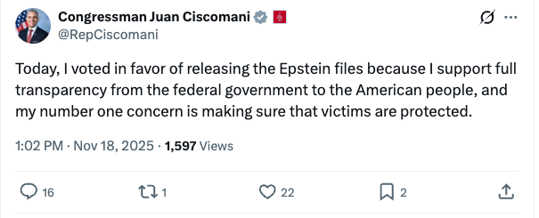
[Twitter, @RepCiscomani, 11/18/25]

But Ciscomani Never Signed the Discharge Petition to Release the Epstein Files that Eventually Made Its Way to The House Floor
Nancy Mace, Lauren Boebert, And Marjorie Taylor Greene Were The Only Other Republicans To Sign Thomas Massie’s Discharge Petition To Get A House Floor Vote On Releasing The Epstein Files.
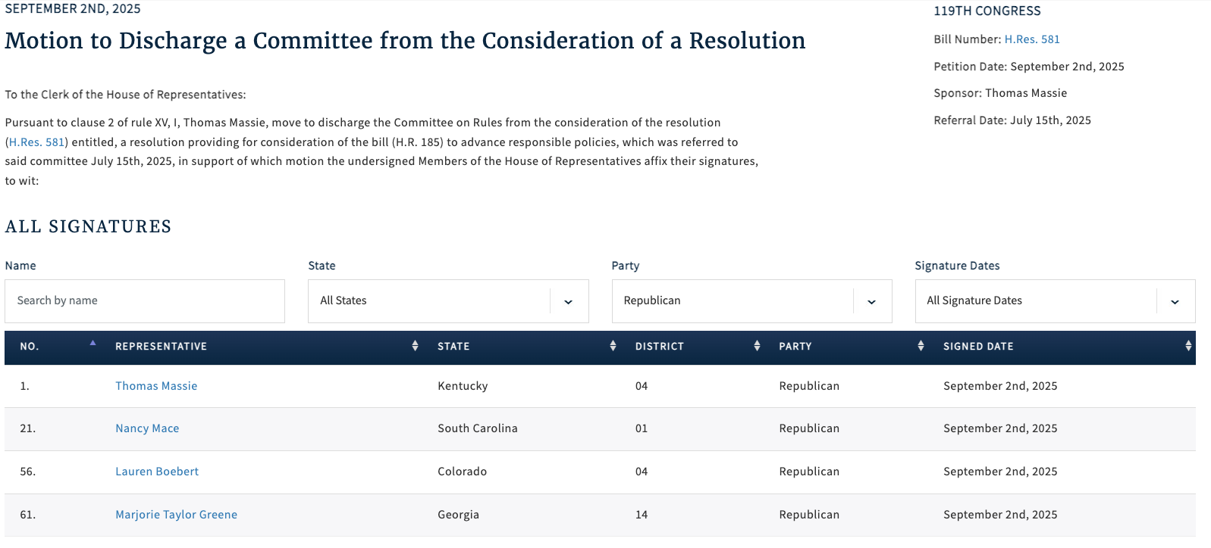
[Clerk of the U.S. House of Representatives, Discharge Petition No. 9, 9/2/25]

And Ciscomani Never Co-Sponsored Legislation that Called for The Epstein Files to Be Released
As Of November 25, 2025, Ciscomani Was Not Listed As A Co-Sponsored On Rep. Thomas Massie’s Legislation That Called To Release The Epstein Files.
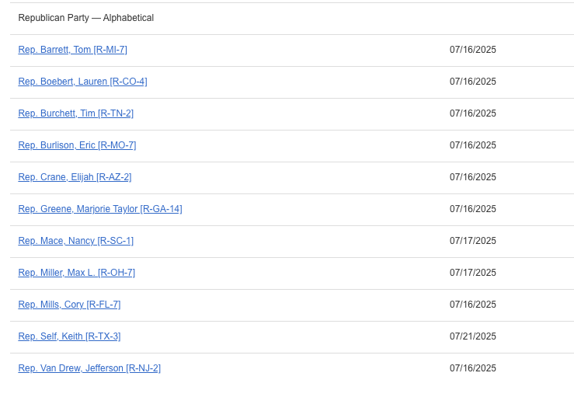
[U.S. House of Representatives, H.Res.581, Introduced 7/15/25]
- H.Res.581 Called On The Justice Department To Release All Unclassified Documents That Related To Jeffrey Epstein Or Ghislaine Maxwell. According to Congress.gov, H.Res.581 would, “This resolution provides a special rule for consideration of H.R. 185 and amends that bill to direct the Department of Justice (DOJ) to make publicly available certain records related to Jeffrey Epstein or Ghislaine Maxwell. Under H.R. 185, as amended by the resolution, DOJ must publicly disclose all unclassified records, documents, communications, and investigative materials in its possession that relate to Epstein or Maxwell. The records include unclassified records referring or relating to Epstein’s detention and death; flight logs of aircraft owned or used by Epstein; individuals named in connection with Epstein’s criminal activities, civil settlements, or immunity or plea agreements; immunity deals, sealed settlements, or plea bargains of Epstein or his associates; entities with ties to Epstein’s trafficking or financial networks; and internal Department of Justice communications concerning decisions to investigate or charge Epstein or his associates. However, under the amended bill, DOJ may withhold or redact portions of records with written justification that such portions contain (1) victims’ personally identifiable information; (2) child sexual abuse materials; (3) images of death, physical abuse, or injury; (4) information which would jeopardize an active federal investigation or prosecution; or (5) classified information. DOJ may not withhold or redact records on the basis of embarrassment, reputational harm, or political sensitivity. Further, within 15 days of completing the required disclosures, DOJ must provide Congress with a report listing all categories of records released and withheld, all redactions made and their legal basis, and all government officials and politically exposed persons named or referenced in the released materials.” [U.S. House of Representatives, H.Res.581, Introduced 7/15/25]

And Ciscomani Previously Voted Against Releasing the Epstein Files

September 2025: Ciscomani Voted Against Releasing The Epstein Files
2025: Ciscomani Effectively Voted Against Releasing The Epstein Files. In September 2025, Ciscomani voted for, according to Congressional Quarterly, “adoption of the rule [that] […] would consider as adopted a resolution (H Res 668) that would direct the House Oversight and Government Reform Committee to continue its ongoing inquiry into the possible mismanagement of the federal government’s investigation of disgraced financier Jeffrey Epstein and his associate Ghislaine Maxwell, the circumstances surrounding Epstein’s death in federal custody, sex trafficking rings and potential ethics violations by elected officials. […] It also would table a rule (H Res 598) that would provide for the adoption of a resolution (H Res 589) concerning the release of certain documents related to the Epstein case.” The vote was on the rule. The House agreed to the rule by a vote of 212 to 208. [House Vote 222, 9/3/25; Congressional Quarterly, 9/3/25; Congressional Actions, H.Res. 672]
- Representatives Massie And Khanna Introduced A Discharge Petition To Force A Vote On The Release Of The Files With Four Republicans Signed On To It As Of Mid-September. According to NBC News, “In the House, the ‘discharge petition’ to force a vote on the Massie-Khanna legislation is on track to succeed. It has 216 signatures — including all Democrats and four Republicans — and needs just two more. Those two are expected to arrive this month in the form of a newly elected Democrat in a Virginia special election and another safe blue seat in Arizona that will get a special election in late September. Massie told NBC News on Tuesday that the four Republicans who have signed on are solidly behind the effort and won’t bow to pressure to remove their names. He said other GOP lawmakers have signaled to him they are open to signing the petition but prefer not to get crosswise with Trump or party leaders publicly if their votes aren’t needed to pass it. [NBC News, 9/10/25]

July 2025: Ciscomani Was The Deciding Vote Against Releasing The Epstein Files
2025: Ciscomani Voted To Block The Release Of The Epstein Files. In July 2025, Ciscomani voted for, according to Congressional Quarterly, the “motion to order the previous question on the rule (H Res 580) providing for floor consideration of the fiscal 2026 Defense appropriations bill (HR 4016), the Anti-CBDC Surveillance State Act (HR 1919), the Digital Asset Market Clarity Act (HR 3633) and the Guiding and Establishing National Innovation for U.S. Stablecoins (GENIUS) Act (S 1582).” The vote was on the previous question. The House agreed to the motion by a vote on of 211 to 210. [House Vote 194, 7/15/25; Congressional Quarterly, 7/15/25; Congressional Actions, H. Res. 580]
- The Vote Served As A Referendum With Its Passage Blocking Consideration Of Representative Khanna’s Amendment To Require Release Of The Epstein Files. According to Politico, “Rep. Ro Khanna (D-Calif.) had slightly more success mounting an effort to amend cryptocurrency-related legislation scheduled to hit the House floor later this week to compel the release of Epstein-related files. Democrats forced a Rules Committee vote on whether to allow a floor vote on Khanna’s amendment; Republicans voted it down, though one Rules member in their ranks, Rep. Ralph Norman of South Carolina, crossed party lines. On the floor Tuesday afternoon, House Democrats attempted to cast a procedural vote as a referendum on releasing the so-called Epstein files. Had their effort to vote down the motion succeeded, they said, they would have moved forward with Khanna’s amendment. But the ‘previous question’ vote, which hasn’t been won by the House minority since 1988, prevailed 211-210 on party lines.” [Politico, 7/15/25]
- If Rep. Ro Khanna’s Maneuver Had Been Successful It Would Have Set Aside The House Republican Majority’s Agenda For The Day In Favor Of Considering Khanna’s Legislation. According to Axios, “What happened: The House voted 211-210 against allowing a House vote on Rep. Ro Khanna’s (D-Calif.) measure to force the DOJ to publish the Epstein files online within 30 days. Democrats’ procedural motion would have scuttled the GOP’s legislative agenda for the day in favor of the Khanna bill, making it difficult for Republicans to vote for it. The vote fell along party lines, with all Democrats who were present voting for their party’s maneuver and all Republicans voting against it. It came after Republicans on the House Rules Committee voted Monday night against attaching the Epstein language to a broader cryptocurrency and defense funding vote.” [Axios, 7/15/25]

If One “Aye” Vote Had Switched To A “No” Vote In House Vote 194, The Measure Being Considered Would Have Failed Instead Of Passing
The Measure Considered In House Vote 194 Passed With 211 “Ayes” And 210 “Nos,” Which Meant If One Aye Vote Had Switched To A No Vote The Measure Would Have Instead Failed.
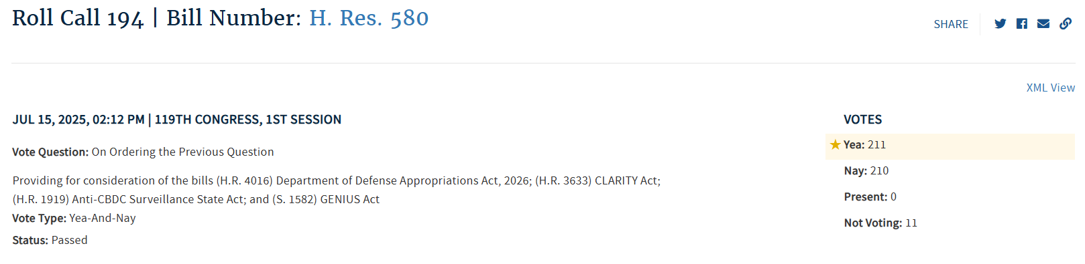
[House Vote 194, 7/15/25; Congressional Quarterly, 7/15/25; Congressional Actions, H. Res. 580]

