Overview
Ciscomani was a threat to women’s reproductive freedom. In April 2024, in response to an 1864 near-total abortion ban going into effect in Arizona, Ciscomani expressed support for the 15-week abortion ban more recently passed by the Arizona legislature.
In congress, Ciscomani has repeatedly voted against protecting reproductive rights, including against protecting service members’ right to travel to access reproductive care and to restrict access to mifepristone.
In 2022, Ciscomani ran as a “pro life” candidate and advocated for restricting access to abortion care for Arizonans. Ciscomani celebrated the overturning of Roe v. Wade. When he worked in Governor Doug Ducey’s office, Ciscomani was responsible for helping appoint anti-abortion state supreme court justices.
In 2008, Ciscomani campaigned on stripping Arizonans of reproductive health care. While running for state house, Ciscomani said he was a “pro-life candidate” and was endorsed by anti-abortion groups, like Arizona Right to Life. Before getting elected to congress, Ciscomani also shared graphic anti-abortion messaging and images on his personal social media platforms.

Ciscomani Was A Danger To Women’s Health And Reproductive Freedom

April 2024: In Response to A Near-Total Abortion Ban from 1864 Going Into Effect, Ciscomani Expressed Support for Arizona’s 15-Week Abortion Ban
Ciscomani Defended Arizona’s 15-Week Abortion Ban And Claimed It “Protected The Rights Of Women And New Life.”
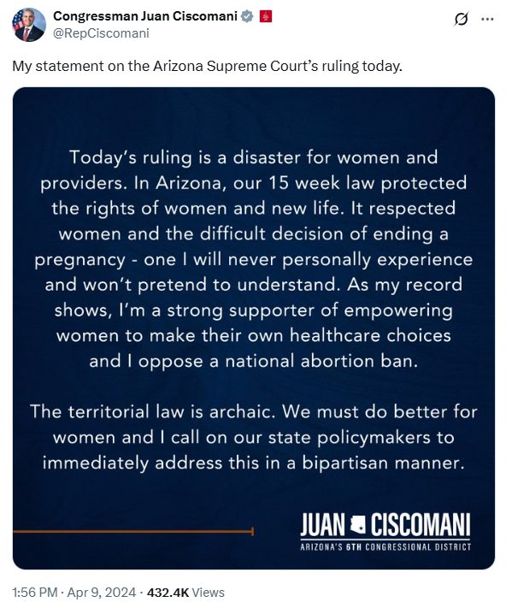
[Facebook, Congressman Juan Ciscomani, 4/9/24]

In Congress, Ciscomani Voted Against Protecting Reproductive Rights

Ciscomani Voted Against Protecting Service Members’ Right To Travel To Access Reproductive Care
Ciscomani Voted To Block The Defense Department From Reimbursing Members Of The Military For Traveling To Receive Abortion Care. According to the Tucson Sentinel, “Ciscomani also voted in favor of HR 2670 and several similar pieces of legislation that would have blocked the Defense Department from paying for or reimbursing expenses for members of the U.S. military or their family members who have to travel to different states to seek abortion care if they cannot access those services in the state where they are stationed.” [Tucson Sentinel, 10/1/24]
- 2024: Ciscomani Voted To Prohibit The Defense Department From Paying Or Reimbursing Abortion-Related Costs. In June 2024, Ciscomani voted for , according to Congressional Quarterly, “amendment no. 55 that would prohibit the Defense Department from paying for or reimbursing certain expenses relating to abortion services.” The vote was on the amendment. The underlying legislation was the FY 2025 National Defense Authorization Act. The House adopted the amendment by a vote of 214 to 207. [House Vote 263, 6/13/24; Congressional Quarterly, 6/13/24; Congressional Actions, H.Amdt.989; Congressional Actions, H.R. 8070]
2023: Ciscomani Effectively Voted To Repeal A 2022 Memorandum Regarding Traveling For Reproductive Care. In September 2023, according to Congressional Quarterly, Ciscomani voted against the “motion to instruct conferees on the part of the House to disagree to section 716, which would repeal an October 2022 Defense Department memorandum concerning traveling for reproductive health care.” The vote was on a motion to instruct conferees. The House rejected the motion by a vote of 205 to 214. [House Vote 400, 9/20/23; Congressional Quarterly, 9/20/23; Congressional Actions, H.R. 2670]
- The 2022 Memorandum Ensured Service Members And Their Families Access To Reproductive Care. According to the Congressional Research Service, “On October 20, 2022, the Secretary of Defense issued a memorandum directing actions to ensure that servicemembers and their families ‘can access reproductive health care and [DOD] health care providers can operate effectively.’ The memo directed the department to establish travel and transportation allowances for servicemembers and their dependents to obtain noncovered reproductive health care that is unavailable in the ‘local area of a Service member’s permanent duty station,’ and establish a reimbursement program to assist a DOD health care provider with obtaining a professional license in another state ‘in order to support the performance of their official duties.’ Section 716 would repeal the October 20, 2022, DOD memorandum and prohibit DOD from using funds to implement the memorandum or a potential successor memorandum. The provision would also amend 10 U.S.C. §1093 to prohibit the Secretary of Defense from paying for or reimbursing fees or expenses for DOD health care providers to obtain a health care license in a state for the purpose of providing abortion services.” [Congressional Research Service, 9/6/23]
2023: Ciscomani Voted To Repeal A 2022 Defense Department Policy Regarding Reproductive Health Care And Prohibit The DoD From Paying For Abortion Services. In July 2023, according to Congressional Quarterly, Ciscomani voted for the National Defense Authorization Act for Fiscal Year 2024, which would “repeal a 2022 Defense Department memorandum regarding access to reproductive health care and prohibit the department from paying for or reimbursing expenses relating to abortion services.” The vote was on passage. The House passed the bill by a vote of 219 to 210, thus the bill was sent to the Senate. [House Vote 328, 7/14/23; Congressional Quarterly, 7/14/23; Congressional Actions, H.R. 2670]
- The Provision Of The FY 2024 NDAA Would Reverse A DoD Policy That Reimburses Expenses For Military Members Who Traveled For Abortion Services. According to Reuters, “The House voted 221 to 213 for an amendment that would reverse the Defense Department’s policy of reimbursing expenses for service members who travel to obtain an abortion.” [Reuters, 7/14/23]
- The Abortion Reimbursement Policy Sought To Help Military Members In Need Of Abortion Services Who Were Stationed In States With Abortion Bans. According to Reuters, “The Pentagon travel reimbursement policy is aimed at helping those in the military or family members who are seeking an abortion but stationed in states that have outlawed it.” [Reuters, 7/14/23]

Ciscomani Voted To Restrict Access To Mifepristone
Ciscomani Supported A Funding Bill That Included A Provision To Revoke An FDA Ruling That Allowed For Mail Distribution Of Mifepristone, Which Was Used For Abortions. According to the Arizona Republic, “Rep. Juan Ciscomani has long been adamant that abortion is a state’s rights issue, rather than a federal issue. Now, he’s changing his stance in what he’s touting as an effort to avoid a government shutdown. […] One bill that is still on the floor appropriates funding for the Department of Agriculture, the Department of Rural Development, the Food and Drug Administration and related agencies. As with other appropriation bills, the Republican majority has taken opportunities to slide social priorities into the bill, including one that limits abortion access. Located on page 107 of the 113-page bill, the provision nullifies a previous FDA ruling that allowed for the by-mail distribution of mifepristone, a medication used for abortions. Politico reported last week that a group of 12 ‘moderate Republicans’ are refusing to support the bill unless the provision is removed, and Ciscomani isn’t one of them. Ciscomani voted to pass the bill out of committee because of how much the overall package could help his district, despite it contradicting his ideal that abortion is a state issue, a House GOP staff member said.” [Arizona Republic, 8/5/23]
Ciscomani Voted For A Bill That Restricted Distribution Of Mifepristone By Mail Despite Claiming Abortion Was An Issue For The States And Not The Federal Government. According to 19th News, “He has long characterized abortion as an issue for the states and not the federal government but as a member of the House Appropriations Committee backed banning the distribution of mifepristone by mail. The provision was not included in the final bill over the objections of moderate Republicans.” [19th News, 10/7/24]

June 2022: Ciscomani Celebrated The Overturning Of Roe v. Wade

June 2022: Ciscomani Celebrated The Supreme Court Decision Overturning Roe V. Wade
June 2022: On The Day Roe Was Overturned, Ciscomani Tweeted, “I Applaud The Supreme Court’s Decision To Overturn Roe V Wade. #Lifewins.” According to tweet on Juan Ciscomani’s campaign Twitter, “A historic day! I applaud the Supreme Court’s decision to overturn Roe v Wade. #LifeWins ‘A historic day! I applaud the Supreme Court’s decision to overturn Roe v Wade. These policies should be set by our states and by We The People. I’m proudly Pro-Life and will always defend life as a member of Congress. As a husband and a father, I believe that life is precious, and as a county, we must protect women and children in every way possible.’”
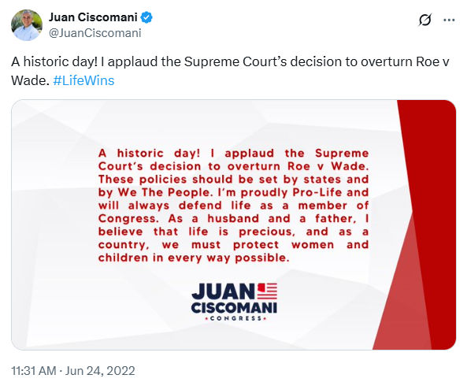
[Twitter, @JuanCiscomani, 6/24/22]

2022: Ciscomani Ran As A “Pro Life” Candidate And Advocated For Restricting Access To Abortion Care For Arizonans
Ciscomani Said He Only Approved Of “Limited” Abortion Exceptions For Cases Of Rape, Incest, Or The Life Of A Mother
2022: Ciscomani Said He Supported Prohibiting Abortion With “Limited” Exceptions For Rape, Incest, And The Life Of A Mother. According to the 2022 Arizona Voter Guide, “2. Prohibiting abortion except when it is necessary to prevent the death of the mother. S* I am pro-life and against abortion, with limited exceptions for cases of rape, incest and the life of the mother.”
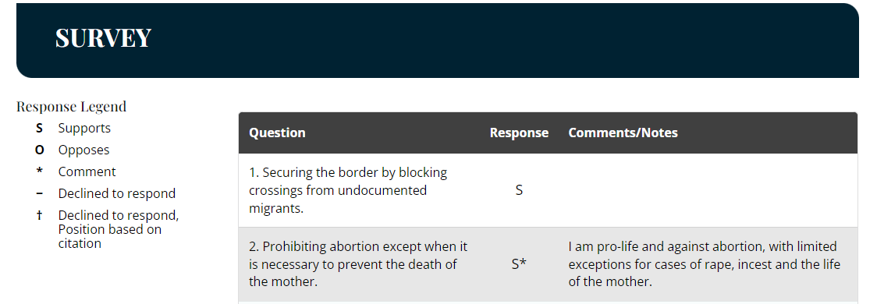
[Arizona Voter Guide, Archived 10/11/22 via archive.org]
On His 2022 Campaign Website, Ciscomani Said He Was “Pro Life With Exceptions For Rape, Incest, And Protecting The Life Of The Mother.” According to Juan Ciscomani’s 2022 campaign website, “Juan’s position on this issue has been consistent since the start of his campaign. Juan will never do anything to jeopardize a woman’s health. Juan is pro-life with exceptions for rape, incest, and protecting the life of the mother.”
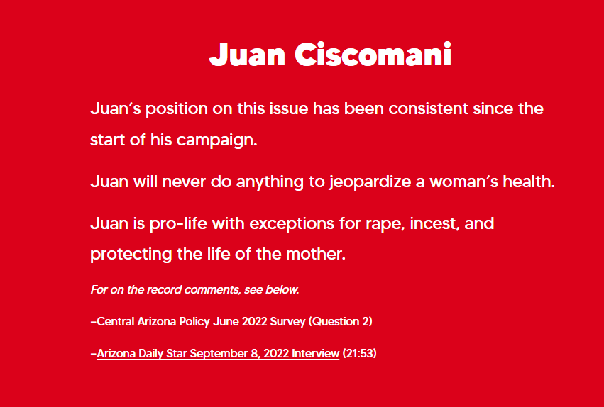
[Ciscomani for Congress, Get the Facts, Archived 11/8/22 via archive.org]
Ciscomani In 2022: “I’m Pro-Life.” According to a post on Juan Ciscomani’s Twitter, “FACT: Engel is the one with the extreme position: taxpayer-funded abortion and abortion up until the moment of birth — her position has NO exceptions. My position has been consistent: I’m pro-life and support exceptions for rape, incest & the life of the mother.” [Twitter, @JuanCiscomani, 9/24/22]
2022: In The Abortion Issue Section Of His Campaign Website, Ciscomani Said He Was “Proudly Pro Life.” According to Juan Ciscomani’s 2022 campaign website, “Juan is proudly pro-life. He is the dad of six kids: 3 boys and 3 girls. “ [Ciscomani for Congress, accessed 2/16/23]

[Juanciscomani.com, Issues, Archived 11/7/22 via archive.org]

When He Worked In Governor Doug Ducey’s Office, Ciscomani Was Responsible For Helping Appoint Anti-Abortion State Supreme Court Justices
HEADLINE: “How Rep. Ciscomani Helped Pack The Arizona Supreme Court With Anti-Abortion Judges” [Copper Courier, 5/9/24]
All Four Justices Who Voted To Reinstate Arizona’s 1864 Abortion Ban Were Appointed When Ciscomani Worked For Former Governor Ducey, Where He Was Tasked With Vetting Judicial Nominees. According to the Copper Courier, “Prior to elected public service, Ciscomani worked as a high-level advisor in former Gov. Doug Ducey’s administration for nearly a decade, meeting with him weekly and one of four staffers tasked with vetting judicial nominees before the judges were reviewed by the governor. All four of the justices who voted to reinstate the 1864 ban were appointed while Ciscomani worked in this capacity. A fifth sitting justice, Bill Montgomery, was also appointed by Ducey but recused himself from the abortion ban ruling because his extreme bias against abortion healthcare was made public.” [Copper Courier, 5/9/24]
- Part Of Former Arizona Governor Ducey’s Process For Vetting Potential Judicial Nominees Included A Meeting With Ciscomani. According to the Arizona Capitol Times, “The Ninth Floor’s vetting process for judicial applicants has become more stringent since Gov. Doug Ducey took office in January. Ducey has added several new layers to the selection process for trial court and appellate court judges and Arizona Supreme Court justices, taking a more hands-on approach that gives his office significantly more engagement. […] Applicants must interview with members of the governor’s staff, including some with legal backgrounds, before they sit down with the governor himself. Liburdi said the staff interviews include different questions than the ones the governor is likely to ask, such as substantive legal questions and candidates’ positions on issues such as separation of powers and rulemaking. Applicants typically meet with Liburdi; his deputy, Kate King; health care adviser Christina Corieri; and Juan Ciscomani, who runs Ducey’s southern Arizona office and is a former member of the commission that selects candidates for Pima County Superior Court.” [Arizona Capitol Times, 10/23/15]
- October 2016: Ciscomani Posted On Facebook That He Was Part Of Former Governor Ducey’s Team That Interviewed Potential Judicial Candidates Before They Met With The Governor. According to the Copper Courier, “One of the justices who were vetted and appointed after the court was expanded—John Lopez IV in December 2016—joined King in the decision to reinstate the total abortion ban, as did fellow Ducey appointees Clint Bolick and James Beene. ‘I have the privilege of being part of the Governor’s team who interviews judicial candidates before they meet with him,’ Ciscomani said in an October 2016 Facebook post. ‘We met with 7 outstanding candidates for the AZ Supreme Court. I’m in that room because of Governor Ducey’s commitment to have Southern AZ at the table when making key decisions that impact our state.’ ‘Thanks Juan,’ Justice Bolick replied to the post. ‘Looking forward to having two terrific new colleagues.’” [Copper Courier, 5/9/24]

2008: Ciscomani Previously Campaigned On Stripping Arizonans Of Reproductive Health Care

2008: While Running For State House, Ciscomani Said He Was A “Pro-Life Candidate”
Ciscomani In September 2008: “I Am A Pro-Life Candidate.” According to the Arizona Daily Star, “Meanwhile, the two Republican hopefuls, Juan Ciscomani and Pat Kilburn, are stepping up their campaigns, hoping to snag independent and Democratic voters and crash the legislative party this fall. […] Ciscomani, 26, is relying more on his ties to the district and personal narrative to reach voters. His family immigrated to the country legally in 1994 from Mexico when he was 11 years old. He is deeply connected to his church, Centro Cristiano Carismatico. ‘We have a lot of churches in the area. I am a pro-life candidate,’ he said. ‘We are really working hard, getting out there, focusing on the south side of the district.’” [Arizona Daily Star, 9/15/08]
2008: Ciscomani Was Endorsed By Arizona Right To Life, An Organization That Pushed For Roe V. Wade To Be Overturned
2008: Ciscomani Was Endorsed By Right To Life. According to Juan Ciscomani’s 2008 campaign website, “JUAN IS ENDORSED BY: Tucson Metropolitan Chamber of Commerce. Southern Arizona Home Builders Association. Southern Arizona Hispanic Leadership Council. Right to Life. Realtors of Arizona.”
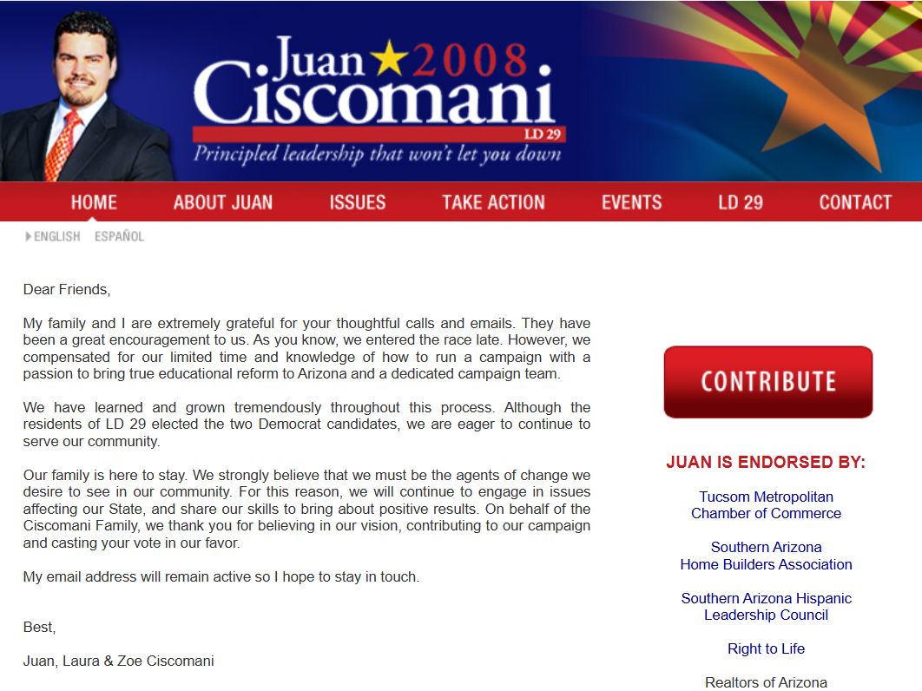
[JuanCiscomani.com, Archived 11/6/08 via archive.org]
- 2008: Arizona Right To Life Tucson’s Website Stated Their Goal Was To “Push For The Over Turn Of Roe Vs. Wade!” According to Arizona Right to Life Tucson’s website, “Our mission is to protect the most precious resource we have, life. Our goal is to support pro-life organization and causes and push for the over turn [sic] of Roe vs. Wade! Now with this Supreme Court, we finally have a chance to over turn [sic] Roe vs. Wade.” [Arizona Right to Life Tucson Chapters, Archived 8/28/08 via archive.org]
- 2008: Arizona Right To Life Tucson’s Website Stated, “We Demand Pro-Life Supreme Court Judges To Overturn This Horrible Supreme Court Decision [Roe V Wade].” According to Arizona Right to Life Tucson’s website, “Our mission is to protect the most precious resource we have, life. Our goal is to support pro-life organization and causes and push for the over turn of Roe vs. Wade! Now with this Supreme Court, we finally have a chance to overturn Roe vs. Wade. We demand pro-life judges on the Supreme Court to over turn this horrible court decision. Remember this effort will take constant emails, phone calls, and letters to our national, state, local representatives and media, as well as our participation in such events as the March for Life, Walk for Life, Diaper drive etc, and our local Pregnancy Centers. So please join one of Tucson’s local chapters, or if your from another area, form your own chapter, because life is precious!”
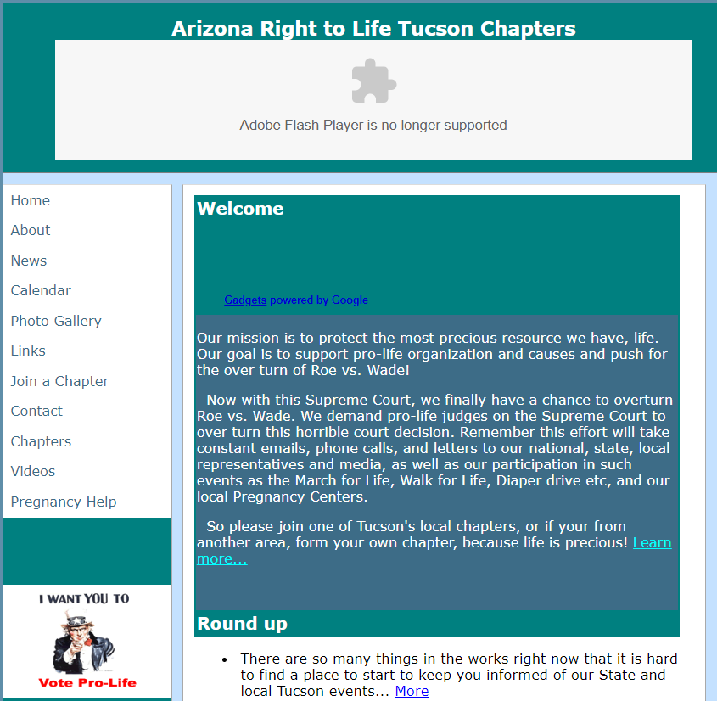
[Arizona Right to Life Tucson Chapters, Archived 8/28/08 via archive.org]

Before Getting Elected to Congress, Ciscomani Shared Graphic Anti-Abortion Messaging and Images on His Personal Social Media Platforms

2012: Ciscomani Shared A Graphic Photo From Texas Alliance For Life Showing A Bloody Fetus Holding A Surgeon’s Hand And Captioned The Post, “Every Life Is Beautiful And Worth Fighting For!”
October 2012: Ciscomani Shared A Graphic Post From Texas Alliance For Life And Captioned The Photo, “Wow, What An Amazing Moment. Every Life Is Beautiful And Worth Fighting For!” According to Facebook, Ciscomani shared a post from Texas Alliance for Life, “In 1999, photographer Michael Clancy took this picture during an in utero spina bifida corrective surgery at Vanderbilt University Medical Center. The unborn baby boy was 21 weeks old during this surgery. Samuel is now a happy, healthy 12 year old. This remarkable image of a baby reaching out from the womb during surgery should remind us all: take my hand, not my life.” The post featured an image of a fetus holding a surgeon’s hand, with the caption “Take my hands… not my life….” Ciscomani wrote, “Wow, what an amazing moment. Every life is beautiful and worth fighting for!” [Facebook, Juan Ciscomani, 10/28/12]

2016: Ciscomani Shared A Photo With A 4D Ultrasound Of A Fetus At 20 Weeks Posted By Pro-Life Wisconsin
August 2016: Ciscomani Shared A Post From “Pro-Life Wisconsin” That Featured A 4D Ultrasound Of A Fetus And Wrote, “He/She Is ALIVE…No Question…And So Is EVERY Baby Inside Their Mommy’s Womb.” According to Facebook, Ciscomani shared a post by Pro-Life Wisconsin, “WOW. Check out these 4D ultrasounds videos at 20 weeks. Life is a miracle!” adding, “This is AMAZING!!! Laura this is what our baby is doing right now! He/She is ALIVE…no question…and so is EVERY baby inside their mommy’s womb. We recently saw our baby’s sonogram and heard the heart beat. We’ve been through this process 5 times and it never gets old, actually it’s more exciting each time. How can you love someone so much when you haven’t met him/her yet? I know Becky and Kevin can relate!…baby freeman in less than a week! LIFE beautiful!” [Facebook, Juan Ciscomani, 8/5/16]

