Overview
As late as 2024, Reid attacked the Affordable Care Act and lamented that the law “won’t go away.” Reid claimed those who benefitted from the ACA used “every sob story” to uphold the law, and that he resented having to pay for “free healthcare” for “people who don’t want to work.” Reid claimed that paying for one’s own healthcare was a “patriotic responsibility.”

Reid Opposed The Affordable Care Act

Reid Wrote Of The Affordable Care Act: “The GOP Didn’t Kill This Horrible Program When It Had The Chance”
2024: Reid Wrote Of The Affordable Care Act: “The GOP Didn’t Kill This Horrible Program When It Had The Chance.” According to John Reid for Lieutenant Governor of Virginia on Facebook, “Don’t be suckered into more Obamacare promises. My healthcare stinks… hate it… and hate even more that I am paying more and more for other people to get free healthcare. Talk about fair? Equity? And the GOP didn’t kill this horrible program when it had the chance. Now the rich are richer and working people are getting stomped. Don’t be fooled again!”
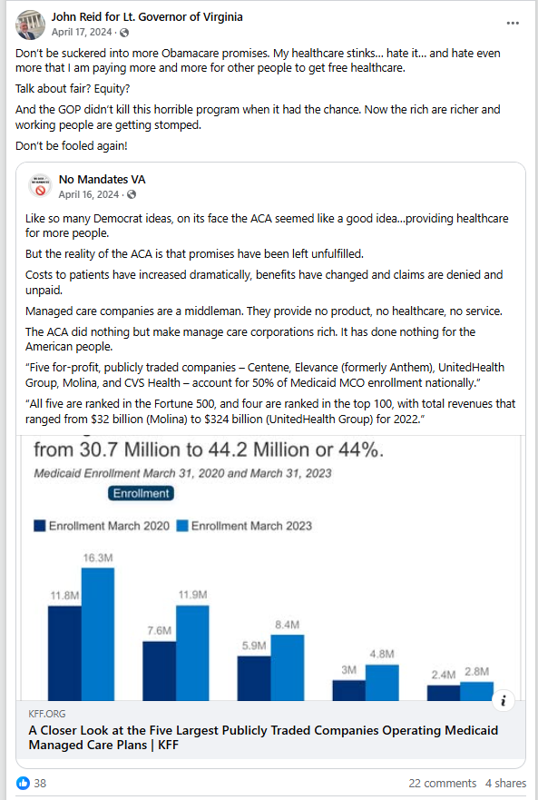
[Facebook, John Reid for Lieutenant Governor of Virginia, 4/17/24]

Reid: “Obamacare Is The Herpes Of Public Policy…. It Won’t Go Away And Keeps Getting Worse”
2022: Reid: “Obamacare Is The Herpes Of Public Policy…. It Won’t Go Away And Keeps Getting Worse.” According to John Reid for Lieutenant Governor of Virginia on Facebook, “Obamacare is the herpes of public policy…. It won’t go away and keeps getting worse.”
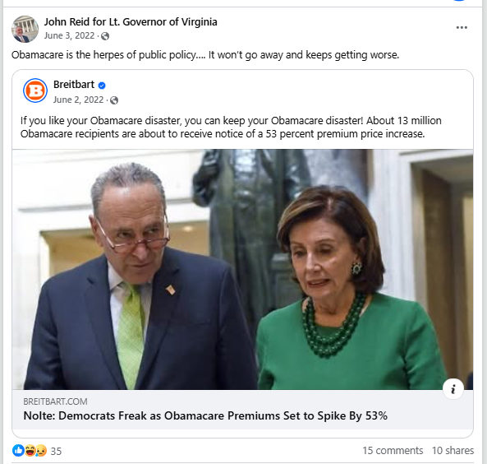
[Facebook, John Reid for Lieutenant Governor of Virginia, 6/2/22]

Reid Called The Affordable Care Act “One Of The Worst Ideas In American History,” And Claimed Its Supporters Used “Every Sad Sob Story” To Uphold The Law
2020: Reid Called The Affordable Care Act “One Of The Worst Ideas In American History,” And Claimed Its Supporters Used “Every Sad Sob Story” To Uphold The Law. According to John Reid for Lieutenant Governor of Virginia on Facebook, “Oh new focus... this hearing isn’t about the Supreme Court, it’s actually about Obamacare. One of the worst ideas in American history. Every sad sob story will be used to convince Americans that magic government money will buy them ‘free’ expensive stuff. And they tell this Fairy Tale- even as we watch country after country around the world collapse financially because the magic money runs out and they can’t pay for all the benefits the socialists promised them.”
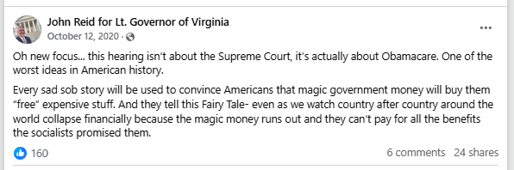
[Facebook, John Reid for Lieutenant Governor of Virginia, 10/12/20]

Reid Claimed The Affordable Care Act Forced Him To Pay For “Free Healthcare” For “People Who Don’t Want To Work”
2020: Reid Claimed The Affordable Care Act Forced Him To Pay For “Free Healthcare” For “People Who Don’t Want To Work.” According to John Reid for Lieutenant Governor of Virginia on Facebook, “Obamacare has been awful for me and it seems for most working Americans. I pay much more now - for a lot less. When I’m sick or worried about a health issue I routinely debate whether I can afford to go to the doctor even though my ridiculously high premium payment comes out of my paycheck every two weeks. But I DO get the privilege of being forced to pay for free healthcare- not for the elderly and handicapped citizens who can’t work- but for healthy people who don’t want to work or prioritize and pay for their own bills. Democrats in government continue to make life worse for those of us who wake up early every morning to work and contribute to society. It’s time to stop them and their bad ideas.”
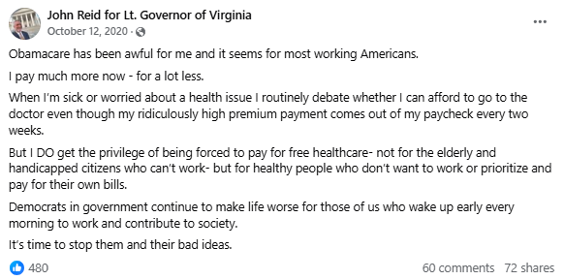
[Facebook, John Reid for Lieutenant Governor of Virginia, 10/12/20]

Reid Said Health Care Expenses Were “An Individual Bill That All Working Age Citizens Should Accept As Their Own Personal And Patriotic Responsibility”
2020: Reid Said Healthcare Expenses Were “An Individual Bill That All Working Age Citizens Should Accept As Their Own Personal And Patriotic Responsibility.” According to John Reid for Lieutenant Governor of Virginia on Facebook, “It is NOT my obligation to pay for your healthcare. And fortunately you should not have to pay for mine. This is an individual bill that all working age citizens should accept as their own personal and patriotic responsibility.”
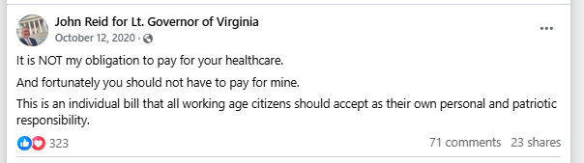
[Facebook, John Reid for Lieutenant Governor of Virginia, 10/12/20]

Reid Attacked The Late Sen. John McCain For Stopping Trump’s Attempted Affordable Care Act Repeal
2020: Reid Attacked The Late Sen. John McCain For Stopping Trump’s Attempted Affordable Care Act Repeal. According to John Reid for Lieutenant Governor of Virginia on Facebook, “Who cares? The same people who tried to destroy their own party nominee in 2016 are coming back to try again. And honestly mentioning John McCain after his active participation in the Russia collusion hoax and ultimate betrayal of his own supporters by stopping the repeal of Obamacare makes me even more confident I SHOULD support Trump.”
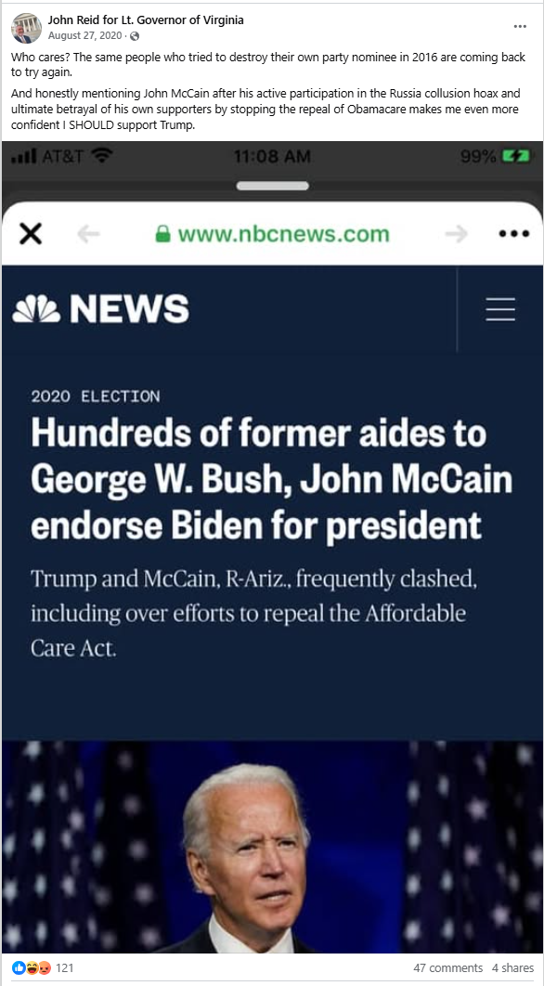
[Facebook, John Reid for Lieutenant Governor of Virginia, 8/27/20]

