Overview
Reid assailed Virginia’s public schools and called for them to be closed in favor of private schools. Reid said of public education in Virginia, “I say we break the whole system and start over… with vouchers to let people send their kids to their own choice!!!” In another Facebook post, Reid wrote, “It TRULY may be time to just close the public schools and hand out vouchers.

Reid Called For Fully Dismantling The Public School System

In 2025, Reid Called For Expanded “School Choice,” And Claimed Democratic Support For Public Schools Was “Ruining Generations Of Kids”
2025: Reid Called For Expanded “School Choice,” And Claimed Democratic Support For Public Schools Was “Ruining Generations Of Kids.” According to John Reid for Lieutenant Governor of Virginia on Facebook, “Why are Democrats sooooooo intent on locking your kids into schools that they KNOW are failing? No way out unless you’re rich. Governor of Virginia Glenn Youngkin and Lieutenant Governor of Virginia Winsome Earle-Sears keep trying to come up with innovative solutions for kids and families and these Democrats just refuse to be reasonable or fair (even with their own constituents who don’t have tons of money) It’s crazy! And it’s wrong. As Lt Governor I’m gonna keep fighting for your kids and your freedom to choose what’s best. And I’ll do it loudly on TV and radio and in person. No more nice covers for these people who are ruining generations of kids.”
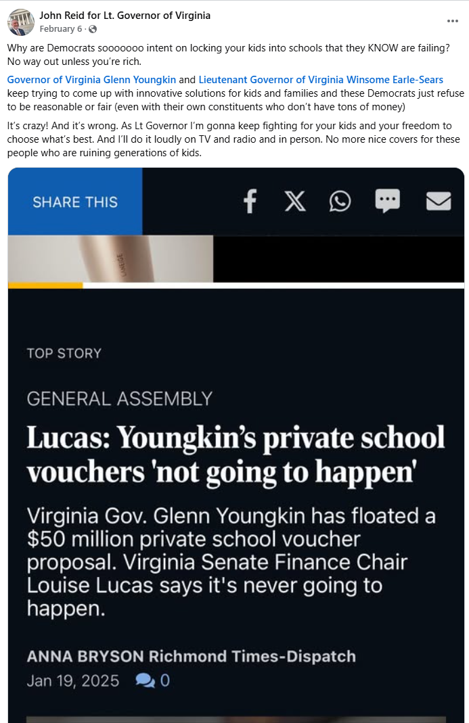
[Facebook, John Reid for Lieutenant Governor of Virginia, 2/6/25]

In 2025, Reid Supported Trump’s Move To Dismantle The U.S. Department Of Education, Writing “It’s Past Time To Make This Dramatic Readjustment”
2025: Reid Supported Trump’s Move To Dismantle The U.S. Department Of Education, Writing “It’s Past Time To Make This Dramatic Readjustment.” According to John Reid for Lieutenant Governor of Virginia on Facebook, “Many people still believe that the NAME of an agency actually reflects what the agency does. The federal Department of Education is actually about labor unions in schools and not about educating kids. . Not one metric has improved for American students since it was created in the 1970s. Our schools are more expensive and less effective and our students are shockingly less literate. It’s past time to make this dramatic readjustment.”
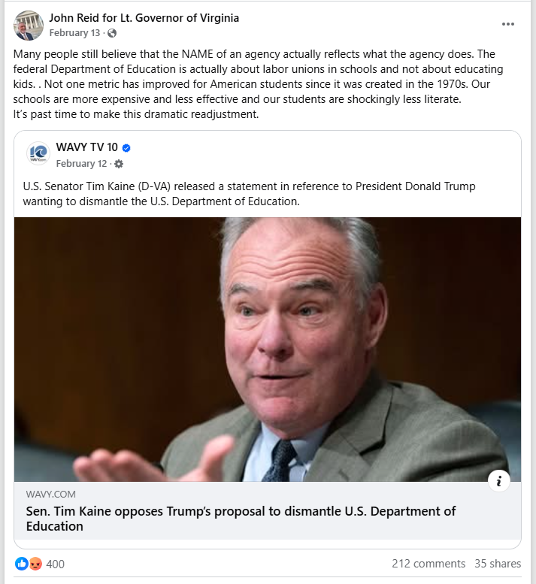
[Facebook, John Reid for Lieutenant Governor of Virginia, 2/13/25]

In 2023, Reid Attacked Virginia Public Schools As A “Disaster” And Said We Should “Break The Whole System And Start Over… With Vouchers To Let People Send Their Kids To Their Own Choice!!!”
2023: Reid Attacked Virginia Public Schools As A “Disaster” And Said We Should “Break The Whole System And Start Over… With Vouchers To Let People Send Their Kids To Their Own Choice!!!” According to John Reid For Lieutenant Governor of Virginia on Facebook, “Anybody wanna keep telling me how fine the public schools are?!? We all know they’re a disaster! So do we continue letting them exist like this or do we get tough and fix the problems and change the entire system? I say we break the whole system and start over… with vouchers to let people send their kids to their own choice!!!”
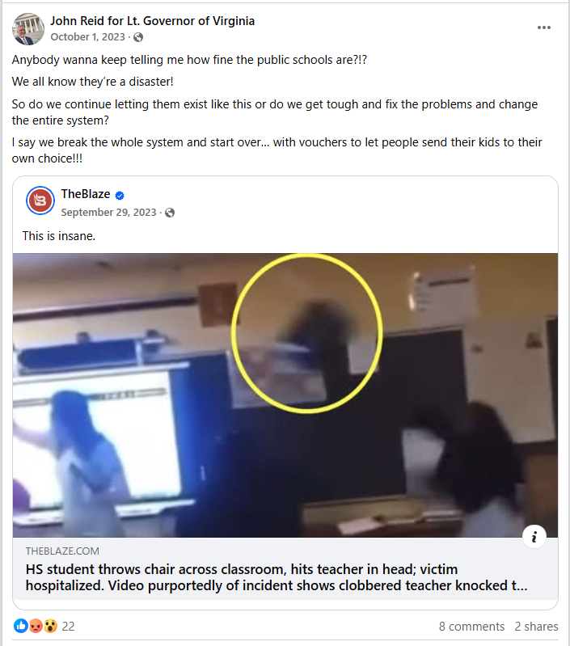
[Facebook, John Reid For Lieutenant Governor of Virginia, 10/1/23]

In 2022, Reid Wrote: “It TRULY May Be Time To Just Close The Public Schools And Hand Out Vouchers”
2022: Reid Wrote: “It TRULY May Be Time To Just Close The Public Schools And Hand Out Vouchers.” According to John Reid For Lieutenant Governor of Virginia on Facebook, “From all the absolutely crazy freak outs I’ve read online today from ‘teachers’ in Virginia who are either *pretending* to be terrified their unmasked students will infect and kill them or are really that stupid…. it TRULY may be time to just close the public schools and hand out vouchers. I’d be delighted if horrified liberal parents suddenly decided to lead the way towards school choice. Truly- and without malice- let them create their own medical bubble charter schools where they and their sad weak little rabbit children can all huddle in fear. If indulging this insanity ultimately allows every citizen to pick their own school for their kids it would be a good trade off.”

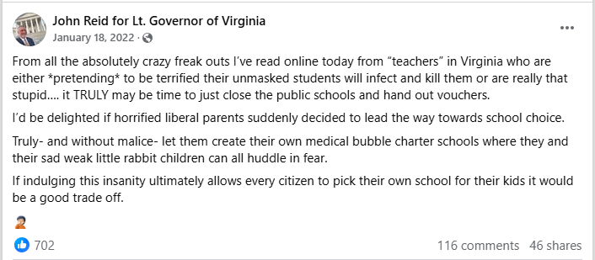
[Facebook, John Reid For Lieutenant Governor of Virginia, 1/18/22]

Reid’s Website: Reid’s “Focus Is Ensuring That Our Educational System Imparts Knowledge And Critical Thinking Skills, Not Political Bias”
Reid’s Website: Reid’s “Focus Is Ensuring That Our Educational System Imparts Knowledge And Critical Thinking Skills, Not Political Bias.” According to John Reid For Lieutenant Governor, “First-Class Learning in Education, Not Leftist Indoctrination John Reid believes we should prioritize first-class learning in education, free from leftist indoctrination. His focus is on ensuring that our educational system imparts knowledge and critical thinking skills, not political bias, preparing students for success in a diverse world instead of creating radical activists.” [John Reid For Lieutenant Governor, Issues, Viewed 5/7/25]

Reid’s Said He Wanted Government To “Provide Opportunities” For Kids, “But Not Mandates And Indoctrination,” And Emphasized “Parental Rights”
Reid’s Said He Wanted Government To “Provide Opportunities” For Kids, “But Not Mandates And Indoctrination,” And Emphasized “Parental Rights.” According to John Reid For Lieutenant Governor, “Protecting Parental Rights Your children are yours. They do not belong to the government and are not the responsibility of the state. John Reid wants the government to provide opportunities for your kids but not mandates and indoctrination. Parents must- in almost all cases- be the final decision makers in their children’s upbringing.” [John Reid For Lieutenant Governor, Issues, Viewed 5/7/25]

