Overview
Reid was a committed Trump supporter, and vocally backed even the Trump policies that harmed Virginia. Reid said of Trump’s mass firing of federal workers, many based in Virginia, “it’s bad and it’s gonna hurt but it has to be done.” Reid also defended Trump’s tariffs.

Reid Supported Trump’s Expansive Firings Of Federal Workers Based In Virginia, And Trump’s Tariff Policy

Reid Said Of Trump’s Federal Worker Firings: “It’s Bad And It’s Gonna Hurt But It Has To Be Done”
February 24, 2025: Reid Said Of Trump’s Federal Worker Firings: “It’s Bad And It’s Gonna Hurt But It Has To Be Done.” According to John Reid for Lieutenant Governor of Virginia on Facebook, “Poor Democrats- we are 36 Trillion Dollars in debt and they still don’t know how to balance a budget. You can’t tax your way to prosperity and sadly now it’s so bad we cant grow our way out of this either. You HAVE to make cuts. It’s bad and it’s gonna hurt but it has to be done. Governor Youngkin is actually trying to help people who need jobs! Maybe rather than complain and attack, Democrats could try to be a rational part of the solution??? Since- let’s be honest- they created the problem with unending welfare spending.”
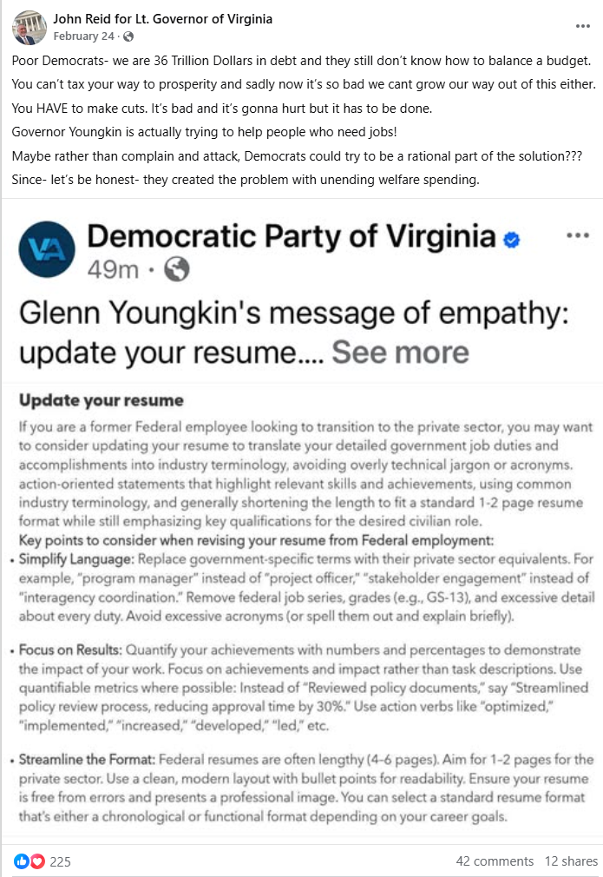
[Facebook, John Reid for Lieutenant Governor of Virginia, 2/24/25]

In April 2025, Reid Attended A Celebration Of Trump’s First 100 Days At Trump’s D.C. Golf Club, And Wrote “Trump Is Doing The Awful Hard Work” To “Right The Ship Of State And Save Our Valuable Western Culture”
April 2025: Reid Attended A Celebration Of Trump’s First 100 Days At Trump’s D.C. Golf Club, And Wrote “Trump Is Doing The Awful Hard Work” To “Right The Ship Of State And Save Our Valuable Western Culture.” According to John Reid for Lieutenant Governor of Virginia on Facebook, “The Golden Age of America was the theme of last night’s sold out Loudoun County GOP gala! It was spectacular and filled with people representing the broad coalition of Americans who want to save the nation for future generations and prevent the socialist anger and failure that Democrats keep trying to sell. I was so honored to be asked to speak to the crowd and tell our friends to stand strong while painful and difficult decisions are made to right the ship of state and to save our valuable Western Culture. When we are $36 Trillion dollars in debt and basic truths are tossed aside with emotions, there are major adjustments that MUST be made. Trump is doing the awful hard work that almost every other politician has been too scared or weak to do for 40 years. Let’s patiently and empathetically and calmly explain what is happening and let’s build the coalition to win in Virginia THIS year!! Congrats to the Loudoun GOP for their success!”
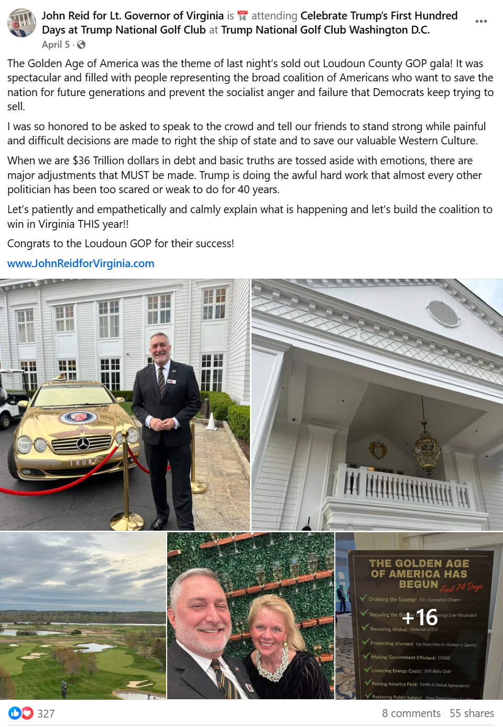
[Facebook, John Reid for Lieutenant Governor of Virginia, 4/5/25]

On April 8, 2025, Reid Defended Trump’s Tariffs, Calling Trump “A Lot Smarter” Than “The International Politicians”
April 8, 2025: Reid Defended Trump’s Tariffs: “The Trump Tariffs Aren’t Really Tariffs – They’re A Short Term Tool To Disrupt The Status Quo… The NYC Business Guy Appears To Be A Lot Smarter Than The International Politicians.” According to John Reid for Lieutenant Governor of Virginia on Facebook, “The Trump tariffs aren’t really tariffs - they’re a short term tool to disrupt the status quo that has been killing American workers and businesses. You may not like Trump’s personality but the NYC business guy appears to be a lot smarter than the international politicians. I think that is regularly proven and is being validated once again. That’s why union workers who make things are siding with Trump. Now can the GOP figure it out too?”
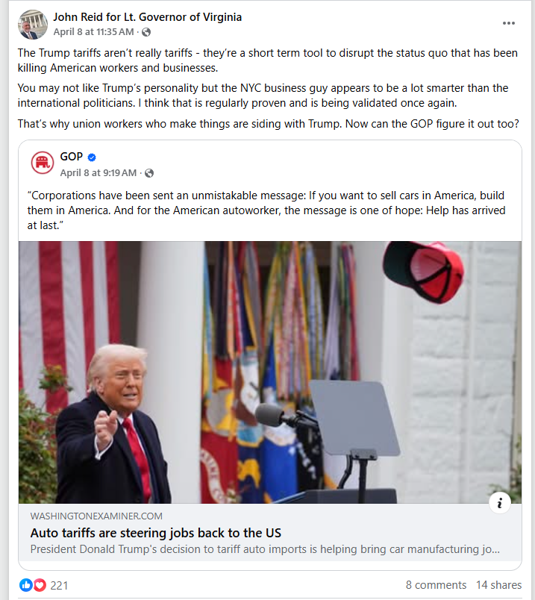
[Facebook, John Reid for Lieutenant Governor of Virginia, 4/8/25]

Reid Posed Next To A Gold-Plated Mercedes-Benz With Trump’s Face On It Days After Trump Announced Sweeping Tariffs That Were Expected To Raise Prices For Consumers

April 5, 2025: Reid Posted A Photo Of Himself Posed In Front Of A Gold-Plated Mercedes Benz With Trump’s Face On It At Trump’s Golf Club In Washington D.C. According to John Reid for Lieutenant Governor of Virginia on Facebook,
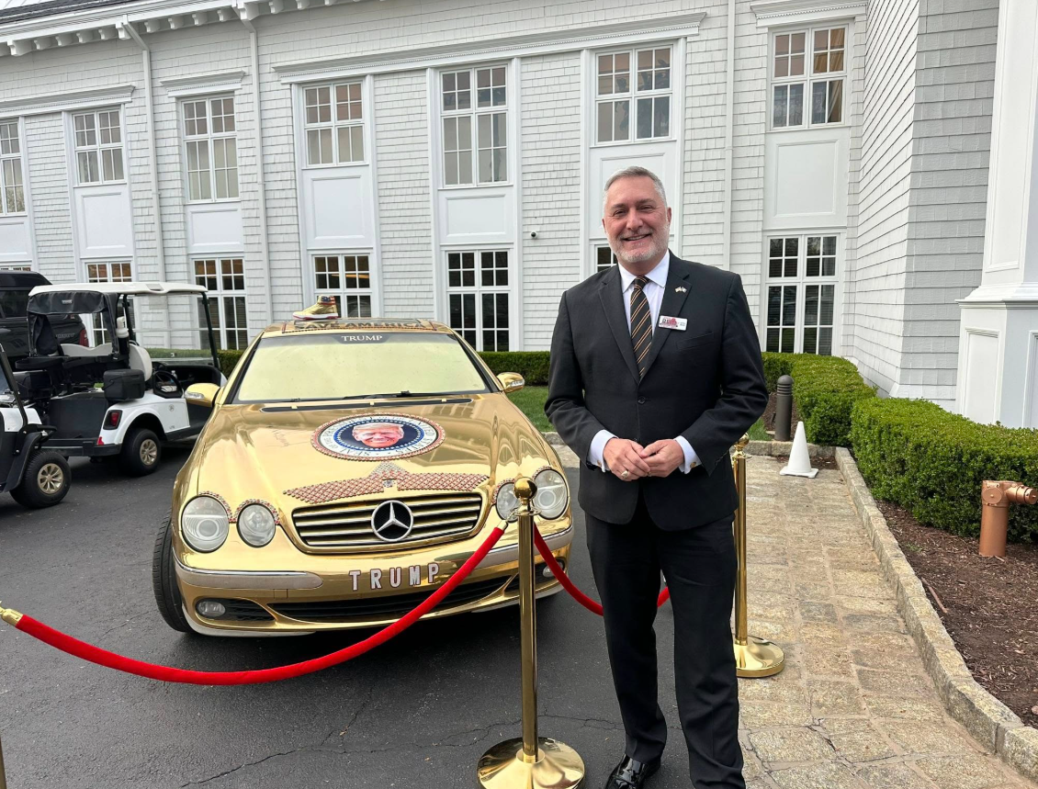
[Facebook, John Reid for Lieutenant Governor of Virginia, 4/5/25]
April 2, 2025: Trump Announced Reciprocal Tariffs On Every Nation In The World, Expected To “Upend The Global Economy” And “Drive Up Prices For American Consumers And Manufacturers.” According to the New York Times, “President Trump unveiled his most expansive tariffs to date on Wednesday, drawing quick promises of retaliation from allies who warned of a trade war that could upend the global economy. Mr. Trump’s move was a significant escalation of his trade fight and is likely to drive up prices for American consumers and manufacturers. While he had been saying for weeks that he would impose ‘reciprocal tariffs,’ his announcement went far beyond what many experts had expected. The tariffs will apply to more than 100 trading partners, including the European Union, China, Britain and India. Mexico and Canada, which had been slapped with levies earlier, were excluded.” [New York Times, 4/2/25]

