Overview
Reid compared abortion to slavery, and called abortion “an atrocity that should be rare if allowed at all.” Reid also appeared to criticize pro-choice women, saying they believed “being able to kill their baby at any time before it’s born is a private and personal right.” In campaigning against abortion rights, Reid repeated the lie that women in Virginia could have abortions though the day of the baby’s birth, which no Virginia lawmaker had proposed. Reid supported Youngkin’s 15-week abortion ban proposal.

Reid Is A Threat To Virginians' Right To Make Their Own Medical Choices

Reid Was Anti-Abortion, And His Website Falsely Claimed Democrats Supported Abortion “Through The Day Of Birth”
Reid’s Website: “John Reid Is Pro-Life And Has Boldly Spoken Out… Against The Democrats’ New Radical Unlimited Any Time Any Place Day Of Birth Abortion Proposals.” According to John Reid For Lieutenant Governor, “The Right to Life John Reid is pro life and has boldly spoken out on TV, radio, and in his personal testimony against the Democrats new radical unlimited any time-any place, day of birth abortion proposals. He is also one of the leading voices against the growing human euthanasia movement.” [John Reid For Lieutenant Governor, Issues, Viewed 5/7/25]
- Virginia Law Only Allowed Abortion In The Third Trimester When A Doctor Affirms A Pregnancy Was Likely To Kill A Woman Or Severely Impair Her Health. According to the Virginia Independent, “Reid’s campaign site says he is ‘pro life and has boldly spoken out on TV, radio, and in his personal testimony against the Democrats new radical unlimited any time-any place, day of birth abortion proposals.’ Virginia law protects abortion rights during the first and second trimesters of pregnancy and allows the procedure in the third trimester only when doctors deem ‘the continuation of the pregnancy is likely to result in the death of the woman or substantially and irremediably impair the mental or physical health of the woman.’ No Virginia Democratic lawmakers have proposed allowing abortion on the day of birth.” [Virginia Independent, 4/22/25]
- No Virginia Democratic Lawmaker Proposed Allowing Abortion Through The Day Of Birth. According to the Virginia Independent, “Reid’s campaign site says he is ‘pro life and has boldly spoken out on TV, radio, and in his personal testimony against the Democrats new radical unlimited any time-any place, day of birth abortion proposals.’ Virginia law protects abortion rights during the first and second trimesters of pregnancy and allows the procedure in the third trimester only when doctors deem ‘the continuation of the pregnancy is likely to result in the death of the woman or substantially and irremediably impair the mental or physical health of the woman.’ No Virginia Democratic lawmakers have proposed allowing abortion on the day of birth.” [Virginia Independent, 4/22/25]

In March 2025, Reid Shared An Article On Facebook About A Woman Who Killed A Dog At An Airport, And Compared The Situation To A Woman Getting An Abortion
2025: Reid Shared An Article On Facebook About A Woman Who Killed A Dog At An Airport, And Compared The Situation To A Woman Getting An Abortion, Repeating The False Claim That Democrats Supported Abortion Until Birth. According to John Reid for Lieutenant Governor of Virginia on Facebook, “If this both outrages you and hurts your heart you are absolutely correct… me too. I want to gently ask how you would feel if the story was about day of birth baby abortion that Democrats keep making easier and easier with no questions asked. I feel a pit in my stomach about a society that is compassionate enough to care about puppies being drowned but disregards and disrespects human life. Maybe I am in the minority… but that doesn’t make me wrong or changes my mind.”

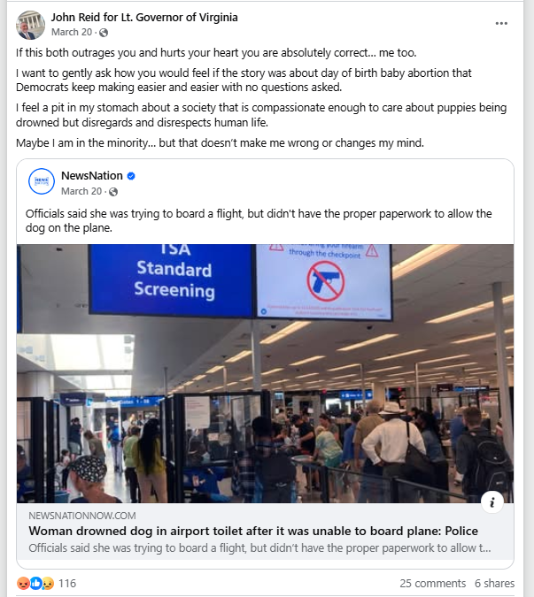
[Facebook, John Reid for Lieutenant Governor of Virginia, 3/20/25]

In 2023, Reid Compared Abortion To Slavery, Claimed Women Who Had Abortions “Kill Their Baby,” And Claimed Abortion Was “An Atrocity That Should Be Rare If Allowed At All”
2023: Reid Compared Abortion To Slavery, Claiming That Slavery Was Once Accepted Until It Was Challenged. According to John Reid for Lieutenant Governor of Virginia on Facebook, “I think it’s absolutely awful and still must be challenged just like accepted slavery was continually challenged over a century ago… but today it’s clear that huge swaths of the population and especially women believe that being able to kill their baby at anytime before it’s born is a private and personal right. What once was seen as an atrocity that should be rare if allowed at all, is now dismissed as a freedom and not a societal moral issue at all. If morals and justice are to be determined by the popular vote then we have a lot of work to do to change the popular opinion on abortion back to something that used to be reserved and life centric and normal. This modern abortion phenomenon also shows why we must aggressively work to make CERTAIN that the shocking physical abuses and mental insanity of trans ideology does not also become mainstreamed and widely acceptable. Why does the society keep catering to the craziest and crudest immoral behaviors and attitudes in its midsts?”
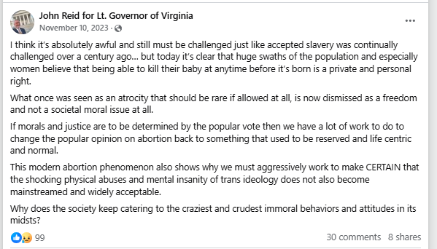
[Facebook, John Reid for Lieutenant Governor of Virginia, 11/10/23]
- 2023: Reid: “It’s Clear That Huge Swaths Of The Population And Especially Woman Believe That Being Able To Kill Their Baby At Anytime Before It’s Born Is A Private And Personal Right.” According to John Reid for Lieutenant Governor of Virginia on Facebook, “I think it’s absolutely awful and still must be challenged just like accepted slavery was continually challenged over a century ago… but today it’s clear that huge swaths of the population and especially women believe that being able to kill their baby at anytime before it’s born is a private and personal right. What once was seen as an atrocity that should be rare if allowed at all, is now dismissed as a freedom and not a societal moral issue at all. If morals and justice are to be determined by the popular vote then we have a lot of work to do to change the popular opinion on abortion back to something that used to be reserved and life centric and normal. This modern abortion phenomenon also shows why we must aggressively work to make CERTAIN that the shocking physical abuses and mental insanity of trans ideology does not also become mainstreamed and widely acceptable. Why does the society keep catering to the craziest and crudest immoral behaviors and attitudes in its midsts?” [Facebook, John Reid for Lieutenant Governor of Virginia, 11/10/23]
- 2023: Reid Claimed Abortion Was An “Atrocity That Should Be Rare If Allowed At All.” According to John Reid for Lieutenant Governor of Virginia on Facebook, “I think it’s absolutely awful and still must be challenged just like accepted slavery was continually challenged over a century ago… but today it’s clear that huge swaths of the population and especially women believe that being able to kill their baby at anytime before it’s born is a private and personal right. What once was seen as an atrocity that should be rare if allowed at all, is now dismissed as a freedom and not a societal moral issue at all. If morals and justice are to be determined by the popular vote then we have a lot of work to do to change the popular opinion on abortion back to something that used to be reserved and life centric and normal. This modern abortion phenomenon also shows why we must aggressively work to make CERTAIN that the shocking physical abuses and mental insanity of trans ideology does not also become mainstreamed and widely acceptable. Why does the society keep catering to the craziest and crudest immoral behaviors and attitudes in its midsts?” [Facebook, John Reid for Lieutenant Governor of Virginia, 11/10/23]

In 2023, Reid Endorsed Glenn Youngkin’s 15-Week Abortion Ban Proposal As A “Reasonable Compromise” And Repeated The False Claim That Democrats Supported Abortion Until Birth
2023: Reid Endorsed Glenn Youngkin’s 15-Week Abortion Ban Proposal As A “Reasonable Compromise” And Repeated The False Claim That Democrats Supported Abortion Until Birth. According to John Reid for Lieutenant Governor of Virginia on Facebook, “Stopping elective abortions after FOUR months is NOT an extreme position (even in Europe) but allowing abortions up to the actual day a baby is born IS extreme. Governor Glenn Youngkin knows that and has proposed a reasonable compromise and solution in Virginia and he’s worked to make sure Republicans agree. Don’t be lied to by Democrats. Abortion is not the only issue being decided in Virginia this year but if that’s something that motivates your vote- you should know who the real extremists are (and it’s not Republicans). Vote wisely. Please.”
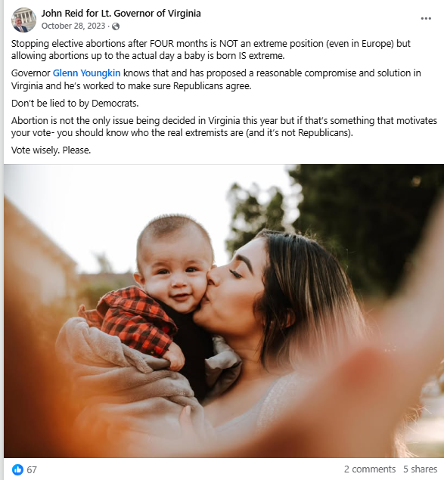
[Facebook, John Reid for Lieutenant Governor of Virginia, 10/28/23]
- 2023: Governor Youngkin Placed A 15-Week Abortion Ban At The Center For The 2023 Legislative Elections. According to NBC News, “Virginia Gov. Glenn Youngkin has put a 15-week abortion ban at the center of his campaign to help the GOP take full control of state government — and he has persuaded a broad slate of Republican candidates in the November election to coalesce behind the proposal.” [NBC News, 10/16/23]

