Overview
- King dismissed Georgians’ “suffering” over the trade war chaos.
- King praised Trump’s tariff strategy and claimed that it created leverage for the U.S.

King Supported Trump’s Economy Wrecking Tariffs

King Praised Trump’s Creating “Leverage” Via Tariffs And Downplayed The Acknowledged “Suffering” Of His Fellow Georgians

King Defended Trump’s Trade War And Dismissed Georgians’ “Suffering” As A Speed Bump On The Road To “Change The Status Quo”
[VIDEO] King Admitted That Tariffs Were “Very Difficult” Because Everyday Americans Were “Suffering” But Praised Trump’s Attempt “To Dynamically Change A Problem” And Stop Other Nations From “Taking Advantage Of Us.” “HOST: Where do you stand on what's being done in Washington right now when it comes to tariffs and the pain that some of these farmers are feeling and what you'd like to see done with it? KING: I will tell you that the tariffs is very difficult, especially because it's real people, it's not just some imaginary person is suffering as a result of this. But President Trump is trying to dynamically change a problem that's been exacerbated for many, many administrations. So kick the can and let foreign nations take advantage of Georgia and take advantage of the United States. President Trump is, you know, functionally trying to change the way that we do business and the way people do business with this nation and without doing the things that he's doing–you see where India, where you see United Kingdom, all these other countries understand how serious we are–and that's what it takes. President Trump is really working hard to change the status quo because people were taking advantage of us for many, many years and politicians being sent to Washington. Just let let the can roll. And we can't we can't stand by that.” [WSAV, 5/12/25]
[VIDEO] King Reaffirmed His Support, Despite Admitting That Tariffs Were “Clearly” Very “Painful” For Average Americans, And Claimed That Previous Trade Policies Were “Not Sustainable.” “So he’s fundamentally changing the way people do business, and I support it. Clearly, this is painful. This is not something– the easiest thing to do, is not do anything about it. But they will crush a market, it is not sustainable the way we will go in. And so the courage that President Trump has had in changing the status quo is absolutely critical.” [WSAV, 5/12/25]

King Praised Trump’s On-And-Off Tariff Strategy
King Claimed That Trump “Created Leverage For The United States” With His Flip-Flopping. Commissioner John King tweeted, “President @realDonaldTrump has created leverage for the United States. It’s refreshing to have a leader who’s putting America first 🇺🇸” [Twitter, @JohnKingGA, 4/9/25]
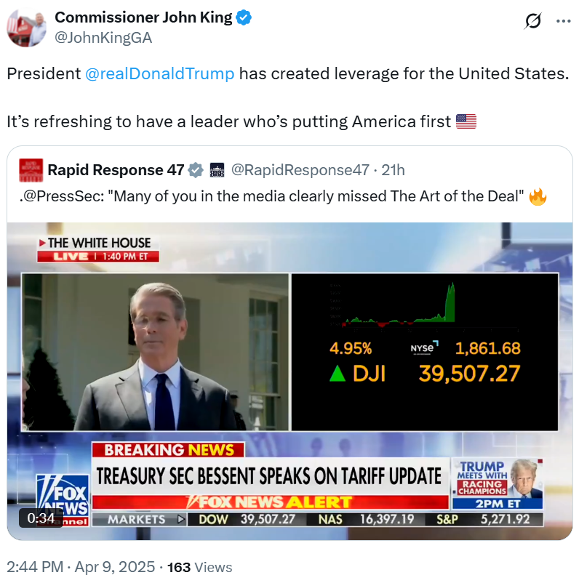
King Claimed That Trump Was “Keeping His Promise To Put America First And Negotiating Better Deals With Countries That Have Taken Advantage Of Us” And Called On Georgians “To Give The President And His Team Room To Negotiate.” According to The Atlanta Journal-Constitution, “The most full-throated endorsement came from Insurance Commissioner John King, who backed the tariffs without hesitation. ‘President Trump is keeping his promise to put America first and negotiating better deals with countries that have taken advantage of us — and were allowed to do so by weak politicians,’ he said. ‘We have to give the president and his team room to negotiate.’” [Atlanta Journal-Constitution, 4/8/25]

