Overview
- King downplayed DOGE’s federal layoffs.
- King supported Elon Musk’s shuttering of USAID.
- King celebrated DOGE’s broad cuts to the federal government.

King Celebrated DOGE Efforts At Georgians’ Expense

King Downplayed DOGE’s Mass Layoffs
King Mocked Democrats’ Outrage Over DOGE’s Firings Asked Why “They Didn’t Say A Word When Biden Fired Military Officers For Refusing The Vaccine.” Commissioner John King tweeted, “Democrats are howling now because DOGE is identifying waste, fraud, and abuse in the federal government. They didn’t say a word when Biden fired military officers for refusing the vaccine.” [Twitter, @JohnKingGA, 3/12/25]
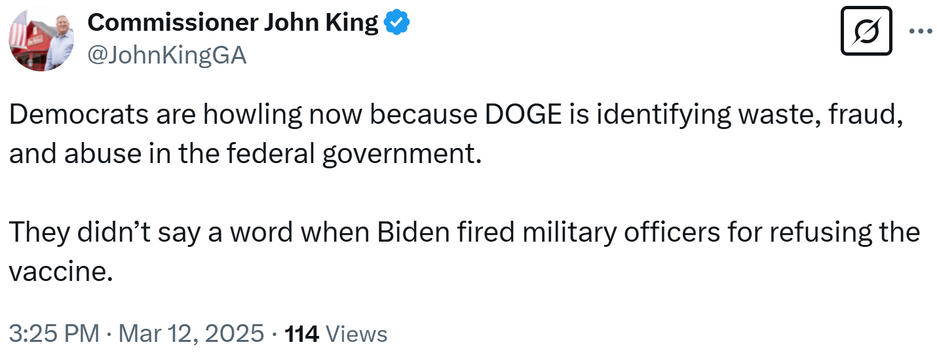

King Supported Elon Musk’s Shuttering USAID
King: “USAID Wasted Billions Of Our Tax Dollars On One Far-Left Priority After Another. I’m Glad Accountability Has Arrived.” Commissioner John King tweeted, “USAID wasted billions of our tax dollars on one far-left priority after another. I’m glad accountability has arrived.” [Twitter, @JohnKingGA, 2/4/25]
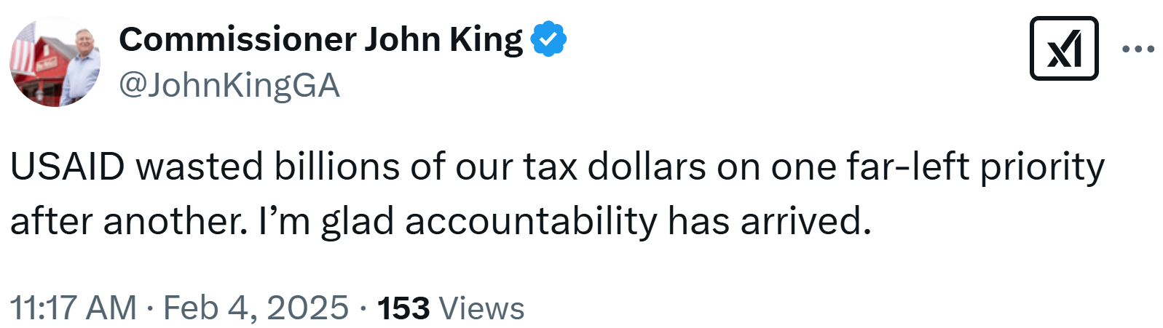

King Praised DOGE’s Cuts To The Federal Government
King Declared That “Everyone Knows” About Fraud In The Federal Government And Celebrated Trump As A President “Committed To Doing Something About It.” Commissioner John King tweeted, “Everyone knows there’s fraud, waste, and abuse in the federal government. The difference now is we have a commander-in-chief committed to doing something about it.” [Twitter, @JohnKingGA, 3/26/25]
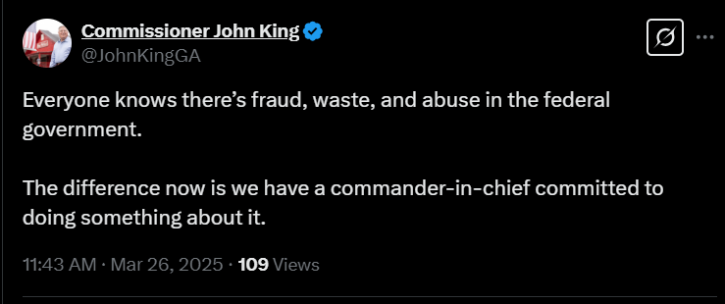
King Bemoaned The Alleged “Fraud, Waste And Abuse” DOGE Identified And Claimed There Was “A Tremendous Amount Of Progress Being Made In Washington.” According to the Marietta Daily Journal, “‘They've always been very in touch with what constituents are thinking right now,’ he said. ‘We have a tremendous amount of progress being made in Washington. Just the fraud, waste and abuse. That right there is extraordinary.’ Around Town asked if he was referring to D.O.G.E: Trump's Department of Government Efficiency. ‘Yeah, absolutely. And that's the number one. And with the slim majorities that the Republicans have, we need to take a really hard look at what seats are even in the realm of possibility. Georgia should not have two Democratic senators. If you just look at our voting, even with the two Democrats if they were effective, that would be something. But we have two back benchers and just sit back and just hang out in Washington.’” [Marietta Daily Journal, 2/21/25]
King Claimed That A Stacey Abrams’ Adjacent Organization Receiving A $2 Billion Clean Energy Grant Was Evidence That “DOGE Is Needed.” Commissioner John King tweeted, “I’m glad Governor Abrams is term-limited. But seriously, this is why DOGE is needed. #gapol” [Twitter, @JohnKingGA, 2/19/25]
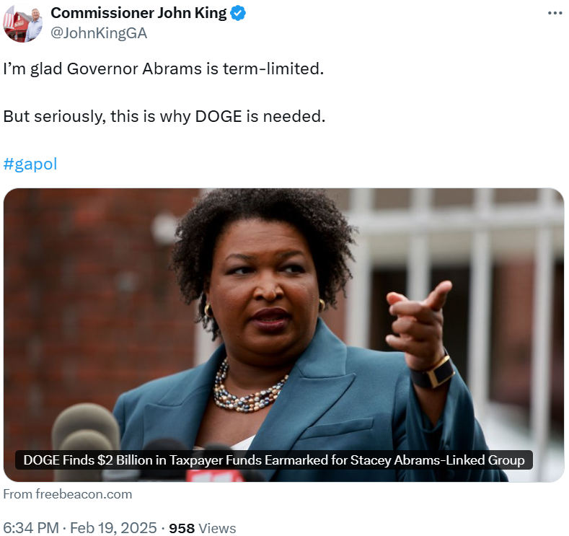
King Defended DOGE’s Effort To “Stop The Government From Growing To An Unsustainable, Unaccountable Level.” Commissioner John King tweeted, “If @realDonaldTrump’s first month isn’t a success, they should rewrite the definition. Statement on the president’s first month & DOGE ⬇️ #gapol Insurance Commissioner John King: ‘Elections matter and President Trump is doing what he promised. He’s secured our border, deported criminal illegal aliens, and protected girls’ sports. The Senate has confirmed his nominees at a clip not seen since 2001. If that’s not success, they should rewrite the definition. As for DOGE, the only reason it exists is because career politicians in both parties didn’t have the guts to stop the government from growing to an unsustainable, unaccountable level. Everyone knows there’s waste and fraud; the difference between DOGE and AWOL politicians like Jon Ossoff is that DOGE is doing something about it.” [Twitter, @JohnKingGA, 2/20/25]
