Overview
- King praised Trump’s January 6th insurrectionist pardons and claimed that the J6 prosecutions were “witch hunts” against “grandmas within 50 miles of DC.”
- King flip-flopped on his hardline immigration stance, celebrated Trump’s deportation efforts, and downplayed immigration fears among the Latino community.
  - King celebrated his coordination with federal agencies on deportations “to remove the cancer” and praised Trump’s immigration enforcements, despite his past reservations about the GOP’s immigration extremism.
  - King dismissed deportation fears among the Latino community and warned them against protests.
- King warned South Georgians to avoid FEMA relief after Hurricane Helene and claimed that FEMA funds were “used for camps to house, you know, illegal aliens.”

King Fear Mongered And Spread Dangerous Conspiracy Theories

King Praised Trump’s January 6th Pardons

King Claimed the January 6 Prosecutions Were “Witch Hunts” Against “Grandmas Within 50 Miles Of DC On January 6th”
King Claimed That President Biden “Carried Out Witch Hunts Against Parents At School Board Meetings, Grandmas Within 50 Miles Of DC On January 6th, And President Trump Himself” Using “Excessive Sentences And The Department Of Justice Itself” As “Weapons.” Commissioner John King tweeted, “Joe Biden carried out witch hunts against parents at school board meetings, grandmas within 50 miles of DC on January 6th, and President Trump himself. His weapons were excessive sentences and the Department of Justice itself. President Trump ran on stopping it, and that’s what he’s doing. Maybe Georgians would take Senator Ossoff’s strongly worded social media post seriously if he’d said a word about the Biden Family Pardon Party and Biden’s pardons for Fauci, the kids for cash judge, and Leonard Peltier — who murdered two law enforcement officers.” [Twitter, @JohnKingGA, 1/24/25]
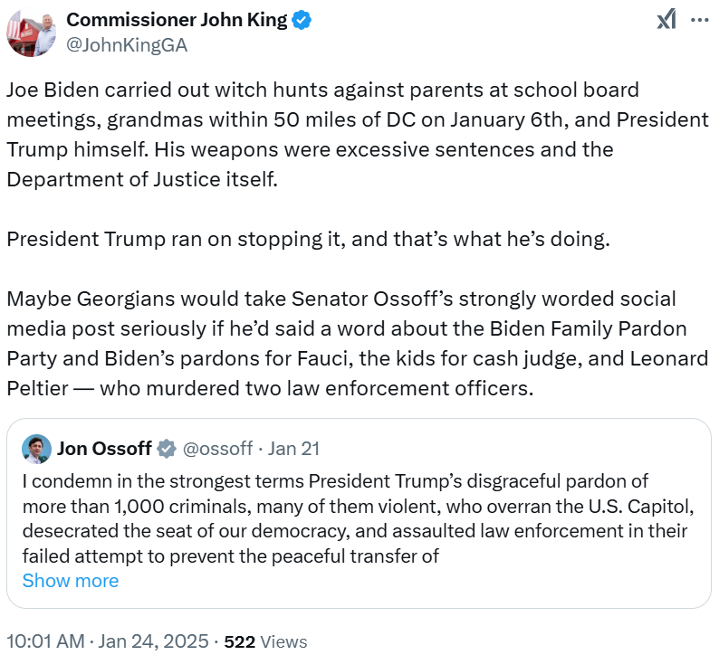

King Called Unlawfully Present Migrants A “Cancer” And Celebrated Trump’s Immigration Raids While Dismissing Fears Among The Latino Community

King Celebrated His Coordination With Federal Agencies On Deportations “To Remove The Cancer” And Praised Trump’s Immigration Enforcements
[AUDIO] King Claimed That He “Deported More Criminal Illegal Aliens Than Probably Almost Anybody Else” While He Was Chief Of Police And Said That He “Used The Law To Remove The Cancer,” In Reference To Migrants. “Oh, I'll tell you Doraville, there's a lot of pressure on police departments and chiefs, too, to declare or so call. Politicians are the ones to declare their status as sanctuary cities. I have deported more criminal illegal aliens than probably almost anybody else that is in office today. I used the law to remove the cancer because I tell you this. Tren de arugra all these gang members are affecting the Latino community more than anyone. And that to me is how do you stand by and allow the criminality in our communities to be done by by an individual from another country? These folks are getting funding. They're getting benefits that even our veterans don't get. Our veterans are sleeping under those bridges in downtown Atlanta. And the fact that these folks get to stay in hotels. That, to me is criminal” [Veterans For America First: The Vet Voice, 4/15/25]
- 2023: King Described The Republicans’ Immigration Policy As, “Round Up Everybody And Return Them Back To Their Home Country” And Called For “More Thoughtful Conversation Than Just A Bumper Sticker.” According to the Marietta Daily Journal, “Asked about the immigration debate, King said neither extreme is the way forward. ‘Both parties have kicked the can down the road. They've used this as an excuse for not doing their job,’ he said to nods of agreement. ‘...One side's for complete amnesty, the other side is, round up everybody and return them back to their home country ... Right now, it's all or nothing, and I think we need to demand better conversation, more thoughtful conversation than just a bumper sticker to solve this very complex problem.’” [Marietta Daily Journal, 2/26/23]
King Celebrated Georgia ICE Raids And Claimed That Trump “Promised To Get Criminal Illegal Immigrants Out Of Our Country And That’s What He’s Doing.” Commissioner John King tweeted, “President @realDonaldTrump promised to get criminal illegal immigrants out of our country and that’s what he’s doing. Promise made, promise kept.” [Twitter, @JohnKingGA, 1/27/25]
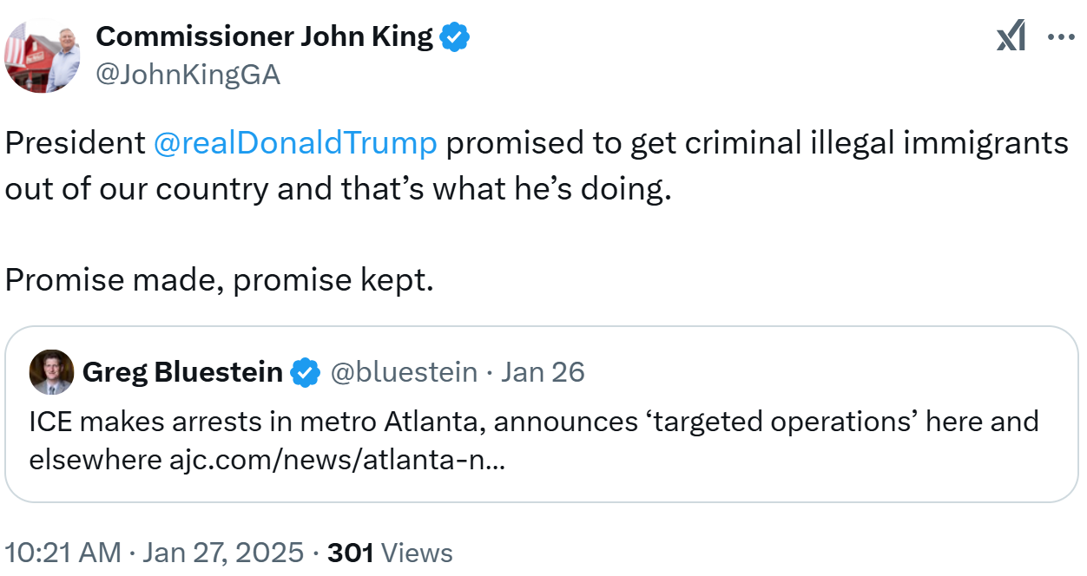
King Praised Trump’s “Getting Criminal Illegal Aliens Out Of Our Country” And Claimed That America Was “Safer” As A Result Of Trump’s Aggressive Deportation Actions. According to a Washington Reporter op-ed by Commissioner John King, “Trump ran for the White House on the promise of securing our border, crushing the cartels, and getting criminal illegal aliens out of our country. Now that he’s back in office, that is exactly what he’s doing. More troops and resources to the southern border? Check. Designating cartels as foreign terrorist organizations? Check. Reinstating the Remain in Mexico policy? Check. Canceling the CBP One app created by the Biden administration? Check. If you look past the media spin and celebrities crying for clicks on social media, you’ll see the real result of President Trump’s actions: a safer America.” [Commissioner John King Op-Ed – Washington Reporter, 2/11/25]
- King: “I Know From Firsthand Experience How Critical It Is That We Get Criminal Illegal Aliens Off Our Streets And Back Where They Came From.” According to a Washington Reporter op-ed by Commissioner John King, “In addition to being a retired General in the Army National Guard, I’m also a career lawman who walked a beat in Atlanta and later served as police chief of one of Georgia’s most diverse communities. I know from firsthand experience how critical it is that we get criminal illegal aliens off our streets and back where they came from, so I’m glad to see the Trump administration taking the steps it promised here.” [Commissioner John King Op-Ed – Washington Reporter, 2/11/25]

King Dismissed Deportation Fears Among Latino Communities
[AUDIO] King Claimed That “Left Wing Activists” Were “Using Misinformation To Scare The Community” And Emphasized That Only “Prevailing Criminal Aliens, Folks That Are Here Illegally, Who've Committed Violent Crimes And And Who Have Been Ordered To Be Deported” Were In Trump’s Sights. “HOST: I want to shift gears just a little bit to something that I know you care a lot about. You know, we were talking to our mutual friend Norma mendez about the fear that there is in the Latino community right now. [...] but you're hearing at places that stores and places and food banks that the Latino community is afraid and don't want to come out. What do you think about that and what are you hearing? KING: I'm hearing the same things more in and it's it it makes me very upset because these left wing activists are using misinformation to scare the community. You know, President Trump has been very clear. Mr. Homan has been incredibly clear that the priorities are prevailing criminal aliens, folks that are here illegally, who've committed violent crimes and and who have been ordered to be deported. Those folks are being the ones that are being in because the previous administration made it much harder before for ice ages to go.” [Martha Zoller Show, 2/13/25]
[AUDIO] King Warned Migrants That It “Doesn't Make You Look Very Smart” To Protest In The Streets With Your Home County’s Flag; He Encouraged His “Friends” To “Really Understand And Read The Words Of The President And Mr. Homan.” “The problem is, is that the left wing activists are going into the community spirit, stirring everybody up to get them to be afraid and using fear as a weapon for political purposes. And that, to me, is disgraceful. You know, and I told you know, we had a protest down in in Doraville, in Chamblee, where. We had a bunch of, you know, agitators out there. You know, a lot of young people out there flying, you know, their nation's flags and blocking the roads. And I tell I tell the community there's a community that is that is dumb. That is that is just bad strategy. When you do that, all you're going to do is aggravate the people who we you know, who this community needs for support. Inconveniencing the public by blocking roads and flying the foreign flag makes you look. That doesn't make you look very smart about wanting to be an American. And so it I really blamed the agitators and said, well, I'm encouraging my friends to go and really understand and read the words of the president and Mr. Horman. They can never be more clear than they are on their priorities.” [Martha Zoller Show, 2/13/25]

King Misled Georgians On FEMA Relief After Hurricane Helene

King Warned South Georgians To Avoid FEMA Relief And Claimed That FEMA Funds Were “Used For Camps To House, You Know, Illegal Aliens”
[AUDIO] King Told South Georgians, “Do Not Believe Them, Don't Sign Any Contract Because You're Going To Be Left Holding The Bag On This,” If They Applied For Disaster Relief And Claimed That FEMA Funds Were “Used For Camps To House, You Know, Illegal Aliens.” “I got attacked merciless by the left when I was saying to cities and counties do not sign contracts expecting because we had two senators and we had a bunch of Democrats coming to communities promising 100% reimbursement, I said do not believe them, don't sign any contract because you're going to be left holding the bag on this. Folks are still waiting down in South Georgia for the FEMA funds because you have two senators showing up oh don’t worry, we're going to have 100% reimbursement. That money was being used for camps to house, you know, illegal aliens.” [Veterans For America First: The Vet Voice, 4/15/25]
[AUDIO] King Claimed That FEMA Was “Planting The Seeds To Make A Confrontation Between Local Communities And Members Of Congress” Because “The Money Had Already Been Spent” On Migrant Housing. “And so, what happened is that they were they were planting the seeds to make a confrontation between local communities and members of Congress to reauthorize more money. It wasn't because they had money in the bank. The money had already been spent. And that to me was criminal. To go to these communities and promise almost 100% reimbursement knowing that the money was never there.” [Veterans For America First: The Vet Voice, 4/15/25]
[AUDIO] King Supported The “Total Disbandment Of FEMA” And Proposed The Mennonite Church As An Alternative. “That's why I fully support the idea of total disbandment of FEMA. Let us have it. Send it straight to the states and let the states be accountable and responsible and be able to be audited or redo FEMA from the ground up. Because I tell you, as an organization, folks in North Carolina are still begging. I mean, the Mennonite church groups have been the most effective and quickest responses to every community in Georgia that I've ever seen.” [Veterans For America First: The Vet Voice, 4/15/25]

