Overview
Kiggans opposed the Inflation Reduction Act, which lowered prescription drug costs and capped the cost of insulin at $35/month for seniors. More than 193,000 Virginians took prescription drugs that had been selected for price negotiation under the law’s provisions.

Kiggans Opposed Legislation That Lowered Prescription Drug Costs For Seniors

Kiggans Claimed The Inflation Reduction Act Included “CountlesS Harmful Provisions”
2022: Kiggans Criticized Her Opponent For Supporting The Inflation Reduction Act. According to the 2022 Virginia 2nd Congressional Debate, “KIGGANS: I run for Congress to restore strength in health care. This is a very important issue for me. I’d like to point out that the Inflation Reduction Act, which my opponent supported, didn’t address drug transparency and it certainly didn’t address every drug.” [C-SPAN, Virginia 2nd Congressional District Debate, 10/12/22] (video) 00:56:43
2025: Kiggans Claimed The Inflation Reduction Act “Contained Countless Harmful Provisions.” According to a video posted on Rep. Jen Kiggans’ Twitter, “KIGGANS: While the Inflation Reduction Act contained countless harmful provisions that led to our conference wholly opposing its package, some of the energy tax credits included in the bill have led to a significant increase in domestic manufacturing and energy production across the country, including in my district.” [Twitter, @RepJenKiggans, 1/23/25] (video)

The Inflation Reduction Act Capped Prescription Drug Costs Under Medicare, Which would Benefit More Than 193,000 Virginians
The Inflation Reduction Act Allowed Medicare To Negotiate Prices For Certain Prescription Drugs. According to the U.S. Department of Health and Human Services, “Negotiations are underway between HHS and the participating drug companies of the first 10 prescription drugs selected for negotiation in the first cycle of the Medicare Drug Price Negotiation Program. The first 10 drugs selected treat conditions such as blood clots, diabetes, heart disease, heart failure, autoimmune diseases, and chronic kidney disease.” [U.S. Health and Human Services, Inflation Reduction Act Of 2022, Viewed 7/1/24]
The Inflation Reduction Act Required Drug Companies To Pay A Rebate To Medicare If They Raised Prices Faster Than The Rate Of Inflation. According to the U.S. Department of Health and Human Services, “Allowing Medicare to negotiate with participating drug companies to get lower drug prices for certain drugs covered under Medicare Beginning negotiations with the participating drug companies that manufacture all 10 drugs selected for the first cycle of negotiations” [U.S. Health and Human Services, Inflation Reduction Act Of 2022, Viewed 7/1/24]
More Than 193,000 Virginians Were Prescribed Drugs Selected For Price Negotiation Under The Inflation Reduction Act. According to the U.S. Department of Health and Human Services,
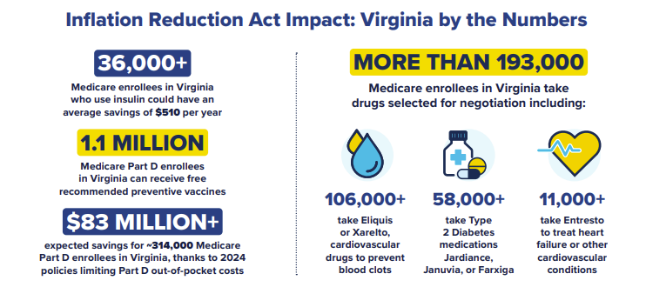
[U.S. Department Of Health And Human Services, Lowering Prescription Drug Costs For Virginia, Viewed 7/1/24]

