Overview
Before getting elected to Congress, Kiggans promised to protect her constituents’ Medicare benefits. However, when presented the opportunity to stand by her word, Kiggans broke her promises. In 2025, Kiggans voted for Republicans’ reconciliation bill, which the Congressional Budget Office estimated would trigger nearly $500 billion in cuts to Medicare, absent future congressional action.

Despite Promising To Protect Medicare, Kiggans Voted For A Republican Spending Bill That Made Massive Cuts To The Program

Kiggans Promised On Multiple Occasions To PReserve Medicare
October 2024: Kiggans Promised Her Constituents That Medicare “Will Not Be Touched” By Spending Cuts. According to the Hampton Road Chamber of Commerce 2024 VA-02 debate, "KIGGANS: But we made it very clear, and I will say here again, that we were protective of Social Security, Medicare and veteran benefits. Those things were not touched. Those things will not be touched. My veteran population, my senior citizens, who I take care of as a nurse practitioner, who live on Social Security and Medicare. I certainly understand the importance of those benefits to those groups of people. But we've got to find a place to cut spending and we can do it responsibly." [Hampton Roads Chamber of Commerce Debate, 10/11/24] (audio)
November 2024: When Asked About Preserving The Affordable Care Act, Kiggans Said She Would Protect Medicare. According to a press conference hosted by Jen Kiggans, “HOST: I asked her if there were parts of Obamacare that were worth saving. KIGGANS: Yeah, so for me and my patient population especially for older adults, I want them to have health care. So being very protective of their health care and especially for our veterans that are out there, I think there’s a large discussion to be had. We obviously want to continue to make sure people know that we protect things like Medicare and Social Security.” [WAVY, 11/11/24] (audio)

2025: After Promising To Protect Medicare, Kiggans Voted In Favor Of The House Republican budget Bill That Included Major Cuts To The Program
May 2025: Kiggans Voted For The FY 2025 Budget Reconciliation Bill That Included $3.8 Trillion In Tax Cuts Offset By $1.5 Trillion In Spending Reductions To Programs Like Medicaid And The Supplemental Nutrition Assistance Program. In May 2025, Kiggans voted for, according to Congressional Quarterly, “the bill that would provide for approximately $3.8 trillion in net tax cuts and $321 billion in military, border enforcement and judiciary spending, offset by $1.5 trillion in spending reductions, as instructed in the fiscal 2025 budget resolution (H Con Res 14). It would raise the statutory debt limit by $4 trillion and provide for increased spending on defense and border security, spending cuts on social safety net programs, such as Medicaid and the Supplemental Nutrition Assistance Program. It also includes a mix of tax breaks for businesses and individuals; tax increases on universities and foundations; and a phase-down of clean energy tax credits. […] It would reduce federal spending on the Supplemental Nutrition Assistance Program by requiring states to shoulder more of the cost, expand work requirements for SNAP, extend programs authorized under the 2018 farm bill, and prohibit the U.S. Department of Agriculture from increasing the cost of the Thrifty Food Program. As amended, it would cap state and local tax deductions at $40,000 for households with incomes below $500,000.” The House passed the bill by a vote of 215 to 214. [House Vote 145, 5/22/25; Congressional Quarterly, 5/22/25; Congressional Actions, H.R. 1]
July 2025: Kiggans Voted For The Senate FY 2025 Budget Reconciliation Bill That Extended $4 Trillion In Expiring Tax Cuts, Added New Tax Breaks, Appropriated $448 Billion In Defense, Border, And Immigration Enforcement Funding, Increased The SALT Deduction To $40,000, And Cut Medicaid And Other Social Programs To Offset The Costs. In July 2025, Kiggans voted for, according to Congressional Quarterly, the “motion to concur in the Senate amendment to the bill that would permanently extend nearly $4 trillion in expiring individual and business tax cuts, create several new tax breaks and fund border and immigration enforcement and air traffic control upgrades. It would cut Medicaid and other safety net programs to partly offset the cost. Among other provisions, it would raise the statutory debt ceiling by $5 trillion and appropriate more than $448 billion in mandatory funding for Trump administration priorities and other needs, including $153 billion for defense, $89 billion for immigration enforcement, and $89.5 billion for border control and security. It also would increase the state and local tax deduction cap to $40,000 annually for five years for households making up to $500,000 a year until 2030, when it would permanently revert to $10,000.” The House passed the bill by a vote of 218 to 214. [House Vote 190, 7/3/25; Congressional Quarterly, 7/3/25; Congressional Actions, H.R. 1]

Kiggans Defended Her Votes For The Republican Budget Bills, Claiming The “Sum Total” Of The Final bill WOuld Benefit Virginians
Kiggans Said The Passing Of The House Reconciliation Bill Was “Exciting News” And Admitted It Was “Not Perfect.” Jen Kiggans tweeted, “Exciting news this morning! The budget reconciliation ‘Big Beautiful Bill’ has just passed out of the House! It has been a busy week in Washington with meeting after meeting to get this bill to the floor. Although the bill is not perfect, it is a step forward. The lies and fear-mongering coming out of the media and the other side of the aisle regarding this bill must stop. Americans voted for change in the right direction last November and this bill does that. There are so many wins for Virginians including: ⁃Permanent middle-class tax cuts preventing a 22% tax hike and allowing families to keep more of their hard earned money ⁃Elimination of taxes on tips, overtime pay, and car loan interest, & provides additional tax relief for seniors ⁃Strengthens and reforms Medicaid by cracking down on fraud, preventing wrongful disenrollments, and preserving access to care for those who qualify and need it the most. ⁃Provides stronger border security including completion of the border wall, hiring of thousands more frontline border personnel, and updating security technology. ⁃Secures robust funding for our national defense, ensuring that our military remains the most capable, ready, and well-equipped fighting force in the world. I would have liked to have seen a less aggressive phase out of the clean energy tax credits to protect jobs and investments which promote an all-of-the-above energy approach, but there is still time. This bill now heads to the Senate where changes can occur. Stay tuned for final passage over the next few weeks. Again- we have work to do still but this bill is step one….!”
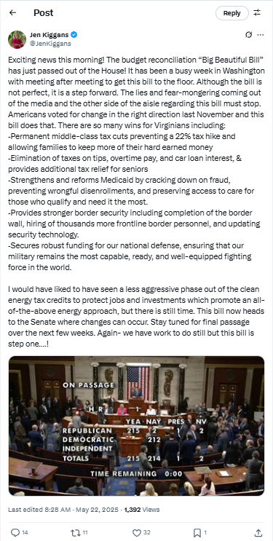
[Twitter, @JenKiggans, 5/22/25]
Kiggans Admitted The Budget Bill Was Not Perfect But That The “Sum Total” Will Benefit Her Constituents. According to a press release from Representative Jen Kiggans, “‘Today I cast my vote in favor of H.R. 1, the One Big Beautiful Bill Act (OBBBA). It’s important to acknowledge that no legislation of this magnitude is perfect. My vote reflects a pragmatic assessment that the sum total of this bill will benefit Coastal Virginia and America. This bill represents months of intense negotiations and hard work to put working families first. It delivers real results that Virginians and Americans across the country have been waiting for and voted for in November— relief for their pocketbooks, security at the border, and strength in our military.” [Press Release – Representative Jen Kiggans, 7/3/25]

Congressional Budget Office Estimated That The Republican Reconciliation Bill Would Trigger Nearly $500 Billion In Cuts To Medicare
HEADLINE: "Trump And GOP’s Tax Bill Would Force Cuts To Medicare, CBO Says" [Washington Post, 5/21/25]
Congressional Budget Office Estimated That The House Republican Reconciliation Bill Would Trigger Nearly $500 Billion In Cuts To Medicare. According to a letter the Congressional Budget Office sent to Rep. Brendan Boyle, "Today the Congressional Budget Office transmitted an estimate of the budgetary effects of the 2025 reconciliation bill, as ordered reported by the House Committee on the Budget on May 18, 2025. 1 CBO has not yet completed estimates of the effects of interactions among the titles of the legislation. This letter responds to your questions concerning the sequestration (the cancellation of budgetary resources) in accordance with the Statutory Pay-As-You-Go Act of 2010 (S-PAYGO) that would occur if an enacted bill raised deficits by $2.3 trillion over 10 years. Under S-PAYGO, the Office of Management and Budget (OMB) is required to maintain 5- and 10-year scorecards that it updates with the estimated cumulative changes in revenues and outlays generated by newly enacted legislation. […] The 4 percent maximum reduction in Medicare spending would apply to sequestration orders for years after 2026. If OMB ordered a sequestration of $230 billion for each year through 2034, the ordered reductions in Medicare spending would increase to about $75 billion in 2034 and would total roughly $490 billion over the 2027–2034 period." [Letter to Rep. Brendan Boyle – Congressional Budget Office, 5/20/25]

