Overview
Kiggans promised that she would protect Medicaid, but then she voted for a bill that would kick 17 million Americans off their health insurance, including nearly 12 million Americans off of Medicaid. More than 22,000 Virginians could lose their health coverage as a result of her votes. The Southampton Memorial Hospital in VA-02 was designated at-risk and three other hospitals in Virginia have already announced they are closing because of Medicaid cuts.

2025: Kiggans Broke Her Promises To Protect Virginians’ Health Care And Voted To Kick Nearly 12 Million Americans Off Medicaid

2/25/25: Kiggans Voted For The Republican Budget Resolution That Set Up Future Cuts To Medicaid
2/25/25: Kiggans Voted For The FY 2025 Budget Framework That Included $2 Trillion In Cuts, Raised The Statutory Debt Limit By $4 Trillion, And Required House Committees To Recommend Legislation That Would Implement Trump’s Agenda. In February 2025, Kiggans voted for, according to Congressional Quarterly, “the concurrent resolution that would recommend a budget for fiscal 2025 and budget levels through fiscal 2034. The resolution would assume minimum savings of $1.5 trillion over 10 years and 2.6 percent economic growth over the same period. It also would require the statutory debt limit to be raised by $4 trillion. It also would authorize the House Ways and Means Committee to increase deficits by $4.5 trillion over 10 years to extend the 2017 tax cuts and implement new tax cuts proposed by the White House. It also would provide instructions for the budget reconciliation process through which separate legislation could be considered and passed in the Senate via a simple majority vote. The measure would deliver instructions to 11 House committees to report legislation that would implement President Donald Trump’s agenda, such as expanding tax cuts and bolstering border security and immigration enforcement. The committees would be required to report their legislative recommendations to the House Budget Committee by March 27, 2025. It also would set a $2 trillion target for the spending cuts to be submitted to the House Budget Committee. The resolution also would stipulate that if the committees don't reach that target, the Ways and Means’ reconciliation instructions to increase the deficit by a maximum of $4.5 trillion would be decreased by the amount the other committees come in below the target. Similarly, it would stipulate that Ways and Means could increase the deficit above the $4.5 trillion level by the amount of savings the committees achieve above the $2 trillion target.” The vote was on passage. The House passed the resolution by a vote of 217 to 215. [House Vote 50, 2/25/25; Congressional Quarterly, 2/25/25; Congressional Actions, H. Con. Res. 14]
- HEADLINE: "House Republican Budget Takes Away Health Care, Food Aid To Pay For Expanded Tax Cuts For Wealthy" [Center on Budget and Policy Priorities, 2/21/25]
- New York Times Reported The $880 Billion In Cuts Required By The Republican Budget Proposal Would Have To Come From Medicaid, Medicare Or CHIP. According to the New York Times, "The budget resolution itself is silent on whether Congress cuts Medicaid, which provides health coverage to 72 million poor and disabled Americans. But it instructs the House Energy and Commerce Committee, which has jurisdiction over the program, to cut spending by $880 billion over the next decade. If the committee can’t save at least that much, the entire effort could be imperiled because of the special process Congress is using to avoid a Senate filibuster. Ten other committees have their own instructions to follow, though none have been assigned with cutting nearly as much. It’s not so simple as finding the cuts elsewhere. The special process, known as budget reconciliation, means Republicans will have to find all $880 billion from within the Energy and Commerce Committee’s jurisdiction. That leaves them with fewer options than one might think. […] If Republicans want to avoid major cuts to Medicaid, the largest pot of available money is in the other big government health insurance program: Medicare. […] Even if the committee cuts everything that’s not health care to $0, it will still be more than $600 billion short. The committee could also save around $200 billion by eliminating the Children’s Health Insurance Program, but that option has not been raised by the budget committee or anyone in House leadership. […] Even if all of these cuts, revenues and rule cancellations from outside health care can pass muster, the committee will still be left with hundreds of billions of dollars to cut to hit its goal. Mathematically, the budget committee’s instructions mean the committee would need to make major cuts to either Medicare, Medicaid or both." [New York Times, 2/25/25]

Following Her Vote On The Republican Budget Resolution, Kiggans Called Claims That It Set Up Cuts To Medicaid A Lie
Kiggans Claimed The U.S. House Budget Resolution Did Not Cut Medicaid Because “The Word Medicaid Isn’t Even In The Bill.” Rep. Jen Kiggans tweeted, “Hearing a lot of lies about last night’s budget resolution… especially when it comes to healthcare. Here’s the truth: the word Medicaid isn’t even in the bill. Fearmongering does nothing to serve the American people."
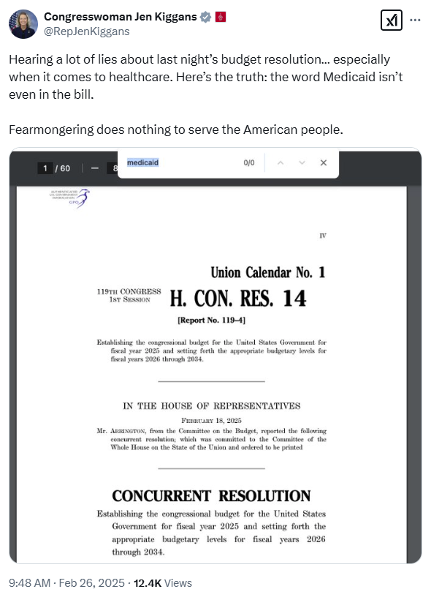
[Twitter, @RepJenKiggans, 2/26/25]
- Kiggans On The Republican Budget Resolution: “Importantly, This Resolution Does Not Include Specific Reductions To Any Programs Or Agencies. It Simply Contains Topline Budgetary Instructions For Committees To Produce Legislation.” According to a press release from Rep. Jen Kiggans, "Congresswoman Jen Kiggans (VA-02) released the statement below following her vote to pass the FY25 budget resolution in the House of Representatives. Overall, this legislation requires $1.5 trillion in mandatory savings over 10 years, provides up to $300 billion for border security and defense, and provides $4.5 trillion to prevent tax hikes. ‘In November, the American people made it clear that they want to reduce out-of-control government spending, secure our borders, and reignite economic growth. I voted for this budget resolution because it provides a path to deliver on those priorities and will allow the government to work more efficiently for all Americans. ‘Importantly, this resolution does not include specific reductions to any programs or agencies. It simply contains topline budgetary instructions for committees to produce legislation that ensures tax relief forworking families and small businesses, makes federal spending more efficient, unleashes energy dominance, and makes America safe again by investing in border security and our national defense." [Press Release – Rep. Jen Kiggans, 2/26/25]

3/3/25: Kiggans Claimed The Republican Budget Resolution Was A “Step In The Right Direction”
3/3/25: Kiggans On The Republican Budget Proposal: "You’ll Hear A Lot Of Lies About Me And What We’re Doing, But Please Don’t Trust The People That Put Our Country Into This Mess To Tell You The Truth. The Bottom Line Is That This Budget Is A Step In Right Direction." Jen Kiggans tweeted, "Americans voted to rein in excessive government spending, secure our borders, and revitalize economic growth. I supported last week’s budget resolution because it lays the foundation to achieve these priorities while ensuring the government operates better for all Americans. You’ll hear a lot of lies about me and what we’re doing, but please don’t trust the people that put our country into this mess to tell you the truth. The bottom line is that this budget is a step in right direction, and as the Congresswoman from Virginia's 2nd District, I will continue to fight for all of us. If you have any questions or concerns, please reach out to my office."
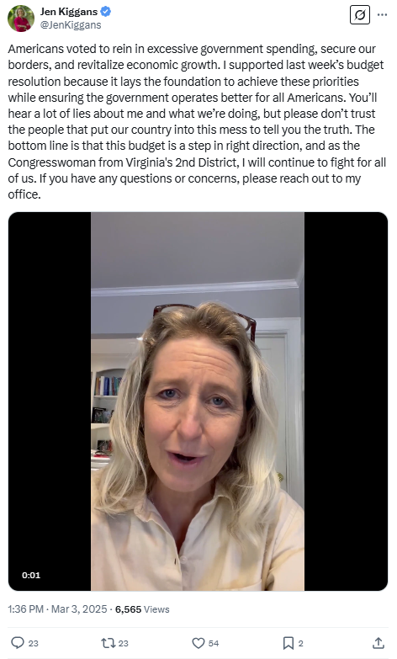
[Twitter, @JenKiggans, 3/3/25] (video)

After Voting For The Republican Budget Resolution, Kiggans Promised To Vote Against Future Legislation That Cut Medicaid
HEADLINE: "NEW AD: Hampton Roads Veterans Call On Rep. Kiggans To Say No To Medicaid Cuts" [Blue Virginia, 5/20/25]
4/16/25: Kiggans Signed A Letter To Speaker Johnson Pledging She Would Not Vote For A Final Budget Bill With Any Reduction In Medicaid Coverage For “Vulnerable Populations.” According to Axios, "The 12 lawmakers wrote in a letter to Johnson and other GOP leaders that many of them represent ‘districts with high rates of constituents who depend on Medicaid.’ ‘Balancing the federal budget must not come at the expense of ... their health and economic security,’ they said in the letter, a copy of which was obtained by Axios. The lawmakers issued an ultimatum: ‘We cannot and will not support a final reconciliation bill that includes any reduction in Medicaid coverage for vulnerable populations.’ Zoom in: The letter was signed by Reps. David Valadao (R-Calif.), Don Bacon (R-Neb.), Jeff Van Drew (R-N.J.), Rob Bresnahan (R-Pa.), Juan Ciscomani (R-Ariz.), Jen Kiggans (R-Va.), Young Kim (R-Calif.), Robert Wittman (R-Va.), Nicole Malliotakis (R-N.Y.), Nick LaLota (R-N.Y.), Andrew Garbarino (R-N.Y.) and Jeff Hurd (R-Colo.)." [Axios, 4/16/25]
- Kiggans Claimed Medicaid Needed To Be “Protected Yet Reformed” While Advocating For Work Requirements. Jen Kiggans tweeted, "Medicaid needs to be protected yet reformed. I joined my colleagues in sending a letter to House leadership this week pushing for commonsense reforms like reducing improper payments, making the program more transparent, and modernizing delivery systems while ensuring those who need this benefit are able to have the care they need. As a nurse practitioner, I know how vital it is that healthcare stays affordable and accessible. As a member of Congress, I know we must put reforms, such as work requirements, in place to ensure the program remains viable for years to come."
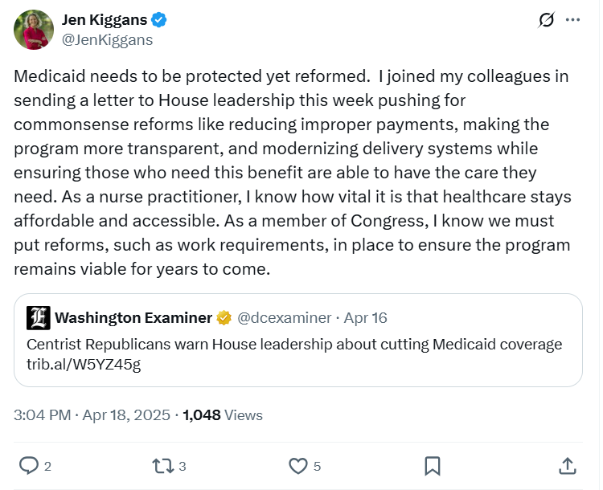
[Twitter, @JenKiggans, 4/18/25]
5/16/25: Kiggans Claimed Republicans Were “Working To Strengthen And Reform Medicaid.” Jen Kiggans tweeted, "Republicans are working to strengthen and reform Medicaid! This program exists to provide healthcare to people who live with challenges difficult to overcome: single mothers, the disabled, and seniors living on modest incomes. It ensures these vulnerable groups always have the care they need. But abuse of this healthcare system, whether by illegal aliens or others who do not qualify for this benefit, cheats the taxpayers who sustain it. I’m proud to fight tirelessly to keep Medicaid strong for the Americans it’s designed to help...!"
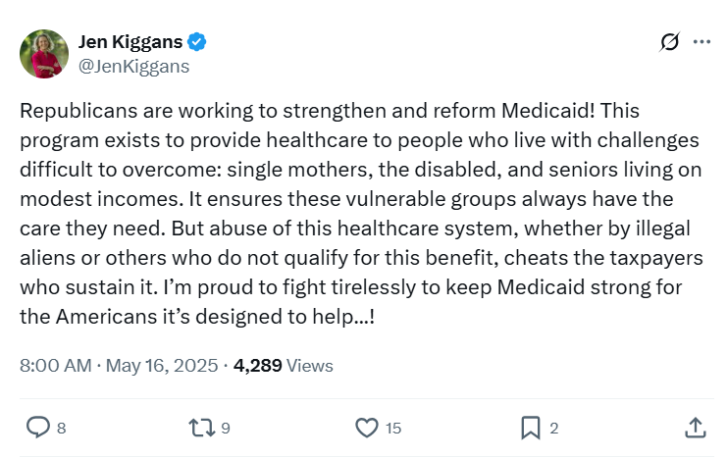
[Twitter, @JenKiggans, 5/16/25]

5/22/25: After Promising To Protect Medicaid, Kiggans Voted For The House Republican Budget Bill That Included Major Cuts To Medicaid
5/22/25: Kiggans Voted For The FY 2025 Budget Reconciliation Bill That Included $3.8 Trillion In Tax Cuts Offset By $1.5 Trillion In Spending Reductions To Programs Like Medicaid And The Supplemental Nutrition Assistance Program. In May 2025, Kiggans voted for, according to Congressional Quarterly, “the bill that would provide for approximately $3.8 trillion in net tax cuts and $321 billion in military, border enforcement and judiciary spending, offset by $1.5 trillion in spending reductions, as instructed in the fiscal 2025 budget resolution. It would raise the statutory debt limit by $4 trillion and provide for increased spending on defense and border security, spending cuts on social safety net programs, such as Medicaid and the Supplemental Nutrition Assistance Program. It also includes a mix of tax breaks for businesses and individuals; tax increases on universities and foundations; and a phase-down of clean energy tax credits. […] It would reduce federal spending on the Supplemental Nutrition Assistance Program by requiring states to shoulder more of the cost, expand work requirements for SNAP, extend programs authorized under the 2018 farm bill, and prohibit the U.S. Department of Agriculture from increasing the cost of the Thrifty Food Program. As amended, it would cap state and local tax deductions at $40,000 for households with incomes below $500,000.” The House passed the bill by a vote of 215 to 214. [House Vote 145, 5/22/25; Congressional Quarterly, 5/22/25; Congressional Actions, H.R. 1]
- The House GOP Budget Bill Was Estimated To Increase The Uninsured Population By 8.6 Million By 2034. According to CNN, “The Medicaid and Affordable Care Act provisions in the package could result in 8.6 million more people being uninsured in 2034, according to an early CBO estimate released by Democratic lawmakers. That number is expected to grow with the latest changes.” [CNN, 5/28/25]
- HEADLINE: “House Republican Budget Takes Away Health Care, Food Aid To Pay For Expanded Tax Cuts For Wealthy” [Center on Budget and Policy Priorities, 2/21/25]
- HEADLINE: “CBO: 7.6 Million Would Go Uninsured Under GOP Medicaid Bill” [Politico, 5/13/25]

Kiggans Defended Voting For The House Republican Budget Bill, Claiming It Provided “A Vision For Government That’s Compassionate, Responsible, And Sustainable”
OP-ED: "The ‘Big, Beautiful Bill’ Protects Medicaid For Those Who Need It" [Rep. Jen Kiggans Op-Ed – Washington Examiner, [6/5/25](file:///C:/Users/esullivan/Downloads/The%20‘big,%20beautiful%20bill’%20protects%20Medicaid%20for%20those%20who%20need%20i)]
Kiggans Claimed The House GOP Budget Bill Provided “A Vision For Government That’s Compassionate, Responsible, And Sustainable." According to an op-ed Rep. Jen Kiggans wrote in the Washington Examiner, "Don’t believe the spin. Believe the facts. This bill preserves Medicaid as a robust safety net for the most vulnerable, ensures accountability for taxpayer dollars, and promotes the dignity of work. That’s a vision for government that’s compassionate, responsible, and sustainable." [Rep. Jen Kiggans Op-Ed – Washington Examiner, [6/5/25](file:///C:/Users/esullivan/Downloads/The%20‘big,%20beautiful%20bill’%20protects%20Medicaid%20for%20those%20who%20need%20i)]
- Kiggans Claimed The House GOP Budget Bill “Does Not Cut Medicaid For Those Who Truly Need It.” According to an op-ed Rep. Jen Kiggans wrote in the Washington Examiner, "Unfortunately, misinformation has clouded the bill’s intent, particularly when it comes to Medicaid. Let me set the record straight: This legislation does not cut Medicaid for those who truly need it. Instead, it strengthens the program for low-income families, seniors, and individuals with disabilities while rooting out waste and holding bad actors accountable." [Rep. Jen Kiggans Op-Ed – Washington Examiner, [6/5/25](file:///C:/Users/esullivan/Downloads/The%20‘big,%20beautiful%20bill’%20protects%20Medicaid%20for%20those%20who%20need%20i)]
- Kiggans Claimed The House GOP Budget Bill Did Not Kick People Off Medicaid. According to an op-ed Rep. Jen Kiggans wrote in the Washington Examiner, "This bill doesn’t ‘kick people off.’ It ensures that those who qualify stay covered, while empowering states to clean up outdated enrollment lists and remove deceased individuals, duplicate IDs, and non-residents, issues flagged by the Department of Health & Human Services Office of Inspector General in multiple reports." [Rep. Jen Kiggans Op-Ed – Washington Examiner, [6/5/25](file:///C:/Users/esullivan/Downloads/The%20‘big,%20beautiful%20bill’%20protects%20Medicaid%20for%20those%20who%20need%20i)]
- Kiggans: “As A Nurse Practitioner Who’s Helped Medicaid Patients Navigate The System Firsthand, I Know How Vital The Program Is, And I’m Committed To Protecting It For Those Who Need It Most." According to an op-ed Rep. Jen Kiggans wrote in the Washington Examiner, "This is not about punishment; it’s about fairness. Medicaid was never meant to be a permanent support system for those who can work but choose not to. As a nurse practitioner who’s helped Medicaid patients navigate the system firsthand, I know how vital the program is, and I’m committed to protecting it for those who need it most." [Rep. Jen Kiggans Op-Ed – Washington Examiner, [6/5/25](file:///C:/Users/esullivan/Downloads/The%20‘big,%20beautiful%20bill’%20protects%20Medicaid%20for%20those%20who%20need%20i)]
Kiggans Said Passage Of The House GOP Reconciliation Bill Was “Exciting News” And Admitted It Was “Not Perfect.” Jen Kiggans tweeted, “Exciting news this morning! The budget reconciliation ‘Big Beautiful Bill’ has just passed out of the House! It has been a busy week in Washington with meeting after meeting to get this bill to the floor. Although the bill is not perfect, it is a step forward. The lies and fear-mongering coming out of the media and the other side of the aisle regarding this bill must stop. Americans voted for change in the right direction last November and this bill does that. There are so many wins for Virginians including: ⁃Permanent middle-class tax cuts preventing a 22% tax hike and allowing families to keep more of their hard earned money ⁃Elimination of taxes on tips, overtime pay, and car loan interest, & provides additional tax relief for seniors ⁃Strengthens and reforms Medicaid by cracking down on fraud, preventing wrongful disenrollments, and preserving access to care for those who qualify and need it the most. ⁃Provides stronger border security including completion of the border wall, hiring of thousands more frontline border personnel, and updating security technology. ⁃Secures robust funding for our national defense, ensuring that our military remains the most capable, ready, and well-equipped fighting force in the world. I would have liked to have seen a less aggressive phase out of the clean energy tax credits to protect jobs and investments which promote an all-of-the-above energy approach, but there is still time. This bill now heads to the Senate where changes can occur. Stay tuned for final passage over the next few weeks. Again- we have work to do still but this bill is step one….!”
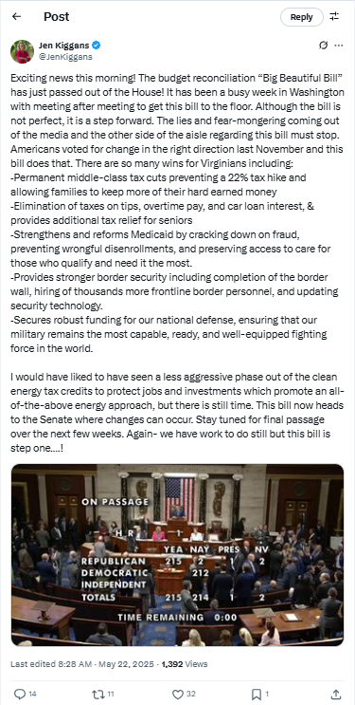
[Twitter, @JenKiggans, 5/22/25]
Kiggans Claimed House Republicans Had Been “Transparent About Their Goals” And Defended The Reconciliation Bill’s Changes To Medicaid, Medicare and SNAP. According to a press release from Rep. Jen Kiggans, “Despite the fearmongering and misinformation from the other side of the aisle, House Republicans have been transparent about our goals: • Make the 2017 Trump tax cuts permanent to prevent a 22% tax hike for families • Secure the border by hiring thousands of new border patrol agents and finishing the wall • Strengthen and reform government programs like Medicaid and SNAP by reducing waste, fraud, and abuse, and initiating work requirements for able-bodied adults without dependents. Let’s be clear: this bill does not cut Medicaid for children, seniors, people with disabilities, foster youth, or those battling addiction. Instead, it protects healthcare for the people who need it the most. Today, roughly 25% of Medicaid spending goes to non-disabled, working-age adults—with no requirement to work, volunteer, or pursue job training.” [Press Release – Rep. Jen Kiggans, 5/22/25]

Kiggans Claimed The House Republican Budget Bill Would Not Result In Hospital Closures Even Though A Provider Said The Opposite
Kiggans On The Big Beautiful Bill: “The Claim That Hospitals Will Be Overwhelmed Or Forced To Close Is Based On A Misunderstanding. This Bill Doesn’t Take Coverage Away From Eligible Individuals—In Fact, It Strengthens The System By Targeting Fraud And Waste, Which Helps Keep It Sustainable.” According to 8 News (WRIC), "In response to Dr. Rozycki’s claims about hospitals being forced to close, Republican Congresswoman Jen Kiggans, who voted for the bill in question, sent 8News the following statement. ‘The claim that hospitals will be overwhelmed or forced to close is based on a misunderstanding. This bill doesn’t take coverage away from eligible individuals—in fact, it strengthens the system by targeting fraud and waste, which helps keep it sustainable. According to the Centers for Medicare & Medicaid Services, over $50 billion in improper Medicaid payments were made last year alone. By cleaning up the rolls and restoring integrity to the program, we’re helping hospitals—not hurting them—by ensuring the system works for those it’s truly intended to serve.’" [8 News (WRIC), 6/4/25]
- HEADLINE: "Doctor Warns Hospitals Could Close If Trump’s ‘One Big Beautiful Bill’ Becomes Law" [8 News (WRIC), 6/4/25]

While Defending The House GOP Budget Bill, Kiggans Warned Senate Republicans That Any New Cuts to Medicaid Risked Her Vote On The Final Version of The Bill
6/24/25: Kiggans Signed Onto A Letter From GOP House Members Warning Their Support For The One Big Beautiful Bill Act Was At Risk If Senate Republicans Ramped Up Medicaid Cuts. According to Spectrum Local News, “A group of more than a dozen House Republicans are warning that their support for President Donald Trump’s ‘one big, beautiful bill’ as he calls it, could be at stake if changes the Senate is proposing to Medicaid stick, arguing they go too far. […] The House Republicans who signed on include Reps. David Valadao of California, Juan Ciscomani of Arizona, Chuck Edwards of North Carolina, Andrew Garbarino of New York, Jen Kiggans of Virginia, Rob Bresnahan of Pennsylvania, Young Kim of California, Mike Lawler of New York, Jeff Van Drew of New Jersey, Dan Newhouse of Washington, Robert Wittman of Virginia, Don Bacon of Nebraska, Zach Nunn of Iowa, Nicole Malliotakis of New York, Mariannette Miller-Meeks of Iowa and Jeff Herd of Colorado.” [Spectrum Local News, 6/24/25]
- Kiggans Signed A Letter In Which GOP House Members Claimed The Senate Version Of The Big Beautiful Bill Went Too Far And They Would Not Support A Final Bill That “Threatens Access To Coverage Or Jeopardizes The Stability Of Our Hospitals And Providers.” According to a letter led by Rep. David Valadao, "As Members of Congress who helped secure a Republican majority, we believe it is essential that the final reconciliation bill reflects the priorities of our constituents—most importantly, the critical need to protect Medicaid and the hospitals that serve our communities. Throughout the budget process, we have consistently affirmed our commitment to ensuring that reductions in federal spending do not come at the expense of our most vulnerable constituents. We write to reiterate that commitment to those we represent here in Washington. We support the Medicaid reforms in H.R. 1, which strengthen the program’s ability to serve children, pregnant women, the elderly, and individuals with disabilities. The proposal released by the Senate Finance Committee on June 16 includes provisions that go beyond H.R. 1. The House’s approach reflects a more pragmatic and compassionate standard, and we urge that it be retained in the final bill. […] Protecting Medicaid is essential for the vulnerable constituents we were elected to represent. Therefore, we cannot support a final bill that threatens access to coverage or jeopardizes the stability of our hospitals and providers." [Letter – Rep. David Valadao, 6/24/25]

7/3/25: Kiggans Voted For The Final Republican Budget Bill That Made Sweeping Cuts To Medicaid
HEADLINE: “Wittman, Kiggans Back Trump Bill, Despite Medicaid Cuts” [Richmond Times-Dispatch, 7/5/25]
7/3/25: Kiggans Voted For The Senate FY 2025 Budget Reconciliation Bill That Extended $4 Trillion In Expiring Tax Cuts, Added New Tax Breaks, Appropriated $448 Billion In Defense, Border, And Immigration Enforcement Funding, Increased The SALT Deduction To $40,000, And Cut Medicaid And Other Social Programs To Offset The Costs. In July 2025, Kiggans voted for, according to Congressional Quarterly, the “motion to concur in the Senate amendment to the bill that would permanently extend nearly $4 trillion in expiring individual and business tax cuts, create several new tax breaks and fund border and immigration enforcement and air traffic control upgrades. It would cut Medicaid and other safety net programs to partly offset the cost. Among other provisions, it would raise the statutory debt ceiling by $5 trillion and appropriate more than $448 billion in mandatory funding for Trump administration priorities and other needs, including $153 billion for defense, $89 billion for immigration enforcement, and $89.5 billion for border control and security. It also would increase the state and local tax deduction cap to $40,000 annually for five years for households making up to $500,000 a year until 2030, when it would permanently revert to $10,000.” The House passed the bill by a vote of 218 to 214. [House Vote 190, 7/3/25; Congressional Quarterly, 7/3/25; Congressional Actions, H.R. 1]
- HEADLINE: "At Least 17 Million Americans Would Lose Insurance Under Trump Plan" [Washington Post, 7/1/25]
- The Congressional Budget Office Estimated That 11.8 Million People Would Become Uninsured As A Result Of The Medicaid Cuts In Republicans’ Reconciliation Bill. According to the Washington Post, "The bill, which narrowly passed the Senate on Tuesday and now heads back to the House, would effectively accomplish what Republicans have long failed to do: unwind many of the key components of the ACA, President Barack Obama’s signature domestic achievement, which dramatically increased the number of Americans with access to health insurance. To start, the Congressional Budget Office estimated that the Senate version of the bill would result in 11.8 million more uninsured in 2034, mostly because of Medicaid cuts, compared with 10.9 million if the House version became law." [Washington Post, 7/1/25]
- The Bill’s $50 Billion In Rural Hospital Relief Funding Would Not Come Close To The Gap Created By Medicaid Cuts, With 300 Rural Hospital At “Immediate Risk” Of Closure. According to the Center For American Progress, “The OBBBA includes $50 billion in relief funding for rural hospitals over a five-year period to help reduce the disastrous impacts of the bill’s roughly $1 trillion in Medicaid cuts. As of May 2025, there were approximately 2,086 rural hospitals receiving $12.2 billion a year in net revenue from Medicaid. At the median, rural hospitals’ revenue from Medicaid is $3.9 million a year.Rural hospitals have some of the lowest operating margins in the nation, especially compared with urban hospitals, meaning that any reductions in revenue could lead to closures. The average operating margin for rural hospitals was 3.1 percent in 2023, with 44 percent of rural hospitals operating with negative margins. As a result, more than 300 rural hospitals are currently at ‘immediate risk’ of closure, especially now that the OBBBA is projected to cut Medicaid spending by $1.02 trillion. The relief fund designed to blunt the negative impacts caused by the bill would not come close to filling that gap. If every rural hospital in the country received an even share of the $50 billion in relief support, it would amount to only $4.5 million every year for five years. At the close of those five years, that funding would disappear altogether.” [Center For American Progress, 7/3/25]

Kiggans Repeatedly Defended Her Vote For The Republican Budget Bill And Its Cuts To Medicaid
Kiggans Admitted The Budget Bill Was Not Perfect But Claimed The “Sum Total” Would Benefit Her Constituents. According to a press release from Rep. Jen Kiggans, “‘Today I cast my vote in favor of H.R. 1, the One Big Beautiful Bill Act (OBBBA). It’s important to acknowledge that no legislation of this magnitude is perfect. My vote reflects a pragmatic assessment that the sum total of this bill will benefit Coastal Virginia and America. This bill represents months of intense negotiations and hard work to put working families first. It delivers real results that Virginians and Americans across the country have been waiting for and voted for in November— relief for their pocketbooks, security at the border, and strength in our military.” [Press Release – Rep. Jen Kiggans, 7/3/25]
Kiggans Said She Voted For The Republican Budget Bill Because She “Knew It Would Benefit” Her Constituents. Rep. Jen Kiggans tweeted, “I voted for the reconciliation bill because I knew it would benefit my constituents, secure our border, and boost our economy.”
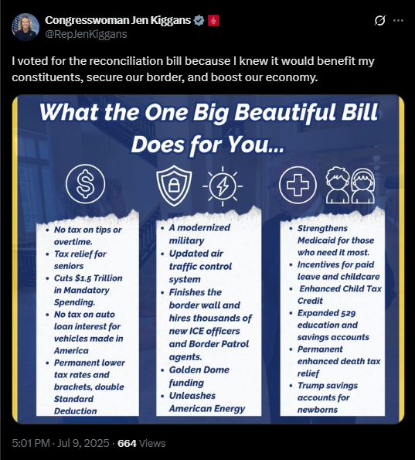
[Twitter, @RepJenKiggans, 7/9/25]
OPINION: Kiggans Defended Medicaid Work Requirements Included In The GOP Budget Bill And Admitted There Were “Tradeoffs” Made To Ensure The Bill’s Passage. According to an opinion by Rep. Jen Kiggans published in the Daily Press, “This legislation also cuts more than $1.6 trillion in waste, fraud and abuse. It tightens eligibility rules, strengthens verification systems, and implements commonsense work requirements for able-bodied adults who receive public benefits. I support safety nets for the vulnerable — not blank checks for those who refuse to participate in the workforce. That’s not just fiscally responsible; it’s fair. We must preserve Medicaid for those who truly need it. No legislation of this scale comes without tradeoffs. But the core of this bill — its heart — is rooted in protecting working families, revitalizing American strength, and putting our country on a more secure footing. It reflects priorities I hear every day from my constituents: Stop the waste, fix the border, support our sailors and lower the cost of living. This bill is pro-America and pro-Hampton Roads.” [Rep. Jen Kiggans Opinion – Daily Press, 7/15/25]

Kiggans Claimed Virginians Thought The GOP Budget Bill Was A “Win”
Kiggans Claimed The Republican Budget Contained “Wins” For Her Constituents. According to a press release from Rep. Jen Kiggans, “A former Navy helicopter pilot, Congresswoman Kiggans emphasized her personal connection to the military community and the everyday Americans she represents. ‘I am a veteran. I served as a Navy helicopter pilot for 10 years of my life. I am married to an F-18 pilot, who served for 20 years. And I am also a very proud Navy Mom to a future Naval aviator,’ Kiggans continued. ‘The people in my district—we are regular, everyday Americans. We just put service to country first,’ she said. ‘Whether you’re a veteran or work with the veteran and defense community, the wins in the One Big Beautiful Bill are important to us. We are hardworking. We are business owners. We are small business owners. We are parents. We are Moms and Dads. And we are people who care about community safety.’” [Press Release – Rep. Jen Kiggans, 7/29/25]

Kiggans Faced Extensive Criticism For Voting For The Republican Budget Bill
LETTER TO THE EDITOR: “Kiggans’ Vote Dismantles Lifeline For Families” [Letter to the Editor – Virginian-Pilot, 8/8/25]
EDITORIAL: "In The End, Reps. Kiggans And Wittman Sold Out Their Constituents" [Virginian-Pilot Editorial Board, 5/22/25]
HEADLINE: "House Bill That Would Cut Medicaid Passes, With Kiggans’ Vote" [WHRO, 5/23/25]
HEADLINE: "'Peak Of Hypocrisy': These 6 Republicans Stand To Profit After Breaking Vow To Protect Medicaid" [AlterNet, 5/23/25]
A Letter To The Editor Criticized Kiggans For Voting To Cut Medicaid Despite Promises Not To. According to a letter to the editor in the Virginian Pilot, "Kiggans In a letter dated April 14, U.S. Rep. Jen Kiggans stated that she would not vote to cut Medicaid. Yet she did vote to cut Medicaid during an overnight session of Congress on Thursday. By trade, she is a geriatric nurse practitioner. She knows the importance of Medicaid for all the people she just turned her back on. Susan Hippen, Virginia Beach" [Letter to the Editor – Virginian Pilot, 5/26/25]
LETTER TO THE EDITOR: “U.S. Reps. Jen Kiggans And Rob Wittman Truly Did Sell Out Their Constituents. After Campaigning On How They Would Help All Virginians, They Voted For Big Cuts To Important Programs That Will Affect Hundreds Of Thousands Of Virginians, Including Those In Their Districts.” According to a letter to the editor in the Daily Press, "Sell-outs Re ‘A Predictable Betrayal’ (Our Views, May 23): U.S. Reps. Jen Kiggans and Rob Wittman truly did sell out their constituents. After campaigning on how they would help all Virginians, they voted for big cuts to important programs that will affect hundreds of thousands of Virginians, including those in their districts. It is a terrible bill that gives big tax cuts to the wealthy while eliminating help for those who need it the most. One of the worst things is that the bill passed by a vote of 215 to 214. If Kiggans and Wittman had had the courage to defend the interests of Virginians and had voted against the bill instead of for it, the bill wouldn’t have passed The vote would have been 216 to 213 against the bill. ‘That they failed to do so should not be forgotten,’ is definitely true, and I hope all of their constituents will remember that when elections are held in 2026. Kiggans and Wittman have definitely let us down. Just when we needed their votes the most, they’ve shown us that they don’t deserve our votes. Connie S. Moore, Virginia Beach" [Letter to the Editor – Daily Press, 5/31/25]

An Estimated 104,200 Virginians In The Second Congressional District Relied On Medicaid Or CHIP For Health Insurance
104,200 Virginians In The 2nd Congressional District Were Enrolled In Medicaid Or CHIP. According to the Center for American Progress,
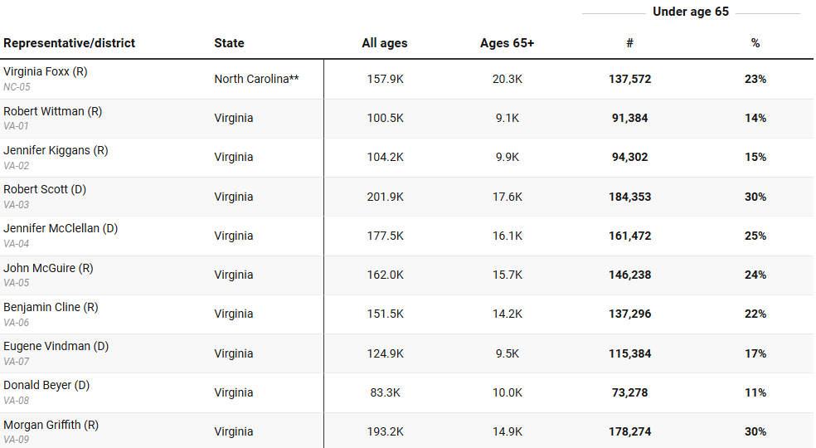
[Center for American Progress, 3/11/25]

