Overview
Kiggans claimed what Trump’s “Department of Government Efficiency” was doing was “so necessary.” Meanwhile, DOGE laid off thousands of federal workers in Virginia and DOGE-driven cuts and downsizing were affecting the federal government’s ability to deliver services to seniors. Kiggans even downplayed Trump’s layoffs of Virginians. Only in November 2025, after reports that DOGE canceled at least 70 contracts with veteran-owned businesses in her district, did Kiggans claim to be “actively working to review and reverse” DOGE’s detrimental cuts. More than 158,000 Virginians in Kiggans district relied on Social Security benefits and more than 30,000 were employed by the federal government.

Kiggans Claimed DOGE’s Work, Which Hurt The Social Security Administration And Virginia Federal Workers Was “So Necessary”

February 2025: Kiggans Claimed DOGE’s Work Was “So Necessary”
February 2025: Kiggans Claimed The Downsizing Of The Federal Government And Cutting “Wasteful Spending” Was “So Necessary.” According to a video posted on Jen Kiggans’ Twitter account, “KIGGANS: But we also ran off the economy and there’s some work to do there. And when you look at what’s happening right now and you look at where we’re finding places to cut spending, we’re looking at the size of the federal government, where can we tweak that. You know and I know it’s a lot of change but this change is so necessary because our economy has gotta get back on the right track. I’m a tax payer, I’m a bill payer, I’m a grocery shopper. These things are still my priority. And the good news is that we’re finding those places, we’re finding the wasteful spending, we’re finding where we can cut the size of government.” [Twitter, @JenKiggans, 2/24/25] (video)
February 2025: Kiggans Said She Looked Forward To Working With DOGE “To Restore Commonsense And Fiscal Responsibility.” According to a post on Jen Kiggans’ Twitter, “Americans called for a decisive change in November… The reckless/wasteful funding priorities of the previous administration that have been uncovered is a prime example of why I look forward to working with the President and the Department of Government Efficiency to restore commonsense and fiscal responsibility! Read more here:”
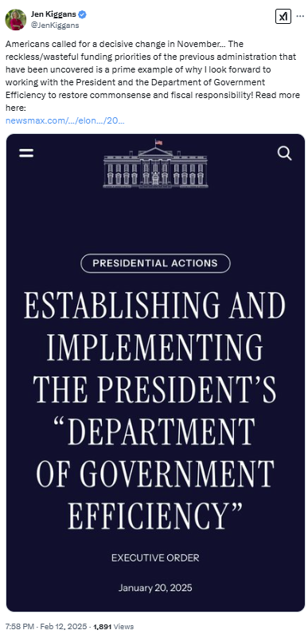
[Twitter, @JenKiggans, 2/12/25]

2025: At the Social Security Administration, Doge Had Forced Mass Layoffs, Longer Wait Times and Frequent Website Crashes
HEADLINE: “Social Security Stops Reporting Call Wait Times And Other Metrics” [Washington Post, 6/20/25]
HEADLINE: “As Social Security Services Are Cut Back, Millions Of Seniors Face Long Drives” [Axios, 6/8/25]
HEADLINE: “Social Security Website Keeps Crashing, As DOGE Demands Cuts To IT Staff” [Washington Post, 4/7/25]
HEADLINE: “Social Security Faces Thousands More Job Cuts Even With Service In Tailspin” [Washington Post, 4/4/25]
The Social Security Administration Website Crashed Four Times In Ten Days In March Because Servers Were Overloaded. According to the Washington Post, “The Social Security Administration website crashed four times in 10 days this month because the servers were overloaded, blocking millions of retirees and disabled Americans from logging in to their online accounts. In the field, office managers have resorted to answering phones in place of receptionists because so many employees have been pushed out. Amid all this, the agency no longer has a system to monitor customer experience because that office was eliminated as part of the cost-cutting efforts led by Elon Musk. And the phones keep ringing. And ringing.” [Washington Post, 3/25/25]
Field Office Managers At Social Security Offices Had To Answer Phones In Place Of Receptionists Because DOGE Had Pushed Out So Many Federal Employees. According to the Washington Post, “The Social Security Administration website crashed four times in 10 days this month because the servers were overloaded, blocking millions of retirees and disabled Americans from logging in to their online accounts. In the field, office managers have resorted to answering phones in place of receptionists because so many employees have been pushed out. Amid all this, the agency no longer has a system to monitor customer experience because that office was eliminated as part of the cost-cutting efforts led by Elon Musk. And the phones keep ringing. And ringing.” [Washington Post, 3/25/25]
DOGE Eliminated The Social Security Administration’s System To Monitor Customer Experience. According to the Washington Post, “The Social Security Administration website crashed four times in 10 days this month because the servers were overloaded, blocking millions of retirees and disabled Americans from logging in to their online accounts. In the field, office managers have resorted to answering phones in place of receptionists because so many employees have been pushed out. Amid all this, the agency no longer has a system to monitor customer experience because that office was eliminated as part of the cost-cutting efforts led by Elon Musk. And the phones keep ringing. And ringing.” [Washington Post, 3/25/25]
Early February-Late March 2025: AARP Said More Than 2,000 People Per Week Had Called Expressing Concerns About Whether They Would Continue To Get Their Social Security Benefits. According to the Washington Post, “Alarmed lawmakers are straining to answer questions back home from angry constituents. Calls have flooded into congressional offices. AARP announced Monday that more than 2,000 people a week have called the retiree organization since early February — double the usual number — with concerns about whether benefits they paid for during their working careers will continue. Social Security is the primary source of income for about 40 percent of older Americans.” [Washington Post, 3/25/25]

2024: More Than 158,000 Virginians In The 2nd Congressional District Relied on Social Security Benefits
2024: 158,254 Virginians In The 2nd Congressional District Relied On Social Security Benefits. According to the Social Security Administration, in 2024, 158,254 Virginians in the 2nd congressional district received Social Security benefits. [Social Security Administration, Virginia, 2024]

September 2025: Kiggans Told Virginians Who Lost Their Job Due To DOGE Cuts To “Go Out And Get” Another Job
9/12/25: Kiggans Told Virginians Who Lost Their Job Due To DOGE Cuts To “Go Out And Get” Another Job. According to Rep. Jen Kiggans on the John Fredericks Radio Show, “FREDERICKS: What is your message to federal workers that have been laid off, some in your district, under the reduction in government effort by the Trump administration? KIGGAN: Jobs are here. We saw the Biden Administration expand the size of government, and we can’t have that. Our $37 trillion debt is not sustainable. So there’s been some reduction in the size of the federal government, which is supported by the American people, but the jobs are there and I encourage people to go out and get them.” [John Fredericks Radio Show, 9/12/25] (audio)

November 2025: Kiggans Claimed She Was “Working To Review And Reverse” DOGE Cuts That Were Hurting Veterans in Her District
Kiggans Said She Was “Troubled” By The Cuts DOGE Made To Veteran-Owned Businesses And Claimed To Be “Actively Working To Review And Reverse” Them. According to Politico, “DOGE claims an additional $39 million in savings from cutting grants meant to benefit veterans, and a further $177 million from VA contracts that were not directly with veteran-owned businesses but benefit veterans after their service. Despite the administration’s assurances, the cuts have rattled some Republicans. ‘As a veteran, I am troubled any time a veteran-owned business is impacted by budget cuts. I am actively working to review and reverse these cuts,’ Rep. Jen Kiggans (R-Va.), a former Navy helicopter pilot and member of the House Committee on Veterans’ Affairs, said in a statement. Kiggans’ district lost at least 70 contracts among veteran-owned businesses.” [Politico, 11/22/25]
- DOGE Canceled At Least 1,251 Contracts With Veteran-Owned Businesses. According to Politico, “DOGE has canceled at least 1,251 contracts with veteran-owned businesses, or just under 10 percent of all contract terminations posted on its public list of records — its ‘wall of receipts’ — according to a POLITICO analysis. This has hit at least 550 of these businesses, and the vast majority of these contracts were held by veterans disabled in the line of service. Both conditions are self-reported and verified by the Small Business Administration for small companies.’ [Politico, 11/22/25]
- DOGE Was Likely Underreporting The Impact Of Its Cuts On Veteran-Owned Businesses Because It Did Not Track The Impact Of Cuts Across Sub-Contracts. According to Politico, “A DOGE spokesperson did not respond to a request for comment but the White House has previously said the ‘wall of receipts’ is up-to-date and accurate. The true number of contracts and veteran-owned operations that lost federal business is likely higher because DOGE doesn’t track its impact across sub-contracts, which multiple business-owners interviewed for this report also hold. But the VA said the agency is more able to provide better care, more efficiently after terminating other work.” [Politico, 11/22/25]

