Overview
Miyares voted against legislation that banned conversion therapy and removed prohibitions on same-sex marriage.

Miyares Voted Against A Bill That Removed Prohibitions On Same-Sex Marriage And Civil Unions From The State Code
March 2020: As A Virginia House Delegate, Miyares Voted Against HB 623, Which Removed Prohibitions On Same-Sex Marriage And Civil Unions From The State Code. In 2020, according to Virginia’s Legislative Information System, Miyares voted against HB 623, “Gender-neutral terms; prohibitions on same-sex marriage and civil unions removed from Code; certain gender-specific crimes; penalty. Replaces the terms ‘husband’ and ‘wife,’ as well as related terms, with gender-neutral terms throughout the Code to comport with the United States Supreme Court decision in Obergefell v. Hodges, 576 U.S. ___ (June 26, 2015). The bill also repeals the statutory prohibitions on same-sex marriages and civil unions or other arrangements between persons of the same sex purporting to bestow the privileges and obligations of marriage, and it makes conforming changes to various laws involving married individuals and their rights stemming from marriage.” The bill was adopted in the Virginia House by 53 to 43 votes. The bill ultimately passed in the Virginia Senate and was signed into law. [Virginia’s Legislative Information System – HB 623 (2020), Introduced 1/6/20; Virginia House Vote, 3/4/20]

Miyares Opposed Protections For LGBTQ Children In Schools
2024: Miyares Asked The Supreme Court To “Provide Much-Needed Clarity And Reaffirm That Government Cannot Override Parents’ Fundamental Rights” After A Wisconsin School District Allowed Students To Change Their Gender Identity Without Parental Notification. According to Miyares’ Twitter, “I'm asking the U.S. Supreme Court to provide much-needed clarity and reaffirm that government cannot override parents' fundamental rights simply because they think they know better. Schools must work with parents, not against them, to support a child's wellbeing.”
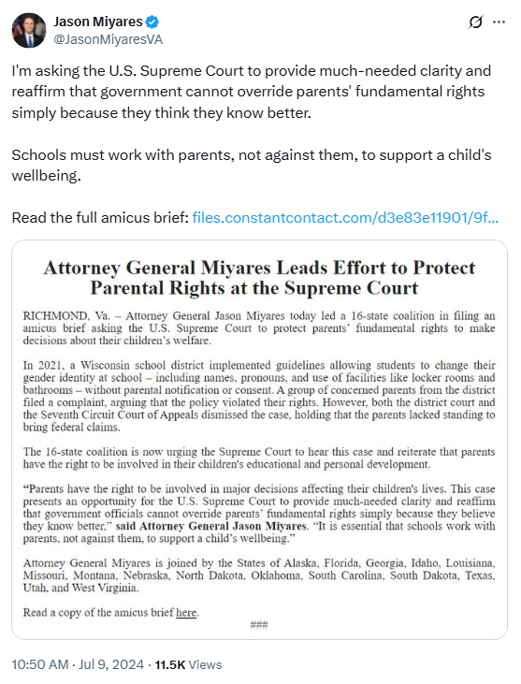
[Twitter, @JasonMiyaresVA, 7/9/24]
2022: Miyares Criticized Schools For Wanting To “Change A Child’s Gender Without Even An E-Mail Notification To Parents” Even Though They Required Parental Permission To Give Children Aspirin. According to Miyares’ Twitter, “Schools cannot give children so much as an aspirin without parental permission, but apparently they now want to change a child’s gender without even an e-mail notification to parents?”
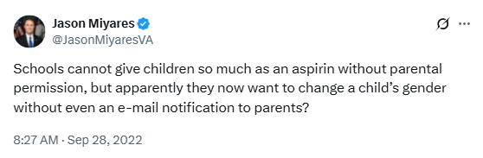
[Twitter, @JasonMiyaresVA, 9/28/22]

Miyares Sued To Stop The Inclusion Of Gender Identity And Sexual Orientation In Title IX Discrimination Protections
2022: Miyares Sued The Federal Government To Stop Gender Identity And Sexual Orientation From Being Included In Title IX Discrimination Protections. According to ABC 8 News, “Virginia Attorney General Jason Miyares joined 22 other states in suing the federal government to stop gender identity and sexual orientation from being included in non-discrimination policies for SNAP, including some school lunch programs. The Biden administration directed the Department of Agriculture (USDA), which oversees SNAP, to update their non-discrimination guidance following a supreme court decision that discrimination based on sexual orientation and gender identity fall under the umbrella of protections against sex discrimination, meaning employers can’t ‘fire someone simply for being homosexual or transgender.’ The Biden administration interpreted that decision as applying not only to Title VII of the Civil Rights Act, which governs employment, but also to Title IX, which provides discrimination protections in educational settings.” [ABC 8 News, 7/27/22]
- Miyares Said The Federal Government Was “Forcing Unlawful Regulatory Measures Onto Schools And Holding Hostage Funding For School Lunches.” According to ABC 8 News, “In a press release announcing the lawsuit, Miyares claimed the federal government was ‘forcing unlawful regulatory measures onto schools and holding hostage funding for school lunches.’” [ABC 8 News, 7/27/22]

Miyares Voted Against A Bill That Made Conversion Therapy For Minors Illegal And Prohibited State Funding For Conversion Therapy
February 2020: As A Virginia House Delegate, Miyares Voted Against HB 386, Which Prohibited Conversion Therapy For Minors. In 2020, according to Virginia’s Legislative Information System, Miyares voted against HB 386, “Conversion therapy; prohibited by certain health care providers.” The bill passed in the Virginia House by 66 to 27 votes. The bill ultimately passed in the Virginia Senate and was signed into law. [Virginia’s Legislative Information System – HB 386 (2020), Introduced 1/8/20; Virginia House Vote, 2/3/20]
HB 386 Made It “Illegal For Licensed Professionals In The State To Engage In Conversion Therapy For Virginias Younger Than 18” And Prohibited “State Funds From Being Used To Conduct The Therapy On Minors.”
According to CNN, “The legislation makes it illegal for licensed professionals in the state to engage in conversion therapy for Virginians younger than 18 and prohibits state funds from being used to conduct the therapy on minors. The practice does not work, and studies show that those subjected to it, or who choose to undergo it, are put at a greater risk of depression and suicide.” [CNN, 3/3/20]

