Overview
Miyares supported charter schools, voted to defund public schools, and opposed protections for LGBTQ students and teaching Critical Race Theory.

February 2017: Miyares Supported Legislation That Would Have Diverted Funding From Public Schools

February 2017: Miyares Supported HB 1605, A Bill That Established “Parental Choice Education Savings Accounts”
Miyares Voted For House Bill 1605, A Bill That Established “Parental Choice Education Savings Accounts.” On February 7, 2016, Miyares voted in favor of House Bill 1605. According to the Summary As Passed, House Bill 1605 “Permits the parents of certain students with disabilities to apply to their resident school division for a Parental Choice Education Savings Account, to consist of the student's Standards of Quality per pupil funds and to be used for certain expenses of the student, including (i) tuition, fees, or required textbooks at a private elementary or secondary school or preschool that is located in the Commonwealth and does not discriminate on the basis of race, color, or national origin; (ii) educational therapies or services for the student from a practitioner or provider, including paraprofessionals or educational aides; (iii) tutoring services; (iv) curriculum; (v) tuition or fees for a private online learning program; (vi) fees for a nationally standardized norm-referenced achievement test, an Advanced Placement examination, or any examination taken to gain admission to an institution of higher education; or (vii) tuition fees or required textbooks at a public two-year or four-year institution of higher education in the Commonwealth or at an accredited private institution of higher education in the Commonwealth.” [Summary As Passed, HB 1605, 3/7/16; Senate Vote, HB 1605, 2/07/17]
On Final Passage, Miyares Voted Nay By Accident. According to the Virginia Legislative Information Service, Miyares voted Nay on final passage of HB 1605 by accident, he meant to vote yea.
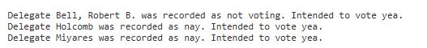
[House Vote: Adoption, HB 1605, 2/22/17]

April 2017: Governor McAuliffe Vetoed House Bill 1605 Because The Bill Would “Deprive” Schools Of “Critically-Needed Resources.”
Governor McAuliffe: HB 1605 “Would Divert State Funds From Our Public School Systems.” According to the Governor’s Veto Explanation, “Pursuant to Article V, Section 6, of the Constitution of Virginia, I veto House Bill 1605. This bill would divert state funds from our public school systems and redirect those funds to "Parental Choice Education Savings Accounts" to pay for educational services outside the public school system. The bill is similar in purpose to HB 389 (2016), which I vetoed. Nothing in HB 1605 addresses the earlier measure's fundamental infirmities. First and foremost, this legislation raises significant constitutional concerns. Tuition at private sectarian institutions would be an approved expense. This places the legislation in direct conflict with Article VIII, Section 10, of the Virginia Constitution, which authorizes the use of public funds only for public and nonsectarian private schools. In requiring local school divisions to transfer the bulk of a qualified student's state SOQ funding to an outside "Education Savings Account," the bill would deprive those schools of critically-needed resources. Additionally, the funds that would be withdrawn from the public system bear no relationship to the cost of the private education to be provided. Since the bill requires only state funding to be transferred, the amount received by eligible families would vary widely, depending on which locality a student is from. Finally, it should be noted that the bill lacks accountability standards for participating schools. There thus is no assurance that these state funds will be used to provide students high quality education. House Bill 1605 raises constitutional concerns, diverts funds from public schools, and creates an inequitable system across different school divisions. It fails to support the goal of using state resources to strengthen and improve public education throughout the Commonwealth. Accordingly, I veto this bill.” [Governor’s Veto Explanation, HB 1605, 3/16/17]
Governor McAuliffe: HB 1605 Would “Deprive” Schools Of “Critically-Needed Resources.” According to the Governor’s Veto Explanation, “Pursuant to Article V, Section 6, of the Constitution of Virginia, I veto House Bill 1605. This bill would divert state funds from our public school systems and redirect those funds to "Parental Choice Education Savings Accounts" to pay for educational services outside the public school system. The bill is similar in purpose to HB 389 (2016), which I vetoed. Nothing in HB 1605 addresses the earlier measure's fundamental infirmities. First and foremost, this legislation raises significant constitutional concerns. Tuition at private sectarian institutions would be an approved expense. This places the legislation in direct conflict with Article VIII, Section 10, of the Virginia Constitution, which authorizes the use of public funds only for public and nonsectarian private schools. In requiring local school divisions to transfer the bulk of a qualified student's state SOQ funding to an outside "Education Savings Account," the bill would deprive those schools of critically-needed resources. Additionally, the funds that would be withdrawn from the public system bear no relationship to the cost of the private education to be provided. Since the bill requires only state funding to be transferred, the amount received by eligible families would vary widely, depending on which locality a student is from. Finally, it should be noted that the bill lacks accountability standards for participating schools. There thus is no assurance that these state funds will be used to provide students high quality education. House Bill 1605 raises constitutional concerns, diverts funds from public schools, and creates an inequitable system across different school divisions. It fails to support the goal of using state resources to strengthen and improve public education throughout the Commonwealth. Accordingly, I veto this bill.” [Governor’s Veto Explanation, HB 1605, 3/16/17]
Governor McAuliffe: HB 1605 “Diverts Funds From Public Schools, And Creates An Inequitable System Across Different School Divisions.” According to the Governor’s Veto Explanation, “Pursuant to Article V, Section 6, of the Constitution of Virginia, I veto House Bill 1605. This bill would divert state funds from our public school systems and redirect those funds to "Parental Choice Education Savings Accounts" to pay for educational services outside the public school system. The bill is similar in purpose to HB 389 (2016), which I vetoed. Nothing in HB 1605 addresses the earlier measure's fundamental infirmities. First and foremost, this legislation raises significant constitutional concerns. Tuition at private sectarian institutions would be an approved expense. This places the legislation in direct conflict with Article VIII, Section 10, of the Virginia Constitution, which authorizes the use of public funds only for public and nonsectarian private schools. In requiring local school divisions to transfer the bulk of a qualified student's state SOQ funding to an outside "Education Savings Account," the bill would deprive those schools of critically-needed resources. Additionally, the funds that would be withdrawn from the public system bear no relationship to the cost of the private education to be provided. Since the bill requires only state funding to be transferred, the amount received by eligible families would vary widely, depending on which locality a student is from. Finally, it should be noted that the bill lacks accountability standards for participating schools. There thus is no assurance that these state funds will be used to provide students high quality education. House Bill 1605 raises constitutional concerns, diverts funds from public schools, and creates an inequitable system across different school divisions. It fails to support the goal of using state resources to strengthen and improve public education throughout the Commonwealth. Accordingly, I veto this bill.” [Governor’s Veto Explanation, HB 1605, 3/16/17]

Miyares Opposed Protections For LGBTQ Children In Schools
2024: Miyares Asked The Supreme Court To “Provide Much-Needed Clarity And Reaffirm That Government Cannot Override Parents’ Fundamental Rights” After A Wisconsin School District Allowed Students To Change Their Gender Identity Without Parental Notification. According to Miyares’ Twitter, “I'm asking the U.S. Supreme Court to provide much-needed clarity and reaffirm that government cannot override parents' fundamental rights simply because they think they know better. Schools must work with parents, not against them, to support a child's wellbeing.”
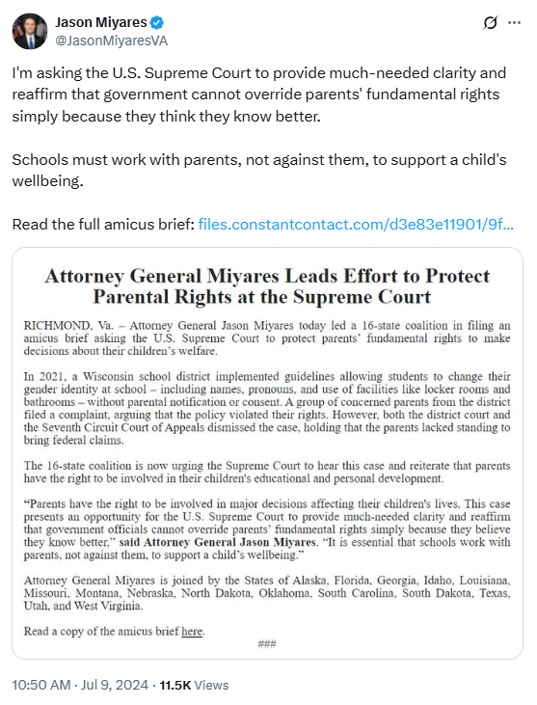
[Twitter, @JasonMiyaresVA, 7/9/24]

Miyares: “The Success And Availability Of Charter Schools In The United States Is Fundamental To Parental Rights”
2022: Miyares Criticized Biden’s Proposal Restricting Federal Grants For Charter Schools, Arguing That “The Success And Availability Of Charter Schools In The United States Is Fundamental To Parental Rights.” According to The Roanoke Star, “Attorney General Miyares today announced he joined 15 other state attorneys general in a letter criticizing the Biden Administration's new regulatory proposal restricting federal grants for public charter schools. […] Attorney General Miyares said that ‘No two children are the same so it's important to have educational diversity and options that work best for each student. The success and availability of charter schools in the United States is fundamental to parental rights. Parents know what is best for their children, and charter schools provide families unhappy with the existing local public schools an alternative. Any effort to weaken the charter school system will be damaging to young Americans nationwide who want a different option for education.’” [Roanoke Star, 4/22/22]

Miyares Said He Was Willing To Go To Court To Ban Critical Race Theory
2021: Miyares Supported Youngkin’s Plan To Ban Critical Race Theory, And Pledged To “Take It To Court,” If Necessary.
According to CNN, “Another popular target for Youngkin and his supporters was critical race theory. ‘Governor Glenn Youngkin will ban it, and if I have to take it to court to stop it, I will,’ said Jason Miyares, the Republican nominee for attorney general, while campaigning with Youngkin in Warrenton.” [CNN, 10/29/21]

