Overview
Miyares supported legislation that disenfranchised voters including requiring proof of citizenship and purging voter rolls and established an “Election Integrity Unit.”

Miyares Celebrated Arizona’s Law Requiring Proof Of Citizenship To Register To Vote
2024: Miyares Celebrated Arizona’s Law Requiring Proof Of Citizenship To Register To Vote Being Passed. According to Miyares’ Twitter, “BREAKING: The Supreme Court just allowed Arizona's law requiring proof of citizenship to register to vote to go into effect. I’m proud to have backed this common sense law through an amicus brief at the Supreme Court.”
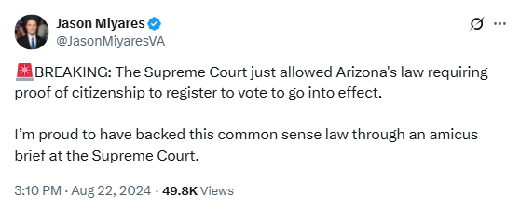
[Twitter, @JasonMiyaresVA, 8/22/24]

Miyares Established A Virginia “Election Integrity Unit” Despite A Lack Of Widespread Issues With Voter Fraud
2022: Miyares Established A Virginia “Election Integrity Unit” Despite A Lack Of Widespread Issues With Voter Fraud In The Commonwealth. According to the Washington Post, “Virginia’s Republican attorney general, Jason Miyares, announced Friday the creation of an ‘Election Integrity Unit’ that will provide legal advice and prosecute election law violations, despite a lack of widespread issues with voter fraud or other irregularities in the state. Miyares joins a growing list of GOP officeholders who have pushed stricter enforcement of voting laws in the wake of former president Donald Trump’s baseless claims that the 2020 election was stolen from him. The efforts have been criticized by voting rights groups and Democrats, who say their true aim is to suppress turnout and intimidate voters.” [Washington Post, 9/9/22]
- Voting Rights Groups And Democrats Claimed Miyares’ True Aim Was To Suppress Turnout And Intimidate Voters. According to the Washington Post, “Virginia’s Republican attorney general, Jason Miyares, announced Friday the creation of an ‘Election Integrity Unit’ that will provide legal advice and prosecute election law violations, despite a lack of widespread issues with voter fraud or other irregularities in the state. Miyares joins a growing list of GOP officeholders who have pushed stricter enforcement of voting laws in the wake of former president Donald Trump’s baseless claims that the 2020 election was stolen from him. The efforts have been criticized by voting rights groups and Democrats, who say their true aim is to suppress turnout and intimidate voters.” [Washington Post, 9/9/22]
Miyares: “Joe Biden Won The 2020 Presidential Election, And There Was No Widespread Voter Fraud In Virginia Or Elsewhere In The Country. But That Has Nothing To Do With My Election Integrity Unit.” According to an op-ed written by Miyares in the Washington Post, “The media has enjoyed making a panic over the unit’s existence, claiming that I’m somehow aiming to discourage voting or spreading disinformation about our elections. Let’s be clear: Joe Biden won the 2020 presidential election, and there was no widespread voter fraud in Virginia or elsewhere in the country. But that has nothing to do with my Election Integrity Unit. […] The Election Integrity Unit is simply a restructuring of lawyers, paralegals and investigators already employed by my office and working on election matters. The goal is to more efficiently work with the election community by creating a more cooperative and collaborative approach from our office. This unit will also work to protect voting rights and crack down on voter intimidation.” [Washington Post, Virginia Attorney General Jason Miyares Op-Ed, 10/19/22]

Miyares Supported A Bill To Purge Voter Rolls
2021: Miyares Supported A Bill To Purge Voter Rolls. According to Miyares’ Facebook, “What is controversial about removing dead voters from the voter list? So my friend Jen Moore Kiggans bill for election accuracy removes the names of the deceased weekly from voter roles to ensure accuracy. As she noted, this bill was supported by voter registrars, had wide bipartisan support in the state Senate and was killed by Va House Democrats. We desperately need a check and balance in Richmond.”
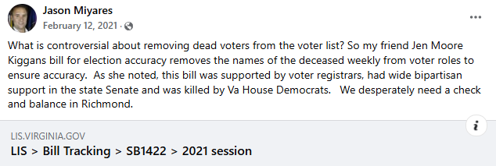
[Facebook, Jason Miyares, 2/12/21]

