Overview
Miyares supported anti-abortion pregnancy centers and the overturning of Roe V. Wade, and spread false claims about pro-choice legislation.

Miyares Supported Anti-Abortion Pregnancy Centers
2023: Miyares Spoke At The Virginia March For Life And Praised Anti-Abortion Crisis Pregnancy Centers For Their “Compassionate Work.” According to Miyares’ Twitter, “It was an honor to speak at the Virginia March for Life today in Richmond and to highlight the compassionate work of Pregnancy Center charities in the face of adversary. #VAMarchForLife Life is Beautiful.”
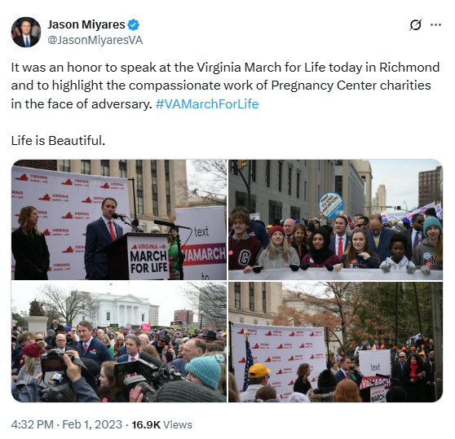
[Twitter, @JasonMiyaresVA, 2/1/23]
2022: Miyares Said He Was “Proud To Stand And Support” Anti-Abortion Crisis Pregnancy Centers. According to Miyares’ Facebook, “Proud to stand and support our Crisis Pregnancy Centers during their time of need.”
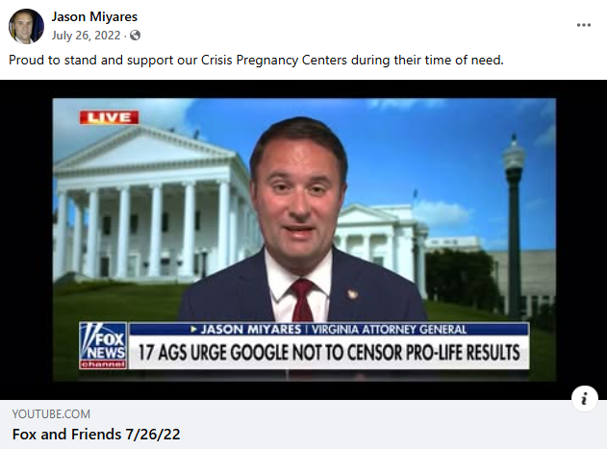
[Facebook, Jason Miyares, 7/26/22]
2022: Miyares Criticized Google For Allegedly Censoring Anti-Abortion Pregnancy Centers From Search Results. According to Miyares’ Facebook, “Political pressure should not dictate what appears in Google searches. Censoring crisis pregnancy centers is wrong. Google has two choices - protect the marketplace of ideas or face the legal consequences.”
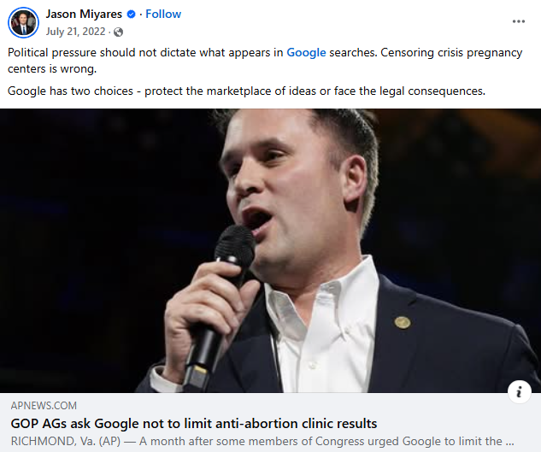
[Facebook, Jason Miyares, 7/21/22]

Miyares Supported The Overturning Of Roe V. Wade
2022: Miyares Supported The Overturning Of Roe V. Wade, Saying The Decision “Ruled That The Issue Of Abortion Should Not Be Decided By Unelected Federal Judges, But By The People Of The States Through Their Elected Representatives.” According to Miyares’ Facebook, “Statement from the Virginia Office of the Attorney General regarding Dobbs v. Jackson Women's Health Organization Richmond, VA – Victoria LaCivita, spokesperson for Attorney General Jason Miyares, has issued the following statement regarding the Supreme Court's decision in the case of Dobbs v. Jackson Women's Health Organization. ‘Today the Supreme Court ruled that the issue of abortion should not be decided by unelected federal judges, but by the people of the States through their elected representatives. Good and reasonable people can disagree on this issue but now Virginians, not federal judges, can decide its future. The Attorney General will continue to uphold and enforce both the Constitution of the United States and the Constitution of Virginia.’”
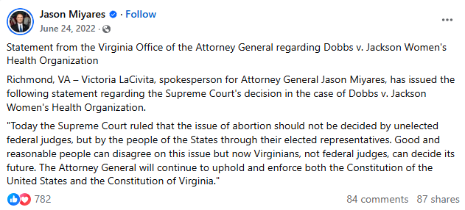
[Facebook, Jason Miyares, 6/24/22]

Miyares Removed Virginia From A Brief Supporting Roe V. Wade And Asked The Supreme Court To Overturn The Ruling
2022: Miyares Filed A Motion To Remove Virginia From A Brief Urging The Supreme Court Not To Overturn Roe V. Wade, Arguing That “Virginia No Longer Adheres To The Arguments Contained In Its Previously Filed Brief.” According to National Review, “Under Herring’s leadership, Virginia joined nearly two dozen progressive states in filing a Supreme Court brief in Dobbs, a case considering the constitutionality of a Mississippi law protecting unborn children after 15 weeks of pregnancy. The brief, led by California, argued that Mississippi’s law is unconstitutional and urged the Court not to overrule precedents such as Roe v. Wade and Planned Parenthood v. Casey, which created and upheld a supposed constitutional right to abortion. The brief also asserted that overturning the Court’s abortion jurisprudence would have a number of negative effects on the states and their citizens. Now, at the end of his first week in office, Miyares is seeking to remove Virginia as a signatory to this pro-abortion brief. In a copy of his motion obtained exclusively by National Review, Miyares writes ‘that Virginia no longer adheres to the arguments contained in its previously filed brief [and] is now of the view that the Constitution is silent on the question of abortion, and that it is therefore up to the people in the several States to determine the legal status and regulatory treatment of abortion.’” [National Review, 1/21/22]
- Miyares Wrote In His Motion That Roe V. Wade Was “Wrongly Decided,” And Asked The Supreme Court To Overturn The Ruling. According to National Review, “The motion goes on to ask the Court to uphold Mississippi’s law, arguing that Roe and Casey should be overturned. ‘It is Virginia’s position that the Court’s decisions in Roe and Casey were wrongly decided,’ the motion concludes. ‘Unmoored from the Constitution’s text, the Court’s abortion jurisprudence has proven unworkable, and the Court’s effort to save it has distorted other areas of the law. This Court should restore judicial neutrality to the abortion debate by permitting the people of the several States to resolve these questions for themselves.’” [National Review, 1/21/22]

2022: Miyares Touted His Motion In Support Of Overturning Roe V. Wade, Saying, “Life Is Beautiful.” According to Miyares’ Facebook, “Life Is Beautiful.”
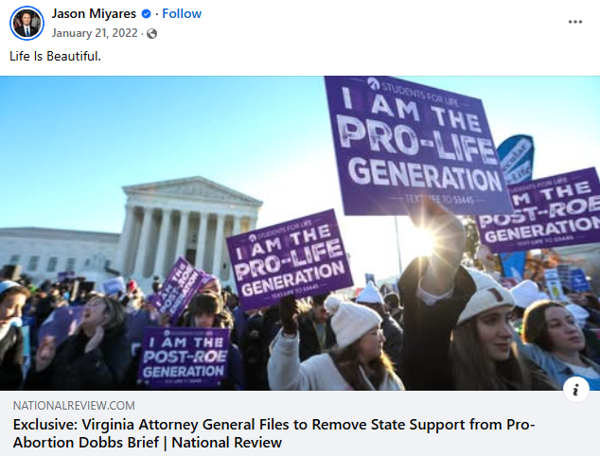
[Facebook, Jason Miyares, 1/21/22]

Miyares Spread False Claims About Pro-Choice Legislation
2019: Miyares Criticized A Virginia Democrat For Supporting A Bill That Allegedly Allowed “Abortion As [A] Woman Is Giving Birth.” According to Miyares’ Facebook, “I wonder how history will judge us......”
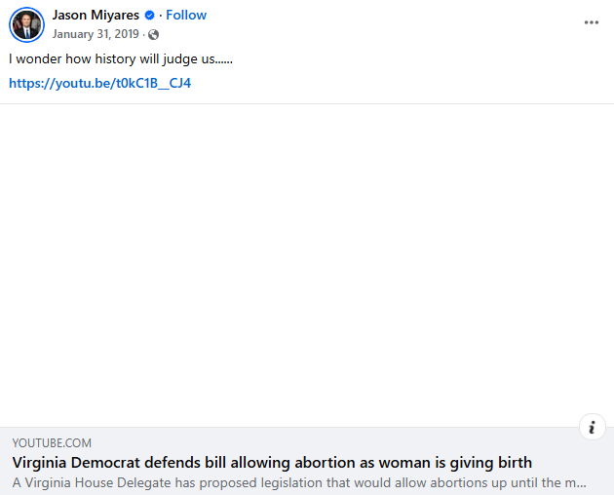
[Facebook, Jason Miyares, 1/31/19]

