Overview
Ciattarelli claimed he supported cost-of-living-adjustments for first responder retirees, but he previously called for the state to skip one year’s pension payment. Additionally, Ciattarelli claimed state worker’s post-retirement benefits were too “generous,” called for the slashing of state workers’ post-retirement benefits, and wanted to turn the pension system into a “cash balance plan.”

Ciattarelli Claimed He Supported Cost-Of-Living-Adjustments For First Responders, But Wanted To Slash Public Workers’ Pensions And Teachers’ Retirement Benefits

Ciattarelli Claimed To Support Restoring Cost-Of-Living Adjustments For Retired First Responders But Previously Opposed Pension Funding

Ciattarelli Claimed To Support Cost-Of-Living Adjustments For Retired Police Officers And Firefighters
2025: Ciattarelli Celebrated The Introduction Of A Bill In The New Jersey Legislature That Would Restore Cost-Of-Living Adjustments For Retired Police And Firefighters. According to Ciattarelli’s Facebook, “Well done by Assemblyman Alex Sauickie and all have worked hard on this important legislation. Now let’s get it passed & I’ll sign it as Governor! It’s time to Restore COLA Now!”
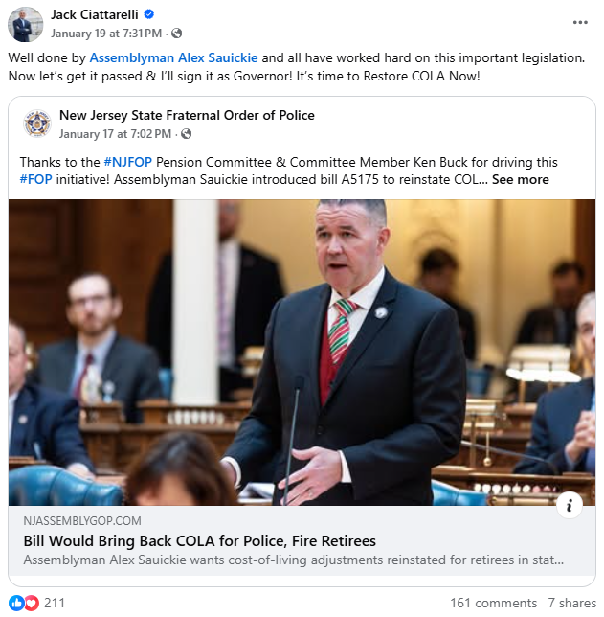
[Facebook, Jack Ciattarelli, 1/19/25]
2024: Ciattarelli Pledged To Sign Legislation That Would Reinstate Cost Of Living Adjustments For Law Enforcement Retirees. According to Ciattarelli’s Facebook, “Well done by Assemblyman Alex Sauickie, Assemblyman Rob Clifton LD12 and other leaders on submitting this important piece of legislation. As Governor, I will sign this bill and nominate an Attorney General that has the backs of our law enforcement community. It’s time to restore COLA and bring back law and order in NJ! #COLANOW.”
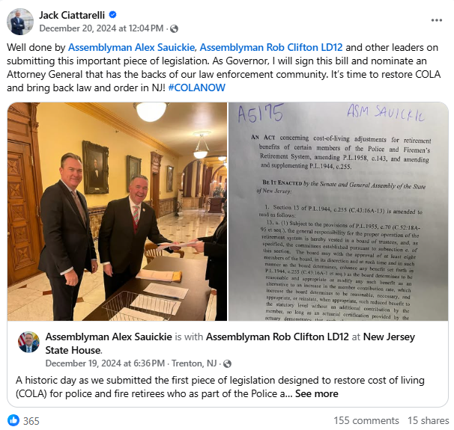
[Facebook, Jack Ciattarelli, 12/20/24]

2021: Ciattarelli Posted And Deleted A Tweet In Support Of Police And Fire Pensions
2021: Ciattarelli Later Tweeted, And Then Deleted, A Post In Support Of Police And Fire Pensions. According to a Ciattarelli tweet via press release from the New Jersey Democrats, “In a hastily deleted tweet, Assemblyman Ciattarelli said he would ‘Protect police and fire pensions’ — directly contradicting his lengthy record of shorting the state pension system, including calling for the state to skip this year’s pension payment and supporting Chris Christie’s budgets that shortchanged billions of dollars from the system and jeopardized the livelihoods of middle-class families.”
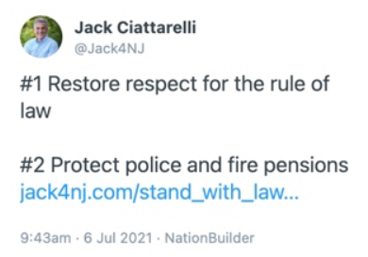
[Twitter – @Jack4NJ via Press Release – New Jersey Democrats, 7/8/21]
Researcher’s Note: We included the New Jersey Democrats press release since they screenshotted Ciattarelli’s deleted tweet.

2021: Ciattarelli Criticized Murphy’s Budget That Increased Pension Funding
2021: Ciattarelli Called Murphy’s State Budget, Which Included Increased Funding To The State Pension System And Tax Cuts For The Middle Class, “Bloated, Inefficient, And Corrupted.” According to The Star-Ledger, “Republican candidate for governor Jack Ciattarelli has slammed his opponent Gov. Phil Murphy for big spending: $11 billion worth. ‘I will tell you that state government is bloated, inefficient and corrupted by special interests,’ Ciattarelli said during Tuesday's debate, the second and final between the two candidates. […] The biggest increase under Murphy comes from funding the historically neglected state pension system. This year's budget included a record $6.9 billion payment, up $4.4 billion from Christie's last payment of $2.5 billion. (Even Christie far outpaced his predecessors of the 1990s and 2000s, who signed budgets that made negligible contributions to the fund.) […] And then there's tax cuts for the middle class. This year's spending plan allocated $319 million to fund tax rebates of up to $500 for individuals with income below $75,000 and at least one dependent child and married couples with income below $150,000 and at least one dependent child. The rebates were part of a deal to raise taxes on the wealthiest residents.” [Star-Ledger, 10/15/21]

2020: Ciattarelli Proposed Skipping One Year’s Pension Payment To Reduce The Budget
2020: Ciattarelli Proposed Skipping One Year’s Pension Payment In Response To Murphy’s Proposed $4.9 Billion Pension Contribution. According to The New Jersey Globe, “Republican gubernatorial candidate Jack Ciattarelli wants New Jersey to skip this year’s pension payment. ‘Because we have a long-term solvency problem with the pension, not a short-term liquidity problem with the pension, I would skip one year’s pension payment,’ the former assemblyman said in an interview with the New Jersey Globe. ‘This budget has the largest pension payment in the history of the state, and some might say it’s bad public policy to skip a pension payment. I’ll tell you it’s worse public policy to borrow to make a pension payment. In his revised budget address, Gov. Phil Murphy announced the state would make a $4.9 billion pension contribution in the coming fiscal year.’” [New Jersey Globe, 8/25/20]

Ciattarelli Called For The Reduction Of Post-Retirement Benefits To Retired Public Workers And Sought To Turn The Public Pension System Into A “Cash Balance Plan”

Ciattarelli Endorsed A Plan To Change The Public Pension System Into A “Cash Balance Plan” And Called For The Modification Of Post-Retirement Healthcare Benefits Of Public Workers
2017: Ciattarelli Endorsed A Plan To Change The Public Pension System Into A “Cash Balance Plan,” Similar To A 401k And Reduce Health Benefits. According to the Associated Press, “Among Republicans, front-runner Lt. Gov. Kim Guadagno and Assemblyman Jack Ciattarelli both endorsed a 2015 commission report that called for changing the pension to a so-called cash balance plan, which is similar to a 401k in the private sector, and for reducing the platinum-level health benefits. Guadagno, similar to the Democrats, has called for cutting fees paid by the state to Wall Street management firms for handling the pension.” [Associated Press, 5/20/17]
2017: Ciattarelli “Called For Ending The Accumulation Of Sick Leave, Transferring Pension Obligations From The State To School Districts For New Teachers, And Requiring Those With Pensions And Benefits Above $50,000 To Contribute To Health Benefits.” According to the Associated Press, “Ciattarelli has also called for ending the accumulation of sick leave, transferring pension obligations from the state to school districts for new teachers, and requiring those with pensions and benefits above $50,000 to contribute to health benefits.” [Associated Press, 5/20/17]
2016: Ciattarelli Called For The Modification Of Post-Retirement Healthcare Benefits For Government Employees In Order To Lower Property Taxes. According to a press release from Assemblyman Jack Ciattarelli, “‘In addition, we need reform school funding, modify post-retirement healthcare benefits for public employees and make our pension system solvent. This would ultimately reduce property taxes, which is everyone's #1 concern.’” [Press Release – Assemblyman Jack Ciattarelli, 7/26/16]

Ciattarelli Wanted To Provide “Less Generous Healthcare Coverage” To Public Employees And Called Post-Retirement Benefits “Grossly” And “Obscenely Generous”
2017: Ciattarelli Supported Providing “Less Generous Healthcare Coverage” To Public Employees In Order To Lower “Public-Employee Benefit Costs.” According to New Jersey Spotlight News, “Ciattarelli, a state lawmaker since 2012, also favors reducing public-employee benefit costs by forcing workers to accept less generous healthcare coverage.” [New Jersey Spotlight News, 5/24/17]
Ciattarelli Op-Ed: Ciattarelli Called Public Workers’ Benefits “Grossly Generous.” According to a Jack Ciattarelli op-ed from the Daily Record, “As someone seeking to be New Jersey's next governor, I feel obligated to put forth a plan that addresses the crises that have New Jersey on the brink and punish our citizens every day. Namely, unfair school funding, suffocating property taxes, grossly generous public workers' employee benefits and a brutal tax code. These unresolved problems are what stagnate our state economy, make New Jersey unaffordable, and No. 1 in the nation in out-migration of our residents.” [Jack Ciattarelli Op-Ed – Daily Record, 4/3/17]
2016: Ciattarelli Claimed New Jersey “Unfairly” Provided “Obscenely Generous” Post-Retirement Benefits To Retired Public Workers And Called For Reforming Public Worker Benefits. According to the Observer, “While Ciattarelli's position on that bill is mostly in line with Guadagno's, he took a more global line of attack against the Democratic majorities in the Assembly and State Senate. Ciattarelli is hanging his hopes of connecting with disaffected Republican voters by sticking to a message of economic change in a state whose growth has lagged. The Central Jersey moderate blamed the opposition across the aisle for the state's economic woes in a statement, alluding to the public pension crisis that has led to a record number of credit downgrades during Christie's tenure. ‘They refuse to overhaul the broken and unfair school funding formula that cheats school children and drives up property taxes,’ said of the Democrats. ‘They also aren't willing to tackle comprehensive pension and benefit reforms. The bottom line is this: There will be no complete economic recovery or significant growth in New Jersey until we permanently fix the real problems that punish New Jerseyans and, in turn, stifle our state economy.’ Funneling of money out of overfunded school districts and into underfunded districts as well as cuts to what he described as overly generous benefits for public employees would also be on the table. ‘We must reform school funding, which ‘robs Peter to pay Paul,’ causing many New Jersey homeowners to pay thousands more than they should in property taxes. We must reform public workers benefits, which unfairly provide post-retirement healthcare coverages that are obscenely generous. We must reform our state tax code, which is page after page after page of disincentive.’” [Observer, 12/6/16]

Ciattarelli Proposed A Reduction To Medicare Benefits For Certain Retired Teachers, Requiring Them To Pay For Their Own Medicare Part B Premiums
2015: Ciattarelli Proposed For Teacher Pensions To Be Paid The Same As Police, Firefighters, And Government Workers Which Would Require Teachers With Pension And Social Security Payments Exceeding $30,000 To Give Up Medicare Part B And Switch Retirement Plans To 401-Ks. According to NJ Spotlight News, “Assemblyman Jack Ciattarelli thinks he has a solution to the state’s pension problem. Instead of the state paying for teachers pensions, local governments would make the payment the way they do for police, firefighters, and local government workers. ‘That’s a piece of the plan. We need a comprehensive reform plan that we can honor and afford,’ said Ciattarelli. Under his multifaceted plan, every town — even former Abbott districts — must pay at least 25 percent of its own school costs. Towns could no longer offer school levy tax abatements to developers. Teachers would have to give up Medicare Part B if their combined pension and Social Security exceeds $30,000 a year. Those with less than 10 years in the system would have to switch into 401-K type plans. And all teachers would lose so-called ‘Cadillac’ health plans as defined and penalized by the Affordable Care Act.” [NJ Spotlight News, 9/1/15]
- Ciattarelli Proposed That Retired Teachers With Social Security And Pension Income More Than $50,000 Or With Less Than 20 Years Of Service Be Required To Pay Their Medicare Part B Premiums. According to Courier News, “Ciattarelli also proposed that retired teachers with Social Security and pension income than $50,000 a year or those with less than 20 years of service be required to pay their Medicare Part B premiums.” [Courier News, 6/9/15]

Ciattarelli Dismissed Teacher Concerns About Their Benefits
2015: Ciattarelli Told Teachers Concerned About Not Receiving Their Pensions, “Life Is Not Fair. If Life Were Fair, Teachers Would Be Paid $1 Million.” According to Courier News, “Bateman and Ciattarelli sympathized with the teachers' worries that their retirements will be jeopardized because the state has not fully funded the pension fund. […] Ciattarelli also proposed that retired teachers with Social Security and pension income than $50,000 a year or those with less than 20 years of service be required to pay their Medicare Part B premiums. Those premiums are now paid by the state. ‘Life is not fair,’ Ciattarelli told Domanski. ‘If life were fair, teachers would be paid $1 million.’” [Courier News, 6/9/15]

