Overview
At an October 2024 congressional debate, Evans repeatedly refused to condemn the use of corporal punishment against kids in public schools.
In March of 2023, when he was in the state legislature, Evans voted against a Colorado bill that banned the beating of children in public schools.
He was also a member of a group called Heritage Defense, which believed parents had the right to exercise corporal punishment against children.

Evans Repeatedly Refused To Condemn Beating Kids In Public Schools

October 2024: During a Congressional Debate, Evans Repeatedly Refused to Condemn Beating Kids in Public Schools
HEADLINE: “On Debate Stage, Gabe Evans Declined To Condemn Child Beatings” [Colorado Times Recorder, 10/10/24]
10/8/24: Asked Three Times When It Was Acceptable To Hit A Child, Evans Never Responded To The Question Directly. According to Colorado Pols, “MODERATOR: When do you believe that it is acceptable to hit a child at home and at school? EVANS: That answer is already in the law right now. It’s in title 18-1-703, so you can go refer to the law where it talks about the special exception that parents and guardians have when they are tasked with the upbringing for a minor. But I want to address something you mentioned… MODERATOR: How about public schools? When is it appropriate for a child to be hit in public school? EVANS: We…we need to ensure that we are providing a safe place for our kids to be able to learn in our public schools. I was a part-time school resource… MODERATOR: There was a security exception. This went beyond the security exception when people needed to be able to control children for safety reasons. When should children be hit in school? EVANS: I was a part-time school resource officer, for about two years, at my, uh, law enforcement agency. And so one of the biggest things that I hear from teachers is… MODERATOR: I apologize sir, if you’re not going to answer the question, we’re going to use the time.” [Colorado Pols, 10/9/24; Colorado 8th District Congressional Debate, 10/8/24] (video)

March 2023: Evans Voted Against a Colorado Bill Banning Child Beatings in Public School
3/15/23: Evans Voted Against A Bill To Ban Child Beatings In Public Schools While In The State Legislature. According to the Colorado Times Recorder, “As the debate moderator Kyle Clark pointed out, Evans, also a member of the state legislature, voted against last year’s bill, HB23-1191, to ban child beating in public schools. That bill ultimately passed the state House 48 to 16 and the state Senate 32 to 3 before being signed by the governor.” [Colorado Times Recorder, 10/10/24]
- 3/15/23: Evans Voted Against A Bill That Banned Corporal Punishment Of Children In Colorado Schools. According to the Colorado General Assembly, Gabe Evans voted against HB23-1191, “Prohibit Corporal Punishment Of Children.” The bill passed the House in a 48-16-1 vote. The bill was signed into law. [Colorado General Assembly, HB23-1191; House Vote, 3/15/23]
- The Bill Defined Corporal Punishment As The “Willful Infliction Of, Or Willfully Causing The Infliction Of, Physical Pain On A Child.” According to the Colorado General Assembly HB23-1191 bill summary, “The act prohibits a person employed by or volunteering in a public school, a state-licensed child care center, a family child care home, or a specialized group facility from imposing corporal punishment on a child. The act defines ‘corporal punishment’ as the willful infliction of, or willfully causing the infliction of, physical pain on a child.” [Colorado General Assembly, HB23-1191, viewed 3/11/25]

Evans Was a Member of Heritage Defense, a Group that Defended Parents’ Use of Corporal Punishment Against Children
Evans Was A Member Of The Conservative, Biblical Group “Heritage Defense.” According to the Colorado Times Recorder, “Evans listed his status as a Heritage Defense member and contributor on a voter guide he filled out during his primary race earlier this year. And while it went unnoticed until the debate, his affiliation with a conservative biblical group that serves Christian homeschoolers can’t be considered all that surprising given his campaign endorsers and his academic background.”
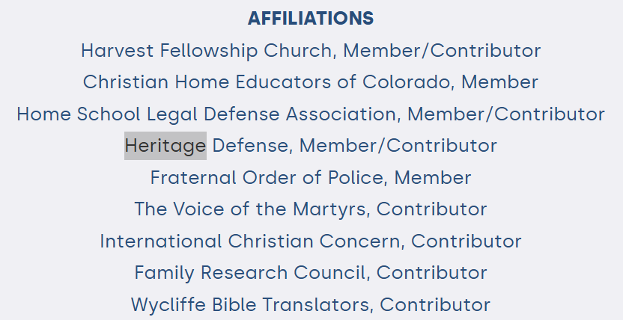
[Colorado Times Recorder, 10/16/25; iVoterGuide Survey, Candidate Profile, Viewed 2/20/25]
- Heritage Defense Was Dedicated To “Empowering The Biblical Family” By “Advancing Biblical Practices.” According to Heritage Defense, “Heritage Defense is a non-profit legal advocacy organization dedicated to advancing the Kingdom of Christ by protecting and empowering the biblical family. Our strategy for accomplishing this mission is simple. By uniting Christian families across the country as members of Heritage Defense, we hope to help the Body of Christ join together in protecting one another, defending the Gospel, advancing biblical practices, and championing the causes of those unlawfully persecuted by the state for obeying God’s commands in raising their children in the nurture and admonition of the Lord.” [Heritage Defense, viewed 4/1/25]
- Heritage Defense Said They Believed Parents Had A Right To Exercise Corporal Punishment Against Kids. According to the Heritage Defense FAQ Page, “What is Heritage Defense’s position on a parent’s right to use corporal punishment? Heritage Defense believes that parents have a right and a duty to exercise reasonable, loving, appropriate corporal punishment relating to the discipline and instruction of their children when Scripture indicates such discipline is proper.” [Heritage Defense, FAQ, Viewed 2/20/25]

