Overview
Despite the negative impact on Arizonans, Crane defended Trump’s tariffs. Crane voted four times to protect Trump’s tariffs, despite the pain the tariffs were bringing to Arizonans. In April 2025, he was even the deciding vote to protect them. Tariffs were contributing to higher food prices, were hurting Arizona businesses and farmers, and could increase car insurance rates.

Crane Was The Deciding Vote To Protect Trump’s Tariffs That Were Hurting Arizonans

Crane Has Repeatedly Voted To Protect Trump’s Tariffs

September 2025: Crane Voted Again To Protect Trump’s Tariffs
2025: Crane Effectively Voted For A Procedural Trick To Block Votes On The Reversal Of Trump’s Tariffs Through March 2026. In September 2025, Crane voted for, according to Congressional Quarterly, “the resolution [that] would allow for the tolling (the pausing of counting) of days for resolutions of inquiry from Sept. 30, 2025 through March 31, 2026. It also would provide that each day during the period from April 9, 2025, through March 31, 2026. would not constitute a calendar day for the purposes of section 202 of the National Emergencies Act with respect to a joint resolution to terminate President Donald Trump’s April 2, 2025 executive order declaring a national emergency regarding tariffs on imported goods. The resolution also would provide that during the period for March 11, 2025 through March 31, 2026, would not constitute a calendar day for purposes of section 202 of the National Emergencies Act with respect to a joint resolution terminating a national emergency executive order declared by President Trump on Feb. 1, 2025. Such an executive order concerned tariffs on many Canadian and Mexican imports and Chinese goods. The resolution also would provide that the provisions of section 202 of the National Emergencies Act would not apply through March 31, 2026 to a joint resolution terminating the national emergency.” The vote was on the rule. The House agreed to the rule by a vote of 213 to 211. [House Vote 268, 9/16/25; Congressional Quarterly, 9/16/25; Congressional Actions, H.Res. 707; Congressional Actions, H.Con. Res. 14]
- Support Was Won From GOP Holdouts Through A Promise Of A Vote Later In The Week To Shorten The Block To End In January Rather Than March. According to Politico, “GOP leaders flipped several of the Republican holdouts with a promise to add language shortening the block on tariff disapproval votes to a forthcoming measure set for approval later in the week, per two Republicans with direct knowledge of the agreement. The expiration date on the block will be reset from March 31 to the end of January, House Majority Leader Steve Scalise said Tuesday. It’s likely the Supreme Court will have ruled on a challenge to Trump’s tariff-declaring powers by then.” [Politico, 9/16/25]
- September 2025: House Republicans Voted In Favor Of A Measure That Effectively Blocked Challenges To Trump’s Tariffs Through March 2026, With The Intent Of Changing The Length Of Time To January 2026. According to Politico, “House Republicans voted in near lockstep Tuesday to again cede congressional power over tariffs to President Donald Trump. A measure that effectively blocks challenges to Trump’s sweeping global tariff declarations through March 2026 was adopted on a 213-211 vote. The vote was gaveled down only after GOP whips had a drawn-out struggle on the floor with a band of Republicans who initially opposed the legislation before flipping to yes. The vote was held open for more than a half-hour as they worked to bring the members back on board. GOP leaders flipped several of the Republican holdouts with a promise to add language shortening the block on tariff disapproval votes to a forthcoming measure set for approval later in the week, per two Republicans with direct knowledge of the agreement. The expiration date on the block will be reset from March 31 to the end of January, House Majority Leader Steve Scalise said Tuesday. It’s likely the Supreme Court will have ruled on a challenge to Trump’s tariff-declaring powers by then.” [Politico, 9/16/25]

April 2025: Crane Cast The Deciding Vote To Protect Trump’s Tariffs
2025: Crane Cast The Deciding Vote For A Procedural Trick To Block Votes On The Reversal Of Trump’s Tariffs Through September 2025. In April 2025, Crane voted for, “adoption of the rule (H Res 313) that would provide for floor consideration of the Senate amendment to the fiscal 2025 budget resolution (H Con Res 14). The rule would provide up to one hour of debate on a motion to concur in the Senate amendment to the measure. It also would block the expedited consideration of joint resolutions terminating President Donald Trump’s tariff actions under the April 2 executive order by providing that each day during the period from April 9, 2025 through Sept. 30, 2025, will not constitute a calendar day under the federal law pertaining to terminating national emergencies.” The vote was on the rule. The underlying legislation was the FY 2025 budget resolution. The House agreed to the rule by a vote of 216 to 215. [House Vote 94, 4/9/25; Congressional Quarterly, 4/9/25; Congressional Actions, H.Res. 313;Congressional Actions, H.Con. Res. 14]
- Speaker Johnson Backed The Move, Claiming Trump Has “Executive Authority” And That The Tariffs Are “In The Interest Of The American People.” According to ABC News, “House Speaker Mike Johnson, R-La., defended the move, telling reporters, ‘I’ve made it very clear I think the president has executive authority. It’s an appropriate level of authority to deal with the unfair trade practices. That’s part of the role of the president is to negotiate with other countries.’ Johnson said Trump told him Tuesday night that ‘there are almost 70 countries that are [in] some stage in negotiation of more fair-trade agreement agreements with the United States. I think that is in the interest of the American people. I think that is an ‘America First’ policy that will be effective, and so we have to give them the space to do it.’” [ABC News, 4/9/25]
- The Vote Was The Second Use Of The Procedural Tactic To Block Votes On The Tariffs, The First Use Of It Being In March. According to ABC News, “House Democrats, led by Rep. Gregory Meeks, D-N.Y., moved to force a vote on Tuesday on terminating the national emergency authority and blocking Trump’s sweeping tariffs. Now, that vote is unlikely to occur. This is the second time Johnson has moved to stop the legislative calendar to prevent votes on Trump’s authority on tariffs. Under House rules, these votes would typically come up within 15 calendar days but now will not if the ‘rule’ passes during the vote series Wednesday afternoon.” [ABC News, 4/9/25]

If One “Aye” Vote Had Switched To A “No” On House Vote 94 The Measure Would Have Failed Instead Of Passing
The Measure Considered In House Vote 94 Passed By A Vote Of 216 “Ayes” To 215 “Nos,” Which Meant If One Aye Vote Had Switched To A No Vote The Measure Would Have Failed.
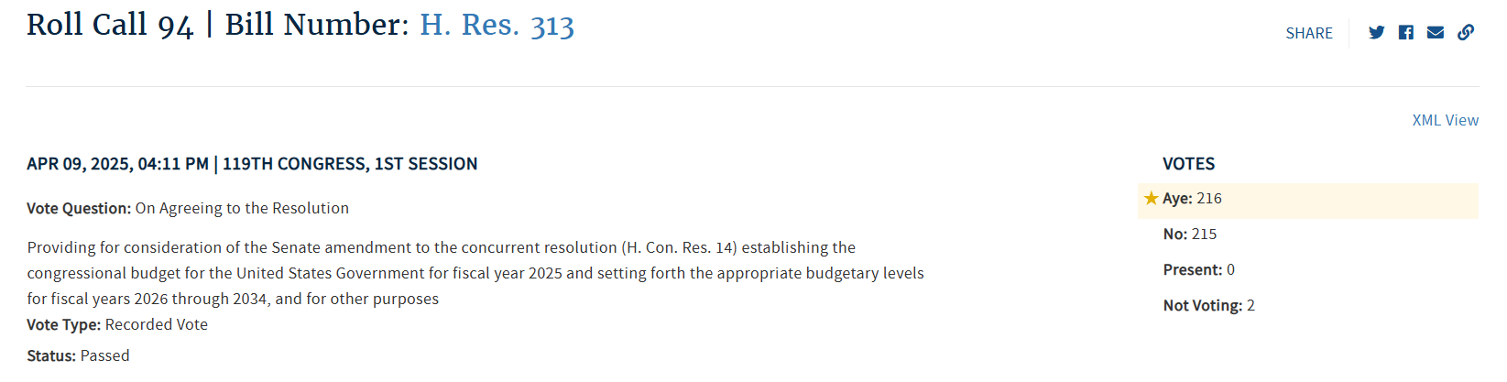
[House Vote 94, 4/9/25; Congressional Quarterly, 4/9/25; Congressional Actions, H.Res. 313;Congressional Actions, H.Con. Res. 14]

April 2025: Crane Voted To Protect Trump’s Tariffs
2025: Crane Effectively Voted For A Procedural Trick To Block Votes On The Reversal Of Trump’s Tariffs Through September 2025. In April 2025, Crane voted for, “motion to order the previous question (thus ending debate and possibility of amendment) on the rule (H Res 313) that would providing for floor consideration of the Senate amendment to the fiscal 2025 budget resolution (H Con Res 14). The rule would provide up to one hour of debate on a motion to concur in the Senate amendment to the measure. It also would block the expedited consideration of joint resolutions terminating President Donald Trump’s tariff actions under the April 2 executive order by providing that each day during the period from April 9, 2025 through Sept. 30, 2025, will not constitute a calendar day under the federal law pertaining to terminating national emergencies.” The vote was on the previous question. The House agreed to the rule by a vote of 217 to 212. [House Vote 93, 4/9/25; Congressional Quarterly, 4/9/25; Congressional Actions, H.Res. 313]

March 2025: Crane Voted To Protect Trump’s Tariffs
2025: Crane Voted To Disapprove An IRS Rule That Established Reporting Requirements For Digital Asset Proceeds And To Effectively Block Votes On The Reversal Of Trump’s Tariffs. In March 2025, Crane voted for, “the bill that would provide for Congressional disapproval of, and nullify, a December 2024 IRS rule related to gross proceeds reporting by brokers involved in digital asset sales. The rule imposed reporting requirements, beginning in 2027, on non-custodial barkers who participate in the decentralized digital asset market. It also required brokers to file information returns and provide payee statements reporting gross proceeds from certain digital asset sales and transactions.” The vote was on passage. The House passed the bill by a vote of 292 to 132. [House Vote 71, 3/11/25; Congressional Quarterly, 3/11/25; Congressional Actions, H.J. Res. 25]
- The Bill Effectively Blocked The House From Voting To Reverse Trump’s Tariffs On Mexico, Canada, And China For The Next Year. According to the New York Times, “Republican leaders on Tuesday slipped language into a procedural measure that would prevent any resolution to end the tariffs on Mexico, Canada and China from receiving a vote this year. It passed on party lines as part of a resolution that cleared the way for a vote later Tuesday on a government spending bill needed to prevent a shutdown at the end of the week.” [New York Times, 3/11/25]
- The Bill Nullified A Law That Would Allow The House And Senate To End A Disaster Declared By The President. According to the New York Times, “In this case, Republican leaders did so using a particularly unusual contortion: They essentially declared the rest of the year one long day, nullifying a law that allows the House and Senate to jointly put an end to a disaster declared by the president.” [New York Times, 3/11/25]
- The National Emergencies Act Required Consideration Of Resolutions Ending A Presidentially Declared Emergency Within Fifteen Calendar Days But Republican Leadership Included A Measure In The Bill Declaring The Rest Of The Year Did Not Constitute A Calendar Day. According to the New York Times, “The national emergency law lays out a fast-track process for Congress to consider a resolution ending a presidential emergency, requiring committee consideration within 15 calendar days after one is introduced and a floor vote within three days after that. But the language House Republicans inserted in their measure on Tuesday declared that, ‘Each day for the remainder of the 119th Congress shall not constitute a calendar day’ for the purposes of the emergency that Mr. Trump declared on Feb. 1.” [New York Times, 3/11/25]

Crane Defended Trump’s Tariffs
March 2025: Crane Claimed “Tariffs Work.” According to a post on Eli Crane’s Twitter,
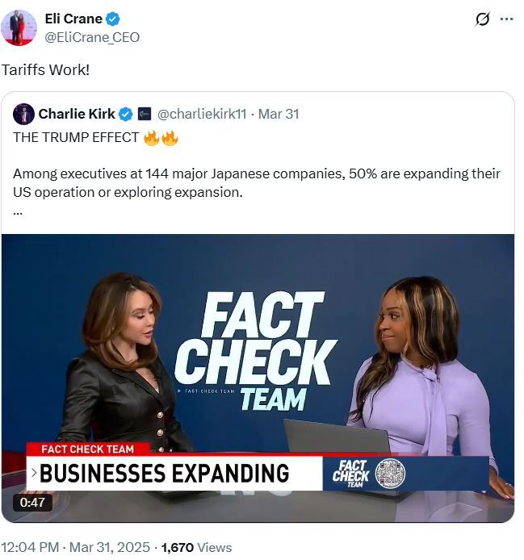
[Twitter, @EliCrane_CEO, 3/31/25]
April 2025: Crane Defended Trump’s Tariff Policies. According to a post on Rep. Eli Crane’s Twitter,
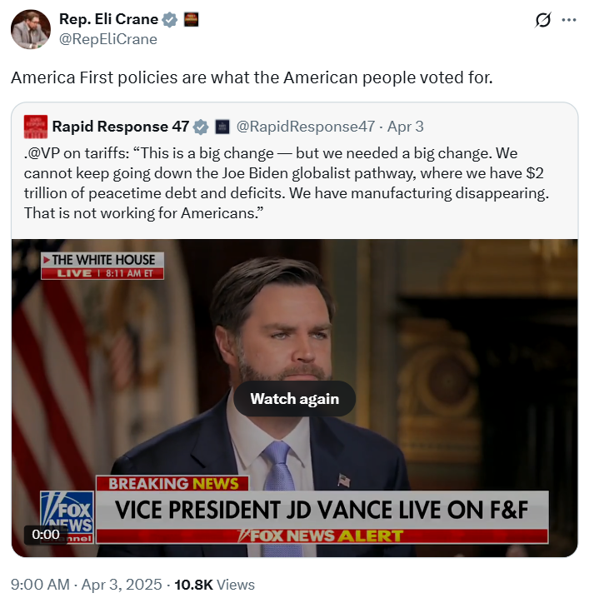
[Twitter, @RepEliCrane, 4/3/25]

Trump’s Tariffs Were Raising Prices On Arizonans
HEADLINE: “Grocery Inflation Highest Since 2022 As Trump Tariffs Pile Up” [Axios, 9/16/25]
Trump’s Tariffs Were Expected To Raise The Price Of Tomatoes And Cause Job Losses In Arizona. According to the Arizona Republic, “Consumers can expect grocery store prices for tomatoes to rise in the coming months after the Trump administration imposed new 17% duties on tomatoes imported from Mexico, according to trade advocates. The new tariffs also are expected to deal a financial blow to Arizona’s multibillion-dollar tomato import industry that could result in job losses and profit declines that will ripple through the broader economy, trade advocates and importers say. The new duties are aimed at preventing Mexican tomato growers from ‘dumping’ lower cost tomatoes on the U.S. market and providing a boost to U.S. tomato growers, especially in Florida, where tomato growers have long complained about tomato dumping from Mexico.” [Arizona Republic, 7/21/25]
Phoenix Toy Store Owner Said Trump’s Tariffs Would Result In Higher Prices. According to AZ Family, “President Donald Trump told American parents this week that their kids might have to live with fewer toys. Most toys are made in China, and the new tariffs will make them more expensive and less available in stores. A Valley toy store said it’s already feeling the impact. Wildlings Toy Boutique in Phoenix says the summer is typically a slow season for them, so they don’t usually stock the store. However, with 80% of toys produced in China, the owner said she’s been buying toys to create a back-stock of inventory. Wildlings Toy Boutique is straight out of owner Jenn Mawcinitt’s imagination. ‘Purposeful play was the mission here. So everything here has a purpose,’ she said. For five years, it’s been her safe haven, and she describes it as one of the best things she’s created. Last month, however, when the Trump administration announced 145% tariffs on items coming from China, her business became a point of stress. ‘Ultimately, toy manufacturers and toy store owners don’t operate on margins that would allow us to absorb those costs. We’re going to have to pass it on to our customers, and that is really hard to say,’ Mawcinitt said.” [AZ Family, 5/2/25]
China Had Stopped Buying U.S. Alfalfa To Feed Their Cattle As A Result Of Trump’s Trade War, Instead Going To Countries In Africa And Europe. According to ABC 15, “In the Harquahala Valley, hay fields stretch as far as the eye can see. Alfalfa hay is mainly used as feed for cattle and is big business in Arizona, with Arizona farms exporting over $100 million of alfalfa overseas a year. Shannon Schulz has been farming in the Harquahala Valley for decades. Business is slow because Chinese dairy farms have all but stopped buying U.S. alfalfa to feed their cattle after the country imposed retaliatory tariffs on U.S. exports. China makes up about half of Arizona’s alfalfa export market. ‘With the current tariffs in place, which is in total about 66% from China to us, it puts our product out of the marketplace,’ Schulz said. Schulz says that now Chinese farms are buying from other countries in Africa and Europe. For the alfalfa now growing in Arizona’s fields, by the time it’s ready to be harvested, there may not be a customer to buy it. Losing about half of his business overnight has not been easy. ‘It could break us,’ Schulz said. ‘It could break a lot of farmers.’” [ABC 15, 4/18/25]
HEADLINE: “Car Insurance Rates Could Rise With Tariffs” [Axios, 8/7/25]

