Overview
Crane voted for a bill that was estimated to kick 17 million Americans off their health insurance including nearly 12 million Americans who rely on Medicaid. More than 41,000 Arizonans could lose their health insurance as a result of Crane’s votes. Navajo leaders also warned that cuts would directly threaten the health care coverage of many Native Americans, which made up 18% of Crane's district. Crane even admitted the bill he voted for cut Medicaid after months of claiming Republicans were only tackling “waste, fraud, and abuse.” Crane, with this House Freedom Caucus colleagues, later bragged about how much more dramatic they were able to make the cuts in the reconciliation bill.

Crane Voted To Take Health Insurance Away From Arizonans Who Relied On Medicaid

Crane Voted For House Republicans’ Budget Bill, Which Would Kick Millions Of People Off Medicaid and Snap To Give Tax Breaks to Billionaires

July 2025: Crane Voted For The Final Version Of The Republican Reconciliation Bill
July 2025: Crane Voted For The Senate FY 2025 Budget Reconciliation Bill That Extended $4 Trillion In Expiring Tax Cuts, Added New Tax Breaks, Appropriated $448 Billion In Defense, Border, And Immigration Enforcement Funding, Increased The SALT Deduction To $40,000, And Cut Medicaid And Other Social Programs To Offset The Costs. In July 2025, Crane voted for, according to Congressional Quarterly, the “motion to concur in the Senate amendment to the bill that would permanently extend nearly $4 trillion in expiring individual and business tax cuts, create several new tax breaks and fund border and immigration enforcement and air traffic control upgrades. It would cut Medicaid and other safety net programs to partly offset the cost. Among other provisions, it would raise the statutory debt ceiling by $5 trillion and appropriate more than $448 billion in mandatory funding for Trump administration priorities and other needs, including $153 billion for defense, $89 billion for immigration enforcement, and $89.5 billion for border control and security. It also would increase the state and local tax deduction cap to $40,000 annually for five years for households making up to $500,000 a year until 2030, when it would permanently revert to $10,000.” The House passed the bill by a vote of 218 to 214. [House Vote 190, 7/3/25; Congressional Quarterly, 7/3/25; Congressional Actions, H.R. 1]
- HEADLINE: "At Least 17 Million Americans Would Lose Insurance Under Trump Plan" [Washington Post, 7/1/25]
- The Congressional Budget Office Estimated That 11.8 Million People Would Become Uninsured As A Result Of The Medicaid Cuts In Republicans’ Reconciliation Bill. According to the Washington Post, "The bill, which narrowly passed the Senate on Tuesday and now heads back to the House, would effectively accomplish what Republicans have long failed to do: unwind many of the key components of the ACA, President Barack Obama’s signature domestic achievement, which dramatically increased the number of Americans with access to health insurance. To start, the Congressional Budget Office estimated that the Senate version of the bill would result in 11.8 million more uninsured in 2034, mostly because of Medicaid cuts, compared with 10.9 million if the House version became law." [Washington Post, 7/1/25]
- HEADLINE: ‘Medicaid Cuts In Trump’s 'Big Beautiful Bill' Could Cripple Some Of Arizona’s Rural Hospitals” [Tucson Sentinel, 7/2/25]

May 2025: Crane Voted For House Republican Budget Bill
May 2025: Crane Voted For The FY 2025 Budget Reconciliation Bill That Included $3.8 Trillion In Tax Cuts Offset By $1.5 Trillion In Spending Reductions To Programs Like Medicaid And The Supplemental Nutrition Assistance Program. In May 2025, Crane voted for, according to Congressional Quarterly, “the bill that would provide for approximately $3.8 trillion in net tax cuts and $321 billion in military, border enforcement and judiciary spending, offset by $1.5 trillion in spending reductions, as instructed in the fiscal 2025 budget resolution (H Con Res 14). It would raise the statutory debt limit by $4 trillion and provide for increased spending on defense and border security, spending cuts on social safety net programs, such as Medicaid and the Supplemental Nutrition Assistance Program. It also includes a mix of tax breaks for businesses and individuals; tax increases on universities and foundations; and a phase-down of clean energy tax credits. […] It would reduce federal spending on the Supplemental Nutrition Assistance Program by requiring states to shoulder more of the cost, expand work requirements for SNAP, extend programs authorized under the 2018 farm bill, and prohibit the U.S. Department of Agriculture from increasing the cost of the Thrifty Food Program. As amended, it would cap state and local tax deductions at $40,000 for households with incomes below $500,000.” The House passed the bill by a vote of 215 to 214. [House Vote 145, 5/22/25; Congressional Quarterly, 5/22/25; Congressional Actions, H.R. 1]
- The House GOP Budget Bill Was Estimated To Increase The Uninsured Population By 8.6 Million By 2034. According to CNN, “The Medicaid and Affordable Care Act provisions in the package could result in 8.6 million more people being uninsured in 2034, according to an early CBO estimate released by Democratic lawmakers. That number is expected to grow with the latest changes.” [CNN, 5/28/25]
- The House GOP Budget Bill Codified A Trump Administration Proposal That Restricted Access To The Affordable Care Act. According to CNN, “The bill also calls for codifying a Trump administration proposal that would make changes to the Affordable Care Act enrollment process, including shortening the open enrollment period and eliminating the ability of low-income Americans to sign up year-round.” [CNN, 5/28/25]
- The House GOP Budget Bill Made The 2017 Income Tax Breaks Permanent And Added An Estimated $3.8 Trillion To The National Debt Over 10 Years. According to CNN, “The package includes several controversial measures that would deeply cut into two of the nation’s key safety net programs – Medicaid and food stamps – while making permanent essentially all of the trillions of dollars of individual income tax breaks contained in the GOP’s 2017 Tax Cuts and Jobs Act. What’s more, it would fulfill Trump’s campaign promises to cut taxes on tips and overtime, albeit temporarily. The magnitude of the measures is evident in the estimates of the cost they would incur or the savings they would produce. […] The tax changes in the package would add $3.8 trillion to the nation’s debt over a decade, according to a Congressional Budget Office analysis released before last-minute changes were made to the bill.” [CNN, 5/28/25]

February 2025: Crane Voted To Pass The House Republican Reconciliation Budget Framework
February 2025: Crane Voted For The FY 2025 Budget Framework That Included $2 Trillion In Cuts, Raised The Statutory Debt Limit By $4 Trillion, And Required House Committees To Recommend Legislation That Would Implement Trump’s Agenda. In February 2025, Crane voted for, according to Congressional Quarterly, “the concurrent resolution that would recommend a budget for fiscal 2025 and budget levels through fiscal 2034. The resolution would assume minimum savings of $1.5 trillion over 10 years and 2.6 percent economic growth over the same period. It also would require the statutory debt limit to be raised by $4 trillion. It also would authorize the House Ways and Means Committee to increase deficits by $4.5 trillion over 10 years to extend the 2017 tax cuts and implement new tax cuts proposed by the White House. It also would provide instructions for the budget reconciliation process through which separate legislation could be considered and passed in the Senate via a simple majority vote. The measure would deliver instructions to 11 House committees to report legislation that would implement President Donald Trump’s agenda, such as expanding tax cuts and bolstering border security and immigration enforcement. The committees would be required to report their legislative recommendations to the House Budget Committee by March 27, 2025. It also would set a $2 trillion target for the spending cuts to be submitted to the House Budget Committee. The resolution also would stipulate that if the committees don't reach that target, the Ways and Means’ reconciliation instructions to increase the deficit by a maximum of $4.5 trillion would be decreased by the amount the other committees come in below the target. Similarly, it would stipulate that Ways and Means could increase the deficit above the $4.5 trillion level by the amount of savings the committees achieve above the $2 trillion target.” The vote was on passage. The House passed the resolution by a vote of 217 to 215. [House Vote 50, 2/25/25; Congressional Quarterly, 2/25/25; Congressional Actions, H. Con. Res. 14]
- HEADLINE: "House Republican Budget Takes Away Health Care, Food Aid To Pay For Expanded Tax Cuts For Wealthy" [Center on Budget and Policy Priorities, 2/21/25]
- New York Times Reported The $880 Billion In Cuts Required By The Republican Budget Proposal Would Have To Come From Medicaid, Medicare, Or CHIP. According to the New York Times, "The budget resolution itself is silent on whether Congress cuts Medicaid, which provides health coverage to 72 million poor and disabled Americans. But it instructs the House Energy and Commerce Committee, which has jurisdiction over the program, to cut spending by $880 billion over the next decade. If the committee can’t save at least that much, the entire effort could be imperiled because of the special process Congress is using to avoid a Senate filibuster. Ten other committees have their own instructions to follow, though none have been assigned with cutting nearly as much. It’s not so simple as finding the cuts elsewhere. The special process, known as budget reconciliation, means Republicans will have to find all $880 billion from within the Energy and Commerce Committee’s jurisdiction. That leaves them with fewer options than one might think. […] If Republicans want to avoid major cuts to Medicaid, the largest pot of available money is in the other big government health insurance program: Medicare. […] Even if the committee cuts everything that’s not health care to $0, it will still be more than $600 billion short. The committee could also save around $200 billion by eliminating the Children’s Health Insurance Program, but that option has not been raised by the budget committee or anyone in House leadership. […] Even if all of these cuts, revenues and rule cancellations from outside health care can pass muster, the committee will still be left with hundreds of billions of dollars to cut to hit its goal. Mathematically, the budget committee’s instructions mean the committee would need to make major cuts to either Medicare, Medicaid or both." [New York Times, 2/25/25]

Crane Admitted To Cutting Medicaid After Previously Hiding Behind “Waste, Fraud, And Abuse” lies

Crane: “There Was Some Cutting Of Medicaid”
July 2025: Crane Said There Were Cuts To Medicaid In The “Big Beautiful Bill.” According to a telephone town hall with Eli Crane, “CONSTITUENT: I'm very concerned that the big, beautiful bill added significantly to the national debt and at the same time was reducing the amount of money available for Medicare. CRANE: As far as your question on Medicaid, there was actually zero cut or I'm sorry, Medicare. There was zero impact to Medicare. There was some cutting of Medicaid.” [Rep. Eli Crane Telephone Town Hall, 7/22/25] (audio)
- HEADLINE: “Republicans’ Claims Of “Fraud” Are A Pretext For Unpopular And Drastic Medicaid Cuts” [Center on Budget and Policy Priorities, 4/16/25]

Crane Previously Claimed Republicans Were Only Cutting “Waste, Fraud, And Abuse” In Medicaid
May 2025: “Eliminating Waste, Fraud And Abuse In Medicaid Is Critical.” According to a post on Rep. Eli Crane’s Twitter, “Eliminating waste, fraud and abuse in Medicaid is critical.”
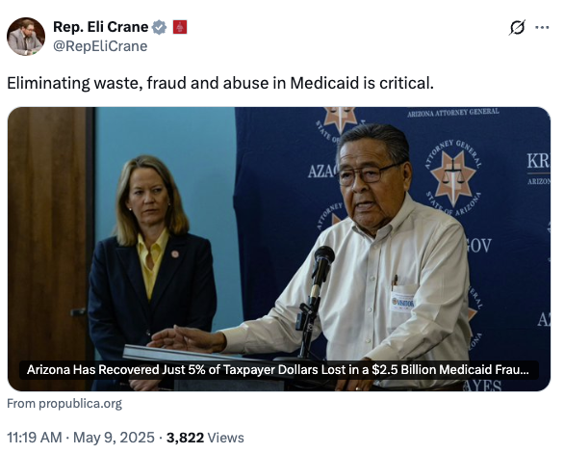
[Twitter, @RepEliCrane, 5/9/25]
- Crane Claimed Stopping Waste, Fraud, And Abuse In Medicaid Would Strengthen Medicaid.
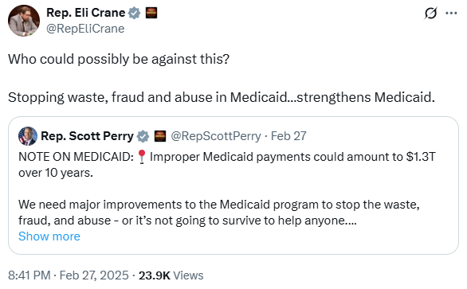
[Twitter, @RepEliCrane, 2/27/25]

Crane Then Bragged With His House Freedom Caucus Colleagues About How Much Deeper They Were Able To Make The Cuts In The Bill
Crane, With His Freedom Caucus Colleagues, Bragged About How They Got Cuts, Including To Medicaid, In The One Big Beautiful Bill Increased From $300 Billion To $1.5 Trillion. According to the Fresh Freedom Podcast, "HOST: And I mean, when you go back to the middle of summer, when the One Big Beautiful Bill was passed, I mean, that fight in particular probably has to stand out as a moment where the Freedom Caucus really flexed to get that bill as conservative as possible. I mean, there are wins in there when you talk to various policy experts around Washington, D.C., particularly about Medicaid reforms. They sit there stunned to think that this town actually moved in a conservative manner on, you know, programs that have largely just been untouched and they've grown to such an extreme amount. KEITH SELF: Well, yeah, when you talk about the initial number that they gave us, they were going to try to save 300. ERIC BURLISON: 300 million. CRANE: Yeah, over ten years. SELF: Over ten years. And we got into 1.5. BURLISON: Trillion. SELF: Trillion, $1.6 trillion. CRANE: Which is still pathetic when you look at the annual debt and deficit. But when you go from 300 billion to 1.5 trillion, that's a big number. And so that's how bad this town is. Even when you rally a group who are willing to use political force, you know, it's still pathetic, but it's, it is a jump. And it does show that, you know, you can move the needle up here in D.C. SELF: And frankly, that 1 trillion out of Medicare, Medicaid is huge because health care costs are what's driving the debt and the deficit. BURLISON: Yeah, I mean, I think the evidence was best said by Scott Bessent whenever after we passed the I guess they're calling it the Working Families Job Act now. But after we passed it, he said on national news that this bill was made incredibly better by the Freedom Caucus. And I mean, and that’s, the truth is, we behind the scenes, it wasn't easy. It was a, it was a mess. It was difficult. It was challenging. There were some heated conversations, a lot of posturing, a lot of threats against us. But we stood firm and we forced this conference to pass the most conservative bill possible." [The Fresh Freedom Podcast, 12/20/25] (video)

An Estimated 201,500 Arizonans In The Second Congressional District Relied On Medicaid Or CHIP For Health Insurance
201,500 Arizonans In The 2nd Congressional District Were Enrolled In Medicaid Or CHIP. According to the Center for American Progress,
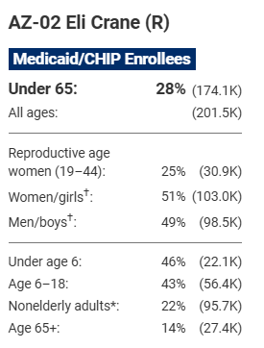
[Center for American Progress, 3/11/25]
June 2025: The Estimated Number Of People Losing Medicaid Coverage In Arizona’s Second District Was 26,014 People.
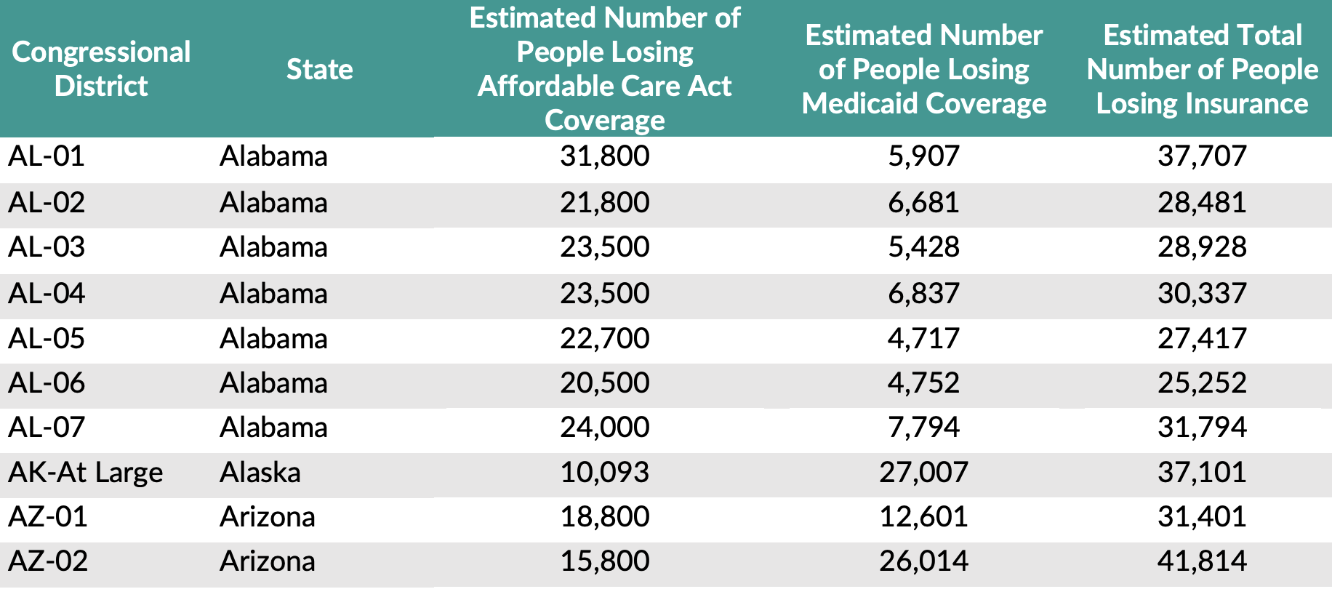
[U.S. Joint Economy Committee Minority, June 2025]

Navajo Leaders Warned Cuts Would Hurt Native Americans’ Health Care Access
Navajo Leaders Warned Cuts To Medicaid Would Disrupt Health Care For Native Americans. According to KFF, "But Nygren and other Navajo leaders said cuts to federal health programs outside the Indian Health Service are hurting Native Americans. ‘You’re disrupting real lives,’ Cherilyn Yazzie, a Navajo council delegate, told KFF Health News as she described recent changes. Kennedy has repeatedly promised to prioritize Native Americans’ health care. But Native Americans and health officials across tribal nations say those overtures are overshadowed by the collateral harm from massive cuts to federal health programs. The sweeping reductions have resulted in cuts to funding directed toward or disproportionately relied on by Native Americans. Staffing cuts, tribal health leaders say, have led to missing data and poor communication." [KFF, 6/3/25]
- 2024: More Than 18 Percent Of Arizona District 2’s Population Was Native American. According to Cronkite News, "According to the Arizona Independent Redistricting Commission, which is in charge of drawing congressional and state legislative district lines, over 18% of District 2’s population is Native American. District 2 covers a significant portion of the Navajo Nation and is home to the Hopi Tribe, White Mountain Apache Tribe, Hualapai Tribe and eight other tribal nations." [Cronkite News, 11/4/24]

