Overview
Crane defended Trump’s “Department of Government Efficiency,” even as DOGE cuts were harming Americans’ ability to access the Social Security Administration. More than 225,000 Arizonans in the second congressional district relied on Social Security benefits.

Crane Backed DOGE Despite The Harm It Caused To The Social Security Administration

Crane Said DOGE Was “necessary”
Crane Said DOGE Was “Necessary” To Fix The “Elitist” Swamp. According to a post on Rep. Eli Crane’s Twitter,
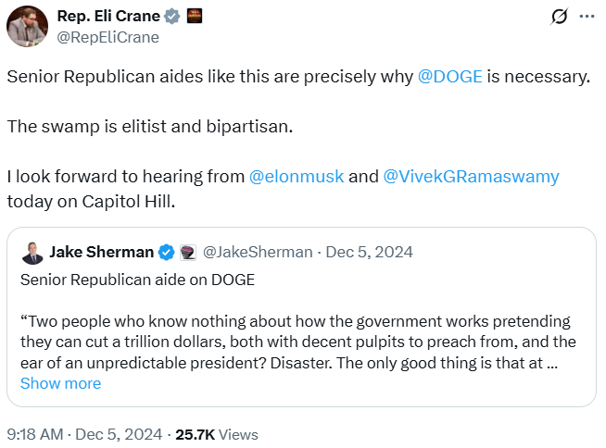
[Twitter, @RepEliCrane, 12/5/24]
Crane: “We Must Support The Work That @POTUS & @DOGE Are Doing.” According to a post on Rep. Eli Crane’s Twitter, “Last week, we learned in @GOPoversight that Anthony Fauci authorized more than $200M in taxpayer funds for ‘transgender animal testing.’ This is just the tip of the iceberg. We must support the work that @POTUS & @DOGE are doing. Huge thanks to @jineane_ford for having me on.” [Twitter, @RepEliCrane, 2/14/25]
6/11/25: Crane Said Republicans Would Win By Passing DOGE Cuts In The House.

[Twitter, @RepEliCrane, 6/11/25]

At The Social Security Administration, DOGE Had Forced Mass Layoffs, Longer Wait Times And Frequent Website Crashes
HEADLINE: “Social Security Stops Reporting Call Wait Times And Other Metrics” [Washington Post, 6/20/25]
HEADLINE: “As Social Security Services Are Cut Back, Millions Of Seniors Face Long Drives” [Axios, 6/8/25]
HEADLINE: “Social Security Website Keeps Crashing, As DOGE Demands Cuts To IT Staff” [Washington Post, 4/7/25]
HEADLINE: “Social Security Faces Thousands More Job Cuts Even With Service In Tailspin” [Washington Post, 4/4/25]
The Social Security Administration Website Crashed Four Times In Ten Days In March Because Servers Were Overloaded. According to the Washington Post, “The Social Security Administration website crashed four times in 10 days this month because the servers were overloaded, blocking millions of retirees and disabled Americans from logging in to their online accounts. In the field, office managers have resorted to answering phones in place of receptionists because so many employees have been pushed out. Amid all this, the agency no longer has a system to monitor customer experience because that office was eliminated as part of the cost-cutting efforts led by Elon Musk. And the phones keep ringing. And ringing.” [Washington Post, 3/25/25]
Field Office Managers At Social Security Offices Had To Answer Phones In Place Of Receptionists Because DOGE Had Pushed Out So Many Federal Employees. According to the Washington Post, “The Social Security Administration website crashed four times in 10 days this month because the servers were overloaded, blocking millions of retirees and disabled Americans from logging in to their online accounts. In the field, office managers have resorted to answering phones in place of receptionists because so many employees have been pushed out. Amid all this, the agency no longer has a system to monitor customer experience because that office was eliminated as part of the cost-cutting efforts led by Elon Musk. And the phones keep ringing. And ringing.” [Washington Post, 3/25/25]
DOGE Eliminated The Social Security Administration’s System To Monitor Customer Experience. According to the Washington Post, “The Social Security Administration website crashed four times in 10 days this month because the servers were overloaded, blocking millions of retirees and disabled Americans from logging in to their online accounts. In the field, office managers have resorted to answering phones in place of receptionists because so many employees have been pushed out. Amid all this, the agency no longer has a system to monitor customer experience because that office was eliminated as part of the cost-cutting efforts led by Elon Musk. And the phones keep ringing. And ringing.” [Washington Post, 3/25/25]
Early February-Late March 2025: AARP Said More Than 2,000 People Per Week Had Called Expressing Concerns About Whether They Would Continue To Get Their Social Security Benefits. According to the Washington Post, “Alarmed lawmakers are straining to answer questions back home from angry constituents. Calls have flooded into congressional offices. AARP announced Monday that more than 2,000 people a week have called the retiree organization since early February — double the usual number — with concerns about whether benefits they paid for during their working careers will continue. Social Security is the primary source of income for about 40 percent of older Americans.” [Washington Post, 3/25/25]

More Than 225,000 Arizonans In The 2nd Congressional District Relied on Social Security Benefits
225,055 Arizonans In The 2nd Congressional District Relied On Social Security Benefits. According to the Social Security Administration, in 2024, 225,055 Arizonans In The 2nd congressional district received Social Security benefits. [Social Security Administration, Arizona, 2024]

