Overview
Bacon is on record saying he supported raising the Social Security retirement age. In July of 2024, his campaign Twitter account also reposted a video of Ben Shapiro who said he supported privatizing Social Security and raising the retirement age. More than 105,000 Nebraskans in Bacon’s district rely on Social Security benefits.

Bacon Supported Raising The Social Security Retirement Age

2018: Bacon Supported Raising The Retirement Age for social security
2018: Bacon Said He Wanted To Raise The Retirement Age To Collect Social Security Benefits. According to a post on Rep. Don Bacon’s Twitter account, "By 2033 social security will become insolvent: we need to start working now by studying and adjusting the retirement age to reflect the increased life expectancy and preserve social security benefits."
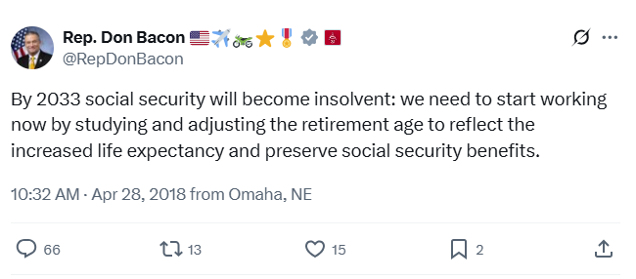
[Twitter, @RepDonBacon, 4/28/18]

2024: Bacon Shared A Video of ben shapiro advocating for privatizing Social Security And Raising The Retirement Age
2024: Bacon Shared A Video Of Ben Shapiro Arguing For Privatizing Social Security And Raising The Retirement Age. According to a video posted by @toottootchoo and reposted by Don Bacon’s Twitter account, “BEN SHAPIRO: I’m not sure what Project 2025’s position on Social Security is. I’m in favor of the restructuring of Social Security along the lines of privatization and lowering, and and—increasing the retirement age, because you, as well as every other congressperson knows social security is going to go bankrupt and yet everyone seems to have an interest in lying about it for the next decade and a half until we have to take austerity measures or radically increase inflation or taxes.”
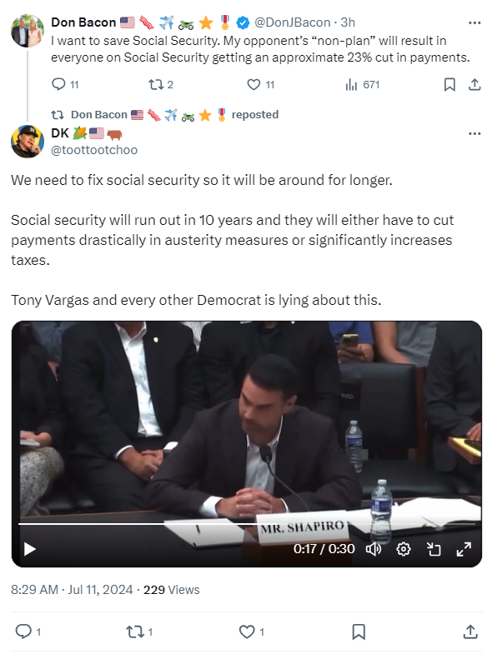
[Twitter, @toottootchoo, 7/11/24] (video)
2023: MORE THAN 105,000 NEBRASKANS IN THE SECOND CONGRESSIONAL DISTRICT RELIED ON SOCIAL SECURITY BENEFITS
2023: 105,344 Nebraskans In The 2nd Congressional District Relied On Social Security Benefits. According to the Social Security Administration, in 2023, 105,344 Nebraskans in the 2nd congressional district received Social Security benefits. [Social Security Administration, Nebraska, 2023]

