Overview
Bacon has previously opposed legislation that provided affordable health care options to Americans. In 2017, Bacon said he was a “hell, yes” on repealing and replacing the Affordable Care Act. Bacon also voted against the Inflation Reduction Act, but tried to take credit for its provision that capped insulin costs for seniors at $35 per month.

Bacon Has Said He Was A “Hell Yes” To Repealing The Affordable Care Act, Which Allowed States To Expand Medicaid

2017: bacon said he voted “hell, yes” to repeal the affordable care act
2017: Bacon Said He Voted “Hell, Yes” To Repeal The Affordable Care Act. According to the Omaha World-Herald, "Abandoning negotiations, President Donald Trump late Thursday demanded a make-or-break vote on health care legislation today in the House, threatening to leave the Affordable Care Act in place and move on to other issues if the vote fails. […] While President Barack Obama’s health care law included good provisions such as guaranteed coverage for those with pre-existing conditions, Bacon said he’s also heard horror stories about Nebraskans hurt by the law. As Bacon emerged from the meeting, he said it included great speeches calling for unity. He reiterated his strong support for the GOP bill. ‘I’ve changed my vote, from ‘yes’ to ‘hell, yes,’’ Bacon said." [Omaha World Herald, 3/24/17]

Bacon Voted Against The Inflation Reduction Act, But Tried To Take Credit For Its Provision That Capped The Cost Of Insulin For Medicare Recipients
HEADLINE: "Rep. Don Bacon Touts Vote For Insulin Cap That Didn’t Become Law" [Washington Post, 6/12/24]
June 2024: Bacon Touted Capping Insulin Costs In An Ad, But Later Acknowledged He Did Not Vote For The Inflation Reduction Act, Which Actually Capped The Cost Of Insulin For Medicare Recipients. According to the Washington Post, "Rep. Don Bacon, a Republican moderate running for reelection in Nebraska, is airing a campaign ad in which his wife, Angie Bacon, touts his vote to cap the price of insulin for seniors on Medicare at $35. That bill, however, never became law. […] In a statement, Bacon said he did not vote for the Inflation Reduction Act because he was not willing ‘to double the size of the IRS.’ The act included provisions that would increase funding to the Internal Revenue Service, which Republicans opposed." [Washington Post, 6/12/24]
6/5/24: Bacon Aired An Ad Claiming He Capped Insulin Costs At $35 A Month. According to a video posted on Don Bacon for Congress’ YouTube channel, “ANGIE BACON: I’m especially proud that he’s capped insulin prices at $35 a month.”
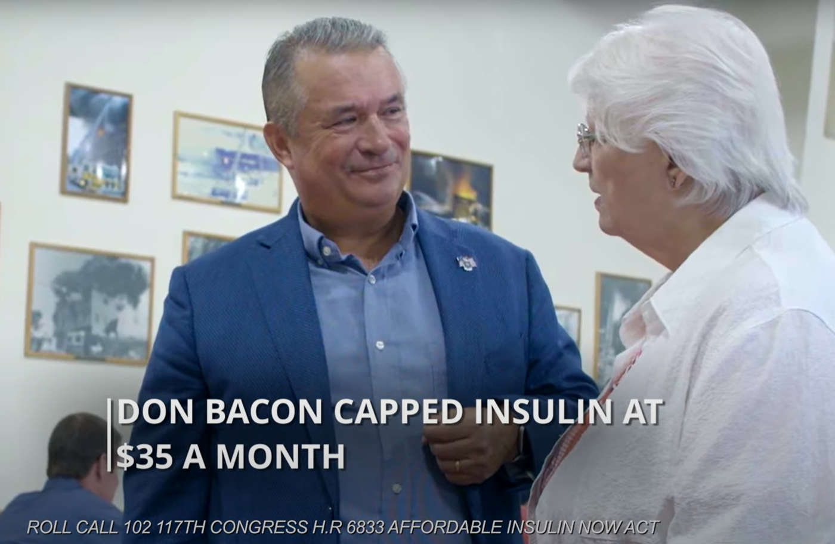
[YouTube, Don Bacon For Congress, “Angie 2024,” 6/5/24] (video)
- 2022: Bacon Voted Against The Inflation Reduction Act. In August 2022, according to Congressional Quarterly, Bacon voted against concurring in the Senate amendment to the Inflation Reduction Act of 2022, which would “require the Health and Human Services Department to negotiate a ‘maximum fair price’ with drug manufacturers for certain Medicare-eligible, brand-name drugs that do not have generic competition.” The vote was on a motion to concur. The House concurred with the Senate by a vote 220-207, thus the bill was sent to President Biden for final signage. President Biden signed the bill and it ultimately became law. [House Vote 420, 8/12/22; Congressional Quarterly, 8/12/22; Congressional Actions, H.R. 5376]
- The Inflation Reduction Act Capped Insulin Prices At $35 A Month. According to CNN, "Medicare enrollees now pay no more than $35 a month for each of their insulin prescriptions, thanks to the Inflation Reduction Act, which Democratic lawmakers pushed through Congress in 2022." [CNN, 1/2/23]

Bacon Claimed He Voted Against The Inflation Reduction Act Because He Did Not Want To Add New Government Jobs
Bacon Acknowledged He Did Not Vote For The Inflation Reduction Act Because He Was Not Willing “To Double The Size Of The IRS.” According to the Washington Post, "Rep. Don Bacon, a Republican moderate running for reelection in Nebraska, is airing a campaign ad in which his wife, Angie Bacon, touts his vote to cap the price of insulin for seniors on Medicare at $35. That bill, however, never became law. […] In a statement, Bacon said he did not vote for the Inflation Reduction Act because he was not willing ‘to double the size of the IRS.’ The act included provisions that would increase funding to the Internal Revenue Service, which Republicans opposed." [Washington Post, 6/12/24]

The Inflation Reduction Act Capped Prescription Drug Costs Under Medicare, Which Benefited More Than 51,000 Nebraskans
The Inflation Reduction Act Allowed Medicare To Negotiate Prices For Certain Prescription Drugs. According to the U.S. Department of Health and Human Services, "Negotiations are underway between HHS and the participating drug companies of the first 10 prescription drugs selected for negotiation in the first cycle of the Medicare Drug Price Negotiation Program. The first 10 drugs selected treat conditions such as blood clots, diabetes, heart disease, heart failure, autoimmune diseases, and chronic kidney disease." [U.S. Health and Human Services, Inflation Reduction Act Of 2022, Viewed 7/1/24]
The Inflation Reduction Act Required Drug Companies To Pay A Rebate To Medicare If They Raised Prices Faster Than The Rate Of Inflation. According to the U.S. Department of Health and Human Services, "Allowing Medicare to negotiate with participating drug companies to get lower drug prices for certain drugs covered under Medicare Beginning negotiations with the participating drug companies that manufacture all 10 drugs selected for the first cycle of negotiations" [U.S. Health and Human Services, Inflation Reduction Act Of 2022, Viewed 7/1/24]
More Than 51,000 Nebraskan Medicare Enrollees Were Prescribed Drugs Selected For Price Negotiation Under The Inflation Reduction Act. According to the U.S. Department of Health and Human Services,
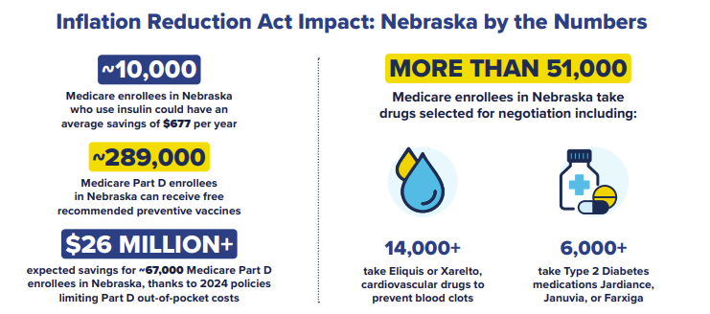
[U.S. Department of Health and Human Services, Lowering Prescription Drug Costs for Nebraska, Viewed 5/6/25]

